DIGITAL TIMER

EXTFEARNAL FEATURES:
An digital timer is an electronic timekeeping device that uses a microcontroller for precise timing. It displays intervals on an LED screen and is fully programmable for countdowns, repetitive cycles, or scheduled operations.
These timers control connected machinery via relay outputs, making them essential for production lines, assembly systems, and process automation. With high accuracy, compact design, and robust reliability, industrial digital timers optimize efficiency, operational precision, and task management across manufacturing environments.
- Physical consruction:
The physical construction of a digital timer typically consists of a plastic or ABS enclosure housing several key electronic components: a power supply, a microcontroller with a highly accurate crystal oscillator, a display (usually LED or LCD), control buttons, and an output mechanism (like a relay)
- Digital timer:
An digital timer is an electronic timekeeping device that uses a microcontroller for precise timing. It displays intervals on an LED screen and is fully programmable for countdowns, repetitive cycles, or scheduled operations.
These timers control connected machinery via relay outputs, making them essential for production lines, assembly systems, and process automation. With high accuracy, compact design, and robust reliability, industrial digital timers optimize efficiency, operational precision, and task management across manufacturing environments.
  - 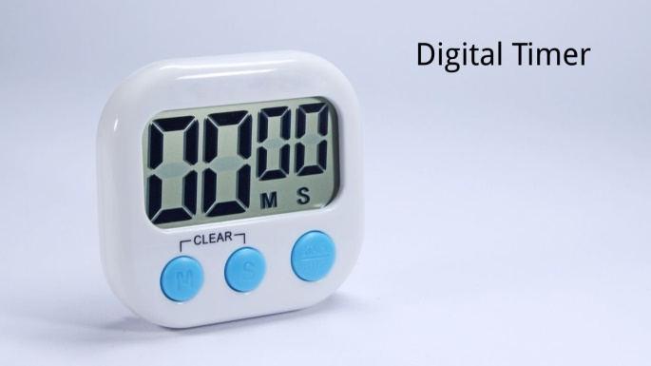
- Principle :
A timer works by using a timing mechanism, like a motor or an electronic circuit, to count down from a set time and then trigger a switch at zero. Mechanical timers use a synchronous motor and gears to move a switch, while electronic timers use a crystal oscillator and logic circuits to precisely control the timing sequence. Both types have a power source and a way to set the desired time duration, with the final action being a signal to turn an electrical device on or off.

- Internal features:
An internal timer of a microcontroller is a built-in hardware component that is used to measure time intervals and trigger events at specific times. It consists of a counter that increments at a certain frequency, typically based on the system clock, and can be configured to generate interrupts or trigger other actions when a specific time or count value is reached.
- Uses:
- Controlling the timing of program execution.
- Measuring the duration of external events.
- Generating periodic signals for use in communication
- Internal timers are a common feature of most microcontrollers and are an important tool for controlling the timing and behavior of embedded system
Thara

Purpose: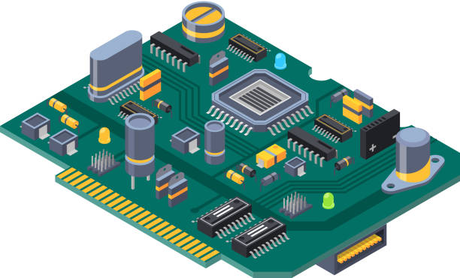
The purpose of a digital timer is to precisely measure and control time intervals to automate tasks, improve efficiency, and save energy, by turning devices on/off at set times for applications like home lighting, industrial machinery, irrigation, and even personal focus techniques (like Pomodoro). They offer greater accuracy, programmability (cycles, days, countdowns), and clear displays compared to mechanical timers, acting as electronic timekeepers for both simple household needs and complex industrial processes.
- Key Purposes & Benefits:
- Automation: Controls equipment (lights, pumps, motors, HVAC) to operate only when needed, reducing manual intervention.
- Energy Savings: Optimizes energy use by switching off systems during off-peak hours, lowering electricity bills.
- Precision & Consistency: Ensures tasks (like chemical dosing, heating cycles, or production runs) happen exactly on schedule.
- Enhanced Security: Simulates occupancy by turning lights on/off, deterring burglars.
- Productivity & Focus: Helps implement time management methods like Pomodoro Technique for better work-life balance and focus.

