PES1UG25AM807
PAVITHRA B

Faculty Research Grant & Publication Tracker
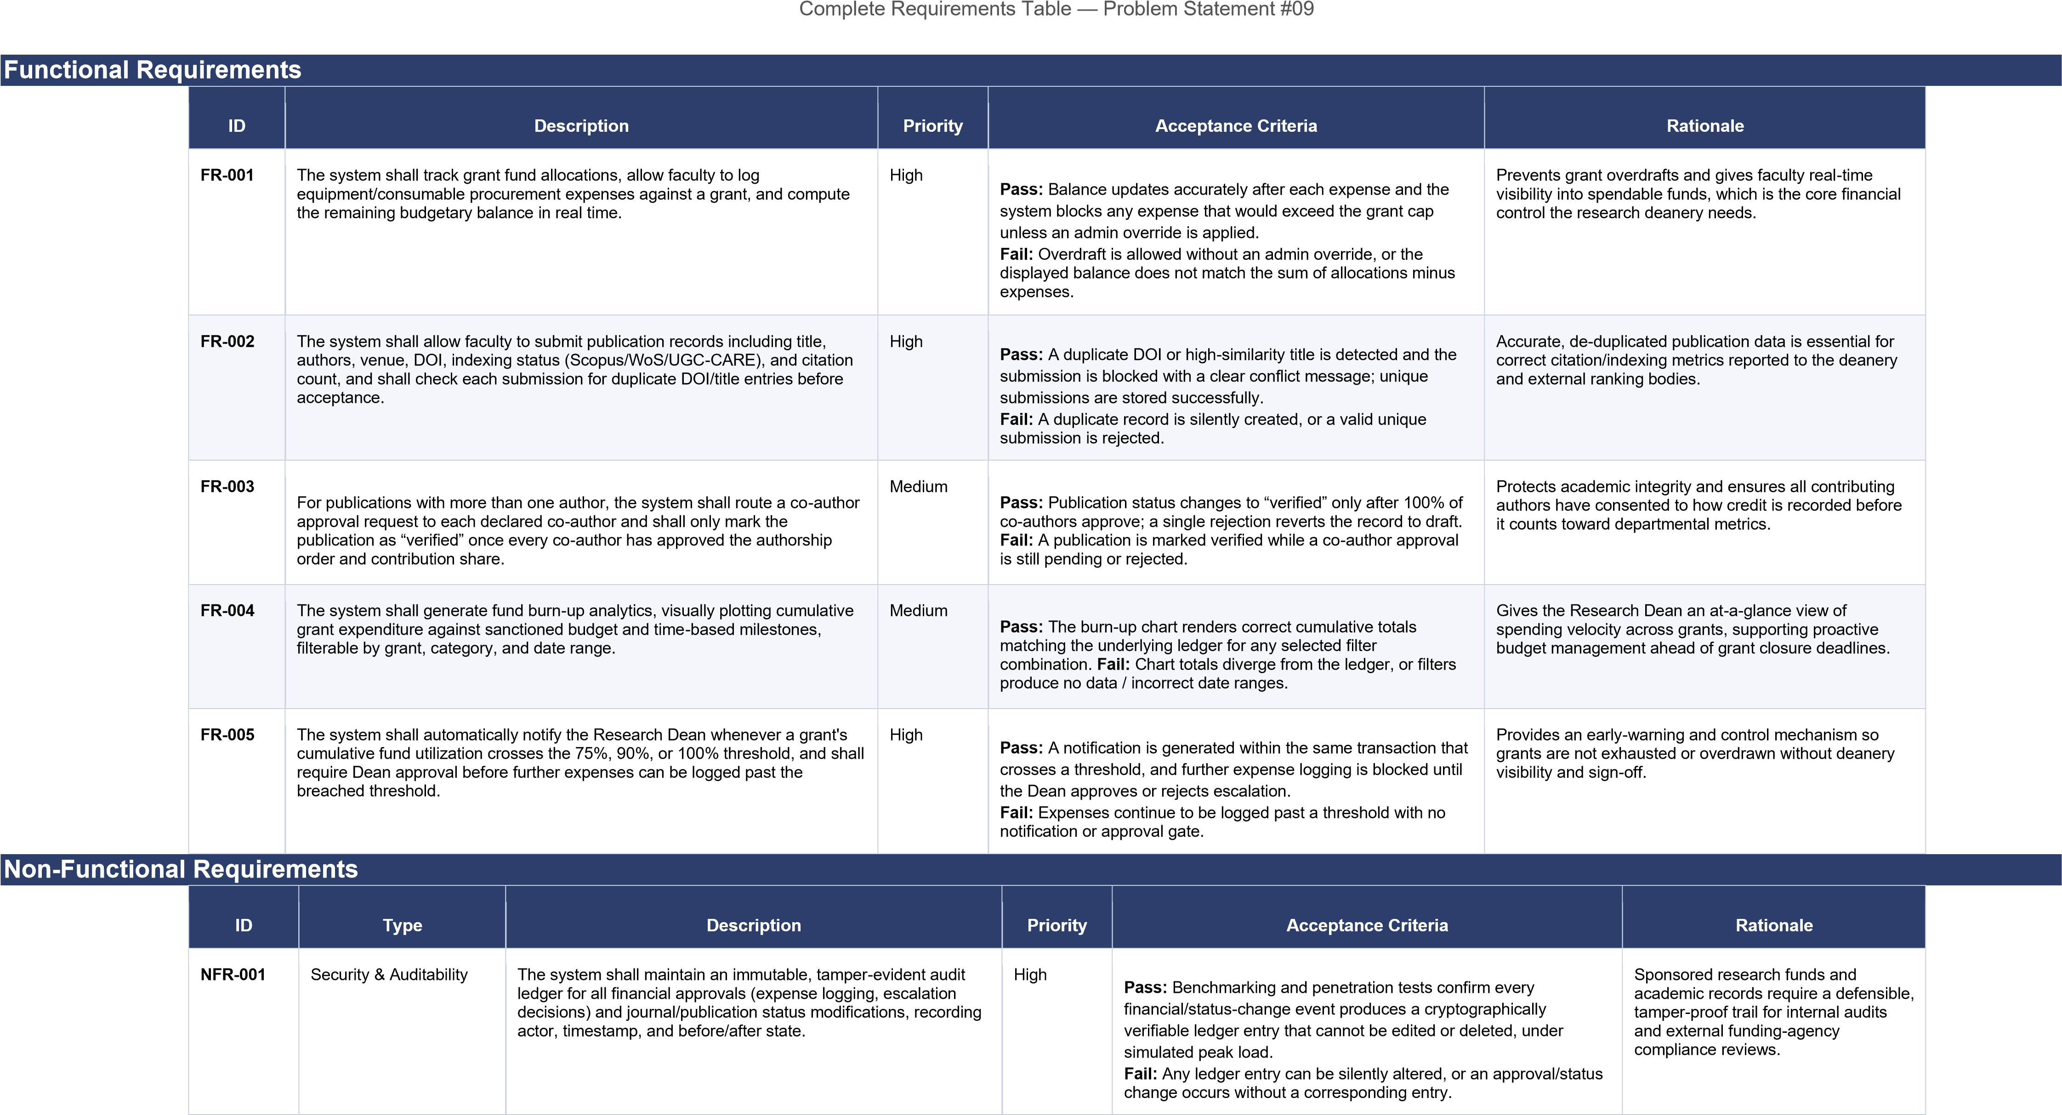
NFR-002 | Availability & Scalability | The system shall be available with at least 99.5% uptime during active grant-submission and publication-reporting windows, and shall support at least 500 concurrent authenticated users without degradation of response time beyond 2 seconds for standard read operations. | Medium | Pass: Load testing at 500 concurrent users maintains sub-2second response for standard reads and uptime monitoring shows ≥99.5% availability over a rolling 30-day window.  Fail: Response times exceed target under load, or uptime falls below  99.5% during a reporting window. | The portal must remain responsive during peak periods such as grantrenewal deadlines and annual publication reporting cycles, when faculty and deanery usage spikes simultaneously.

UML USE CASE DIAGRAM:

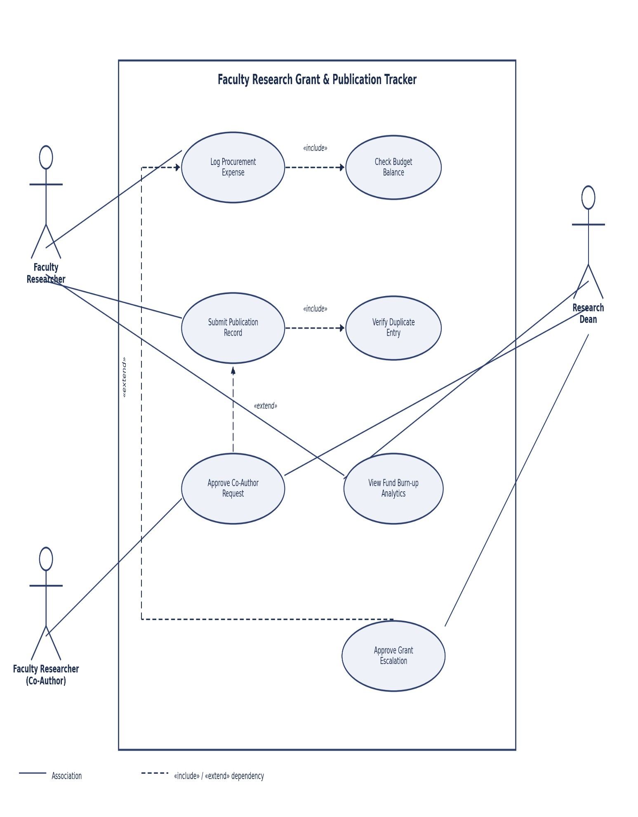
Use Case ID: UC-02
Use Case Name: Submit Publication Record

Primary Actor(s): Faculty Researcher
Secondary Actor(s): System (Indexing Validator)

Related FR(s): FR-002
Relationship: «include» Verify Duplicate Entry

Brief Description

Enables a Faculty Researcher to submit a publication (journal/conference paper) with its indexing status (Scopus, Web of Science, UGC-CARE) and citation metrics. Every submission mandatorily triggers a duplicate-check sub-process to preserve data integrity across the tracker.

Preconditions

- The Faculty Researcher is authenticated and associated with at least one active or closed grant, or is submitting an unsponsored publication.
- The publication has a valid DOI or manuscript identifier available for entry.

Postconditions

- A new publication record is created in “pending verification” status.

- The record is linked to the relevant grant (if sponsored) for burn-up and output reporting.

- An audit-ledger entry documents the submission event.

Main Success Scenario

- Faculty Researcher selects “Submit Publication” and enters title, authors, venue, DOI, and indexing status.

- Faculty Researcher optionally links the publication to a sponsored grant.

- System <<includes>> Verify Duplicate Entry to check the DOI/title against existing records.

- Verify Duplicate Entry confirms no existing match is found and returns control to the main flow.
- System stores the publication record with status “pending verification” and timestamps the submission.

- System notifies the Research Dean that a new publication is awaiting review.

- System displays a submission confirmation to the Faculty Researcher.

Alternate Flow — Duplicate Publication Detected

- At step 3, Verify Duplicate Entry finds an existing record with a matching DOI or a high title-similarity score.

- System halts the submission and displays the conflicting record to the Faculty Researcher.

- Faculty Researcher may amend the DOI/title if the match was a false positive and resubmit, resuming at step 1.

- If the Faculty Researcher confirms it is a genuine duplicate, the use case terminates without creating a new record.

Exception / Error Flow

If the indexing status field is left blank, the system rejects the submission at step 1 with a validation message.
If the linked grant has been closed for more than 90 days, the system disallows linking and requires the publication to be submitted as unsponsored.

Notes / UML Relationship Detail

Verify Duplicate Entry is modeled with an «include» relationship because duplicate checking is compulsory, identical logic reused on every publication submission, and independently testable as its own scenario.

