Smart Library Request Workflow in ServiceNow

Abstract:
The Smart Library Request Workflow is an automated system developed using the ServiceNow platform to streamline library operations. This project focuses on managing book requests, approvals, and tracking efficiently through a structured workflow. Users can request books, and librarians can review and approve them using an automated approval system. The system ensures proper record maintenance, notification handling, and data security using access controls. By reducing manual intervention, this solution enhances operational efficiency, accuracy, and user satisfaction.
Introduction:
Libraries traditionally rely on manual processes for handling book requests, approvals, and record maintenance. These methods are time-consuming, error-prone, and lack proper tracking mechanisms.
This project introduces an automated solution using ServiceNow to simplify and optimize library management.
Objectives:
- Automate book request and approval process
- Improve efficiency and reduce manual workload
- Provide real-time tracking of borrowed books
- Ensure data security using role-based access
- Enhance user experience through notifications
Literature Review:
Several traditional and digital library systems exist, but many lack complete automation and integration. Most systems depend on manual approval processes or basic database management without workflow automation.
Modern platforms like ServiceNow provide:
- Workflow automation
- Role-based access control
- Real-time notifications
- Scalable architecture
Compared to existing systems, this project leverages ServiceNow capabilities to deliver a more efficient and structured solution.
Methodology:
1. Requirement Analysis
- Identified need for automation in library system
- Defined roles (Student, Librarian)
- Determined workflow steps
2. System Design
- Designed data model using tables
- Planned workflow logic
- Defined UI rules and validations
3. Development
- Created custom tables
- Configured Flow Designer
- Implemented UI Policies and ACL
4. Testing
- Tested request creation
- Verified approval flow
- Checked email notifications
- Validated UI policies
Implementation:
🔹 Table Creation
- Book table for storing book details
- Borrow Request table for managing requests
🔹 Flow Designer
- Trigger: When request is created
- Action: Ask for Approval
- Action: Update Book Status → Issued
- Action: Send Email Notification

🔹 UI Policy
- Return Date becomes mandatory when Status = Issued
🔹 Access Control (ACL)
- Student → Read access
- Librarian → Read, Write, Delete
🔹 Reports
- Created “Most Borrowed Books” report using bar chart

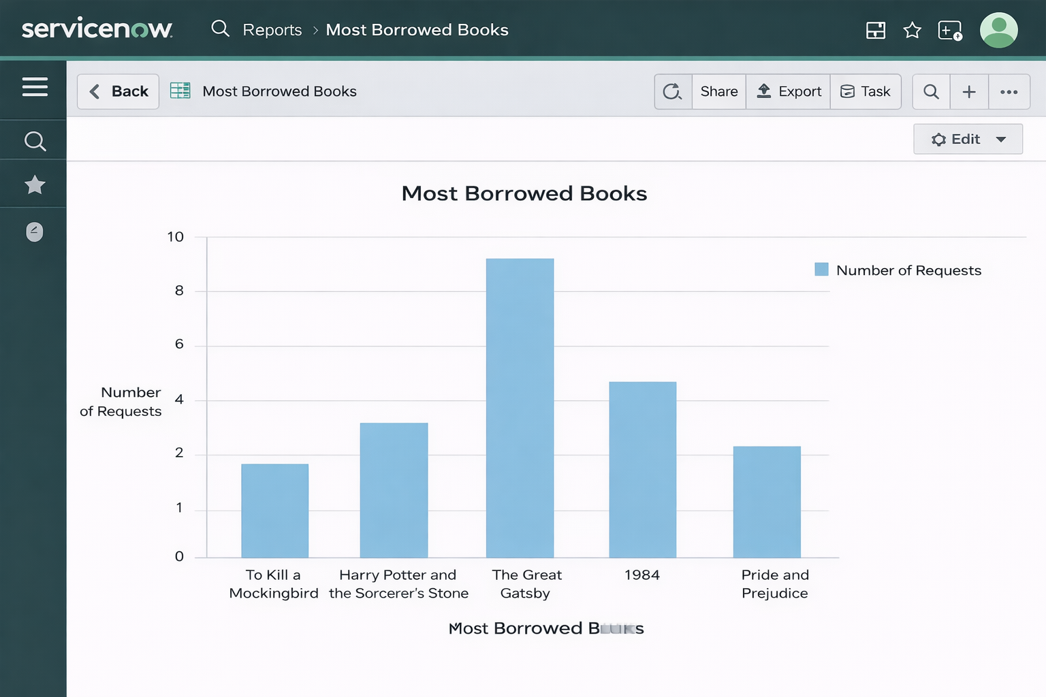
System Architecture:
The system consists of:
- User Interface (Forms & UI Policies)
- Business Logic (Flow Designer)
- Database (Custom Tables)
- Security Layer (ACL)

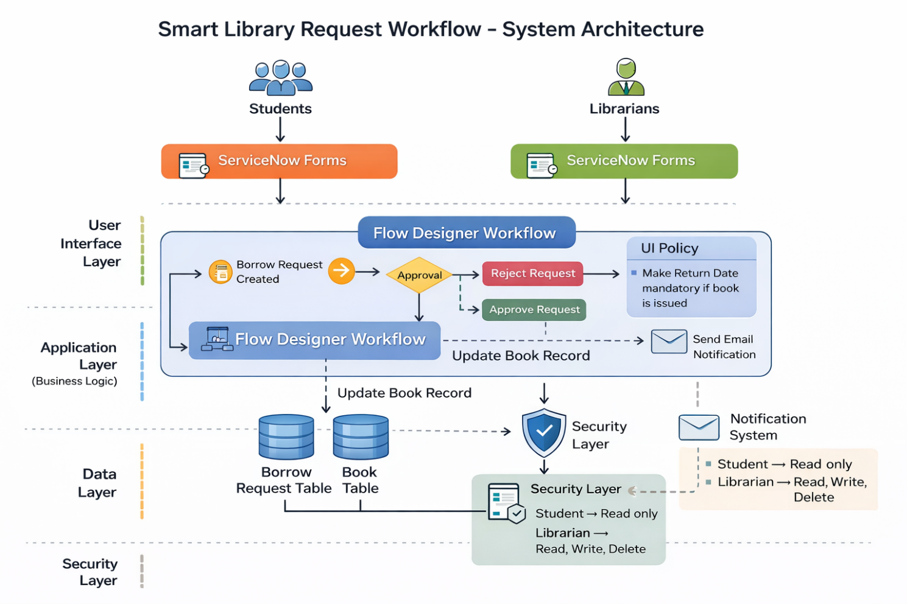
Advantages:
- Automation reduces workload
- Improves accuracy
- Easy to use
- Scalable system
- Secure access control

Limitations:
- Depends on ServiceNow platform
- Requires user training
- Limited customization in basic version

Results:
The system successfully achieved:
- Automated approval workflow
- Reduced manual intervention
- Accurate tracking of book status
- Role-based secure access
- Improved data visibility through reports

Conclusion:
This project demonstrates the effective use of ServiceNow in automating real-world processes. The Smart Library Request Workflow improves efficiency, ensures accuracy, and provides better control over library operations. It highlights the importance of workflow automation in modern systems and its impact on productivity and user experience.
Future Scope:
- Integration with barcode/RFID scanning
- Mobile-friendly interface
- Advanced dashboards with analytics
- Automated reminders for due dates
- Integration with external APIs and library databases
References:
- ServiceNow Official Documentation
- https://developer.servicenow.com
- ServiceNow Learning Modules
- Online tutorials (YouTube, training platforms)
- Project guidelines provided by faculty

