PES University - Dept. of CSE
Lab 1: Requirements Engineering &
UML Use-Case Modelling
NAME:-PAVITHRA G C
SRN:-PES2UG24CS346 SECTION:-5F
Problem Statement #38:
Dropshipping Inventory & Order
Orchestrator
Req ID | Type | Description | Priority | Acceptance  Criteria | Rationale
FR-001. | Functional | The system  shall receive  and process  inbound order  webhooks from  Shopify or  WooCommerce. | High | Pass: When a valid order  webhook is  received, the system  successfully  extracts the  order ID,  customer  address,  product SKU, and quantity.  Fail: The  order data is  not  processed or required  details are  missing. | Receiving  customer  orders is the  core function  of the system.
FR-002. | Functional | The system  shall verify the  real-time stock  availability of  each ordered  product using | High | Pass: The  system  checks stock  availability  for every  ordered SKU | Prevents  orders for  products that  are  unavailable.

 |  | the  corresponding  supplier API. |  | before  sending a  purchase  order. Fail: A  purchase  order is sent  without  verifying  stock.
FR-003. | Functional | The system  shall split an  order  containing  products  from  multiple  suppliers  into separate supplier-  specific  purchase  orders | High | Pass: An  order  containing  products  from 3  different  suppliers  generates 3  separate  purchase  orders. Fail:  Products  from  different  suppliers are incorrectly  combined  into one  purchase  order. | Supports  correct multi-  vendor  dropshipping  fulfillment.
FR-004. | Functional | The system  shall send  supplier-  specific  purchase  orders  containing  product details, quantities, and  customer  delivery  information | High | Pass: A  purchase  order is  successfully  sent to the  correct  supplier with  the correct  products,  quantities,  and delivery  address. Fail:  The purchase  order is  missing  required  information  or is sent to  the wrong  supplier. | Automates  the  fulfillment  process.
FR-005. | Functional | The system  shall store  supplier  tracking | Medium | Pass: When a  supplier  provides a  tracking | Enables  shipment  tracking and  order

 |  | numbers and  associate them with the  corresponding  customer  order. |  | number, it is  stored and  linked to the  correct  customer  order. Fail:  The tracking  number is  missing or  linked to an  incorrect  order. | monitoring.
NFR-001 . | Non-  Functional | The system  shall  acknowledge  receipt of  inbound  webhooks with  HTTP 200  within 200  milliseconds. | High | Pass:  Performance  testing shows  that valid  inbound  webhooks  receive an  HTTP 200  response  within 200  ms under  simulated  peak load.  Fail: The  response  time exceeds 200 ms. | Prevents  webhook  retry storms  and ensures  fast  processing.
NFR-002. | Non-  Functional | The system  shall retain  order data and  log failures  when a  supplier API  or network  connection is  temporarily  unavailable. | High | Pass: During  a simulated  supplier API  failure, the  order data is retained and the failure is  logged for  later retry.  Fail: Order  data is lost or the failure is  not recorded. | Ensures  reliability  and prevents  loss of  customer  orders.
Actors:-
Actor

Role

E-Commerce  Platform | Sends customer order webhooks to the system

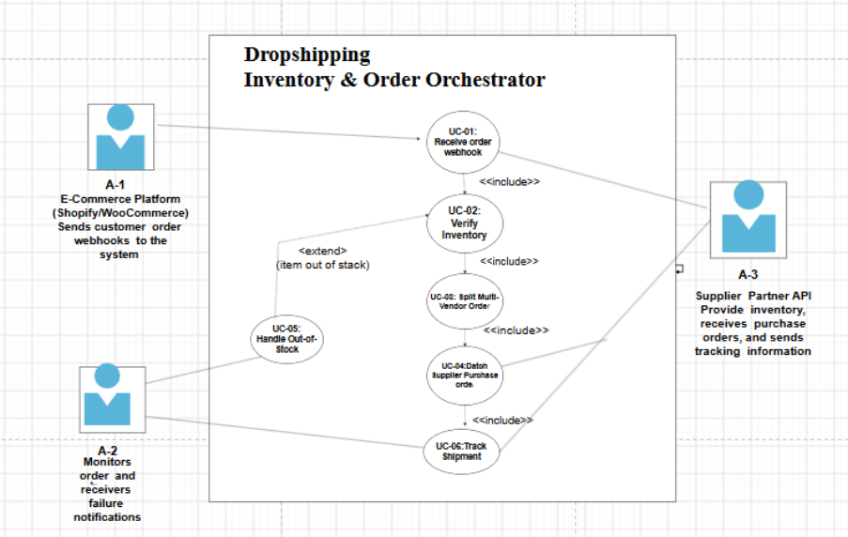

Actor

Role

Supplier Partner

Provides inventory, receives purchase orders, and sends tracking
information

Monitors orders and receives failure notifications

E-Store Owner

Use Cases:-
ID

Use Case

UC-01

Receive Order Webhook

UC-02

Verify Inventory

UC-03

Split Multi-Vendor Order

UC-04

Dispatch Supplier Purchase Order

UC-05

Track Shipment

Notify E-Store Owner

UC-06

UML Use-Case Diagram for Dropshipping Inventory &
Order Orchestrator

Use Case: UC-01 – Process Incoming Customer
Order:-
Primary Actor
E-Commerce Platform (Shopify/WooCommerce)
Supporting Actors
• Supplier Partner
• E-Store Owner
Preconditions
1. The E-Commerce Platform is connected to the system.
2. The webhook endpoint is configured and available.
3. Supplier API details are available.
4. Product SKUs are mapped to their corresponding suppliers.
Postconditions
1. Inventory availability is verified for the ordered products.
2. The order is split into supplier-specific orders if multiple suppliers
are involved.
3. Purchase orders are dispatched for available products.
4. Order and fulfillment information is stored.
5. The E-Store Owner is notified if a fulfillment problem occurs.
Main Success Scenario
1. The E-Commerce Platform sends a customer order webhook to the
Dropshipping Inventory & Order Orchestrator.
2. The system receives and validates the webhook.
3. The system acknowledges receipt of the webhook with HTTP 200.
4. The system extracts the order ID, customer delivery address, product
SKUs, and quantities.
5. The system identifies the supplier associated with each ordered
product.
6. The system requests current inventory information from the
corresponding Supplier Partner.

7. The system verifies that the required quantity of each product is
available.
8. The system groups the products according to their suppliers.
9. If products belong to multiple suppliers, the system splits the order into
separate supplier-specific purchase orders.
10. The system generates a purchase order for each supplier.
11. The system sends the purchase orders to the respective Supplier
Partners.
12. The system stores the supplier order references and updates the
order status to Processing.
13. When tracking information is received, the system associates the
tracking number with the corresponding customer order.
14. The use case ends successfully.
Alternate Flow: Product Out of Stock
7a. Insufficient Inventory Detected
7a1. The Supplier Partner reports that one or more requested products are
out of stock.
7a2. The system does not dispatch a purchase order for the unavailable
product.
7a3. The system records the order ID, product SKU, supplier, and failure
reason.
7a4. The system marks the affected item as Out of Stock.
7a5. The system triggers the Notify E-Store Owner use case.
7a6. The E-Store Owner receives a notification containing the relevant
order and failure details.
7a7. The affected order is marked as Requires Attention.
7a8. The use case ends.

