CUSTOMER REVIEW SENTIMENT ANALYSIS

Using TF-IDF + Logistic Regression

and DistilBERT

AI/ML Specialisation Capstone Project

Domain: Customer Experience / NLP

Dataset: IMDb Large Movie Review Dataset

Prepared by:
Pavithra H Moolya

Date:
August 2026

Table of Contents

1. Introduction
2. Problem Statement
3. Objectives
4. Dataset
5. Data Preparation
6. EDA
7. Baseline Model
8. DistilBERT
9. Evaluation
10. Error Analysis
11. Model Selection
12. Deployment
13. Limitations & Risks
14. Future Improvements
15. Conclusion
16. References

1. Introduction
Businesses receive large volumes of customer reviews, making it difficult to manually analyse every review. Sentiment analysis provides a way to automatically classify reviews according to their sentiment and can help customer experience teams identify negative feedback efficiently.
This project develops an NLP-based binary sentiment classification system using the IMDb Large Movie Review Dataset. Two modelling approaches were investigated: a traditional TF-IDF + Logistic Regression baseline and a transformer-based DistilBERT model.

2. Problem Statement
The objective is to build a machine learning system capable of classifying movie reviews into positive and negative sentiment categories. The project compares a traditional machine learning baseline with a transformer-based NLP model and evaluates their predictive performance, computational cost and practical suitability for deployment.
Target Users:
- Customer experience teams
- Marketing analysts
- Product managers
- Support managers

3. Project Objectives
- Load and validate the IMDb dataset.
- Inspect and preprocess the review data.
- Perform exploratory data analysis.
- Develop a TF-IDF + Logistic Regression baseline.
- Fine-tune a DistilBERT transformer model.
- Compare both approaches using multiple evaluation metrics.
- Perform error analysis.
- Measure inference latency.
- Deploy the selected model using Streamlit.
- Document limitations, risks and future improvements.

4. Dataset

4.1 Dataset Name
IMDb Large Movie Review Dataset

4.2 Source
Hugging Face Datasets

4.3 Task
Binary sentiment classification.

4.4 Labels
Label | Meaning
0 | Negative
1 | Positive

4.5 Dataset Split

2,000 reviews → DistilBERT development training
500 reviews → validation

Model | Test Accuracy
TF-IDF + Logistic Regression | 89.11%
DistilBERT | 87.91%
The IMDb dataset provides predefined training and test splits. The training data was further divided into training and validation subsets for model development, while the predefined IMDb test set was retained as a holdout set for final evaluation. For the initial DistilBERT development experiment, 2,000 reviews were used for training and 500 reviews for validation, corresponding to an 80:20 development split.

5. Data Preparation and Preprocessing
- Loaded the IMDb dataset.
- Inspected train/test/unsupervised splits.
- Retained labelled data for supervised learning.
- Checked missing values.
- Checked duplicate records.
- Examined label distribution.
- Prepared text and labels for modelling.
- For DistilBERT
  - Tokenizer: distilbert-base-uncased
  - Maximum sequence length: 256

6. Exploratory Data Analysis
6.1 Sentiment Distribution
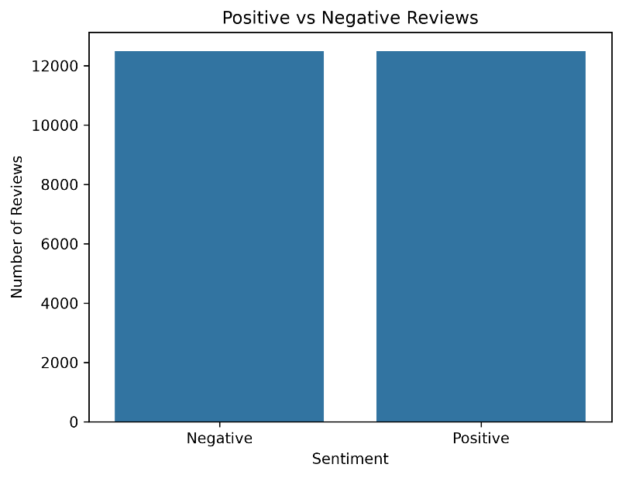
The distribution of sentiment classes shows that the dataset is almost perfectly balanced between positive and negative reviews. Both classes contain approximately 12,500 reviews. This balanced distribution is beneficial for binary sentiment classification because the models are not heavily biased toward either sentiment class. Therefore, accuracy can be used as one of the evaluation metrics alongside precision, recall, F1-score and ROC-AUC.

6.2 Review Length Distribution
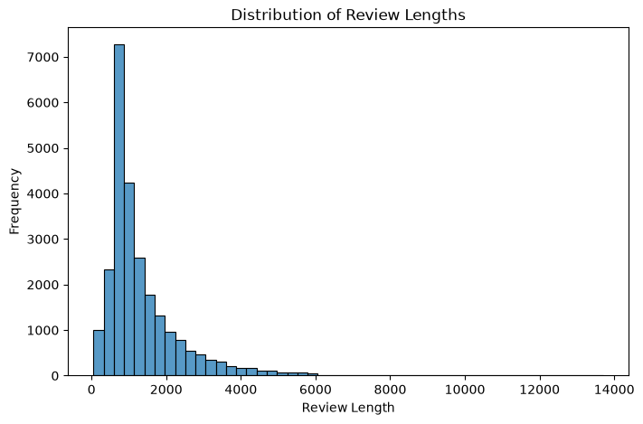
The review-length distribution is strongly right-skewed. Most reviews have relatively short to moderate lengths, while a smaller number of reviews are substantially longer. The distribution extends to very long reviews, with some observations exceeding 10,000 characters.
This variation in review length is important for NLP modelling. Shorter reviews can generally be processed efficiently, whereas very long reviews may increase computational requirements. For transformer-based models such as DistilBERT, a maximum sequence length is required, which can result in truncation of longer reviews and potential loss of contextual information.

7. Baseline Model — TF-IDF + Logistic Regression

Review Text
↓
TF-IDF Vectorization
↓
Logistic Regression
↓
Positive / Negative

Metric | TF-IDF + Logistic Regression
Accuracy | 89.11%
Precision | 88.73%
Recall | 89.59%
F1 Score | 89.16%
ROC-AUC | 95.80%
Inference latency | ~0.000001 sec/review

8. Advanced Model — DistilBERT
Document the experiment configuration used:
- Model: distilbert-base-uncased
- Maximum sequence length: 256
- Epochs: 1 for your development experiment
- Batch size: 8
- Learning rate: 2e-5(0.00002)

9. Model Evaluation
9.1 Final Comparison
Metric | TF-IDF + Logistic Regression | DistilBERT
Accuracy | 89.11% | 87.91%
Precision | 88.73% | 85.70%
Recall | 89.59% | 91.01%
F1 Score | 89.16% | 88.28%
ROC-AUC | 95.80% | 95.35%
Inference latency | ~0.000001 sec/review | 0.224930 sec/review

9.2 Interpretation
TF-IDF + Logistic Regression achieved better overall performance on the holdout test set, with higher accuracy, precision, F1-score and ROC-AUC. DistilBERT achieved higher recall, indicating that it identified a larger proportion of positive reviews. However, DistilBERT had substantially higher inference latency.

9.3 Confusion Matrices
Figure 1. TF-IDF + Logistic Regression confusion matrix on the test set.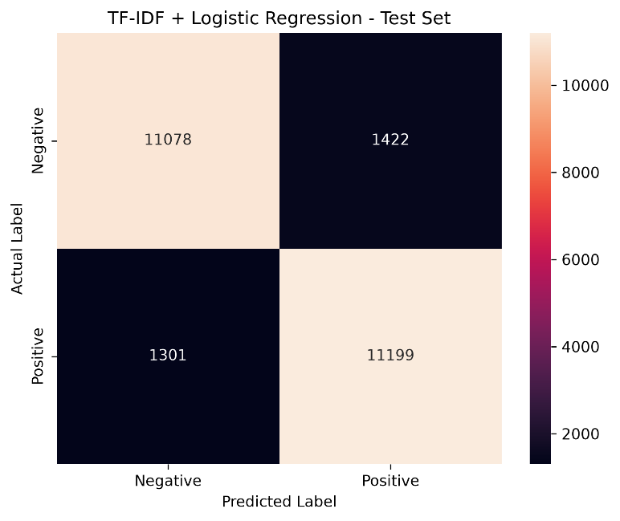
The confusion matrix shows that the TF-IDF + Logistic Regression model correctly classified 11,078 negative reviews and 11,199 positive reviews. The model incorrectly classified 1,422 negative reviews as positive and 1,301 positive reviews as negative.
Overall, the model produced 22,277 correct predictions out of 25,000 test reviews. The relatively similar numbers of false positives and false negatives indicate that the model does not show a strong bias toward either sentiment class.
The relatively high number of true positives and true negatives demonstrates that the baseline model performs well on both sentiment classes. However, the presence of 2,723 misclassified reviews indicates that the model still has difficulty with some reviews, particularly those containing ambiguous or context-dependent sentiment.

Figure 2. DistilBERT confusion matrix on the test set.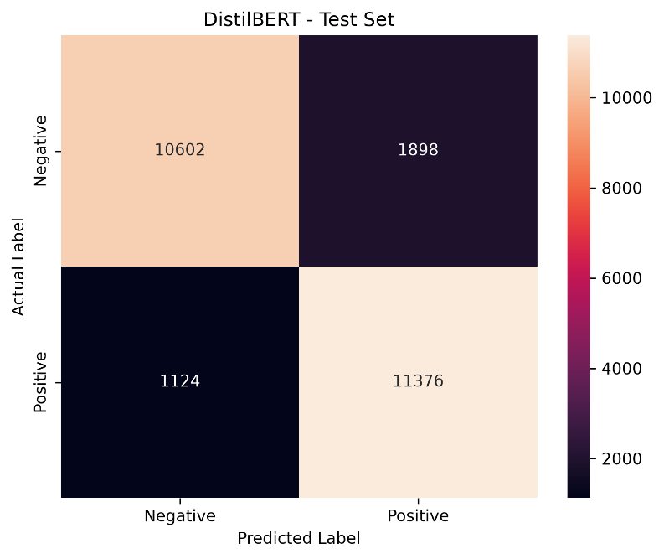
The DistilBERT model correctly classified 10,602 negative reviews and 11,376 positive reviews. It incorrectly classified 1,898 negative reviews as positive and 1,124 positive reviews as negative.
The model therefore produced 21,978 correct predictions out of 25,000 test reviews. Compared with Logistic Regression, DistilBERT generated fewer false negatives but more false positives.
The confusion matrix supports the metric results: DistilBERT achieved higher recall than Logistic Regression but produced more false-positive predictions. This trade-off contributed to its lower precision and F1-score.

10. Error Analysis
The error analysis indicates that sentiment classification can be challenging when reviews contain mixed sentiment, negation, sarcasm or context-dependent language. These cases may contain individual words associated with one sentiment while the overall meaning of the review indicates another sentiment.
Model | False Positives | False Negatives
TF-IDF + Logistic Regression | 1,422 | 1,301
DistilBERT | 1,898 | 1,124

Examples:
Mixed sentiment
"The acting was excellent, but the movie was painfully boring."
The review contains both positive and negative language.
Negation
"I expected this movie to be good, but it wasn't."
The word "good" is positive, but the overall meaning is negative.
Sarcasm
"What a fantastic way to waste two hours."
The word "fantastic" is positive lexically, but the overall sentiment is negative.
Context-dependent sentiment
Some words may have different meanings depending on the surrounding text.

10.1 Known Failure Case
"The acting was excellent, but the movie was painfully boring."

Actual sentiment: Positive
Model prediction: Negative
Confidence: 83.95%

This example demonstrates the challenge of classifying mixed sentiment. The review contains positive language about the acting while also containing strong negative language about the movie. Such contextual combinations can be difficult for a bag-of-words-based representation to interpret correctly.

11. Final Model Selection

TF-IDF + Logistic Regression was selected as the final deployment model. It achieved higher accuracy, precision, F1-score and ROC-AUC than DistilBERT on the holdout test set and had substantially lower inference latency. DistilBERT achieved higher recall, but its additional computational cost was not justified by the overall test-set performance for this project.

12. Deployment

User Review
↓
TF-IDF Vectorizer
↓
Saved Logistic Regression Model
↓
Sentiment
↓
Confidence

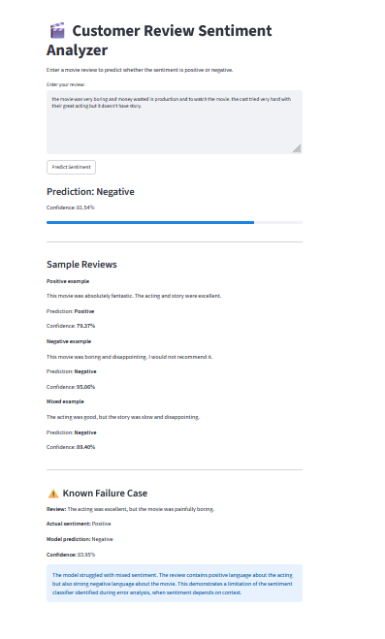

13. Limitations and Risks
13.1 Dataset limitation
IMDb movie-review language may not fully represent ecommerce or service reviews.
13.2 Long reviews
Long reviews may require truncation, potentially losing contextual information.
13.3 Computational cost
Transformer fine-tuning can be computationally expensive.
13.4 Sentiment ambiguity
Sarcasm, mixed sentiment and contextual language can lead to incorrect predictions.
13.5 Responsible use
Sentiment predictions should support human review and should not be the only basis for customer-service decisions.

14. Future Improvements
- Train on a larger and more representative customer-review dataset.
- Fine-tune DistilBERT with more extensive hyperparameter tuning.
- Investigate longer sequence lengths.
- Improve handling of sarcasm and mixed sentiment.
- Evaluate on Amazon/Yelp/customer-service review data.
- Monitor model performance after deployment.

15. Conclusion
This project developed an end-to-end sentiment classification system using the IMDb Large Movie Review Dataset. A TF-IDF + Logistic Regression baseline and a DistilBERT transformer model were implemented and evaluated on a holdout test set.
TF-IDF + Logistic Regression achieved the strongest overall performance, with 89.11% accuracy, 89.16% F1-score and 95.80% ROC-AUC. DistilBERT achieved higher recall at 91.01%, but had substantially higher inference latency.
Based on the balance of predictive performance and computational efficiency, TF-IDF + Logistic Regression was selected for deployment through a Streamlit application.
The project also demonstrated that sentiment classification can be challenging for mixed, ambiguous and context-dependent reviews, highlighting the importance of error analysis and responsible use.

16. References
- IMDb Large Movie Review Dataset
- Hugging Face Datasets
- Scikit-learn
- Hugging Face Transformers
- PyTorch
- Streamlit

