**VISVESVARAYA TECHNOLOGICAL UNIVERSITY**

**“Jnanasangama”, Belagavi-590018, Karnataka**



**BENGALURU INSTITUTE OF TECHNOLOGY**

**K.R. Road, V.V.Puram, Bengaluru-560 004**



**DEPARTMENT OF COMPUTER SCIENCE & ENGINEERING**

**FULL STACK DEVELOPMENT PROJECT**

**“BANKING MANAGEMENT SYSTEM”**

**Submitted By**

**THE ORIGINALS:**

**LAGISHETTY NAGA PAVITHRA (1BI20CS096)**

**in the academic year 2022-23**

**Department of Computer Science & Engineering**

**Bangalore Institute of Technology**

**K.R. Road, V.V.Puram, Bengaluru-560 004**

**VISVESVARAYA TECHNOLOGICAL UNIVERSITY**

**“Jnanasangama”, Belagavi-590018, Karnataka**

**BENGALURU INSTITUTE OF TECHNOLOGY**

**K.R. Road, V.V.Puram, Bengaluru-560 004**



**Department of Computer Science & Engineering**

***Certificate***

This is to certify that the implementation of **FULL STACK DEVELOPMENT PROJECT**

entitled **“BANKING MANAGEMENT SYSTEM”** has been successfully completed

by

**THE ORIGINALS:**

**USN:1BI20CS096 NAME: Lagisetty Naga Pavithra**

of VI semester B.E. for the partial fulfillment of the requirements for the Bachelor's degree in

Computer Science & Engineering of the Visvesvaraya Technological University during the

academic year 2022-2023.

**ACKNOWLEDGEMENT**

The satisfaction and euphoria that accompany the successful completion of many task would be incomplete without the people who made it possible and under whose constant guidance and encouragement the task was completed.

I would like to express my sincere gratitude to the project coordinator Dr. Savitha S.K professor, Department of computer science engineering, Bengaluru, for her encouragement and suggestion which helped us a lot in the completion of the project.

I would like to express my sincere gratitude to Arunava Chakraborty for his guidance which helped us a lot in the completion of the project. Without him, this project would not have seen the light of the day.

I would also like to use this opportunity to thank all who lend their hand for completing this project successfully. I would also like to express my immense gratitude to Dr.Aswath M U, principle of Bengaluru institute of technology, Bengaluru, for this project.

I extended my heartful thanks to all the faculty members for their guidance and their constant support for providing necessary information about project.

**THE ORIGINALS:**

**Lagisetty Naga Pavithra (1BI20CS096)**

**TABLE OF CONTENTS**

|  |  |  |  |
| --- | --- | --- | --- |
| **Sl. No** | **Contents** | | **Page No.** |
| **1.** |  | **Introduction** |  |
| **1.1** | **Introduction** |  |
| **1.2** | **Problem Statement** |  |
| **2** |  | **Major Modules** |  |
| **3** |  | **Implementation** |  |
| **3.1** | **Implementation using MYSQL/PHP** |  |
| **3.2** | **Snapshots** |  |
| **4** |  | **Applications** |  |
| **5** |  | **Conclusions** |  |

**CHAPTER-1**

**INTRODUCTION**

**INTRODUCTION**

* 1. **Introduction**

Banking Management system is a website that allows the user to view the existing customers, the user can add new customers or can delete one of his/her clients and might view and conduct the transactions with them . It offers an interface between the bank and customers, making the process easy and efficient

A database management system (DBMS) refers to the technology for creating and managing databases. Basically DBMS is a software tool to organize (create, retrieve, update and manage) data in a database. The main aim of a DBMS is to supply a way to store up and retrieve database information that is both convenient and efficient. By data, we mean known facts that can be recorded and that have embedded meaning. Normally people use software such as DBASE IV or V, Microsoft ACCESS, or EXCEL to store data in the form of database. Database systems are meant to handle large collection of information. Management of data involves both defining structures for storage of information and providing mechanisms that can do the manipulation of those stored information. Moreover, the database system must ensure the safety of the information stored, despite system crashes or attempts at unauthorized access. This project aims at computerizing the manual process of banking system. Front end and backend are implemented using HTML, EXPRESS JS and SQL LITE respectively.

* 1. **Problem statement**

The outline of this project is to develop a data management system that conducts transactions between the customers. Moreover, it provides facilities to add, delete or view existing customers **.**

**CHAPTER-2**

**Major Modules**

**2.1 ADMIN MODULE:**

* Admin needs to get logged in by entering valid credentials.
* Admin can view all the details of the registered users and can authorize them.
* Admin can add customers
* Admin can view send request and will send to the customer
* Admin can view receiver response and will confirm it with a confirmation mail to users.

**2.2 ADD CUSTOMER ACCOUNT MODULE:**

* The customer will be added by admin and will get his/her credentials to their mail id.
* The customer needs to give valid username and password.
* The customer can view request sent by admin and can give a response to admin.

**2.3 DELETE CUSTOMER ACCOUNT MODULE:**

* The customer‘s name can be removed from the customer list by the admin.
* The Admin deletes the customer’s account with his/her name.

**2.4 SEND MONEY MODULE:**

* This module handles the transactions between the customers.
* The transactions happen between the “from customer name” to “to customer name”.
* The amount to be transferred must be specified.
* Then, the specified amount

**CHAPTER-3**

**Implementation**

**3.1 Implementation using MySQL/php**

**Index.js**

var exphbs = require('express-handlebars');

var sqlite3 = require('sqlite3')

var { open } =require ('sqlite')

const dbPromise = open({

filename: 'data.db',

driver: sqlite3.Database

})

const path = require("path");

var express = require('express')

var app = express();

app.use(express.static(path.join('http://localhost:8000/', 'views')));

app.engine('handlebars', exphbs.engine());

app.set('view engine', 'handlebars');

app.use(express.static("views"));

app.set('views', './views');

app.use(express.urlencoded())

app.get('/', async (req,res)=>{

const db = await dbPromise;

const messages=await db.all('SELECT * FROM Message;')

console.log(messages)

res.render('home',{messages})

})

app.get('/time',(req,res)=>{

res.send('the current time is '+(new Date()).toLocaleTimeString())

})

app.post('/update',async(req,res)=>{

console.log(req.body);

const db = await dbPromise;

const from_cutomer_name = req.body.from_customer_name;

const to_cutomer_name = req.body.to_customer_name;

const transfer_amount = req.body.transfer_amount;

let data = [transfer_amount, from_cutomer_name];

let sql = `UPDATE Message

SET balance = balance-?

WHERE customer_name = ?`;

db.run(sql, data, function(err) {

if (err) {

return console.error(err.message);

}

});

let data1 = [transfer_amount, to_cutomer_name];

let sql1 = `UPDATE Message

SET balance = balance+?

WHERE customer_name = ?`;

db.run(sql1, data1, function(err) {

if (err) {

return console.error(err.message);

}

});

res.redirect('/transaction')

})

app.post('/delete',async(req,res)=>{

const db=await dbPromise;

const delete_customer_name=req.body.delete_customer_name;

await db.run('delete from Message where customer_name=?',delete_customer_name)

res.redirect('/delete');

})

app.post('/submit',async(req,res)=>{

console.log(req.body);

const db = await dbPromise;

const customer_name = req.body.customer_name;

const emailid = req.body.emailid;

const balance = req.body.balance;

const city = req.body.city;

await db.run('INSERT INTO Message (customer_name,emailid,balance,city) VALUES (?,?,?,?);',customer_name,emailid,balance,city)

res.redirect('/add')

})

const setup=async()=>{

const db=await dbPromise

await db.migrate()

app.listen(8000,()=>{

console.log('listening on localhost:8000')

})

}

app.get('/customers', async (req,res)=>{

const db = await dbPromise;

const messages=await db.all('SELECT * FROM Message;')

console.log(messages)

res.render('customers',{messages})

})

app.get('/delete', async (req,res)=>{

const db = await dbPromise;

const messages=await db.all('SELECT * FROM Message;')

console.log(messages)

res.render('delete',{messages})

})

app.get('/add', async (req,res)=>{

const db = await dbPromise;

const messages=await db.all('SELECT * FROM Message;')

console.log(messages)

res.render('add',{messages})

})

app.get('/transaction', async (req,res)=>{

const db = await dbPromise;

const messages=await db.all('SELECT * FROM Message;')

console.log(messages)

res.render('transaction',{messages})

})

app.get('/aboutus', async (req,res)=>{

res.render('aboutus');

})

app.get('/login', async (req,res)=>{

res.render('login');

})

app.post('/login_success', async (req,res)=>{

alert("User account not found.")

})

app.use(express.static('public'));

setup()

function sendMoney(){

var enterName = document.getElementById("enterName").value;

var enterAmount = parseInt(document.getElementById("enterAmount").value);

if (enterAmount > 8000) {

alert("Insufficient Balance.")

} else {

var findUserBankAccount = enterName + "BankBalance";

var finalAmount = parseInt(document.getElementById(findUserBankAccount).innerHTML) + enterAmount;

var myAccountBalance = parseInt(document.getElementById("myAccountBalance").innerText) - enterAmount

document.getElementById("myAccountBalance").innerText = myAccountBalance

document.getElementById(findUserBankAccount).innerHTML = finalAmount;

alert(`Successful Transaction !!

$${enterAmount} is sent to ${enterName}@email.com.`)

var createPTag = document.createElement("li");

var textNode = document.createTextNode(`$${enterAmount} is sent to recepient with Email-id ${enterName}@email.com on ${Date()}.`);

createPTag.appendChild(textNode);

var element = document.getElementById("transaction-history-body");

element.insertBefore(createPTag, element.firstChild);

}

}

**Customers.html**

<!DOCTYPE html>

<html lang="en">

<head>

<meta charset="UTF-8">

<meta name="viewport" content="width=device-width, initial-scale=1.0">

<title>All Accounts | Basic Banking System</title>

<link rel="stylesheet"

href="./thirdparty/bootstrap-material-design.min.css">

<link type="text/css" href="http://localhost:8000/assets/css/customer.css">

<link type="text/css" href="./thirdparty/Sans_css2.css" rel="stylesheet">

<link type="text/css" href="./thirdparty/Sansita_css2.css" rel="stylesheet">

<link type="text/css" href="./thirdparty/Roboto_css2.css" rel="stylesheet">

</head>

<body>

<!-- navbar starts here -->

<nav class="navbar navbar-expand-lg navbar-light bg-light">

<a class="navbar-brand" href="/">BIT Bank</a>

<button class="navbar-toggler" type="button" data-toggle="collapse" data-target="#navbarSupportedContent"

aria-controls="navbarSupportedContent" aria-expanded="false" aria-label="Toggle navigation">

<span class="navbar-toggler-icon"></span>

</button>

<div class="collapse navbar-collapse" id="navbarSupportedContent">

<ul class="navbar-nav ml-auto">

<li class="nav-item">

<a class="nav-link" href="/">Home </a>

</li>

<li class="nav-item ">

<a class="nav-link" href="/transaction"

>Send Money</a>

</li>

<li class="nav-item ">

<a class="nav-link" href="/add"

>Add Account</a>

</li>

<li class="nav-item ">

<a class="nav-link" href="/delete"

>Delete Account</a>

</li>

</ul>

</div>

</nav>

<!-- navbar ends here -->

<script type="type="application/json"" src="./assets/js/script.js"></script>

<script src="./thirdparty/jquery-3.2.1.slim.min.js"></script>

<script src="./thirdparty/popper.js"></script>

<script src="./thirdparty/bootstrap-material-design.js"></script>

<ul>

<li>Customers list</li>

<!-- <li style="font-style:italic">{{id}}:{{customer_name}}:{{emailid}}:{{balance}}:{{city}}</li>-->

<table>

<tr class="table-danger">

<th>

Sl. No.

</th>

<th>

Name

</th>

<th>

E-mail

</th>

<th>

Bank Balance(Rupees)

</th>

<th>

City

</th>

</tr>

{{#each messages}}

<tr class="table-info">

<td>

{{id}}

</td>

<td>

{{customer_name}}

</td>

<td>

{{emailid}}

</td>

<td>

{{balance}}

</td>

<td>

{{city}}

</td>

</tr>

{{/each}}

</table>

</ul>

<style>

table {

font-family: arial, sans-serif;

border-collapse: collapse;

width: 100%;

}

td, th {

border: 1px solid #dddddd;

text-align: left;

padding: 8px;

}

tr:nth-child(even) {

background-color: #dddddd;

}

</style>

</body>

</html>

**Index.html**

<!DOCTYPE html>

<html lang="en">

<head>

<meta charset="UTF-8">

<meta name="viewport" content="width=device-width, initial-scale=1.0">

<title>BIT Banking System</title>

<base href="/">

<!-- Bootstrap CDN -->

<link rel="stylesheet" type="text/css" href="./thirdparty/bootstrap-material-design.min.css">

<link rel="stylesheet" type="text/css" href="./thirdparty/all.min.css">

<link rel="stylesheet" type="text/css" href="./thirdparty/font-awesome.min.css">

<!-- Fonts -->

<link rel="stylesheet" type="text/css" href="./style.css">

<link type="text/css" href="./thirdparty/Sans_css2.css" rel="stylesheet">

<link type="text/css" href="./thirdparty/Sansita_css2.css" rel="stylesheet">

<link type="text/css" href="./thirdparty/Roboto_css2.css" rel="stylesheet">

<!-- AOS -->

<link type="text/css" rel="stylesheet" href="./thirdparty/aos.css"/>

<link rel="stylesheet" type="text/css" href="./customer.css">

<link rel="stylesheet" type="text/css" href="./login.css">

</head>

<body onload="loader()">

<div id="loading"></div>

<nav class="navbar navbar-expand-lg navbar-light bg-light">

<a class="navbar-brand" href="/">BIT-(Bangalore Institue of Technology) - Welcome To BIT Bank</a>

<button class="navbar-toggler" type="button" data-toggle="collapse" data-target="#navbarSupportedContent" aria-controls="navbarSupportedContent" aria-expanded="false" aria-label="Toggle navigation">

<span class="navbar-toggler-icon"></span>

</button>

<div class="collapse navbar-collapse" id="navbarSupportedContent">

<ul class="navbar-nav ml-auto">

<li class="nav-item active">

<a class="nav-link" href="/">Home <span class="sr-only">(current)</span></a>

</li>

<li class="nav-item">

<a class="nav-link" href="/aboutus">AboutUs</a>

</li>

<li class="nav-item">

<a class="nav-link" href='/customers'>Customers</a>

</li>

</ul>

</div>

</nav>

<div class="container-fluid hero-content">

<div class="row align-items-center">

<div class="col-md-6 col-sm-12 text-center" data-aos="fade-up">

<h3>Customers</h3>

<p class="lead muted">Easy Way To See Customers</p>

<br>

<a class="get-started" href="/customers">Customers</a>

<br>

<br>

</div>

<div class="col-md-6 col-sm-12 text-center" data-aos="fade-up">

<h3>Add Account</h3>

<p class="lead muted">Easy Way To Add Account</p>

<br>

<a class="get-started" href="/add">Add Account</a>

<br>

<br>

<br>

<br>

</div>

<div class="col-md-6 col-sm-12 text-center" data-aos="fade-up">

<br>

<h3>Money Transaction</h3>

<p class="lead muted">Easy Way To Transfer Money</p>

<br>

<a class="get-started" href="/transaction">Transfer</a>

<br>

<br>

</div>

<div class="col-md-6 col-sm-12 text-center" data-aos="fade-up">

<br>

<h3>Delete Account</h3>

<p class="lead muted">Easy Way To Delete Account</p>

<br>

<a class="get-started" href="/delete">Delete Account</a>

<br>

<br>

</div>

<div class="col-md-3 col-sm-3 text-center" data-aos="fade-left">

<div class="hero-img-div">

<img class="hero-img" src="./emblem.jpg" alt="img-showing-money-transfer">

</div>

</div>

</div>

</div>

<div class="footer" style="margin-top: 1px;">

<div class="container" id="Foodie">

<h1 style="color:orangered;font-family: Lucida Handwriting; margin-top: 55px;font-size: 30px;font-weight: 500; box-shadow:2px 6px 18px rgba(66,57,238,0.3);

" ><b>BIT Bank</b></h1>

</div>

<div class="container">

<div class="row">

<div class="col-sm-6">

<p style="color: white;font-size: 17px;margin-top: 10px;">BIT Bank place where<br>

customer transaction will be quick and safe.<br>

Users will do hashless transactions.<br>

Benifits with coupon users who uses this bank.<br>

</p>

<a class="btn btn-danger btn-lg" href="/aboutus">Info On BIT Bank</a>

</div>

<div class="col-sm-6">

<h3 style="color: white;color: red;">Reach Out Here for More</h3>

<p style="color: white;font-size: 17px;">

CSE Student, Bangalore Institue of Technology<br>

Bengaluru. 560004. <br>

</p>

<h3 style="color: white;color: red">Reach Me in Social Media</h3><br>

<a href="https://www.linkedin.com/in/lagisetty-naga-pavithra-614794211/" class="fa fa-linkedin"></a>

</div>

</div>

</div>

</div>

<script>

var preloader = document.getElementById("loading");

function loader(){

preloader.style.display = 'none';

}

</script>

<script type="application/json" src="./assets/js/script.js"></script>

<script src="./thirdparty/jquery-3.2.1.slim.min.js"></script>

<script src="./thirdparty/popper.js"></script>

<script src="./thirdparty/bootstrap-material-design.js"></script>

<script src="./thirdparty/jquery-1.11.0.min.js"></script>

<script src="./thirdparty/bootstrap.min.js"></script>

<script src="./thirdparty/aos.js"></script>

<script>

AOS.init({

duration: 700,

});

</script>

</body>

</html>

**Add.html**

<!DOCTYPE html>

<html lang="en">

<head>

<meta charset="UTF-8">

<meta name="viewport" content="width=device-width, initial-scale=1.0">

<title>All Accounts | Basic Banking System</title>

<link rel="stylesheet"

href="./thirdparty/bootstrap-material-design.min.css">

<link type="text/css" href="./assets/css/customer.css">

<link type="text/css" href="./thirdparty/Sans_css2.css" rel="stylesheet">

<link type="text/css" href="./thirdparty/Sansita_css2.css" rel="stylesheet">

<link type="text/css" href="./thirdparty/Roboto_css2.css" rel="stylesheet">

</head>

<body>

<!-- navbar starts here -->

<nav class="navbar navbar-expand-lg navbar-light bg-light">

<a class="navbar-brand" href="/">BIT Bank</a>

<button class="navbar-toggler" type="button" data-toggle="collapse" data-target="#navbarSupportedContent"

aria-controls="navbarSupportedContent" aria-expanded="false" aria-label="Toggle navigation">

<span class="navbar-toggler-icon"></span>

</button>

<div class="collapse navbar-collapse" id="navbarSupportedContent">

<ul class="navbar-nav ml-auto">

<li class="nav-item ">

<a class="nav-link" href="/">Home </a>

</li>

<li class="nav-item">

<a class="nav-link" href="/transaction"

>Send Money</a>

</li>

<li class="nav-item">

<a class="nav-link" href="/delete"

>Delete Account</a>

</li>

</ul>

</div>

</nav>

<!-- navbar ends here -->

<!-- Modal send money -->

<div class="modal fade" id="sendMoney" tabindex="-1" role="dialog" aria-labelledby="exampleModalLabel"

aria-hidden="true">

<div class="modal-dialog" role="document">

<div class="modal-content">

<div class="modal-header">

<h5 class="modal-title" id="exampleModalLabel">Send Money</h5>

<button type="button" class="close" data-dismiss="modal" aria-label="Close">

<span aria-hidden="true">&times;</span>

</button>

</div>

<form "/update" method = "post">

<div class="modal-body">

<div class="input-group mb-3">

<input type="text" id="from_customer_name" name ="from_customer_name" class="form-control" placeholder="Senders's Name"

aria-label="Senders's username" aria-describedby="basic-addon2">

<div class="input-group-append">

<span class="input-group-text" id="basic-addon2"></span>

</div>

</div>

<div class="input-group mb-3">

<input type="text" id="to_customer_name" name ="to_customer_name" class="form-control" placeholder="Recipient's Name"

aria-label="Recipient's username" aria-describedby="basic-addon2">

<div class="input-group-append">

<span class="input-group-text" id="basic-addon2"></span>

</div>

</div>

<div class="input-group mb-3">

<div class="input-group-prepend">

<span class="input-group-text">Rs</span>

</div>

<input type="text" id = "transfer_amount" name ="transfer_amount" class="form-control" placeholder=" Enter Amount"

aria-label="Amount (to the nearest dollar)">

<div class="input-group-append">

<span class="input-group-text">.00</span>

</div>

</div>

</div>

<div class="modal-footer">

<button type="button" class="btn btn-secondary" data-dismiss="modal">Close</button>

<button type="submit" class="btn btn-success" data-dismiss="modal">Send

Money</button>

</div>

</form>

</div>

</div>

</div>

<!-- Modal transaction History-->

<div class="modal fade" id="transactionHistory" tabindex="-1" role="dialog" aria-labelledby="exampleModalLabel"

aria-hidden="true">

<div class="modal-dialog" role="document">

<div class="modal-content">

<div class="modal-header">

<h5 class="modal-title" id="exampleModalLabel">Transaction History</h5>

<button type="button" class="close" data-dismiss="modal" aria-label="Close">

<span aria-hidden="true">&times;</span>

</button>

</div>

<div class="modal-body">

<ol id="transaction-history-body">

</ol>

</div>

<div class="modal-footer">

<button type="button" class="btn btn-danger" data-dismiss="modal">Close</button>

</div>

</div>

</div>

</div>

<!-- table -->

<script type="type="application/json"" src="./assets/js/script.js"></script>

<script src="./thirdparty/jquery-3.2.1.slim.min.js"></script>

<script src="./thirdparty/popper.js"></script>

<script src="./thirdparty/bootstrap-material-design.js"></script>

<ul>

<li>Customers list</li>

<!-- <li style="font-style:italic">{{id}}:{{customer_name}}:{{emailid}}:{{balance}}:{{city}}</li>-->

<table>

<tr class="table-danger">

<th>

Sl. No.

</th>

<th>

Name

</th>

<th>

E-mail

</th>

<th>

Bank Balance(Rupees)

</th>

<th>

City

</th>

</tr>

{{#each messages}}

<tr class="table-info">

<td>

{{id}}

</td>

<td>

{{customer_name}}

</td>

<td>

{{emailid}}

</td>

<td>

{{balance}}

</td>

<td>

{{city}}

</td>

</tr>

{{/each}}

</table>

</ul>

<form action="/submit" method = "post">

<table>

<tr>

<th>

Customer Name

</th>

<th>

Email Id

</th>

<th>

Bank Balance

</th>

<th>

City

</th>

</tr>

<tr>

<td>

<label for="Name:"></label>

<input type="text" id = "customer_name:" name ="customer_name"/>

</td>

<td>

<label for="email:"></label>

<input type="text" id = "emailid" name ="emailid"/>

</td>

<td>

<label for="balance:"></label>

<input type="text" id = "balance" name ="balance"/>

</td>

<td>

<label for="city:"></label>

<input type="text" id = "city" name ="city"/>

</td>

</tr>

</table>

<button type = "submit">Add Account</button>

</form>

<style>

table {

font-family: arial, sans-serif;

border-collapse: collapse;

width: 100%;

}

td, th {

border: 1px solid #dddddd;

text-align: left;

padding: 8px;

}

tr:nth-child(even) {

background-color: #dddddd;

}

</style>

</body>

</html>

**Delete.html**

<!DOCTYPE html>

<html lang="en">

<head>

<meta charset="UTF-8">

<meta name="viewport" content="width=device-width, initial-scale=1.0">

<title>All Accounts | Basic Banking System</title>

<link rel="stylesheet"

href="./thirdparty/bootstrap-material-design.min.css">

<link type="text/css" href="http://localhost:8000/assets/css/customer.css">

<link type="text/css" href="./thirdparty/Sans_css2.css" rel="stylesheet">

<link type="text/css" href="./thirdparty/Sansita_css2.css" rel="stylesheet">

<link type="text/css" href="./thirdparty/Roboto_css2.css" rel="stylesheet">

</head>

<body>

<!-- navbar starts here -->

<nav class="navbar navbar-expand-lg navbar-light bg-light">

<a class="navbar-brand" href="/">BIT Bank</a>

<button class="navbar-toggler" type="button" data-toggle="collapse" data-target="#navbarSupportedContent"

aria-controls="navbarSupportedContent" aria-expanded="false" aria-label="Toggle navigation">

<span class="navbar-toggler-icon"></span>

</button>

<div class="collapse navbar-collapse" id="navbarSupportedContent">

<ul class="navbar-nav ml-auto">

<li class="nav-item">

<a class="nav-link" href="/">Home </a>

</li>

<li class="nav-item ">

<a class="nav-link" href="/transaction"

>Send Money</a>

</li>

<li class="nav-item ">

<a class="nav-link" href="/add"

>Add Account</a>

</li>

</ul>

</div>

</nav>

<script type="type="application/json"" src="./assets/js/script.js"></script>

<script src="./thirdparty/jquery-3.2.1.slim.min.js"></script>

<script src="./thirdparty/popper.js"></script>

<script src="./thirdparty/bootstrap-material-design.js"></script>

<ul>

<li>Customers list</li>

<!-- <li style="font-style:italic">{{id}}:{{customer_name}}:{{emailid}}:{{balance}}:{{city}}</li>-->

<table>

<tr class="table-danger">

<th>

Sl. No.

</th>

<th>

Name

</th>

<th>

E-mail

</th>

<th>

Bank Balance(Rupees)

</th>

<th>

City

</th>

</tr>

{{#each messages}}

<tr class="table-info">

<td>

{{id}}

</td>

<td>

{{customer_name}}

</td>

<td>

{{emailid}}

</td>

<td>

{{balance}}

</td>

<td>

{{city}}

</td>

</tr>

{{/each}}

</table>

</ul>

<form action="/delete" method = "post">

<label for="Name:">Customer Name:</label>

<input type="text" id = "delete_customer_name:" name ="delete_customer_name"/>

<button type = "submit">Delete Account</button>

</form>

<style>

table {

font-family: arial, sans-serif;

border-collapse: collapse;

width: 100%;

}

td, th {

border: 1px solid #dddddd;

text-align: left;

padding: 8px;

}

tr:nth-child(even) {

background-color: #dddddd;

}

</style>

</body>

</html>

**Tranction.html**

<!DOCTYPE html>

<html lang="en">

<head>

<meta charset="UTF-8">

<meta name="viewport" content="width=device-width, initial-scale=1.0">

<title>All Accounts | Basic Banking System</title>

<link rel="stylesheet"

href="./thirdparty/bootstrap-material-design.min.css">

<link type="text/css" href="./assets/css/customer.css">

<link type="text/css" href="./thirdparty/Sans_css2.css" rel="stylesheet">

<link type="text/css" href="./thirdparty/Sansita_css2.css" rel="stylesheet">

<link type="text/css" href="./thirdparty/Roboto_css2.css" rel="stylesheet">

</head>

<body>

<!-- navbar starts here -->

<nav class="navbar navbar-expand-lg navbar-light bg-light">

<a class="navbar-brand" href="/">BIT Bank</a>

<button class="navbar-toggler" type="button" data-toggle="collapse" data-target="#navbarSupportedContent"

aria-controls="navbarSupportedContent" aria-expanded="false" aria-label="Toggle navigation">

<span class="navbar-toggler-icon"></span>

</button>

<div class="collapse navbar-collapse" id="navbarSupportedContent">

<ul class="navbar-nav ml-auto">

<li class="nav-item">

<a class="nav-link" href="/">Home </a>

</li>

<li class="nav-item ">

<a class="nav-link" href="/add"

>Add Account</a>

</li>

<li class="nav-item ">

<a class="nav-link" href="/delete"

>Delete Account</a>

</li>

</ul>

</div>

</nav>

<!-- navbar ends here -->

<script type="type="application/json"" src="./assets/js/script.js"></script>

<script src="./thirdparty/jquery-3.2.1.slim.min.js"></script>

<script src="./thirdparty/popper.js"></script>

<script src="./thirdparty/bootstrap-material-design.js"></script>

<ul>

<li>Customers list</li>

<!-- <li style="font-style:italic">{{id}}:{{customer_name}}:{{emailid}}:{{balance}}:{{city}}</li>-->

<table>

<tr class="table-danger">

<th>

Sl. No.

</th>

<th>

Name

</th>

<th>

E-mail

</th>

<th>

Bank Balance(Rupees)

</th>

<th>

City

</th>

</tr>

{{#each messages}}

<tr class="table-info">

<td>

{{id}}

</td>

<td>

{{customer_name}}

</td>

<td>

{{emailid}}

</td>

<td>

{{balance}}

</td>

<td>

{{city}}

</td>

</tr>

{{/each}}

</table>

</ul>

<form action="/update" method = "post">

<table>

<tr>

<th>

From Customer Name

</th>

<th>

To Customer Name

</th>

<th>

Amount to transfer

</th>

</tr>

<tr>

<td>

<label for="From Customer:"></label>

<input type="text" id = "from_customer_name:" name ="from_customer_name"/>

</td>

<td>

<label for="To Customer:"></label>

<input type="text" id = "to_customer_name:" name ="to_customer_name"/>

</td>

<td>

<label for="Transfer Amount:"></label>

<input type="text" id = "transfer_amount" name ="transfer_amount"/>

</td>

</tr>

</table>

<button type = "submit">Send Money</button>

</form>

<style>

table {

font-family: arial, sans-serif;

border-collapse: collapse;

width: 100%;

}

td, th {

border: 1px solid #dddddd;

text-align: left;

padding: 8px;

}

tr:nth-child(even) {

background-color: #dddddd;

}

</style>

</body>

</html>

**SQL Schema:**

CREATE TABLE Message(

id INTEGER PRIMARY KEY,

customer_name STRING,

emailid STRING,

balance FLOAT,

city STRING

);

**CHAPTER-4**

**Snapshots**

**Home Page:**

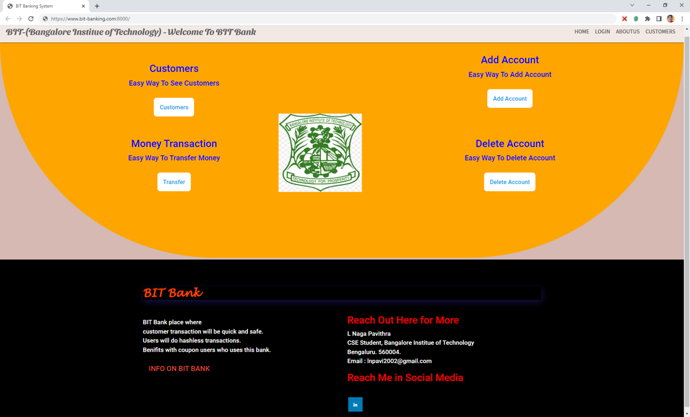

Fig 4.1: login page of the website

**Customer’s list:**

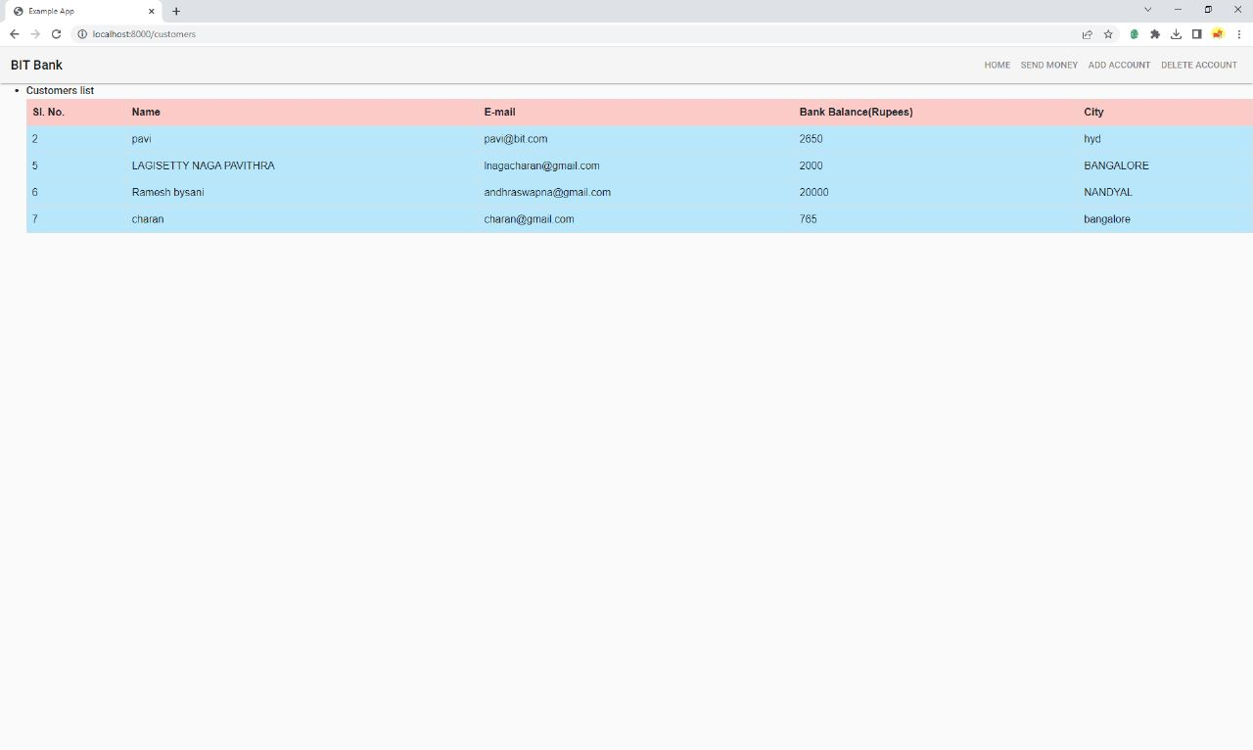

Fig 4.2: Page showing the list of customers

**Add Customer’s account:**

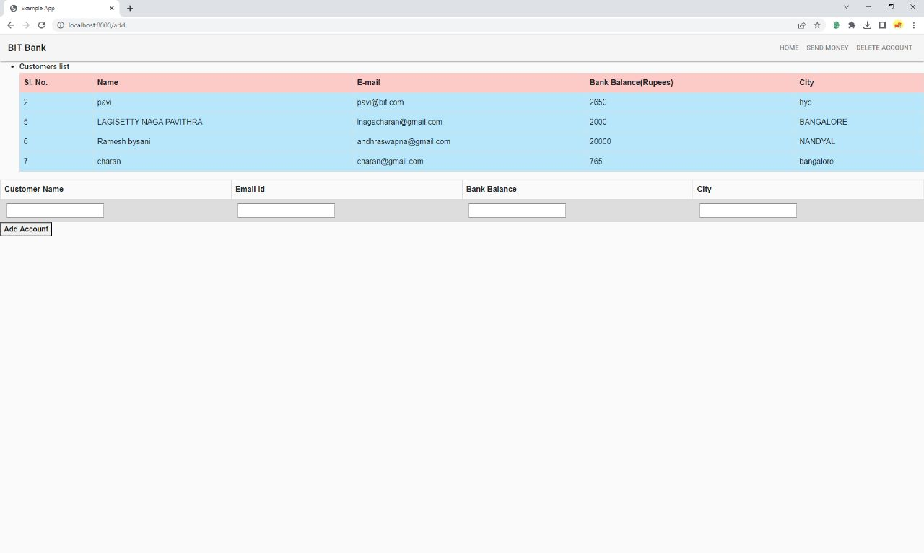

Fig 4.3: adding an account

**Delete Customer’s account:**

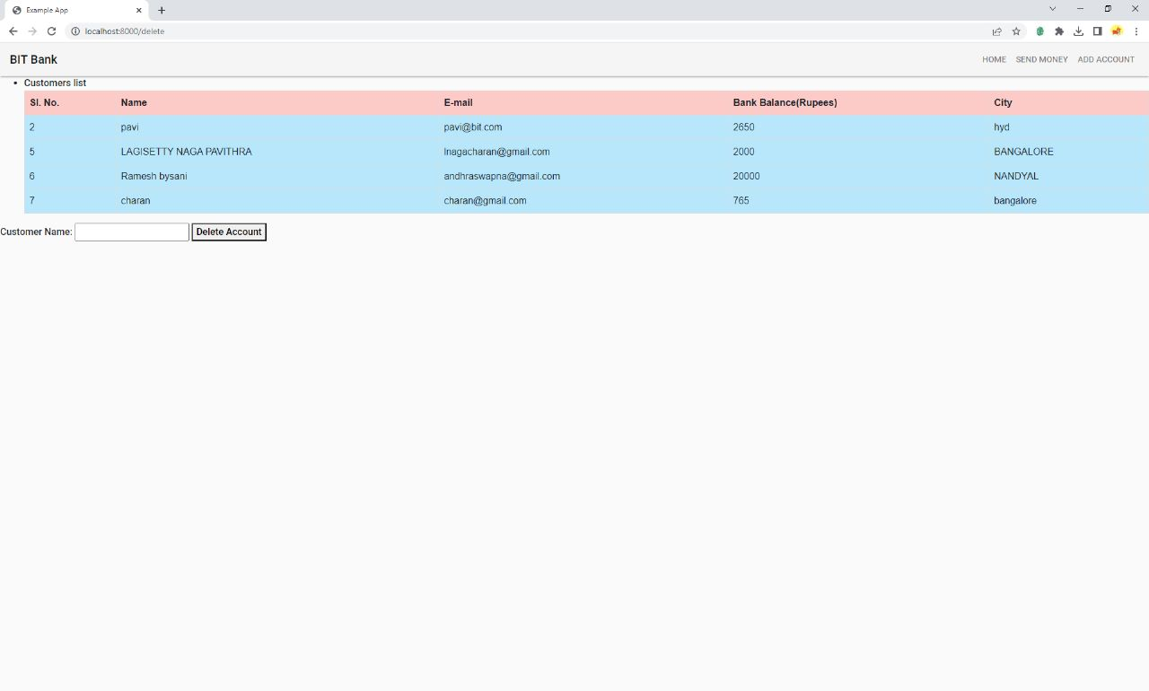

Fig 4.4: deleting an account

**Transactions:**

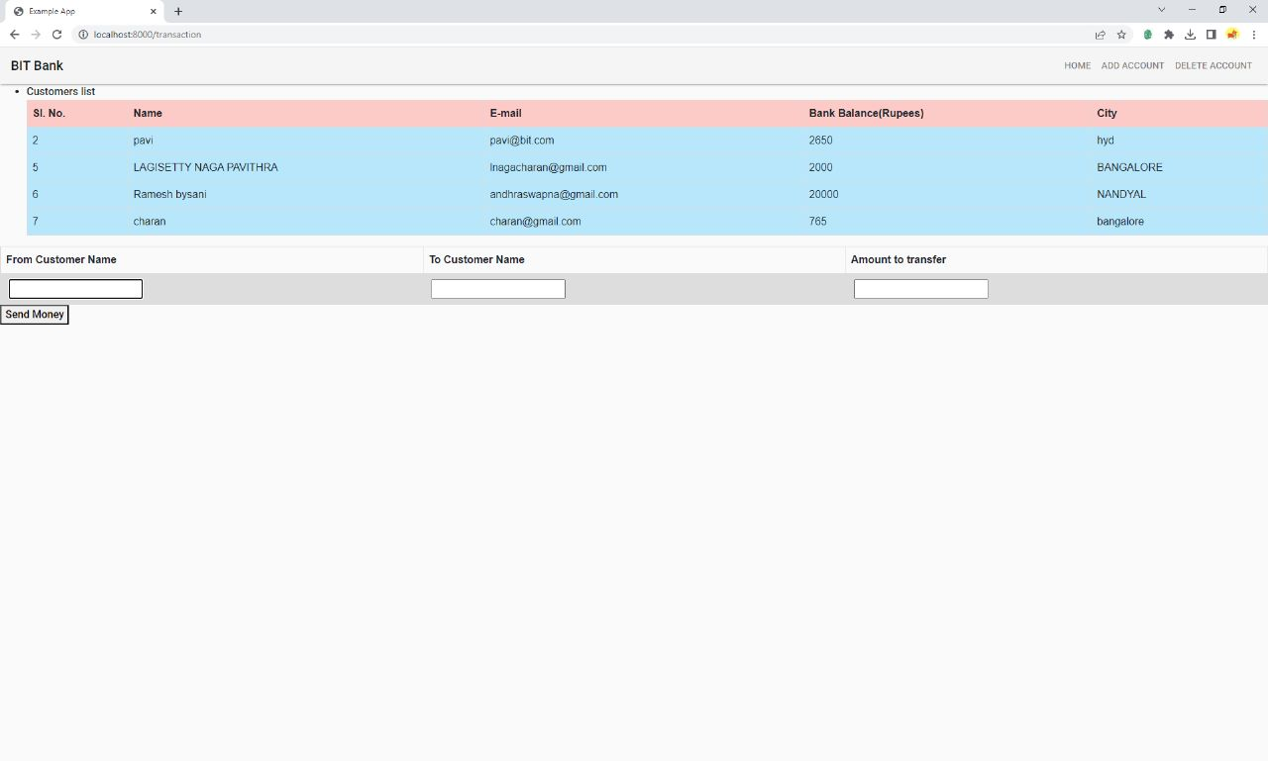

Fig 4.5: shows transactions between the accounts.

**CHAPTER-5**

**Applications**

**Applications**

Can be used as the management purpose and help several bank managers in corporate sectors too

* It can be used to manage online banking events
* It can be used as an analytical tool to view the list of the existing customers.
* It can be useful in managing the customers account.
* It can be useful in handling the transactions between customers.

**CHAPTER-6**

**Conclusion**

**Conclusion:**

Bank management system is a virtualization of transactions in the banking system. These system were operated manually but when we used as an online banking system, it is totally virtualization process which avoid manual process and converts it in automatic process. Bank management system is saving the time with accuracy than bank manual system.