IBM NAAN MUDHALAVAN PHASE:5

PROBLEM STATEMENT

|  |  |
| --- | --- |
| DATE | 01-11-2023 |
| TEAM ID | PROJ_224711_TEAM_2 |
| PROJECT TITLE | AIR QUALITY ANALYSIS AND PREDICTION IN TAMILNADU |

PROBLEM STATEMENT:

* The project aims to analyze and visualize air quality data from monitoring stations in Tamil Nadu.Based on the current trends and the predictions from the TNPCB, the air quality in Tamil Nadu in 2022 is expected to be similar to or slightly worse than the air quality in 2021. The levels of SO2 and NO2 are expected to be particularly high in major cities such as Chennai, Coimbatore, and Madurai.
* The survival of mankind cannot be imagined without air. Consistent developments in almost all realms of modern human society affected the health of the air adversely. Daily industrial, transport, and domestic activities are stirring hazardous pollutants in our environment.

Problem statement template:

1 Project Objectives:

The project’s objective was to analyze air quality in Tamil Nadu by examining historical data, with

a focus on SO2, NO2, and RSPM/PM10 levels. We implemented data preprocessing, visualization,

and linear regression modeling. Example outputs include time series plots and predictive models.

This analysis offers insights into trends, showing fluctuations in pollutant levels over time. The

code aids in estimating air quality, providing valuable information for understanding and managing

pollution in Tamil Nadu.

2 ANALYSIS

3 The analysis of air quality data in Tamil Nadu offers valuable in-

sights into air pollution trends and pollution levels in the region

in the following ways:

Temporal Trends: By visualizing time series data for pollutants like SO2, NO2, and

RSPM/PM10, the analysis reveals how pollution levels change over time. Patterns, fluctuations,

and long-term trends become apparent, aiding in understanding the impact of various factors on

air quality.

Spatial Variations: Heatmaps and location-based visualizations show variations in pollutant

levels across different monitoring stations in Tamil Nadu. This helps identify areas with consistently

high or low pollution, which can inform policy decisions and resource allocation.

Statistical Summaries: Summary statistics and box plots provide a comprehensive view of

the distribution of pollutant concentrations. Mean, median, and standard deviation values, as well

as potential outliers, offer insights into the central tendency and variability of air pollution levels.

Regression Modeling: The linear regression model for estimating RSPM/PM10 levels based

on SO2 and NO2 concentrations allows us to make predictions and understand how these key

pollutants contribute to particulate matter in the air. This can be crucial for pollution control

efforts.

Overall, the analysis enables stakeholders, policymakers, and researchers to gain a deeper under-

standing of air pollution trends in Tamil Nadu. This understanding can drive informed decisions

and interventions to improve air quality, protect public health, and mitigate environmental impacts.

[ ]: import pandas as pd

import matplotlib.pyplot as plt

[ ]: # Assuming your data is in a CSV file

data = pd.read_csv('/content/cpcb_dly_aq_tamil_nadu-2014 (1).csv')

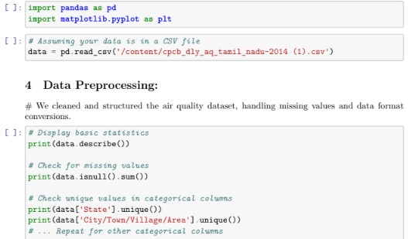

Stn Code SO2 NO2 RSPM/PM10 PM 2.5

count 2879.000000 2868.000000 2866.000000 2875.000000 0.0

mean 475.750261 11.503138 22.136776 62.494261 NaN

std 277.675577 5.051702 7.128694 31.368745 NaN

min 38.000000 2.000000 5.000000 12.000000 NaN

25% 238.000000 8.000000 17.000000 41.000000 NaN

50% 366.000000 12.000000 22.000000 55.000000 NaN

75% 764.000000 15.000000 25.000000 78.000000 NaN

max 773.000000 49.000000 71.000000 269.000000 NaN

Stn Code 0

Sampling Date 0

State 0

City/Town/Village/Area 0

Location of Monitoring Station 0

Agency 0

Type of Location 0

SO2 11

NO2 13

RSPM/PM10 4

PM 2.5 2879

dtype: int64

['Tamil Nadu']

['Chennai' 'Coimbatore' 'Cuddalore' 'Madurai' 'Mettur' 'Salem'

'Thoothukudi' 'Trichy']

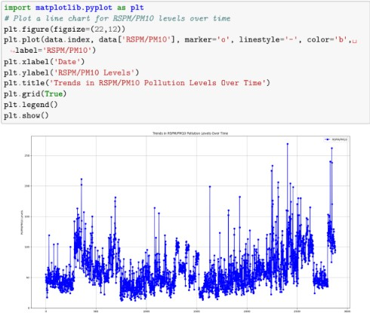

5 Groups the air quality data by date

6 Calculates the mean values for SO2, NO2, and RSPM/PM10,

and plots the daily average air quality in Tamil Nadu. The

line chart provides a clear visualization of how these pollutant

concentrations vary over time, aiding in understanding daily air

quality trends and fluctuations.

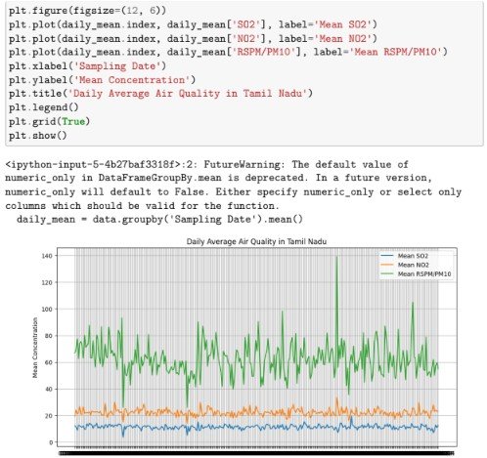

7 Concentrations of Sulfur Dioxide (SO2) and Nitrogen Dioxide

(NO2)

#Calculates the daily average concentrations of Sulfur Dioxide (SO2) and Nitrogen Dioxide (NO2)

in Tamil Nadu. The resulting line chart provides insights into how these pollutants’ levels change

over time. It aids in visualizing and understanding the variations in SO2 and NO2 concentrations,

essential for monitoring air quality in the region.

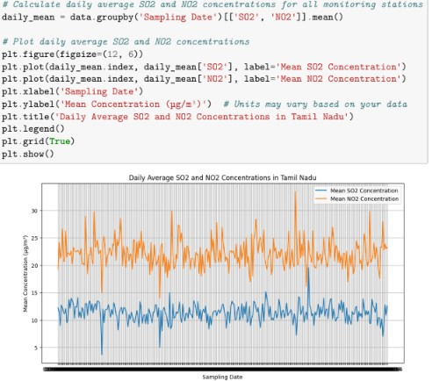

8 Displays statistics for Sulfur Dioxide (SO2) and Nitrogen Diox-

ide (NO2) concentrations

# computes and displays statistics for Sulfur Dioxide (SO2) and Nitrogen Dioxide (NO2) concentra-

tions. It generates two box plots, one for SO2 and the other for NO2. These plots help visualize the

distribution of concentration values, showing the central tendency, spread, and potential outliers.

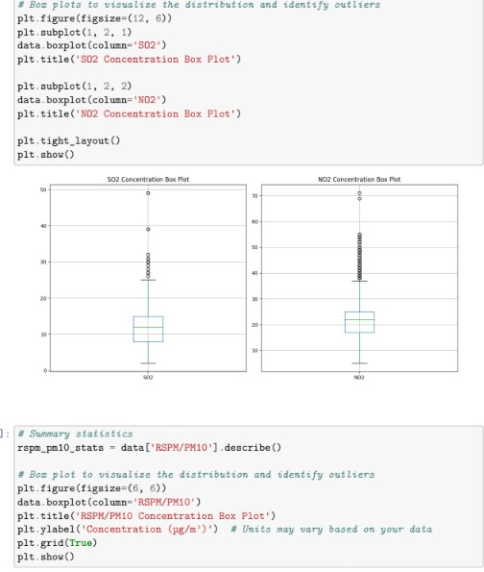

9 Data Visualization:

10 We used Matplotlib and Seaborn to create visualizations such

as time series plots to explore pollutant trends.

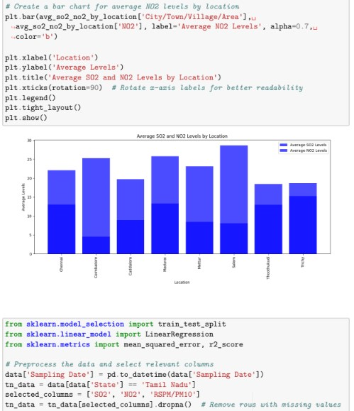

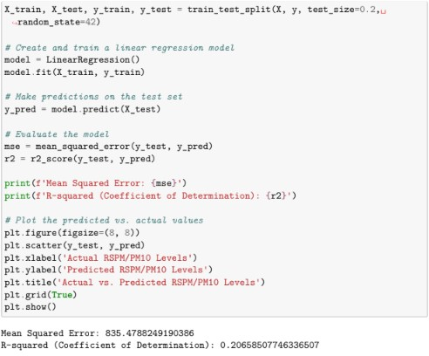

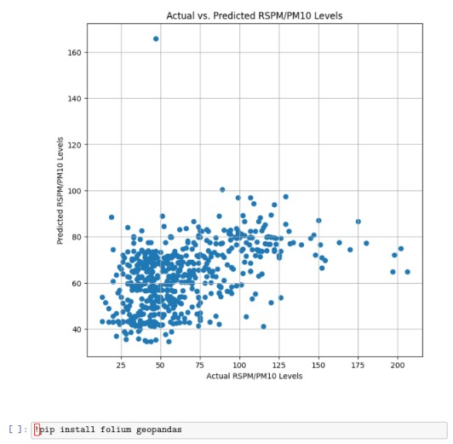

Requirement already satisfied: folium in /usr/local/lib/python3.10/dist-packages

(0.14.0)

Requirement already satisfied: geopandas in /usr/local/lib/python3.10/dist-

packages (0.13.2)

Requirement already satisfied: branca>=0.6.0 in /usr/local/lib/python3.10/dist-

packages (from folium) (0.6.0)

Requirement already satisfied: jinja2>=2.9 in /usr/local/lib/python3.10/dist-

packages (from folium) (3.1.2)

Requirement already satisfied: numpy in /usr/local/lib/python3.10/dist-packages

(from folium) (1.23.5)

Requirement already satisfied: requests in /usr/local/lib/python3.10/dist-

packages (from folium) (2.31.0) Requirement already satisfied: fiona>=1.8.19 in /usr/local/lib/python3.10/distpackages (from geopandas) (1.9.5) Requirement already satisfied: packaging in /usr/local/lib/python3.10/distpackages (from geopandas) (23.2) Requirement already satisfied: pandas>=1.1.0 in /usr/local/lib/python3.10/distpackages (from geopandas) (1.5.3) Requirement already satisfied: pyproj>=3.0.1 in /usr/local/lib/python3.10/distpackages (from geopandas) (3.6.1) Requirement already satisfied: shapely>=1.7.1 in /usr/local/lib/python3.10/distpackages (from geopandas) (2.0.2) Requirement already satisfied: attrs>=19.2.0 in /usr/local/lib/python3.10/distpackages (from fiona>=1.8.19->geopandas) (23.1.0) Requirement already satisfied: certifi in /usr/local/lib/python3.10/distpackages (from fiona>=1.8.19->geopandas) (2023.7.22) Requirement already satisfied: click~=8.0 in /usr/local/lib/python3.10/distpackages (from fiona>=1.8.19->geopandas) (8.1.7) Requirement already satisfied: click-plugins>=1.0 in /usr/local/lib/python3.10/dist-packages (from fiona>=1.8.19->geopandas) (1.1.1) Requirement already satisfied: cligj>=0.5 in /usr/local/lib/python3.10/distpackages (from fiona>=1.8.19->geopandas) (0.7.2) Requirement already satisfied: six in /usr/local/lib/python3.10/dist-packages (from fiona>=1.8.19->geopandas) (1.16.0) Requirement already satisfied: setuptools in /usr/local/lib/python3.10/distpackages (from fiona>=1.8.19->geopandas) (67.7.2) Requirement already satisfied: MarkupSafe>=2.0 in /usr/local/lib/python3.10/dist-packages (from jinja2>=2.9->folium) (2.1.3) Requirement already satisfied: python-dateutil>=2.8.1 in /usr/local/lib/python3.10/dist-packages (from pandas>=1.1.0->geopandas) (2.8.2) Requirement already satisfied: pytz>=2020.1 in /usr/local/lib/python3.10/distpackages (from pandas>=1.1.0->geopandas) (2023.3.post1) Requirement already satisfied: charset-normalizer=2 in /usr/local/lib/python3.1

: !pip install gmaps Collecting gmaps Downloading gmaps-0.9.0.tar.gz (1.1 MB) 1.1/1.1 MB 8.2 MB/s eta 0:00:00 Preparing metadata (setup.py) … done Requirement already satisfied: ipython>=5.3.0 in /usr/local/lib/python3.10/distpackages (from gmaps) (7.34.0) Requirement alr /usr/local/lib/python3.10/dist-packages (from gmaps) (7.7.1) Requirement already satisfied: traitlets>=4.3.0 in /usr/local/lib/python3.10/dist-packages (from gmaps) (5.7.1) Collecting geojson>=2.0.0 (from gmaps) Downloading geojson-3.0.1-py3-none-any.whl (15 kB) Requirement already satisfied: six in /usr/local/lib/python3.10/dist-packages (from gmaps) (1.16.0) Requirement already satisfied: setuptools>=18.5 in /usr/local/lib/python3.10/dist-packages (from ipython>=5.3.0->gmaps) (67.7.2) Collecting jedi>=0.16 (from ipython>=5.3.0->gmaps) Downloading jedi-0.19.1-py2.py3-none-any.whl (1.6 MB) 1.6/1.6 MB 46.0 MB/s eta 0:00:00 Requirement already satisfied: decorator in /usr/local/lib/python3.10/dist-packages (from ipython>=5.3.0->gmaps) (4.4.2) Requirement already satisfied: pickleshare in /usr/local/lib/python3.10/distpackages (from ipython>=5.3.0->gmaps) (0.7.5) Requirement already satisfied: prompt-toolkit!=3.0.0,!=3.0.1,=2.0.0 in /usr/local/lib/python3.10/dist-packages (from ipython>=5.3.0->gmaps) (3.0.39) Requirement already satisfied: pygments in /usr/local/lib/python3.10/distpackages (from ipython>=5.3.0->gmaps) (2.16.1) Requirement already satisfied: backcall in /usr/local/lib/python3.10/distpackages (from ipython>=5.3.0->gmaps) (0.2.0) Requirement already satisfied: matplotlib-inline in /usr/local/lib/python3.10/dist-packages (from ipython>=5.3.0->gmaps) (0.1.6) Requirement already satisfied: pexpect>4.3 in /usr/local/lib/python3.10/distpackages (from ipython>=5.3.0->gmaps) (4.8.0) Requirement already satisfied: ipykernel>=4.5.1 in /usr/local/lib/python3.10/dist-packages (from ipywidgets>=7.0.0->gmaps) (5.5.6) Requirement already satisfied: ipython-genutils~=0.2.0 in /usr/local/lib/python3.10/dist-packages (from ipywidgets>=7.0.0->gmaps) (0.2.0) Requirement already satisfied: widgetsnbextension~=3.6.0 in /usr/local/lib/python3.10/dist-packages (from ipywidgets>=7.0.0->gmaps) (3.6.6) Requirement already satisfied: jupyterlab-widgets>=1.0.0 in /usr/local/lib/python3.10/dist-packages (from ipywidgets>=7.0.0->gmaps) (3.0.9) Requirement already satisfied: jupyter-client in /usr/local/lib/python3.10/distpackages (from ipykernel>=4.5.1->ipywidgets>=7.0.0->gmaps) (6.1.12) Requirement already satisfied: tornado>=4.2 in /usr/local/lib/python3.10/distpackages (from ipykernel>=4.5.1->ipywidgets>=7.0.0->gmaps) (6.3.2) Requirement already satisfied: parso=0.8.3 in /usr/local/lib/python3.10/dist-packages (from jedi>=0.16->ipython>=5.3.0->gmaps) (0.8.3) Requirement already satisfied: ptyprocess>=0.5 in /usr/local/lib/python3.10/dist-packages (from pexpect>4.3->ipython>=5.3.0->gmaps) (0.7.0) Requirement already satisfied: wcwidth in /usr/local/lib/python3.10/distpackages (from prompttoolkit!=3.0.0,!=3.0.1,=2 Requirement already satisfied: notebook>=4.4.1 in /usr/local/lib/python3.10/dist-packages (from widgetsnbextension~=3.6.0->ipywidgets>=7.0.0->gmaps) (6.5.5) Requirement already satisfied: jinja2 in /usr/local/lib/python3.10/dist-packages (from notebook>=4.4.1->widgetsnbextension~=3.6.0->ipywidgets>=7.0.0->gmaps) (3.1.2) Requirement already satisfied: pyzmq=17 in /usr/local/lib/python3.10/distpackages (from notebook>=4.4.1->widgetsnbextension~=3.6.0->ipywidgets>=7.0.0->gmaps) (23.2.1) Requirement already satisfied: argon2-cffi in /usr/local/lib/python3.10/distpackages (from notebook>=4.4.1->widgetsnbextension~=3.6.0->ipywidgets>=7.0.0->gmaps) (23.1.0) Requirement already satisfied: jupyter-core>=4.6.1 in /usr/local/lib/python3.10/dist-packages (from notebook>=4.4.1->widgetsnbextension~=3.6.0->ipywidgets>=7.0.0->gmaps) (5.4.0) Requirement already satisfied: nbformat in /usr/local/lib/python3.10/ distpackages (from notebook>=4.4.1->widgetsnbextension~=3.6.0->ipywidgets>=7.0.0->gmaps) (5.9.2) Requirement already satisfied: nbconvert>=5 in /usr/local/lib/python3.10/distpackages (from notebook>=4.4.1->widgetsnbextension~=3.6.0->ipywidgets>=7.0.0->gmaps) (6.5.4) Requirement already satisfied: nest-asyncio>=1.5 in /usr/local/lib/python3.10/dist-packages (from notebook>=4.4.1->widgetsnbextension~=3.6.0->ipywidgets>=7.0.0->gmaps) (1.5.8) Requirement already satisfied: Send2Trash>=1.8.0 in /usr/local/lib/python3.10/dist-packages (from notebook>=4.4.1->widgetsnbextension~=3.6.0->ipywidgets>=7.0.0->gmaps) (1.8.2) Requirement already satisfied: terminado>=0.8.3 in /usr/local/lib/python3.10/dist-packages (from notebook>=4.4.1->widgetsnbextension~=3.6.0->ipywidgets>=7.0.0->gmaps) (0.17.1) Requirement already satisfied: prometheus-client in /usr/local/lib/python3.10/dist-packages (from notebook>=4.4.1->widgetsnbextension~=3.6.0->ipywidgets>=7.0.0->gmaps) (0.17.1) Requirement already satisfied: nbclassic>=0.4.7 in /usr/local/lib/python3.10/dist-packages (from notebook>=4.4.1->widgetsnbextension~=3.6.0->ipywidgets>=7.0.0->gmaps) (1.0.0) Requirement already satisfied: python-dateutil>=2.1 in /usr/local/lib/python3.10/dist-packages (from jupyterclient->ipykernel>=4.5.1->ipywidgets>=7.0.0->gmaps) (2.8.2) Requirement already satisfied: platformdirs>=2.5 in /usr/local/lib/python3.10/dist-packages (from jupyter-core>=4.6.1->notebook>=4.4 .1->widgetsnbextension~=3.6.0->ipywidgets>=7.0.0->gmaps) (3.11.0) Requirement already satisfied: jupyter-server>=1.8 in /usr/local/lib/python3.10/dist-packages (from nbclassic>=0.4.7->notebook>=4.4.1- >widgetsnbextension~=3.6.0->ipywidgets>=7.0.0->gmaps) (1.24.0) Requirement already satisfied: notebook-shim>=0.2.3 in /usr/local/lib/python3.10/dist-packages (from nbclassic>=0.4.7->notebook>=4.4.1- >widgetsnbextension~=3.6.0->ipywidgets>=7.0.0->gmaps) (0.2.3) 14 Requirement already satisfied: lxml in /usr/local/lib/python3.10/dist-packages (from nbconvert>=5->notebook>=4.4.1->widgetsnbextension~=3.6.0->ipywidgets>=7.0. 0->gmaps) (4.9.3) Requirement already satisfied: beautifulsoup4 in /usr/local/lib/python3.10/distpackages (from nbconvert>=5->notebook>=4.4.1->widgetsnbextension~=3.6.0->ipywidg ets>=7.0.0->gmaps) (4.11.2) Requirement already satisfied: bleach in /usr/local/lib/python3.10/dist-packages (from nbconvert>=5->notebook>=4.4.1->widgetsnbextension~=3.6.0->ipywidgets>=7.0. 0->gmaps) (6.1.0) Requirement already satisfied: defusedxml in /usr/local/lib/python3.10/distpackages (from nbconvert>=5->notebook>=4.4.1->widgetsnbextension~=3.6.0->ipywidg ets>=7.0.0->gmaps) (0.7.1) Requirement already satisfied: entrypoints>=0.2.2 in /usr/local/lib/python3.10/dist-packages (from nbconvert>=5->notebook>=4.4.1->wid getsnbextension~=3.6.0->ipywidgets>=7.0.0->gmaps) (0.4) Requirement already satisfied: jupyterlab-pygments in /usr/local/lib/python3.10/dist-packages (from nbconvert>=5->notebook>=4.4.1->wid getsnbextension~=3.6.0->ipywidgets>=7.0.0->gmaps) (0.2.2) Requirement already satisfied: MarkupSafe>=2.0 in /usr/local/lib/python3.10/dist-packages (from nbconvert>=5->notebook>=4.4.1->wid getsnbextension~=3.6.0->ipywidgets>=7.0.0->gmaps) (2.1.3) Requirement already satisfied: mistune=0.8.1 in /usr/local/lib/python3.10/dist-packages (from nbconvert>=5->notebook>=4.4.1->wid getsnbextension~=3.6.0->ipywidgets>=7.0.0->gmaps) (0.8.4) Requirement already satisfied: nbclient>=0.5.0 in /usr/local/lib/python3.10/dist-packages (from nbconvert>=5->notebook>=4.4.1->wid getsnbextension~=3.6.0->ipywidgets>=7.0.0->gmaps) (0.8.0) Requirement already satisfied: packaging in /usr/local/lib/python3.10/distpackages (from nbconvert>=5->notebook>=4.4.1->widgetsnbextension~=3.6.0->ipywidg ets>=7.0.0->gmaps) (23.2) Requirement already satisfied: pandocfilters>=1.4.1 in /usr/local/lib/python3.10/dist-packages (from nbconvert>=5->notebook>=4.4.1->wid getsnbextension~=3.6.0->ipywidgets>=7.0.0->gmaps) (1.5.0) Requirement already satisfied: tinycss2 in /usr/local/lib/python3.10/distpackages (from nbconvert>=5->notebook>=4.4.1->widgetsnbextension~=3.6.0->ipywidg ets>=7.0.0->gmaps) (1.2.1) Requirement already satisfied: fastjsonschema in /usr/local/lib/python3.10/distpackages (from nbformat->notebook>=4.4.1->widgetsnbextension~=3.6.0->ipywidgets>=7.0.0->gmaps) (2.18.1) Requirement already satisfied: jsonschema>=2.6 in /usr/local/lib/python3.10/dist-packages (from nbformat->notebook>=4.4.1->widgetsnbextension~=3.6.0->ipywidgets>=7.0.0->gmaps) (4.19.1) Requirement already satisfied: argon2-cffi-bindings in /usr/local/lib/python3.10/dist-packages (from argon2-cffi->notebook>=4.4.1->widg etsnbextension~=3.6.0->ipywidgets>=7.0.0->gmaps) (21.2.0) Requirement already satisfied: attrs>=22.2.0 in /usr/local/lib/python3.10/dist15 packages (from jsonschema>=2.6->nbformat->notebook>=4.4.1->widgetsnbextension~=3 .6.0->ipywidgets>=7.0.0->gmaps) (23.1.0) Requirement already satisfied: jsonschema-specifications>=2023.03.6 in /usr/local/lib/python3.10/dist-packages (from jsonschema>=2.6->nbformat->noteboo k>=4.4.1->widgetsnbextension~=3.6.0->ipywidgets>=7.0.0->gmaps) (2023.7.1) Requirement already satisfied: referencing>=0.28.4 in /usr/local/lib/python3.10/dist-packages (from jsonschema>=2.6->nbformat->noteboo k>=4.4.1->widgetsnbextension~=3.6.0->ipywidgets>=7.0.0->gmaps) (0.30.2) Requirement already satisfied: rpds-py>=0.7.1 in /usr/local/lib/python3.10/distpackages (from jsonschema>=2.6->nbformat->notebook>=4.4.1->widgetsnbextension~=3 .6.0->ipywidgets>=7.0.0->gmaps) (0.10.6) Requirement already satisfied: anyio=3.1.0 in /usr/local/lib/python3.10/dist-packages (from jupyter-server>=1.8->nbclassic>=0. 4.7->notebook>=4.4.1->widgetsnbextension~=3.6.0->ipywidgets>=7.0.0->gmaps) (3.7.1) Requirement already satisfied: websocket-client in /usr/local/lib/python3.10/dist-packages (from jupyter-server>=1.8->nbclassic>=0. 4.7->notebook>=4.4.1->widgetsnbextension~=3.6.0->ipywidgets>=7.0.0->gmaps) (1.6.4) Requirement already satisfied: cffi>=1.0.1 in /usr/local/lib/python3.10/distpackages (from argon2-cffi-bindings->argon2-cffi->notebook>=4.4.1->widgetsnbexte nsion~=3.6.0->ipywidgets>=7.0.0->gmaps) (1.16.0) Requirement already satisfied: soupsieve>1.2 in /usr/local/lib/python3.10/distpackages (from beautifulsoup4->nbconvert>=5->notebook>=4.4.1->widgetsnbextension ~=3.6.0->ipywidgets>=7.0.0->gmaps) (2.5) Requirement already satisfied: webencodings in /usr/local/lib/python3.10/distpackages (from bleach->nbconvert>=5->notebook>=4.4.1->widgetsnbextension~=3.6.0- >ipywidgets>=7.0.0->gmaps) (0.5.1) Requirement already satisfied: idna>=2.8 in /usr/local/lib/python3.10/distpackages (from anyio=3.1.0->jupyter-server>=1.8->nbclassic>=0.4.7->notebook> =4.4.1->widgetsnbextension~=3.6.0->ipywidgets>=7.0.0->gmaps) (3.4) Requirement already satisfied: sniffio>=1.1 in /usr/local/lib/python3.10/distpackages (from anyio=3.1.0->jupyter-server>=1.8->nbclassic>=0.4.7->notebook> =4.4.1->widgetsnbextension~=3.6.0->ipywidgets>=7.0.0->gmaps) (1.3.0) Requirement already satisfied: exceptiongroup in /usr/local/lib/python3.10/distpackages (from anyio=3.1.0->jupyter-server>=1.8->nbclassic>=0.4.7->notebook> =4.4.1->widgetsnbextension~=3.6.0->ipywidgets>=7.0.0->gmaps) (1.1.3) Requirement already satisfied: pycparser in /usr/local/lib/python3.10/distpackages (from cffi>=1.0.1->argon2-cffi-bindings->argon2-cffi->notebook>=4.4.1-> widgetsnbextension~=3.6.0->ipywidgets>=7.0.0->gmaps) (2.21) Building wheels for collected packages: gmaps Building wheel for gmaps (setup.py) … done Created wheel for gmaps: filename=gmaps-0.9.0-py2.py3-none-any.whl size=2076086 sha256=40b7725c2867fe885f2fe0fd33fff84621eb01e27185d11647a72f1cab3cc5a8 Stored in directory: /root/.cache/pip/wheels/b3/c2/dc/48b3ef16c2184dae51a003f1 7eb5d065bbbf1af3437d9f14e3 Successfully built gmaps 16 Installing collected packages: jedi, geojson, gmaps Successfully installed geojson-3.0.1 gmaps-0.9.0 jedi-0.19.1 #In the Air Quality Analysis, incorporating Google Maps (GMap) can visually display pollution hotspots, helping users pinpoint areas with higher pollution levels. This feature enhances spatial understanding and facilitates informed decisions for better air quality management in Tamilnadu

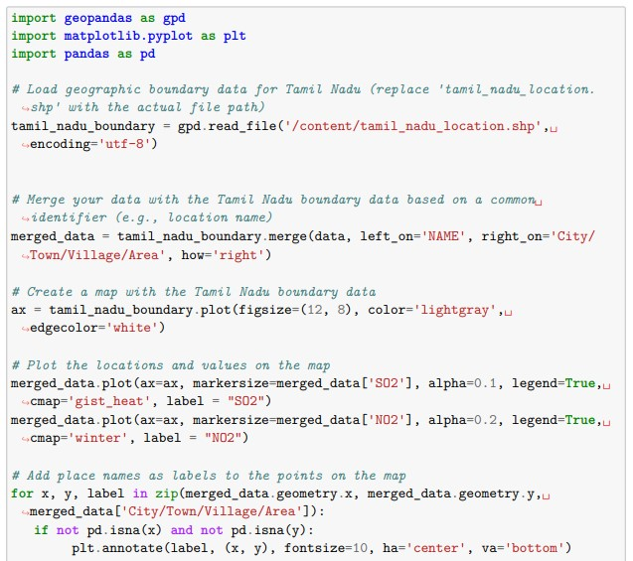

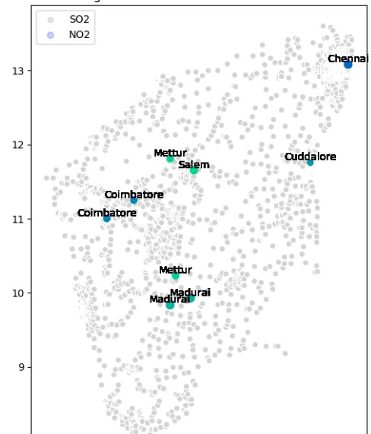

11 Linear Regression Modeling:

12 We employed a simple linear regression model to estimate RSPM/PM10 levels based on SO2 and NO2 concentrations 13 Predict Respirable Suspended Particulate Matter (RSPM/PM10) levels 14 The segment demonstrates how to use a linear regression model to predict Respirable Suspended Particulate Matter (RSPM/PM10) levels based on Sulfur Dioxide (SO2) and Nitrogen Dioxide (NO2) levels. It loads and preprocesses the data, trains a linear regression model, and then predicts RSPM/PM10 levels for new data with specified SO2 and NO2 values.

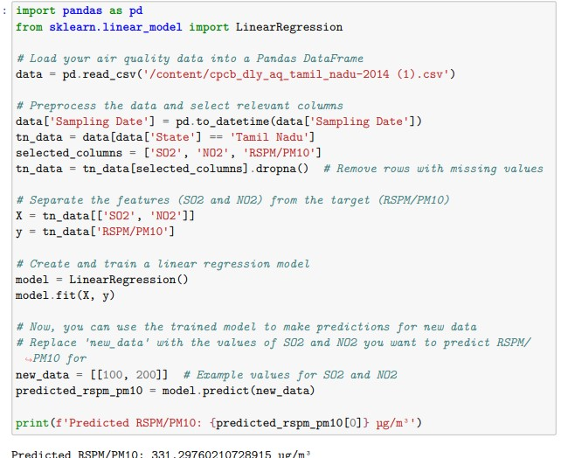

15 Heatmap to visualize pollutant levels (RSPM/PM10)

16 To loads an air quality dataset and creates a heatmap to visualize pollutant levels (RSPM/PM10) by location and time in Tamil Nadu. It uses the Seaborn library for heatmap creation. The heatmap provides a graphical representation of air quality trends across different monitoring locations over time, aiding in identifying variations and hotspots in pollution levels.

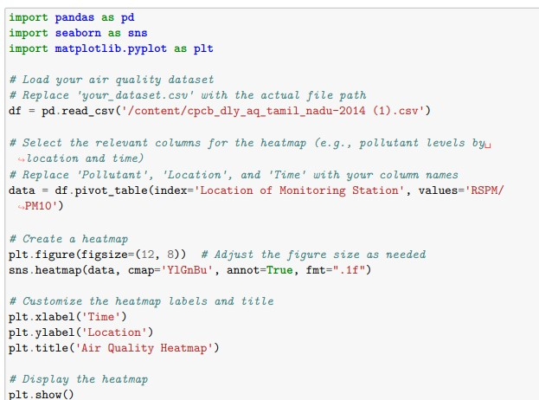

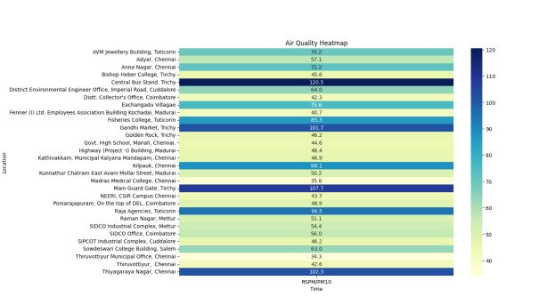

|  |  |
| --- | --- |
| TEAM ID | PROJ_224711_TEAM_2 |
| NAME | PAVITHRA M |
| TEAM MEMBERS | DIVYA DHARSHINI S,SHARMILA S, ARTHI M |
| REGISTER NUMBER | 420421205014 |