freestyle nginx job using jenkins

Installing java

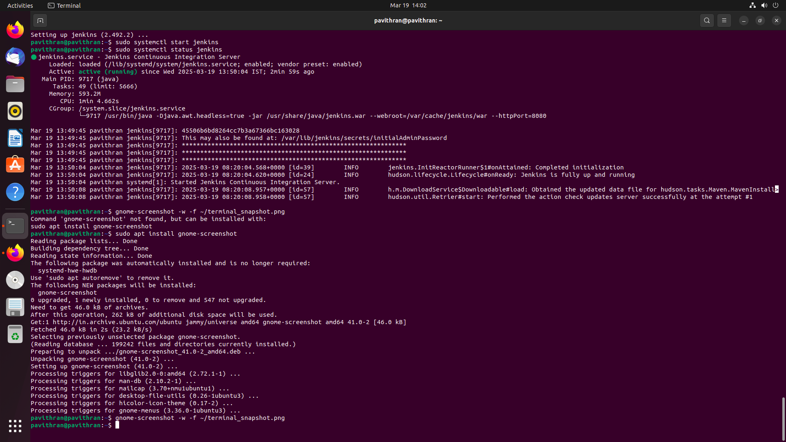

Jenkins Installation

Checking Status of Jenkins

project creation

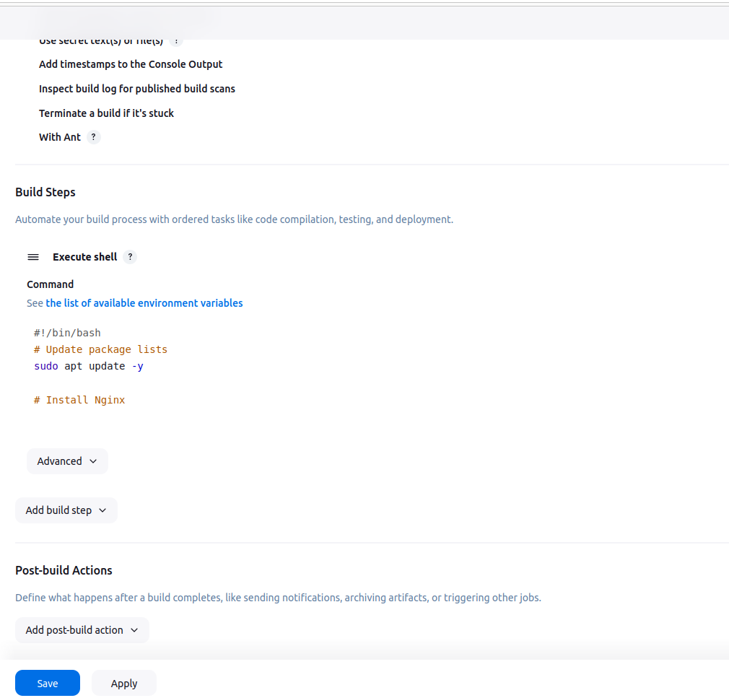

Restart the nginx engine

