SESSION 13
SIMPLE MOVING AVERAGE
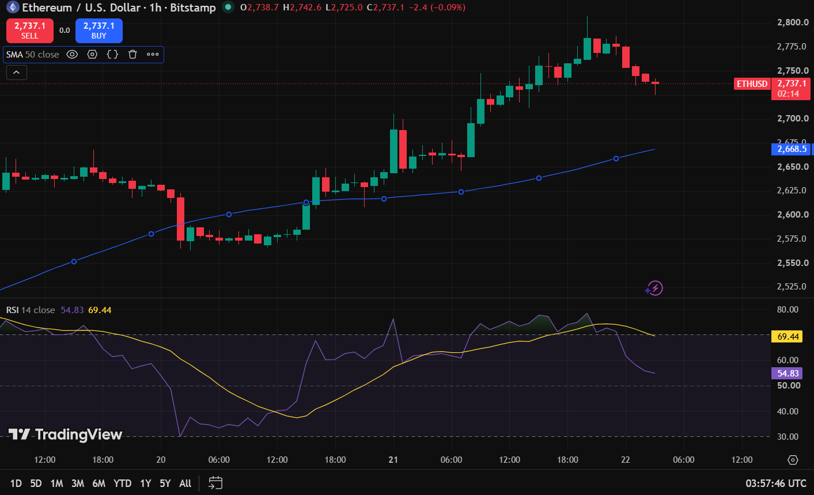

SESSION 14
RELATIVE STRENGTH INDEX
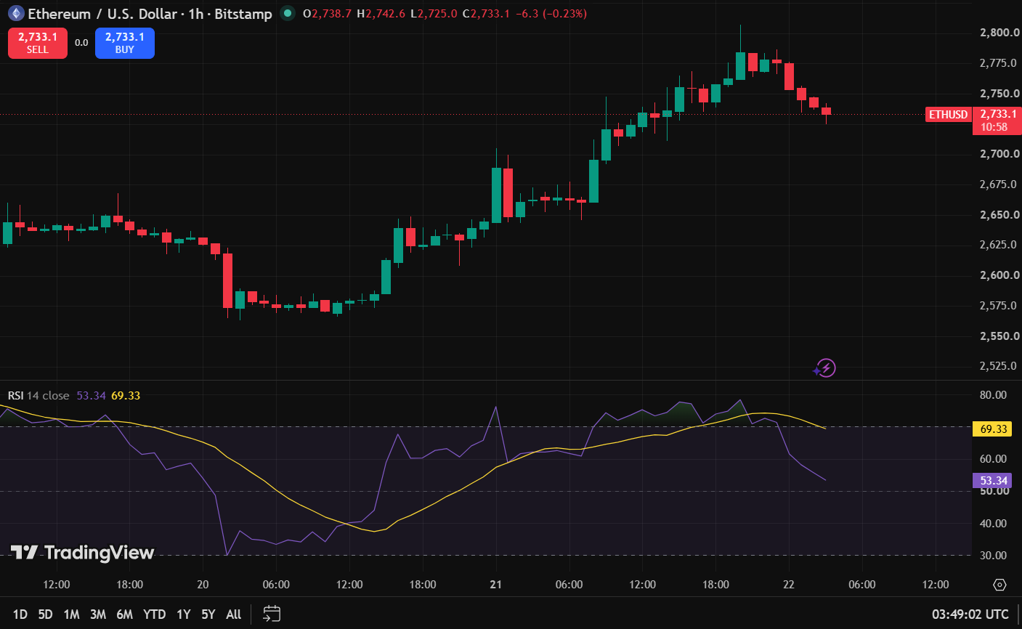

The RSI is 69.33, it is neutral so we can hold.

SESSION 15
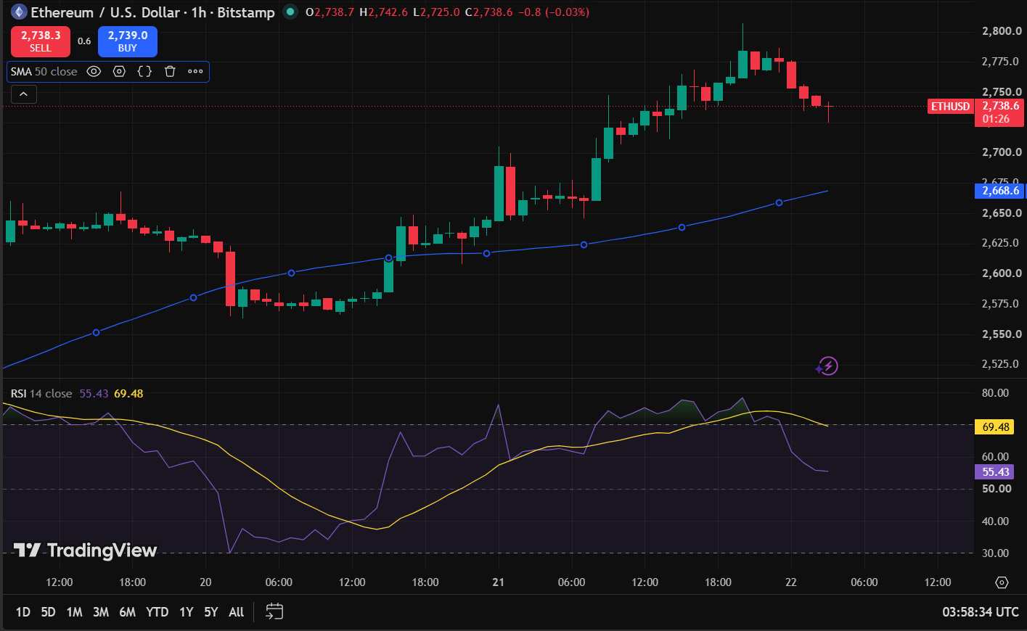

Indicator-Based Trading Report

Market Observation
Particular | Observation
Asset | ETHUREUM (ETHUSD)
Timeframe | 1 Hour (1H)
Price Position | Above 50 SMA
SMA Direction | Upward
Current RSI | 55.43
RSI Zone | Neutral (30–70)

Trading Decision
Particular | Observation
Trade Executed | Yes
Trade Type | Long (Buy)
Reason | Price is above 50 SMA, indicating an upward trend, while the RSI remains in the neutral zone, suggesting balanced momentum without an overbought condition.

Trade Details
Particular | Observation
Entry Price | 2,739.254
Exit Price | 2,737.346
Realized Profit/Loss | +292.36 INR
Trade Outcome | PROFIT

