Session 7
Reading Candlestick Chart
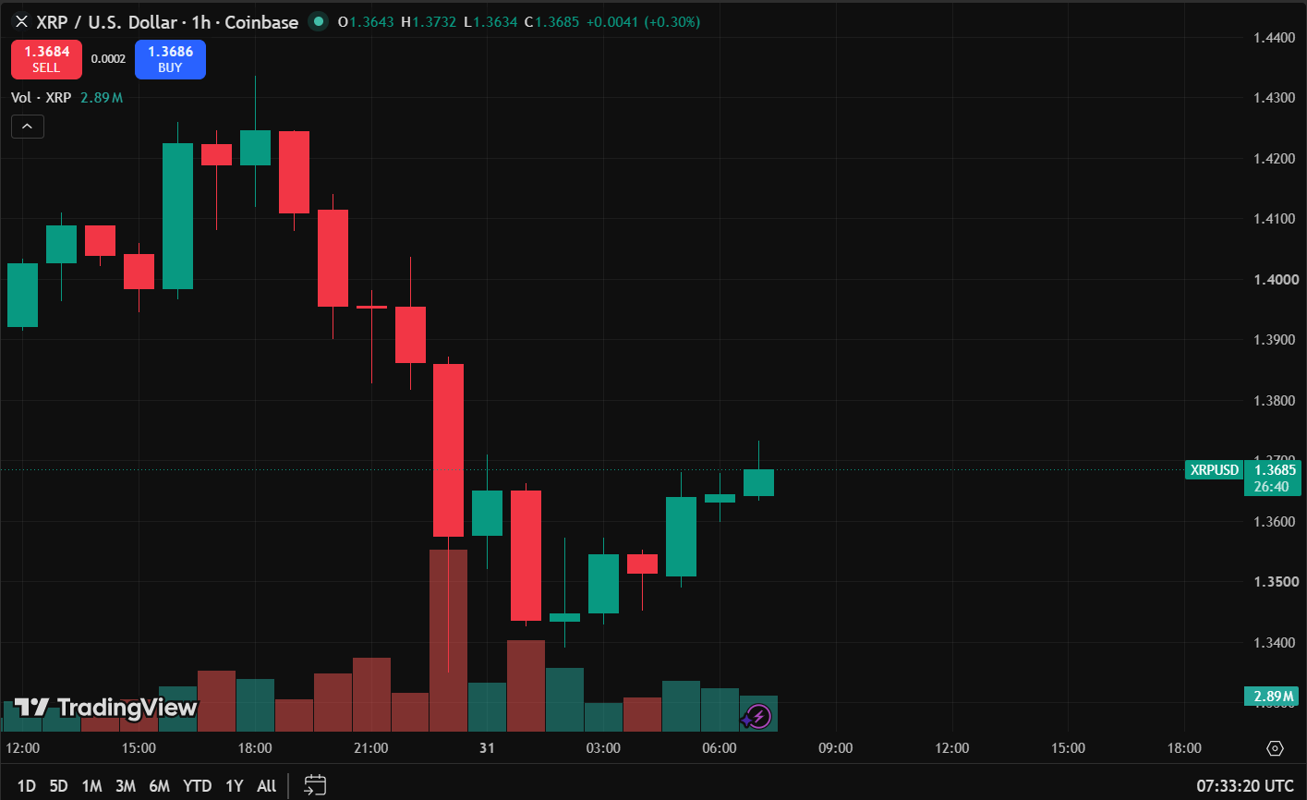

Candlestick Observation Report
Particular | Observation
Asset Name | XRP
Symbol | XRPUSD
Timeframe | 1 Hour(1h)
Number of Green Candles Observed | 10
Number of Red Candles Observed | 10
Doji Observed | Observed
Hammer Observed | Not Observed
Shooting Star Observed | Not Observed

Session 8
OBSERVING PRICE DIRECTION
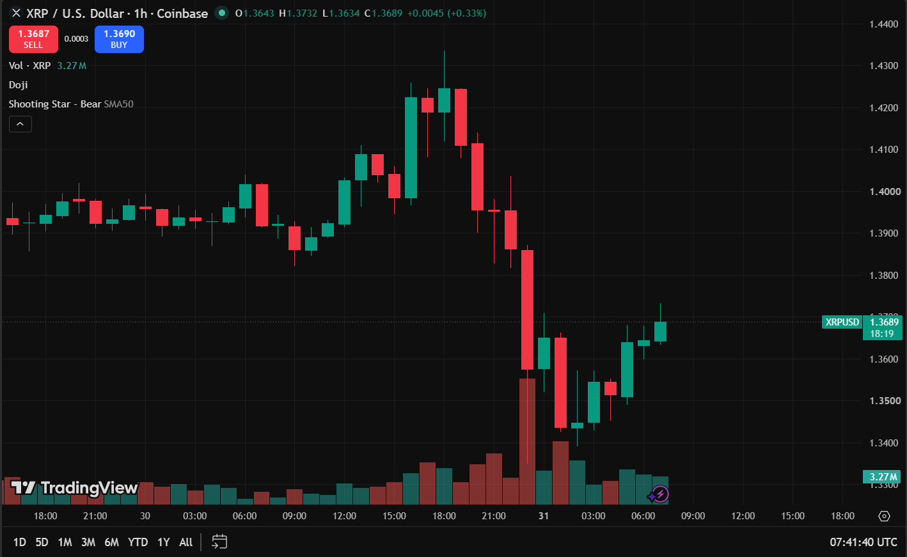
TREND OBSERVATION REPORT
Particular | Observation
Asset Name | XRP
Symbol | XRPUSD
Timeframe | 1 Hour(1h)
Trend Observed | Downtrend
Number of Candlesticks Observed | 40
Reason for Identifying the Trend | The chart shows a series of lower highs and lower lows, indicating a clear downtrend.

Session 9
Trend-Based Trade Report

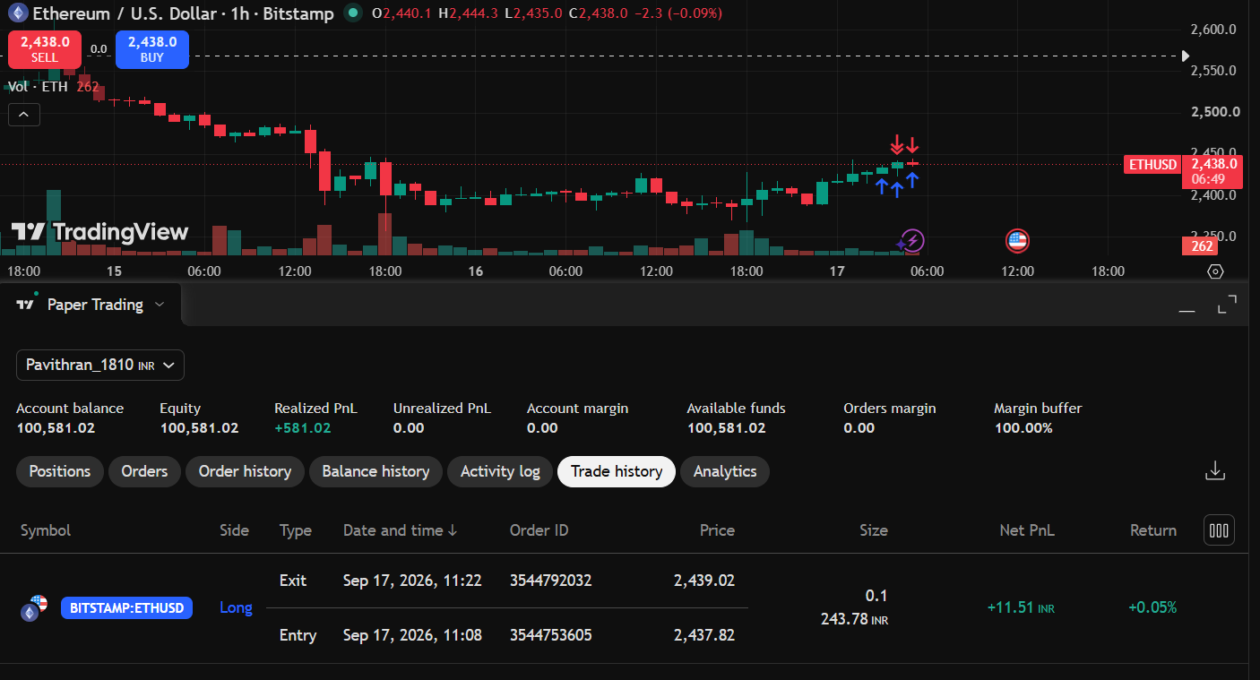

Particular | Observation
Asset Name | ETHEREUM
Symbol | ETHUSD
Timeframe | 1 Hour (1H)
Trend Observed | Uptrend
Trade Type | Long (buy)
Entry Price | 2,437.82
Exit Price | 2,439.02
Realized Profit/Loss | +11.51 INR
Trade Outcome | PROFIT
Reason for Identifying the Trend | Price is forming higher highs and higher lows after a decline, indicating buying pressure.

