SESSION 16
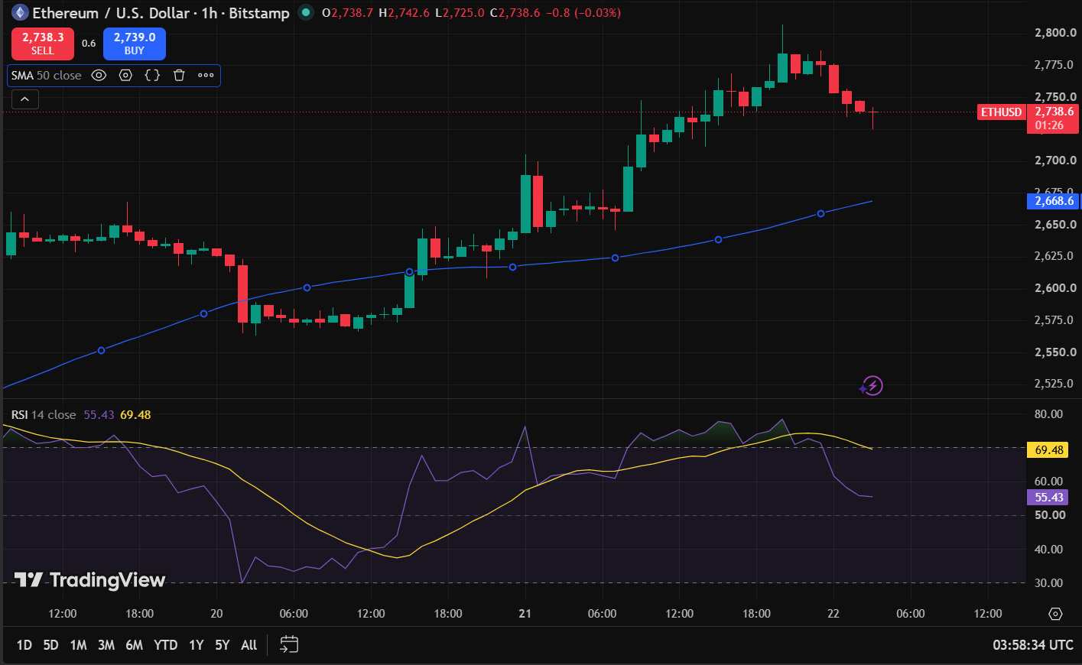

Observation | Sample Finding
Asset | ETHUSD
Timeframe | 1 Hour
Price Position | Above 50 SMA
SMA Direction | UPWARD
RSI Value | 55.43
RSI Zone | Neutral
Near Support | NO
Near Resistance | YES
Recent Candlestick | Bearish
Final Decision | Wait / Observe
Reason | Price is above the rising 50 SMA, showing an overall bullish trend, but the recent bearish candles indicate short-term selling pressure. Therefore, wait for confirmation before entering a trade.

SESSION 17
EXIT PLANNING SHEET
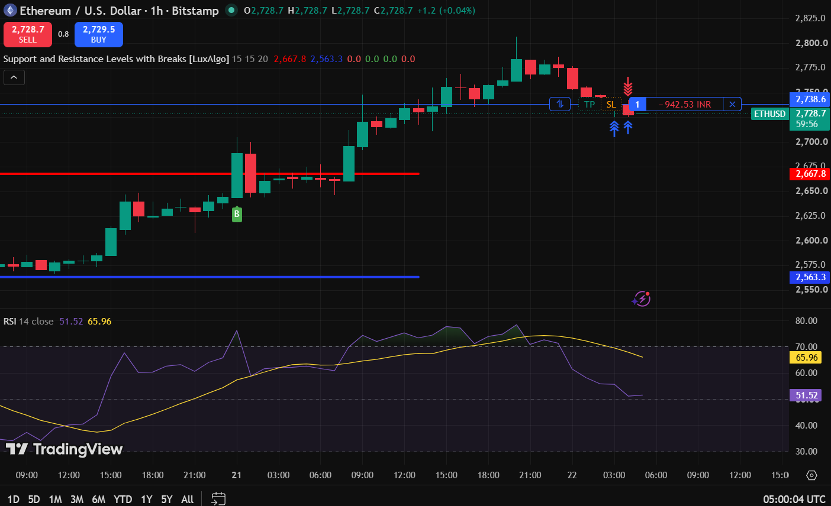

Observation | Sample Finding
Asset | ETHUSD
Timeframe | 1 Hour
Current Trade | short
Price Near Support / Resistance | Yes, near Resistance
RSI Value | 52.52
RSI Observation | Neutral
Candlestick | Small bullish/neutral candle near Resistance
Final Decision | Hold
Reason | The price is near the recent resistance area, which can support a downward reversal. However, the RSI at 51.52 is neutral and the latest candle does not give strong bearish confirmation. Therefore, hold the short trade and wait for stronger bearish confirmation before making an exit decision.

SESSION 18
Trading Plan Review and Execution Report
Field | Details
Asset | ETHUSD
Timeframe | 1 Hour
Trade Position | HOLD
Original Entry Plan | Near Resistance
Original Exit Plan | Near Resistance
Were Current Market Conditions Different from the Original Plan? | Yes
Were Any Revisions Made? | Yes
If Yes, Describe the Revisions | The short trade was kept on hold while the market was observed for stronger bearish confirmation.
Reason for the Revision | The price was near resistance, but the RSI at 51.52 was neutral and there was no strong bearish confirmation.
Final Trading Decision | Continued Observing
Trade Status | Trade Held
Was the Trading Plan Followed? | Yes
Outcome (if executed) | Loss
Key Learning | Do not make an exit decision without sufficient confirmation. When RSI is neutral and price action is unclear, wait and observe before making a major decision

