SESSION 4

CRYPTO CURRENCIES

- Wishlist

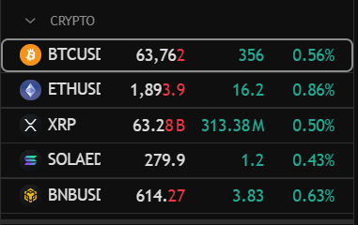

- Bitcoin USD

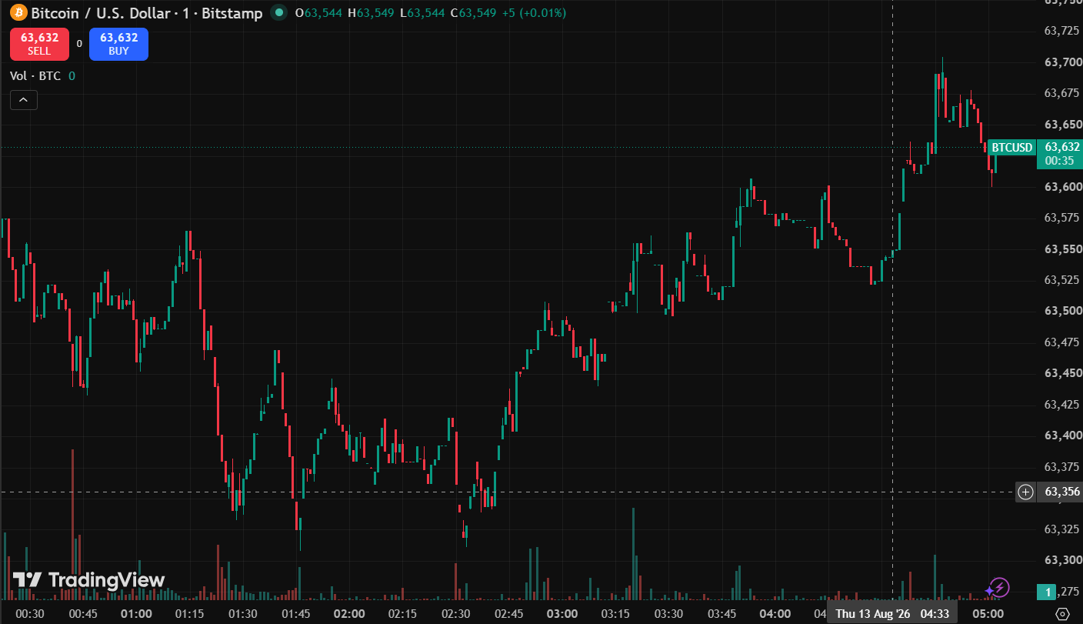

- Ethereum USD

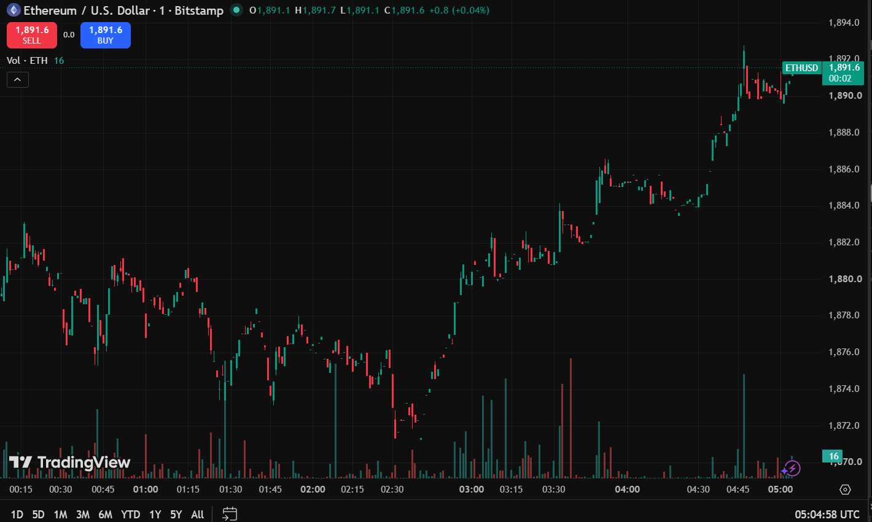

- XRP
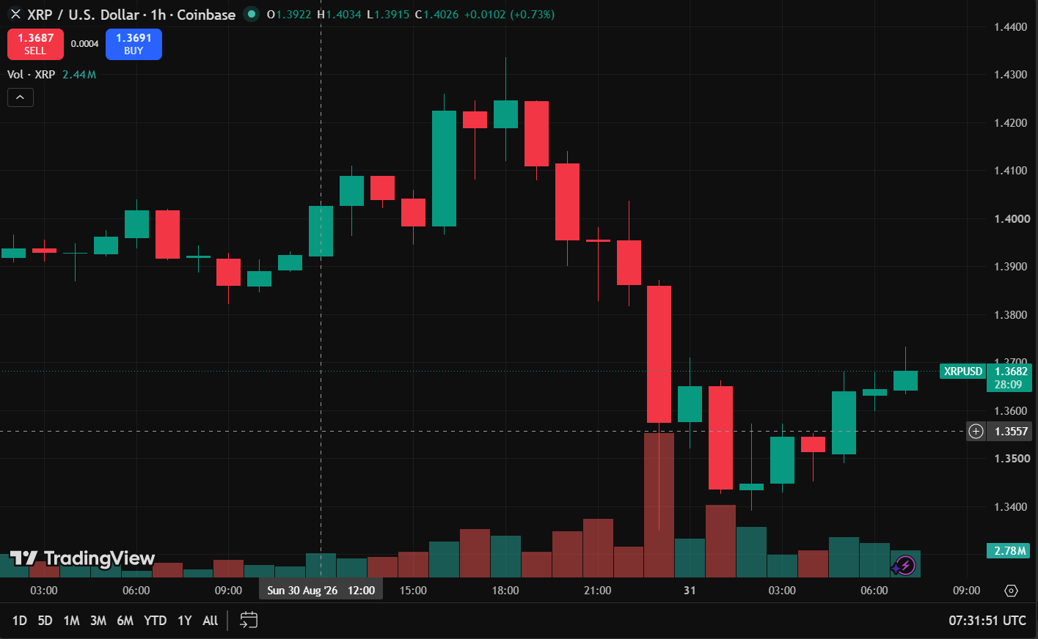

- Solana United Arab Emirates
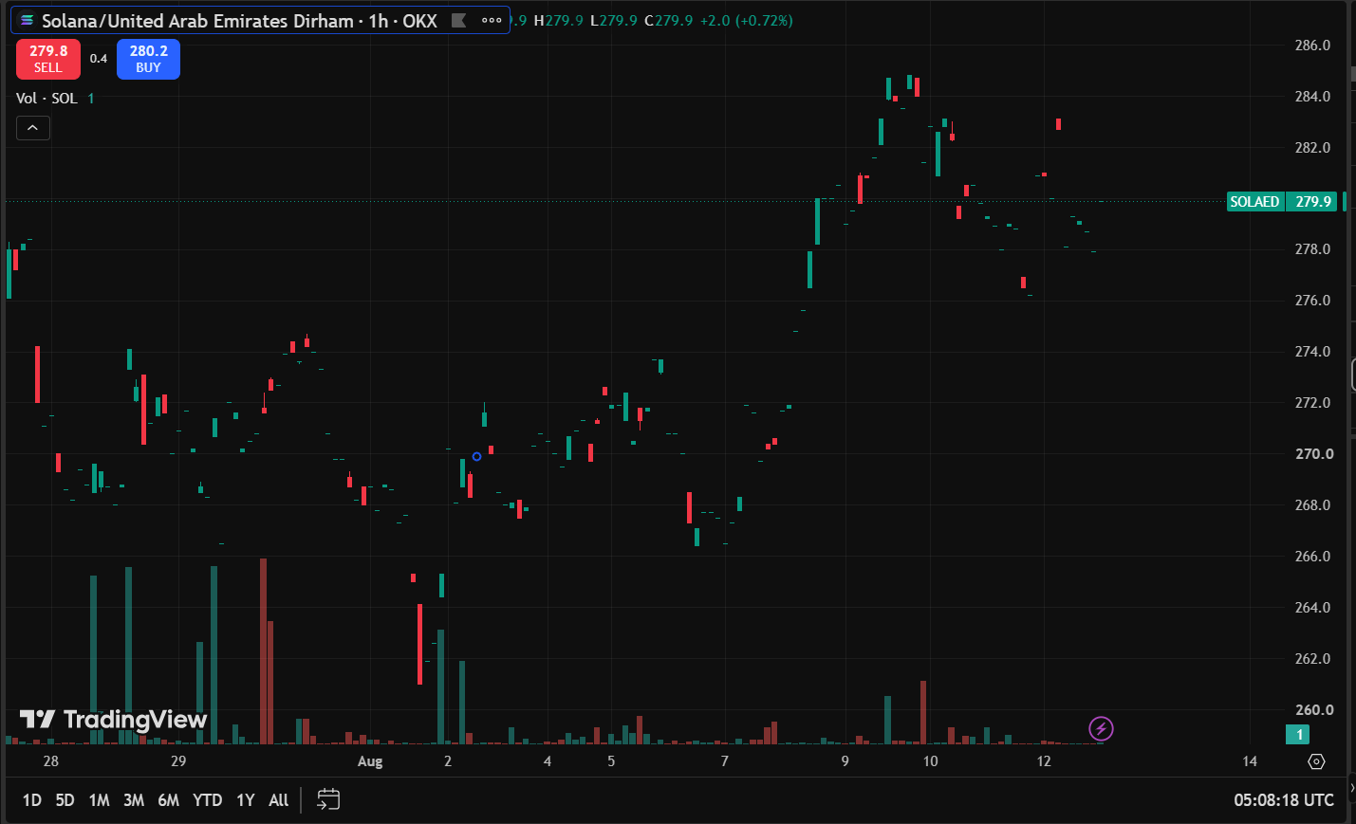

- Binance Coin
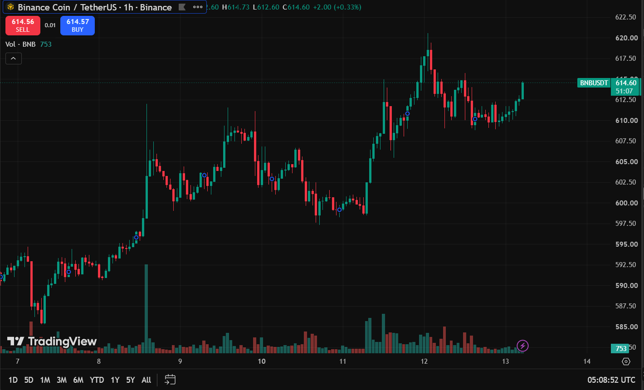

SESSION 5
Screenshot of Executed Buy Order / Open Position.

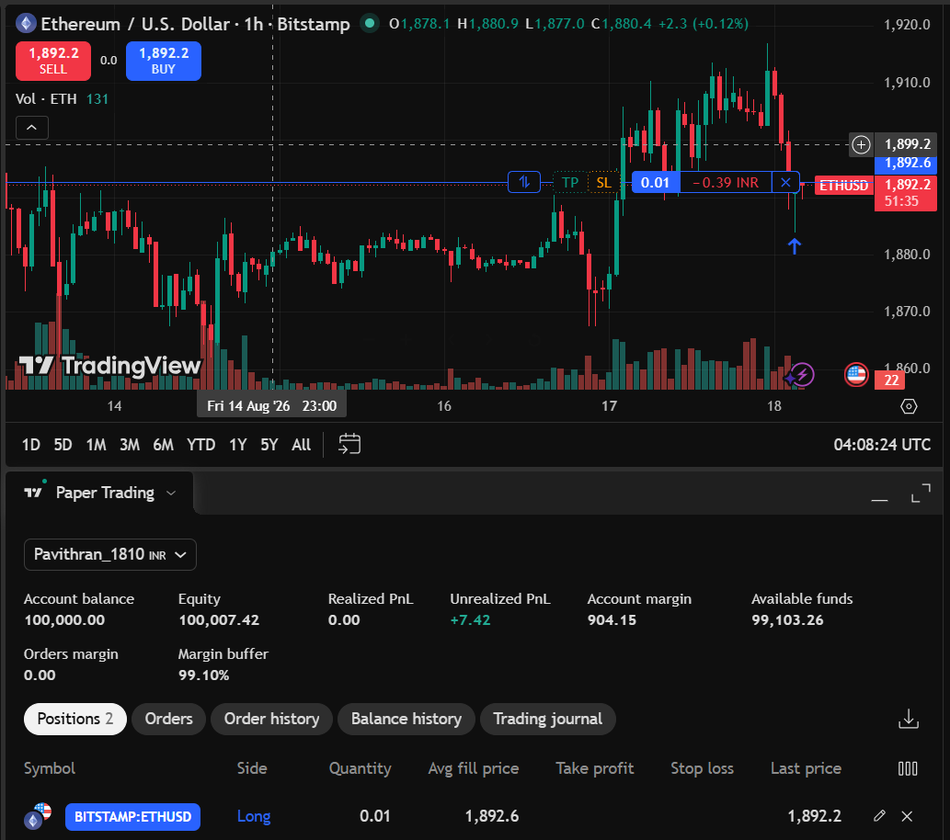

First Trade Record
Trade details:

Particulars | Details
Asset Name | Ethereum
Symbol | ETHUSD
Trade Type | Buy
Quantity Purchased | 0.01
Average Fill Page | 1,892.6
Trade Value | 1,811.31INR
Date & Time of Trade | 2026-08-18 09:44:43

Position Observation

Particular | Value
Last Price | 1,892.6
Trade Value | 1,811.31INR
Unrealized PnL | +0.09INR

SESSION 6
Profit/Loss Observation Table

Particulars | Details
Asset Name | Ethereum
Symbol | ETHUSD
Quantity Purchased | 0.01
Purchased Date & Time of Trade | 2026-08-18 09:44:43
Average Fill Page(Purchase Price) | 1,892.6
Exit Date & Time of Trade | 2026-08-18 10:11:05
Exit Price (Selling Price) | 1,895.0
Final Profit/Loss (Realized PnL) | +2.29INR
Trade Outcome (Profit/Loss) | Profit

SESSION 7
Reading Candlestick Chart
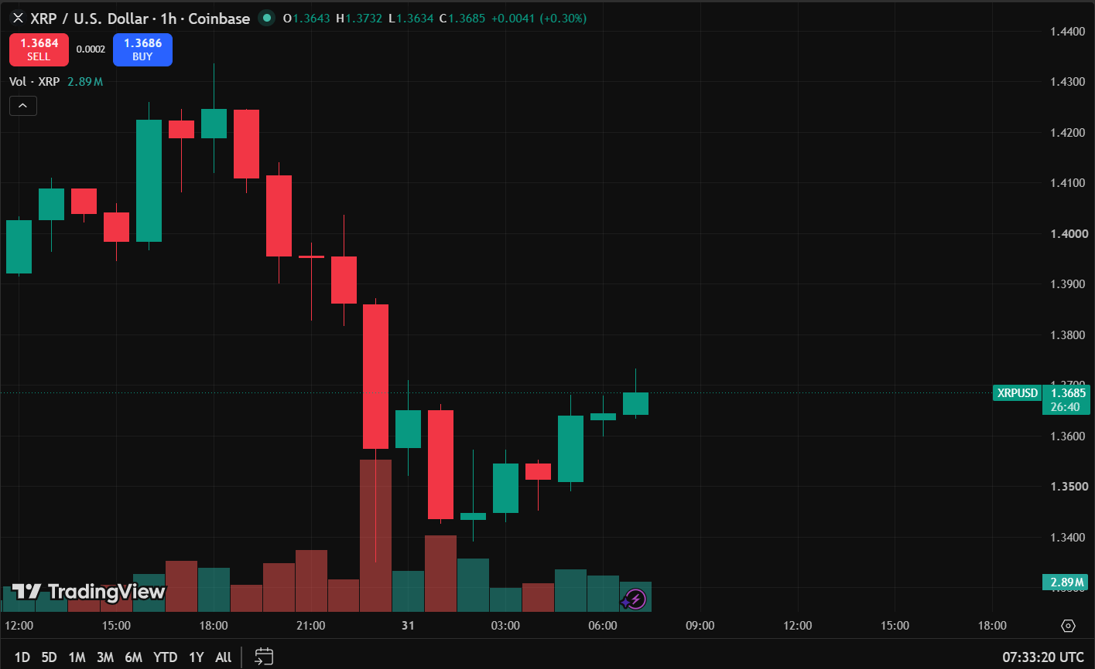

Candlestick Observation Report
Particular | Observation
Asset Name | XRP
Symbol | XRPUSD
Timeframe | 1 Hour(1h)
Number of Green Candles Observed | 10
Number of Red Candles Observed | 10
Doji Observed | Observed
Hammer Observed | Not Observed
Shooting Star Observed | Not Observed

