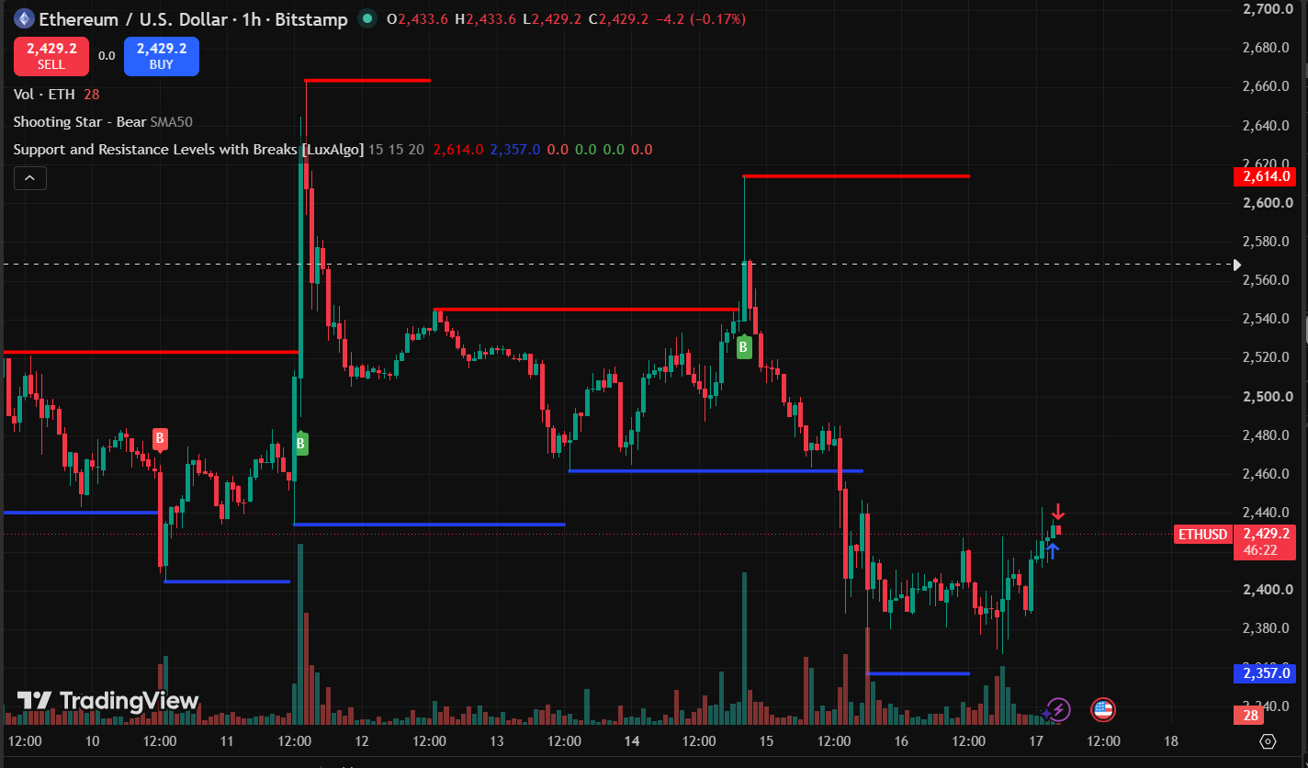
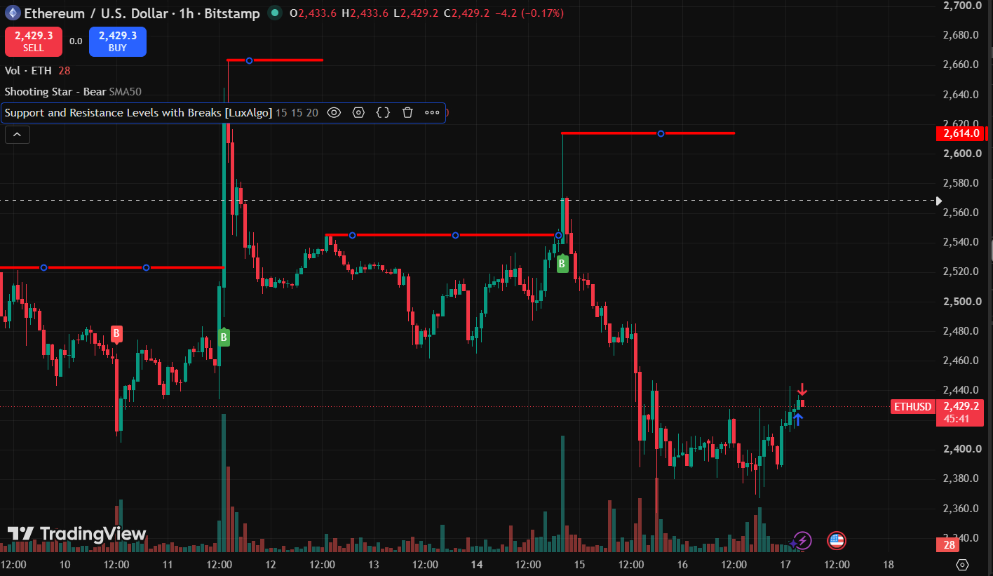
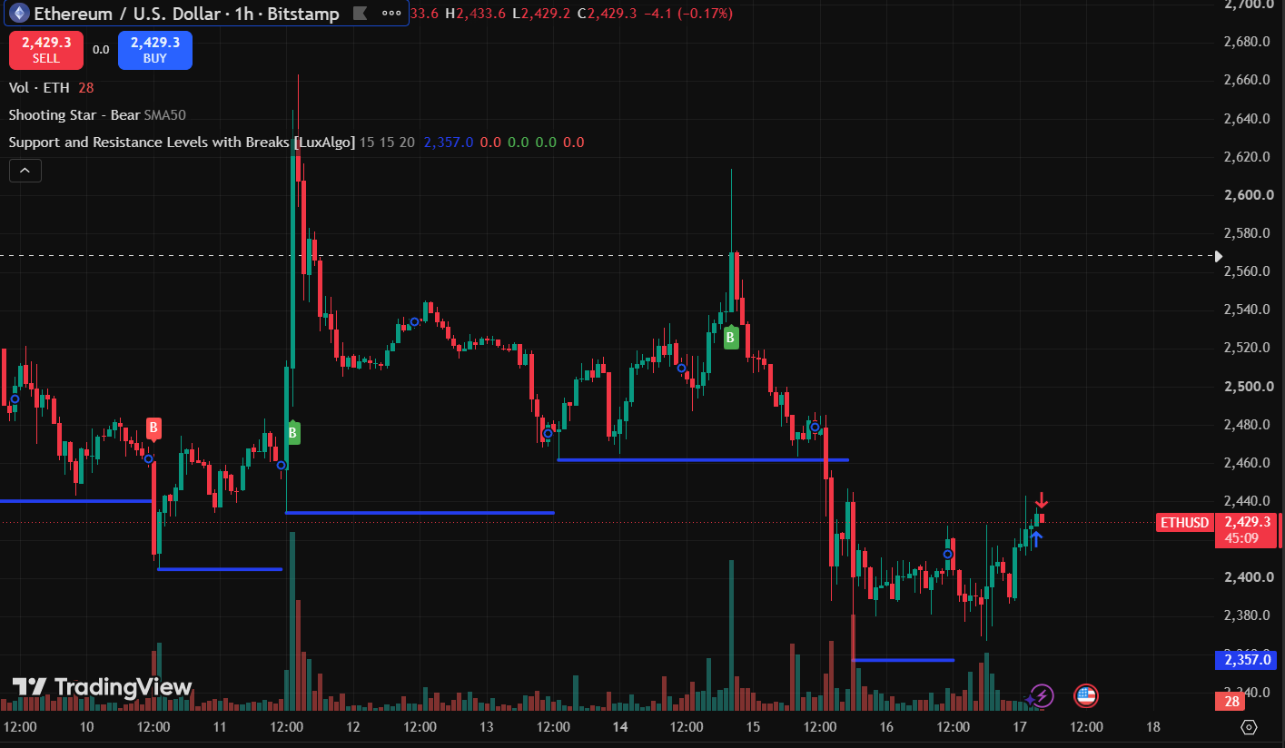

SUPPORT & RESISTANCE TRADE ANALYSIS REPORT
REPORT

CHART ANALYSIS

Particulars | Observation
Asset Name | ETHEREUM
Symbol | ETHUSD
Time Frame | 1 Hour(1 H)
Support Level | 2,357
Resistance Level | 2,614
Current Price Position (Near Support/Near Resistance/Between Levels) | Near Support

TRADING DECISION

Particulars | Observation
Trade Executed | Yes
Trade Type (Long/Short/No Trade) | Long
Reason for Trading Decision | Price was near support, so a long trade was taken expecting an upward move.

Trade Details

Particular | Observation
Entry Price | 2,434.01
Exit Price | 2,438.54
Realized Profit/Loss | +217.00 INR
Trade Outcome (Profit / Loss) | Profit

