# LINUX COMMANDS

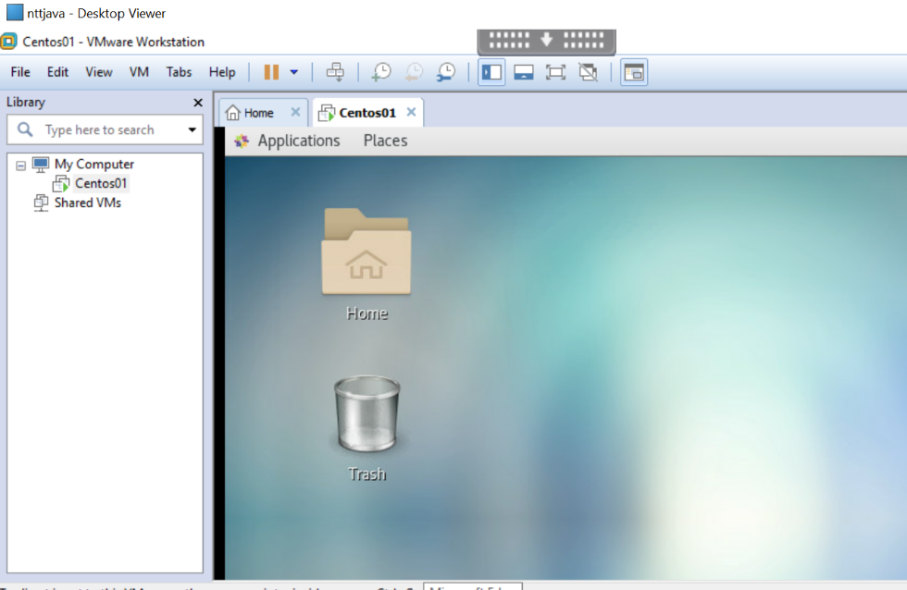

Installation of Centos(which is basically a linux distribution) in virtual machine is depicted in the above screenshot.

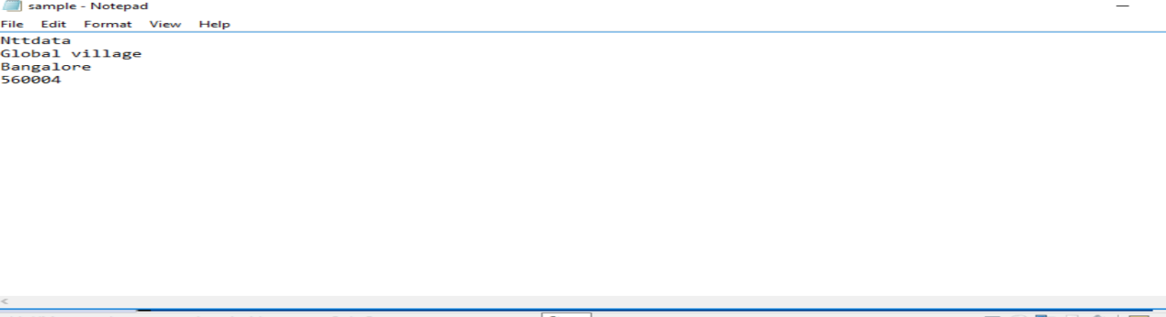

This is a text file which is created so that manipulations can be done this text file

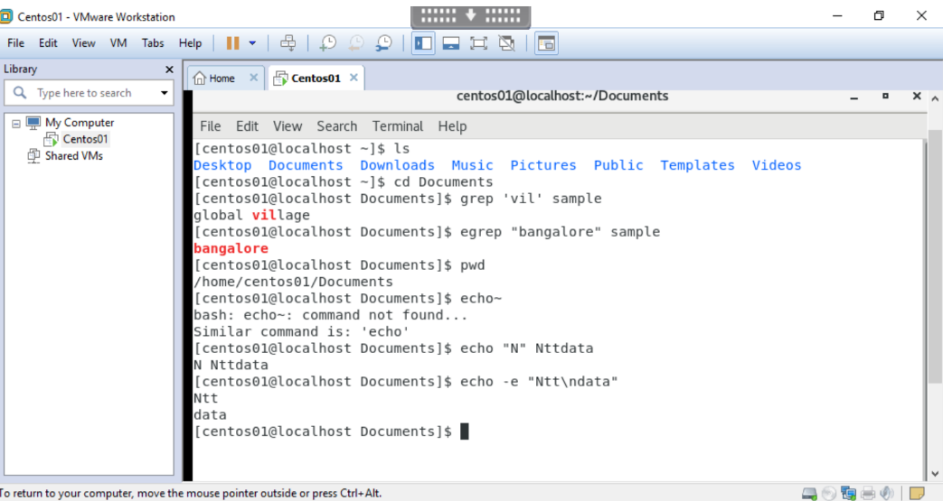

* Grep command is used to search a particular text in a file and tries to match the entered word in the command as you can see in the above snapshot. It results in the word contains the particular text entered.
* Egrep command belongs to the family of grep, used for pattern searching in linux. It scans the specific file line by line and prints the line that contains the search expression as depicted in the above snapshot.
* PWD command is used to print the current directory that you are working on
* Echo command is a built in command that is mostly used in shell scripts, it is used to display line of text or string that are passed as a argument.

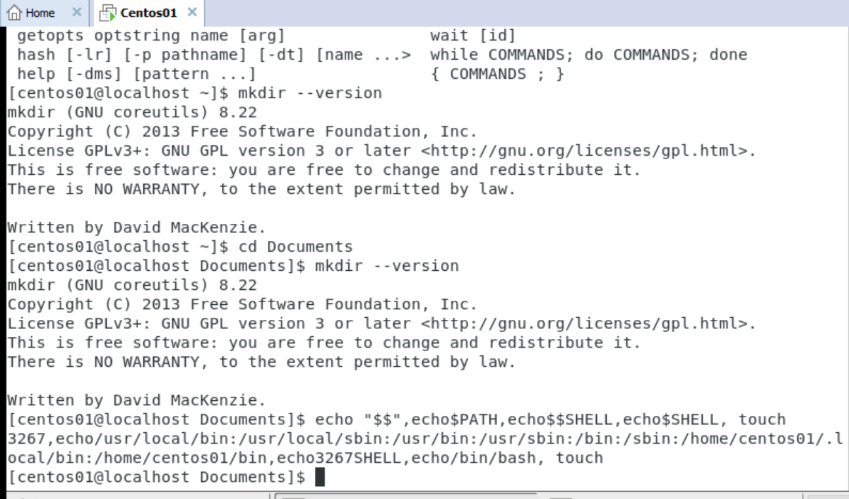

* Mkdir command in linux allows users to create directories. The snapshot contains --version which displays a brief info of that particular directory you are in ex: license and exits.
* Echo “$$” refers to the PID of the bash instance running in the script
* Echo $path here path is a environment variable which tells the shell which directories to search for executable files and in the above snapshot the path is being displayed.
* Echo $shell command tells us which shell would be executed when you log in
* Echo $$shell command refers to the PID of the current running shell script

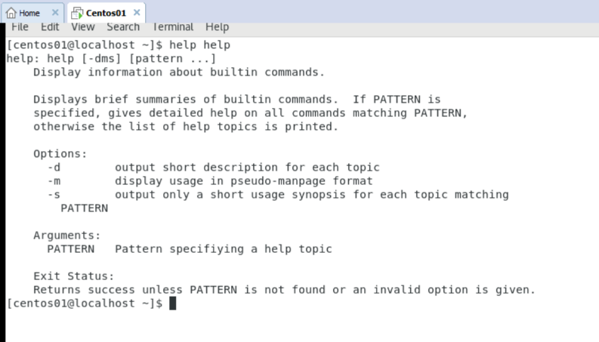

* Help command is used to display information about shell built in commands as shown in the above snapshot which displays the respective built in’s.

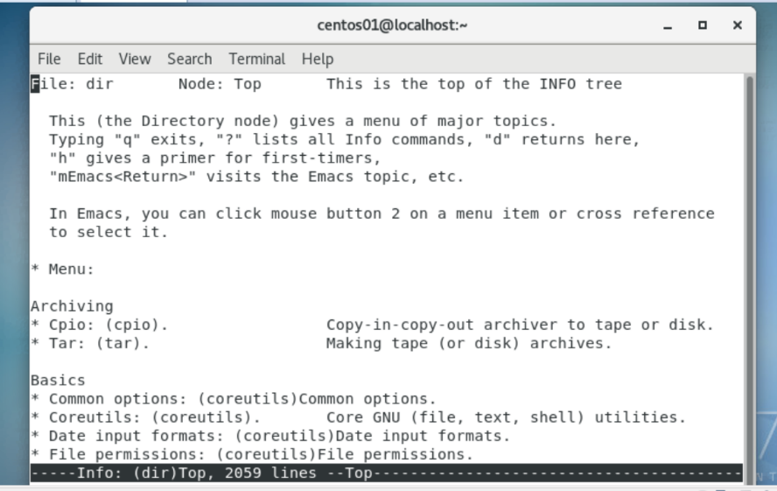

* Info command is used to display detailed information for a command when compared with man(system’s manual viewer) page.

* Chgrp command is used to change the group ownership of a file or directory as you can see in the above snapshot.

* Sudo command allows you to run the program with the security privileges of the superuser.

For any manipulations in the file permissions as well as user’s sudo command should be used.

* Useradd command allows us to add a new user in the existing group or different group
* Etc/passwd is used as it stored essential information of the user which will be required during login.

* Groupadd command is used to add a new group or create a new group. As depicted in the above sanapshot

* Userdel command is used to delete or remove any existing user
* Goupdel command is used to remove or delete an existing group

* Head command as the name implies prints the to ‘n’ number of data present in a file, by default it prints it prints first 10 lines of data of the specified file. As depicted in the above snapshot.
* Tail command is a complementary of head command

* More command is used to view the text file in the command prompt with any modifications in ‘read ‘format the +’n’ specifies the line from which data to be viewed.

* Less command is used to read contents of text file one page per time

* Cut command is used for cutting out the sections from each line of the file or files and writing the result to standard output.
* Paste command is used to combine or merge the data among various files in that particular directory here ‘sample’ and ‘os’ are the two files .

* Tr(short for translate) command is used for translating or deleting characters  It supports a range of transformations including uppercase to lowercase, squeezing repeating characters, deleting specific characters and basic find and replace.
* Sort command is used to sort the data present in the specified file and specified format

* Rsync command or remote synchronization is a software utility for Unix-Like systems that efficiently sync files and directories between two hosts or machines. One of them being the source or the local-host from which the files will be synced, the other one being the remote-host, on which synchronization will take place.
* Route command is used to show/manipulate the IP routing table. It is primarily used to setup static routes to specific host or networks via an interface.

* Netstat command is used to list out all the network (socket) connections on a system. It lists out all the tcp, udp socket connections and the unix socket connections.

* Nslookup command is used to display DNS details, such as the IP address of a particular computer, the MX records for a domain or the NS servers of a domain. nslookup can operate in two modes: interactive and non-interactive.

* $Path command it is used to print or display current directories /paths in search of executable files.
* Logname command is used to display the username of the current login user.
* Home command is used to return to your home directory from any other directory.
* Read command is used when t is required to read the inputs from the keyboard
* Reply command is used to print the input text entered.

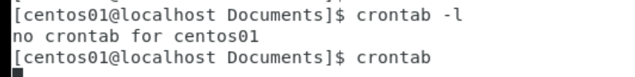

* Crontab command it opens up the cron table for editing; cron is basically a list of tasks scheduled to run at regular intervals on the system.

* Setfacl(setfile access control file) this command is used to set file access permissions for a user or file
* Getfacl(getfile access control file) this command is used to display the file access permissions of user or a file which is already set.

* Ip address command displays various information about the public ip address or the mac address with various other options as well as the pid’s.

* The ip route command is nothing but a path or way to the specific or range of destination IP addresses. Linux kernel maintains these routes called as kernel routing table and will route the traffic accordingly.

* Nslookup command is used for displaying the information of the entered domain.
* Hostname is used to obtain the DNS(Domain Name System) name and set the system's hostname or NIS(Network Information System) domain name. A hostname is a name which is given to a computer and it attached to the network. Its main purpose is to uniquely identify over a network