Automated Auction Bidder — Architecture Design

1. Overview
This document describes a serverless application that discovers auctions on an external Auction Platform and automatically submits bids according to configured pricing and negotiation rules. The design prioritizes independent auction processing, recoverability, controlled concurrency, and a straightforward Java deployment.
Scope: This application is a bidder, not the Auction Platform. The external platform owns auction listings, statuses, and bid evaluation.

2. Technology Stack
Component | Technology
Runtime | Java 17
Build tool | Maven
Scheduling | Amazon EventBridge Scheduler
Compute | AWS Lambda (two functions)
Messaging | Amazon SQS with dead-letter queue
Polling checkpoint | Amazon DynamoDB
Business database | Amazon RDS for MySQL
Database connections | Amazon RDS Proxy
Monitoring | Amazon CloudWatch
Credentials | AWS Secrets Manager

3. High-Level Architecture
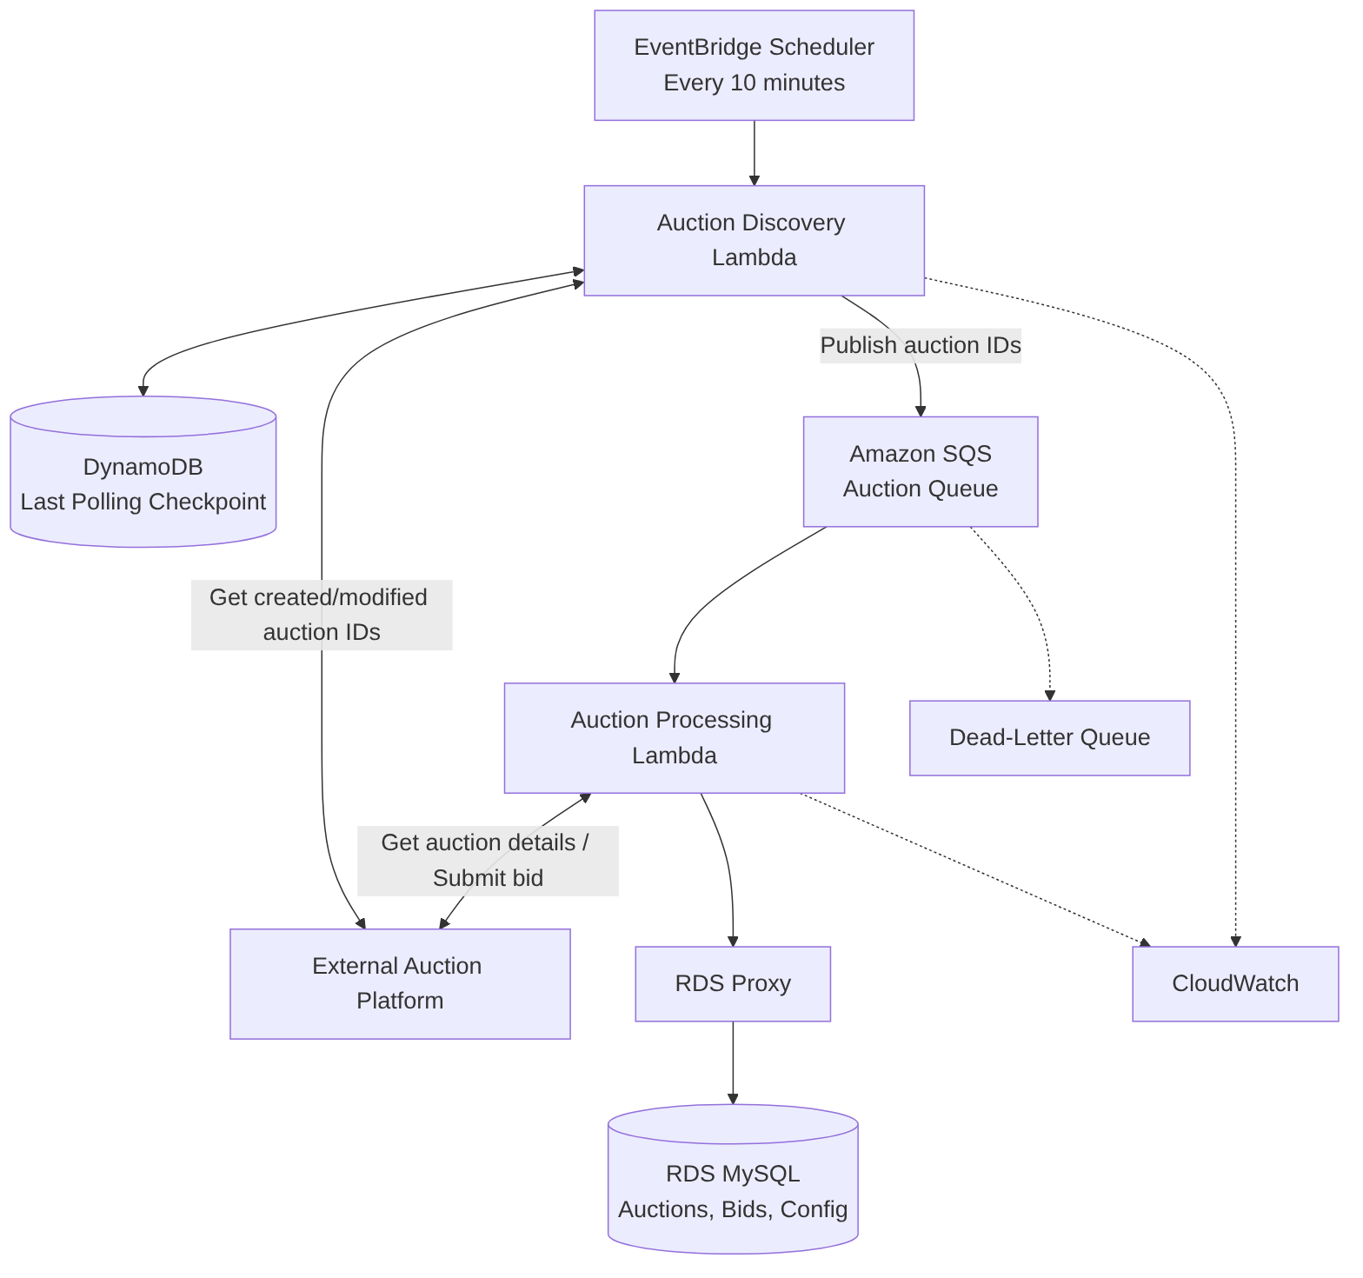

4. Processing Workflow
- Auction Discovery: Amazon EventBridge triggers the Discovery Lambda every 10 minutes. The Lambda retrieves the last successful polling timestamp from DynamoDB and calculates the polling window:
  - fromTime = Last successful polling timestamp
  - toTime = fromTime + 10 minutes
- The Lambda calls the Auction Platform REST API to retrieve auction IDs created or modified within this interval. The polling window follows [fromTime, toTime), including auctions modified at fromTime and excluding those modified exactly at toTime. The initial checkpoint is configured during application setup. The Discovery Lambda processes only completed polling windows and does not advance the checkpoint beyond the current safe polling time.
- Queue Auction IDs: The Discovery Lambda publishes the retrieved auction IDs to Amazon SQS. Once all IDs are successfully published, it updates the polling timestamp in DynamoDB with toTime. This becomes the fromTime for the next polling cycle.
- Retrieve Auction Details: Amazon SQS triggers the Processing Lambda with the auction IDs. The Lambda calls the external Auction Platform REST API to retrieve the latest auction details and status.
- Process Based on Auction Status:
  - OPEN: The Processing Lambda retrieves the existing bid history and bidding configuration from the DB. Before calculating a new bid, it checks for any PENDING bid and verifies its status using the Request ID. For a new auction, it calculates the initial bid and minimum threshold using the configured pricing rules. For an existing auction, if the platform minimum bid used for our previously submitted bid and the latest platform minimum bid are the same, no further bidding is required. If the values are different, it calculates the next bid by subtracting the configured reduction amount from the latest platform minimum bid. If the platform minimum bid is unavailable, it calculates the bid using PricingStrategy and checks for duplicate submissions. If the calculated bid meets the minimum threshold and maximum attempt limit, it records the bid as PENDING, submits it to the Auction Platform, and updates the bid status based on the response.
  - WON: Updates the auction status to WON in the DB and stops further bidding.
  - CLOSED: Updates the auction status to CLOSED in the DB and stops further bidding.
- Complete Processing: The Processing Lambda completes its execution after processing the auction. If the auction is created or modified again, its ID will be retrieved during a subsequent polling cycle and processed based on its latest status.

Example Negotiation
Configuration: Reduction amount = $10, minimum acceptable threshold = $1,100, maximum attempts = 11.
Attempt | Platform Minimum Bid | Our Calculated Bid | Submission Status | Auction Status
1 | $1,200 | $1,190 | SUBMITTED | OPEN
2 | $1,180 | $1,170 | SUBMITTED | OPEN
3 | $1,160 | $1,150 | SUBMITTED | WON
Each bid is submitted with a unique Request ID. SUBMITTED indicates that the Auction Platform acknowledged receiving the bid. The auction outcome is retrieved separately during a subsequent processing cycle. If the platform minimum bid remains unchanged, no additional bid is submitted.

5. Sequence Diagram

5.1 Auction Discovery
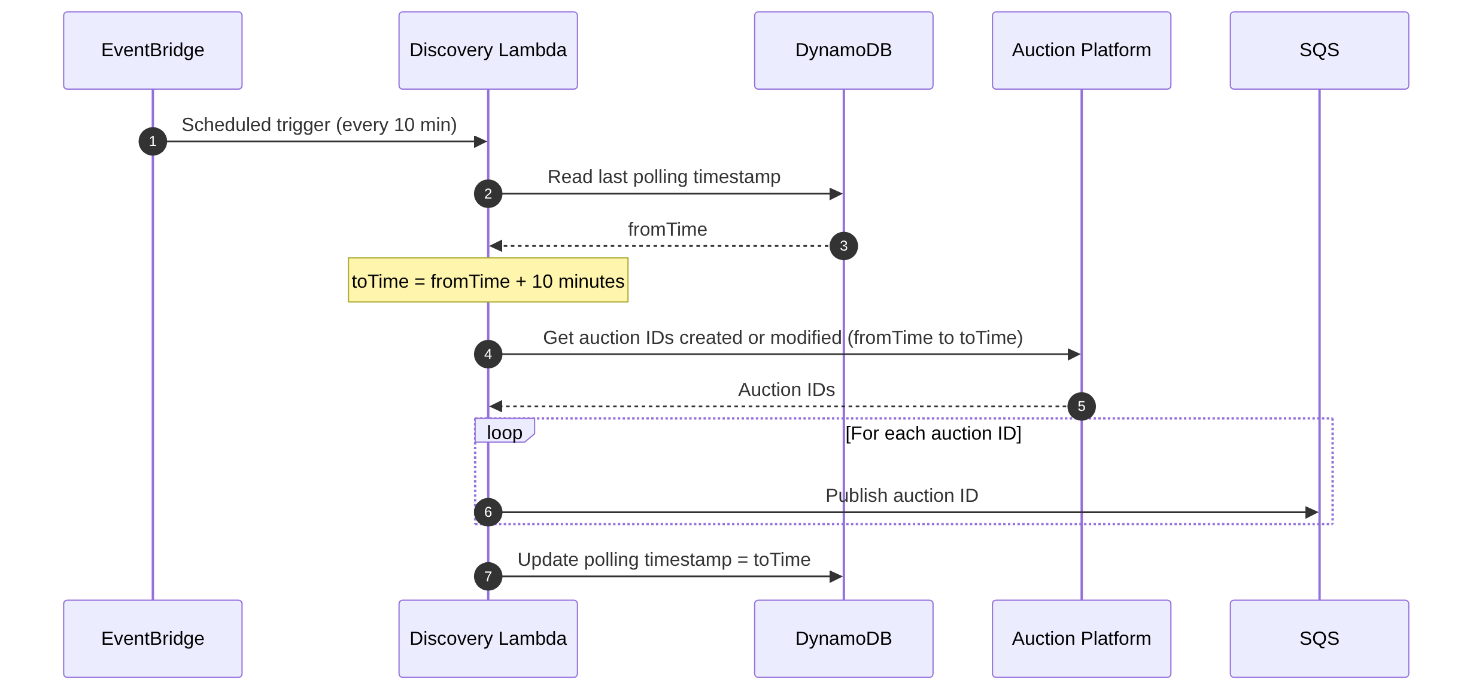

5.2 Auction Processing
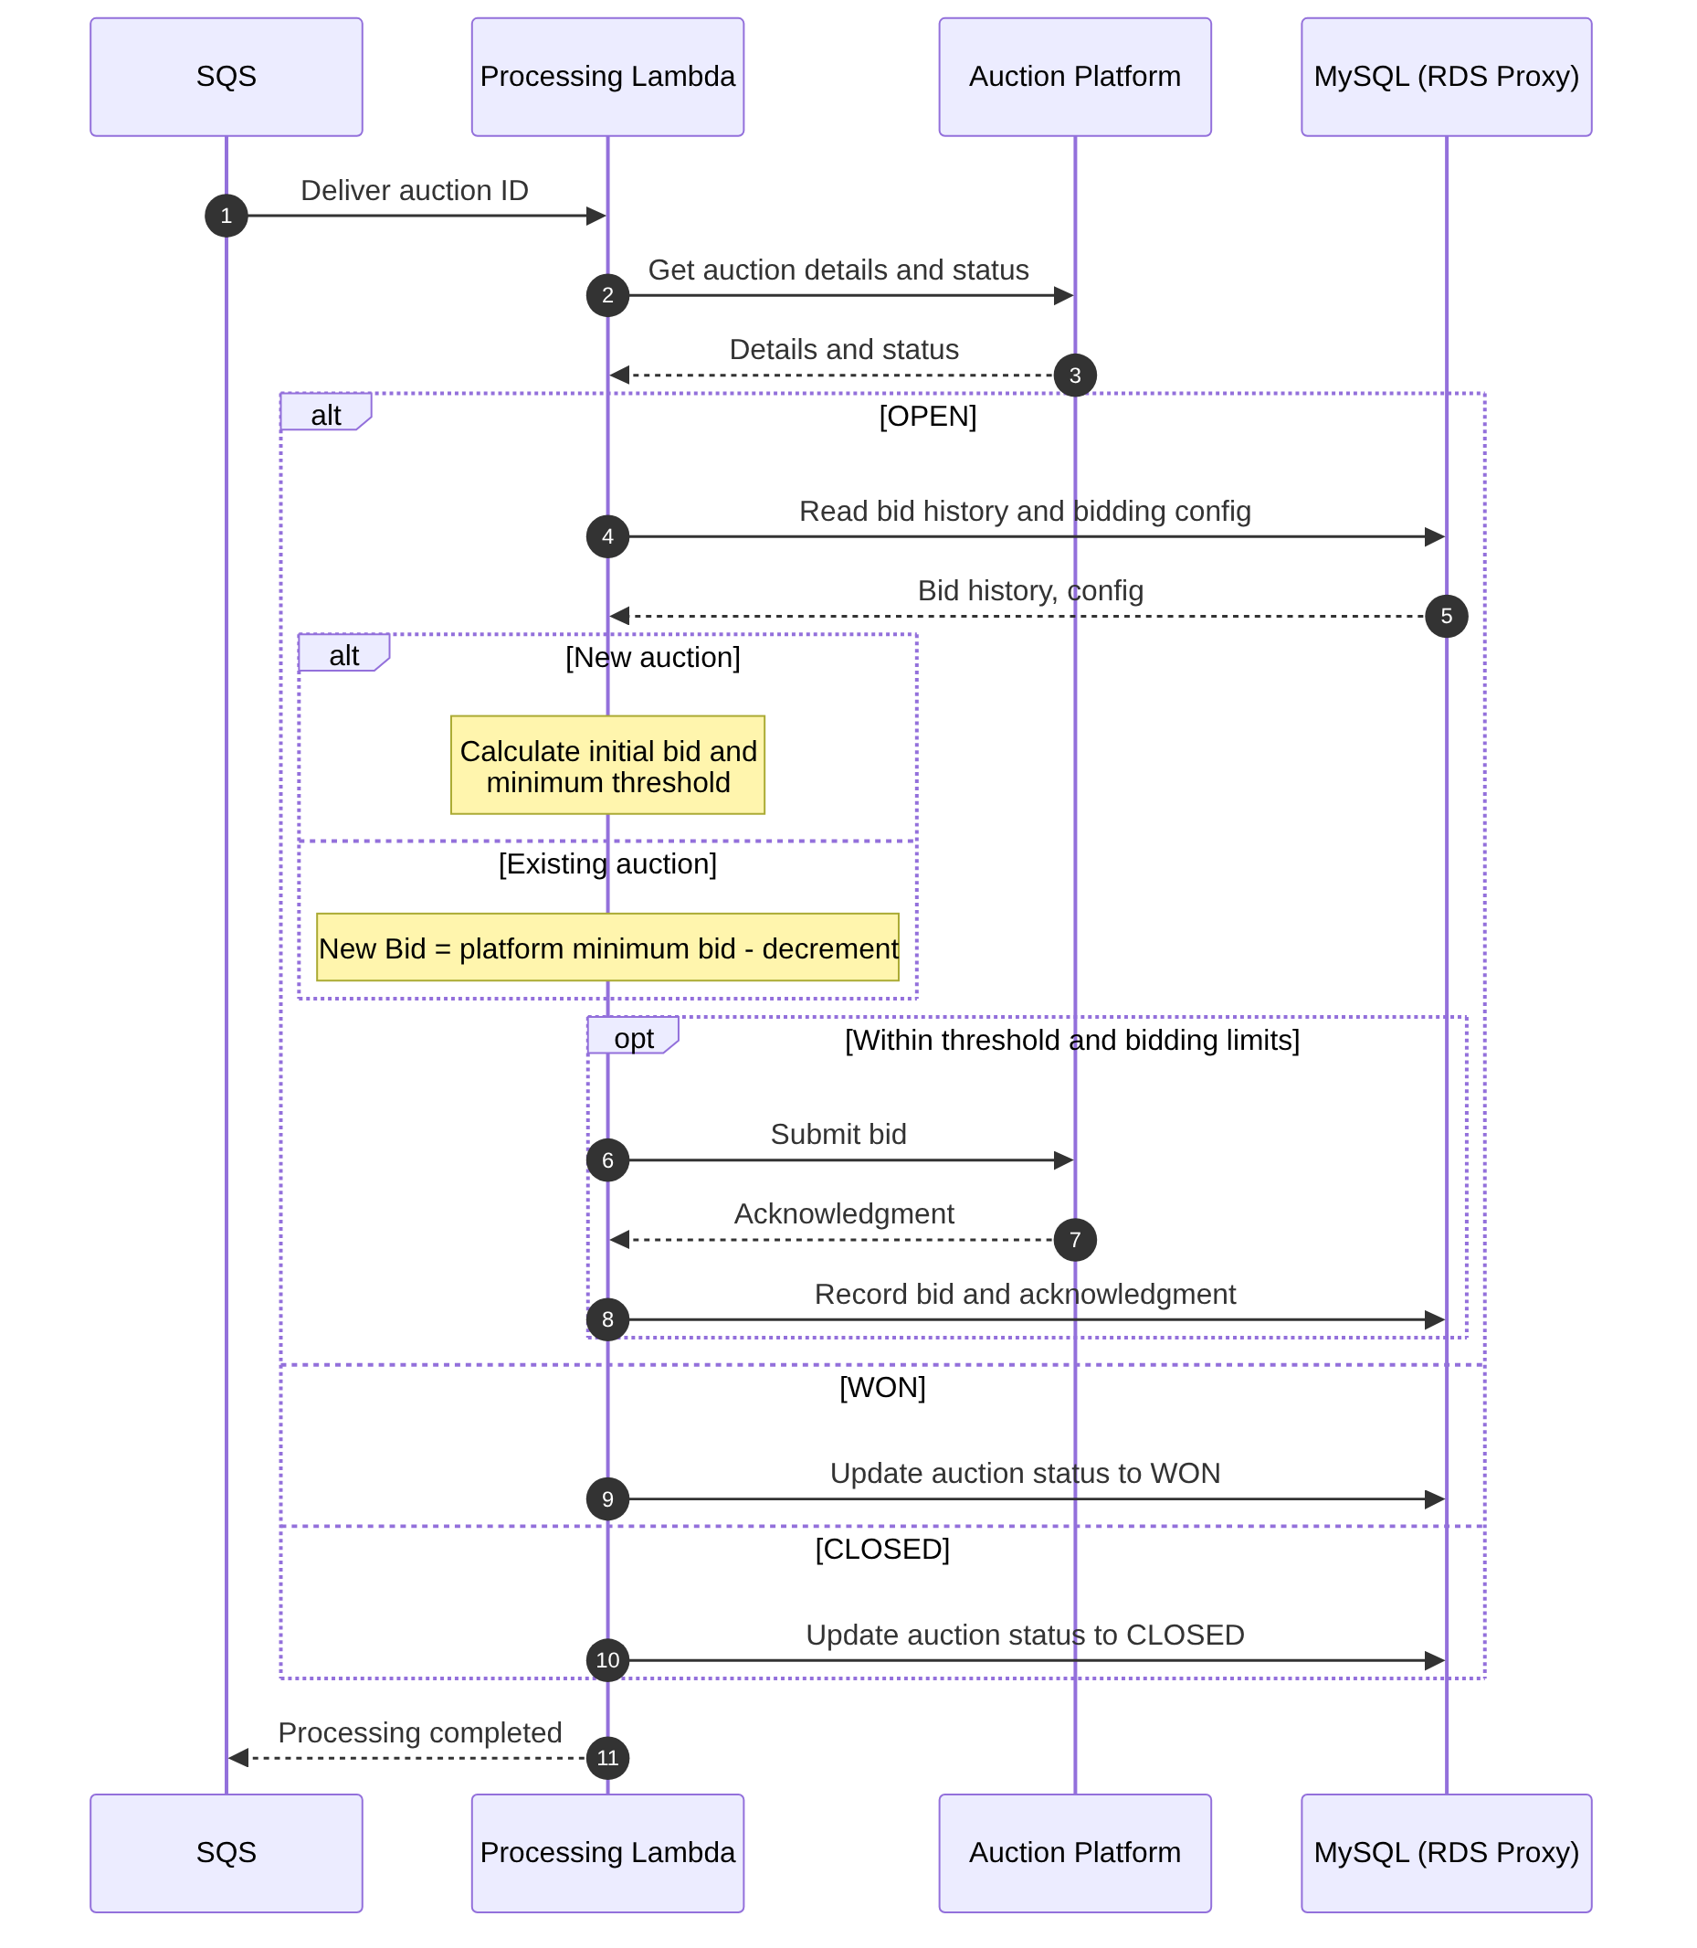

6. Logical Object Model
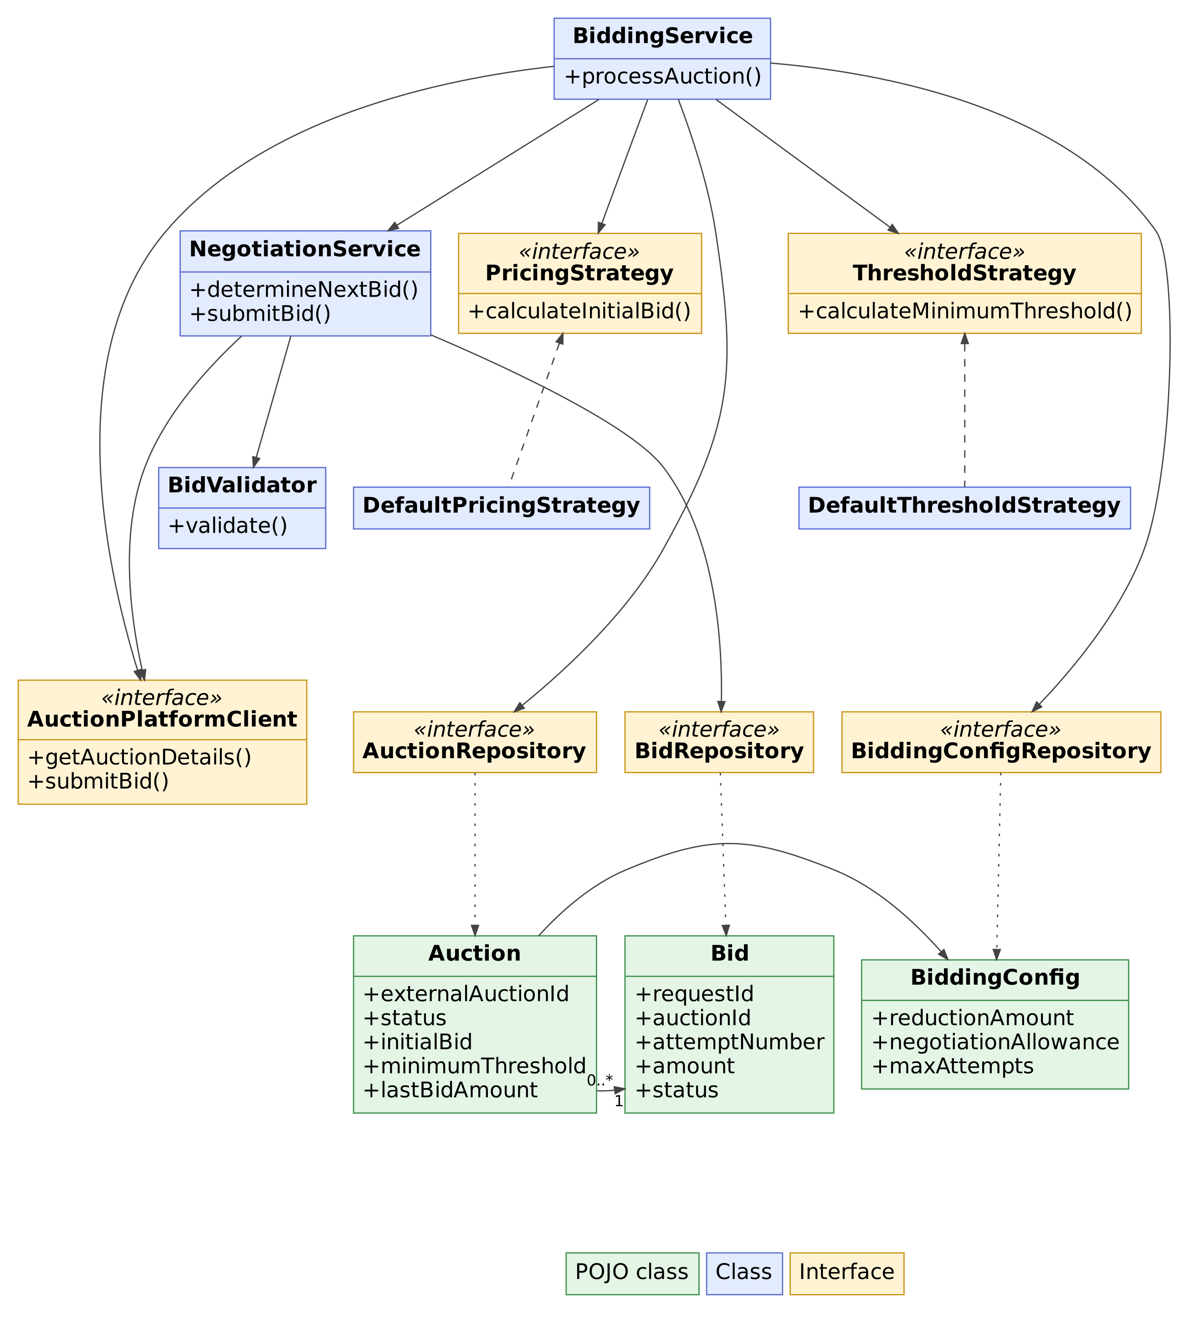
BiddingService coordinates the auction lifecycle. NegotiationService determines and submits one eligible bid per processing invocation, rather than running a continuous negotiation loop. Fixed implementations of the pricing and threshold strategies are used; no strategy factory is required.

Object Model – Class Responsibilities
1. POJO Classes
Class | Responsibility
Auction | POJO class that holds auction details, status, and bidding information.
Bid | POJO class that stores individual bid details, including amount and status.
BiddingConfig | POJO class that holds bidding configuration, such as decrement amount and maximum attempts.
2. Classes
Class | Responsibility
BiddingService | Coordinates the overall bidding process for an auction.
NegotiationService | Calculates the next eligible bid and manages bid submission.
DefaultPricingStrategy | Implements the logic for calculating the initial bid amount.
DefaultThresholdStrategy | Implements the logic for calculating the minimum acceptable bid amount.
BidValidator | Validates the bid against the minimum threshold and bidding limits.
3. Interfaces
Interface | Responsibility
PricingStrategy | Defines the contract for calculating the initial bid amount.
ThresholdStrategy | Defines the contract for calculating the minimum acceptable bid amount.
AuctionPlatformClient | Defines REST API operations for retrieving auction details, submitting bids, and retrieving bid submission details by Request ID.
AuctionRepository | Defines database operations for managing auction details.
BidRepository | Defines database operations for managing bid history.
BiddingConfigRepository | Defines database operations for retrieving bidding configuration.

7. Data Design
RDS MySQL stores the business records:
Table | Key information | Purpose
auctions | Auction ID, external ID, status, initial bid, minimum threshold, last bid, last platform minimum bid, timestamps | Current auction state
bids | Bid ID, auction ID, request ID, attempt number, amount, status, timestamp | Submission history and audit trail
bidding_config | Reduction amount, maximum attempts | Bidding rules
bidding_config
Column | Data type | Key / description
id | bigint | Primary key
reduction_amount | decimal | Amount reduced from the platform minimum bid
max_attempts | int | Maximum bid attempts
auctions
Column | Data type | Key / description
id | bigint | Primary key
external_auction_id | varchar | Unique key (auction ID on the Auction Platform)
config_id | bigint | Foreign key to bidding_config
status | varchar | Auction status
initial_bid | decimal | Initial bid amount
minimum_threshold | decimal | Minimum acceptable bid amount
last_bid_amount | decimal | Stores the most recent bid amount acknowledged by the Auction Platform. The value is updated only after the platform confirms successful receipt of the bid. Bids awaiting confirmation remain recorded in the bids table with status PENDING.
last_platform_minimum_bid | decimal | Platform minimum bid used for the last acknowledged submission
bids
Column | Data type | Key / description
id | bigint | Primary key
auction_id | bigint | Foreign key to auctions
request_id | varchar | Unique key (request ID sent with the bid)
attempt_number | int | Bid attempt number
amount | decimal | Bid amount
status | varchar | Bid status (see section 8)
Constraint: UNIQUE (auction_id, attempt_number)
DynamoDB holds a polling_checkpoint record with the discovery job ID and last successfully completed polling timestamp.

8. Reliability and Error Handling
- Duplicate Messages: SQS may deliver the same auction ID multiple times. The Processing Lambda checks existing bid history, including PENDING bids, before creating a new attempt. Database transactions, row-level locking, and unique constraints help prevent duplicate bid submissions. Database locks are released before calling the Auction Platform.
- Controlled Retries: Temporary failures, such as API unavailability or network errors, are handled through SQS retries. If processing continues to fail beyond the configured retry limit, the message is moved to the Dead Letter Queue (DLQ) for investigation and reprocessing.
- Polling Consistency: The Discovery Lambda updates the DynamoDB checkpoint only after all auction IDs are successfully published to SQS. If publishing fails, the checkpoint remains unchanged, allowing the same polling window to be retried. Conditional checkpoint updates prevent overlapping executions from overwriting a newer checkpoint.
- Safe Bid Submissions: Each bid attempt is assigned a unique Request ID, which is stored in the DB and sent to the Auction Platform. If the API times out, the Processing Lambda uses the same Request ID to verify whether the bid was received before retrying, avoiding duplicate submissions.
- State Consistency: Before submitting a bid, the Processing Lambda records the attempt in the DB with status PENDING. Based on the Auction Platform response, the status is updated to SUBMITTED or REJECTED. If the submission result is uncertain or the DB update fails, the Lambda verifies the previous submission using the Request ID during retry processing.
Bid Status | Description
PENDING | Bid attempt recorded in the DB, but successful submission is not yet confirmed.
SUBMITTED | Auction Platform acknowledged receiving the bid; final auction outcome is not yet confirmed.
REJECTED | Auction Platform explicitly rejected the bid submission due to business validation or platform rules.
- Business Rules: The Processing Lambda validates each bid against the calculated minimum threshold, configured decrement amount, and maximum attempt limit. Auctions marked WON or CLOSED are treated as terminal states, preventing further bidding.

9. Performance and Scalability
- Discovery retrieves IDs only, reducing data transfer and keeping the scheduled Lambda lightweight.
- SQS buffers auction IDs and allows multiple Processing Lambda invocations to run concurrently.
- Lambda concurrency is limited to protect the external Auction Platform and MySQL from overload.
- RDS Proxy helps manage MySQL connections from concurrent Lambda executions.
- Each Processing Lambda handles one auction decision and at most one bid submission, avoiding long-running negotiations and the Lambda 15-minute execution limit.
- The 10-minute discovery interval creates a trade-off between API usage and responsiveness.
Caching is intentionally excluded from the initial design.

10. Security, Monitoring and Deployment
- Deploy both Lambda functions using Java 17 and Maven, without Spring Boot.
- Use least-privilege IAM roles, Secrets Manager for credentials, and HTTPS for external API calls.
- Keep RDS in private subnets; provide required VPC connectivity and outbound access for the Lambda functions.
- Use CloudWatch logs, metrics, and alarms for Lambda errors, duration, SQS backlog, DLQ messages, and external API failures.
- Deploy infrastructure across suitable Availability Zones for production resilience.

11. Observability
- Centralized Logging: Use Amazon CloudWatch Logs to capture Discovery Lambda and Processing Lambda execution logs, including auction IDs, request IDs, and error details.
- Monitoring: Use CloudWatch Metrics to monitor Lambda failures, execution duration, external API errors, and SQS queue depth.
- Alerting: Configure CloudWatch Alarms to detect repeated Lambda failures, increasing SQS queue depth, or messages arriving in the DLQ.
- Notifications: Integrate CloudWatch Alarms with Amazon SNS to notify the support team when failures occur.

12. Design Decisions and Trade-offs
Decision | Benefit | Trade-off
Two Lambda functions | Clear separation between discovery and processing | Coordination through SQS
Incremental ID discovery | Less data fetched on each poll | Depends on the platform's modified-ID API
DynamoDB checkpoint | Simple, durable polling state | Additional data service
SQS | Decoupling, buffering, and retries | Duplicate deliveries require idempotency
One bid per invocation | Short execution and no long-running waiting | Subsequent bids depend on future discovery cycles
RDS MySQL | Relational auction and bid history | Connection and capacity management
Fixed pricing/threshold strategies | Simple, maintainable object model | New calculation models require code changes

13. Assumptions and Scope
- The Auction Platform exposes an API to retrieve auction IDs created or modified in a time window.
- The Auction Platform exposes auction details and a current status such as OPEN, WON, or CLOSED.
- OPEN means the auction remains eligible for bidding under our configured business rules; it does not by itself authorize duplicate submissions for the same opportunity.
- Bid submissions may return an acknowledgment rather than an immediate final result.
- Request ID Support: The Auction Platform supports receiving a unique client-generated Request ID with each bid submission and provides an API to retrieve the submission details using that Request ID. This allows the application to verify previous submissions after API timeouts and reconcile bid status without creating duplicate requests. Idempotent submission using the same Request ID is preferred for safe retries.
- Minimum Bid Amount: The Auction Platform may provide the current minimum bid amount with the auction details. When it does, the application compares it with the platform minimum bid stored for the previous acknowledged submission to avoid unnecessary bids.
- Auction hosting, winner selection, and the external platform's internal status logic are outside this application's scope.

Architecture: EventBridge → Discovery Lambda → SQS → Processing Lambda → Auction Platform / RDS MySQL, with DynamoDB for the polling checkpoint.

