County Search Service – Backend Coding Exercise
This document contains screenshots demonstrating:
- Project structure
- Swagger API functionality
- Search scenarios
- Validation behavior
- Successful test execution
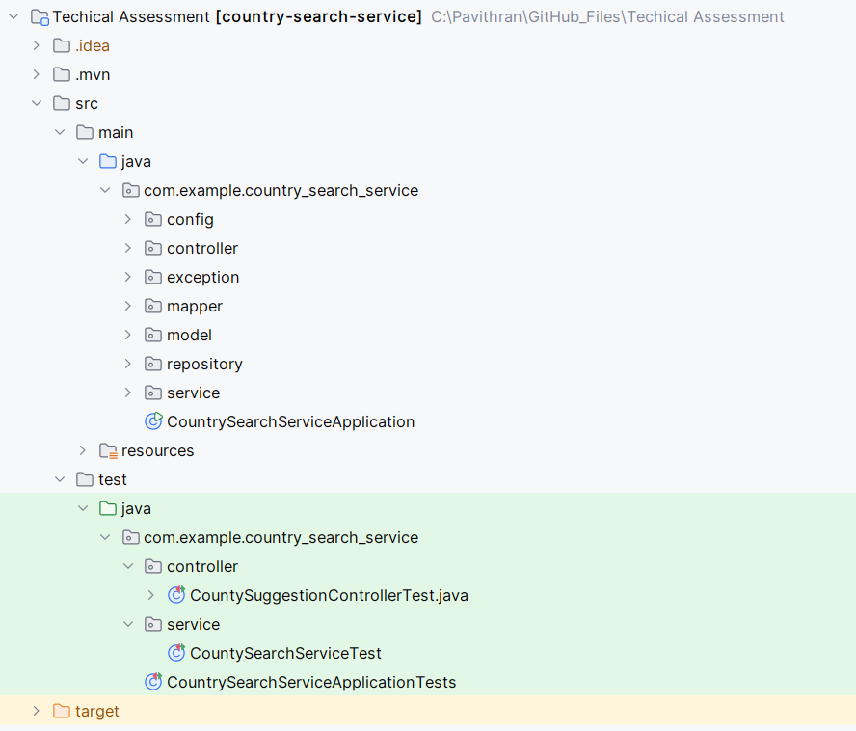
Project Structure
This screenshot shows the overall project structure following a layered Spring Boot architecture.
The application is organized into controller, service, repository, entity, mapper, exception, and configuration packages to ensure clear separation of concerns, maintainability, and testability.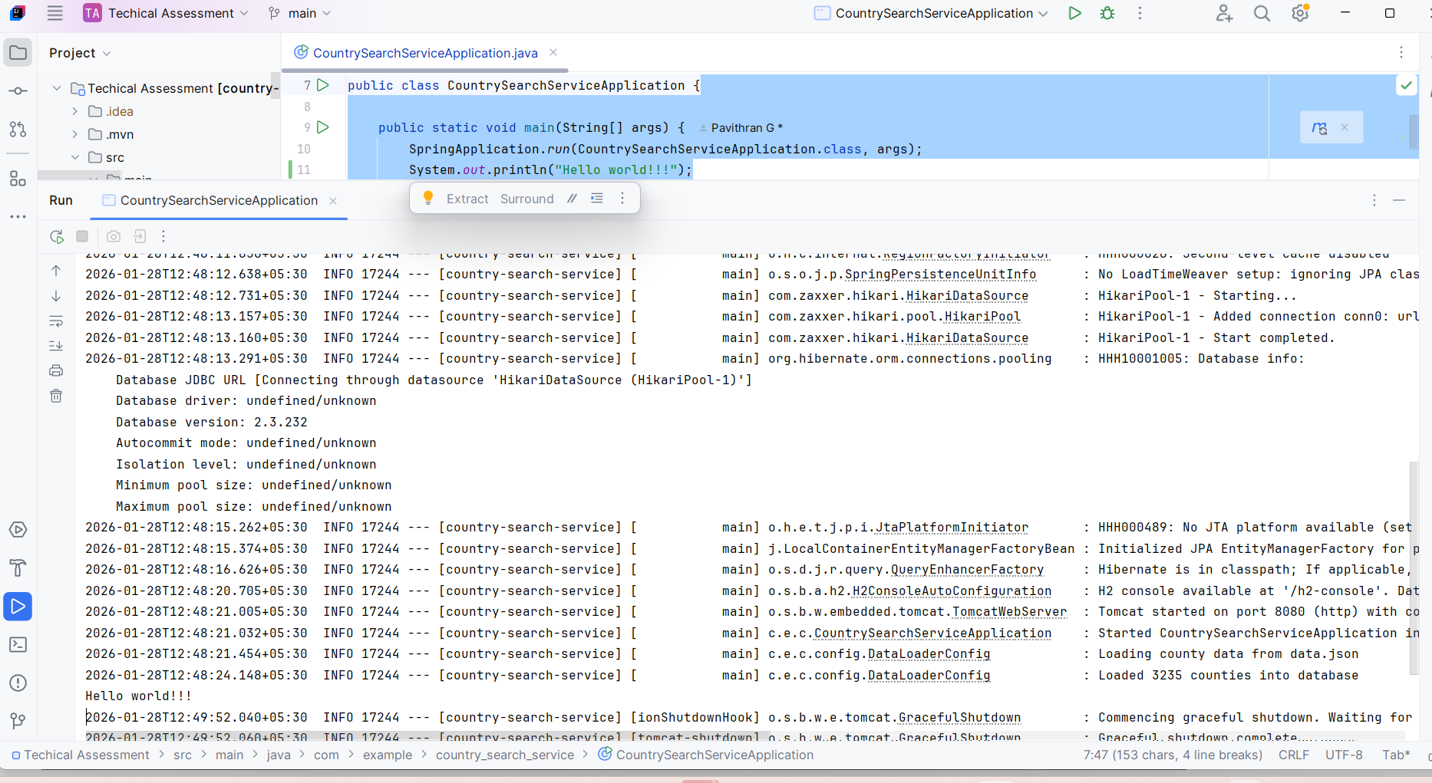
- Application Startup
This screenshot confirms that the Spring Boot application starts successfully without errors.
All required components, including database initialization, data loading, and API configuration, are completed during application startup.
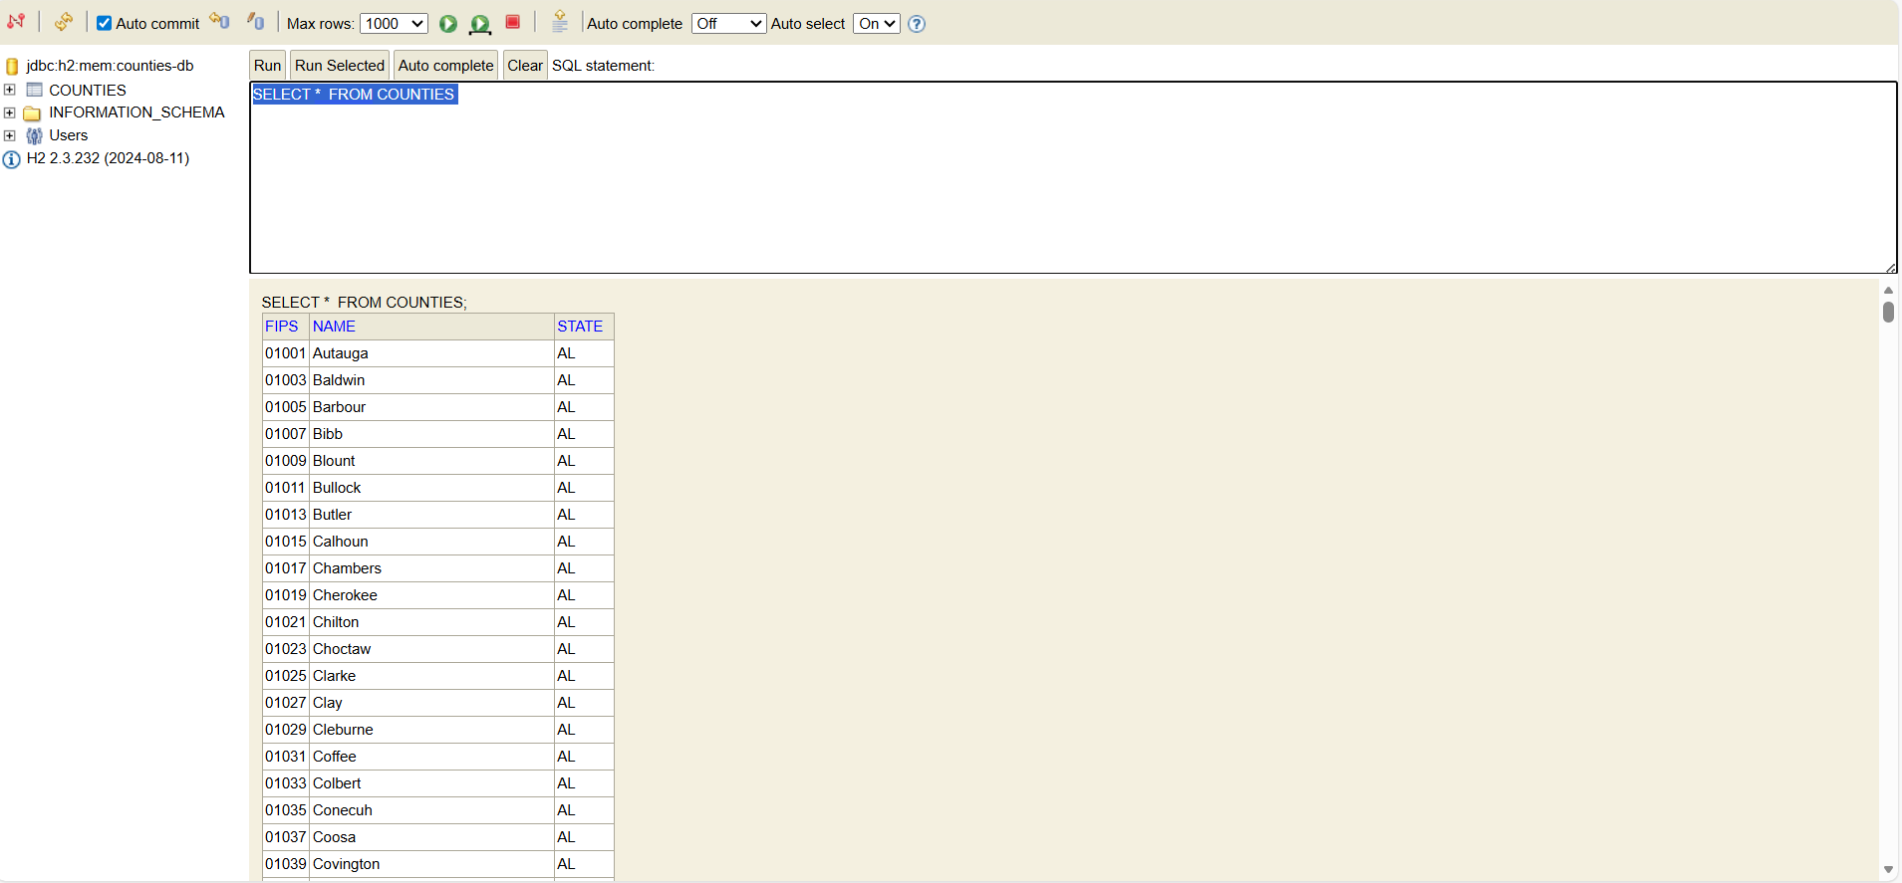
H2 Database with Preloaded Data
This screenshot shows the in-memory H2 database console containing county data loaded from the provided data.json file.
The data is loaded during application startup and stored in the database, enabling fast and efficient search operations without reading from the file at runtime.
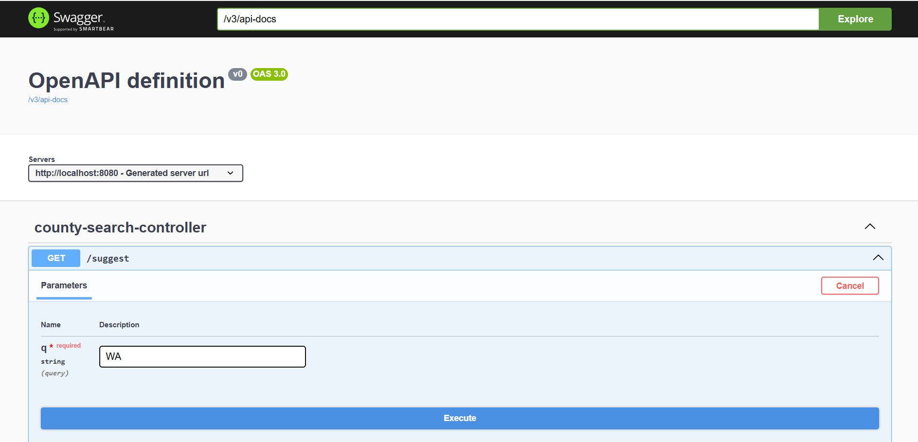
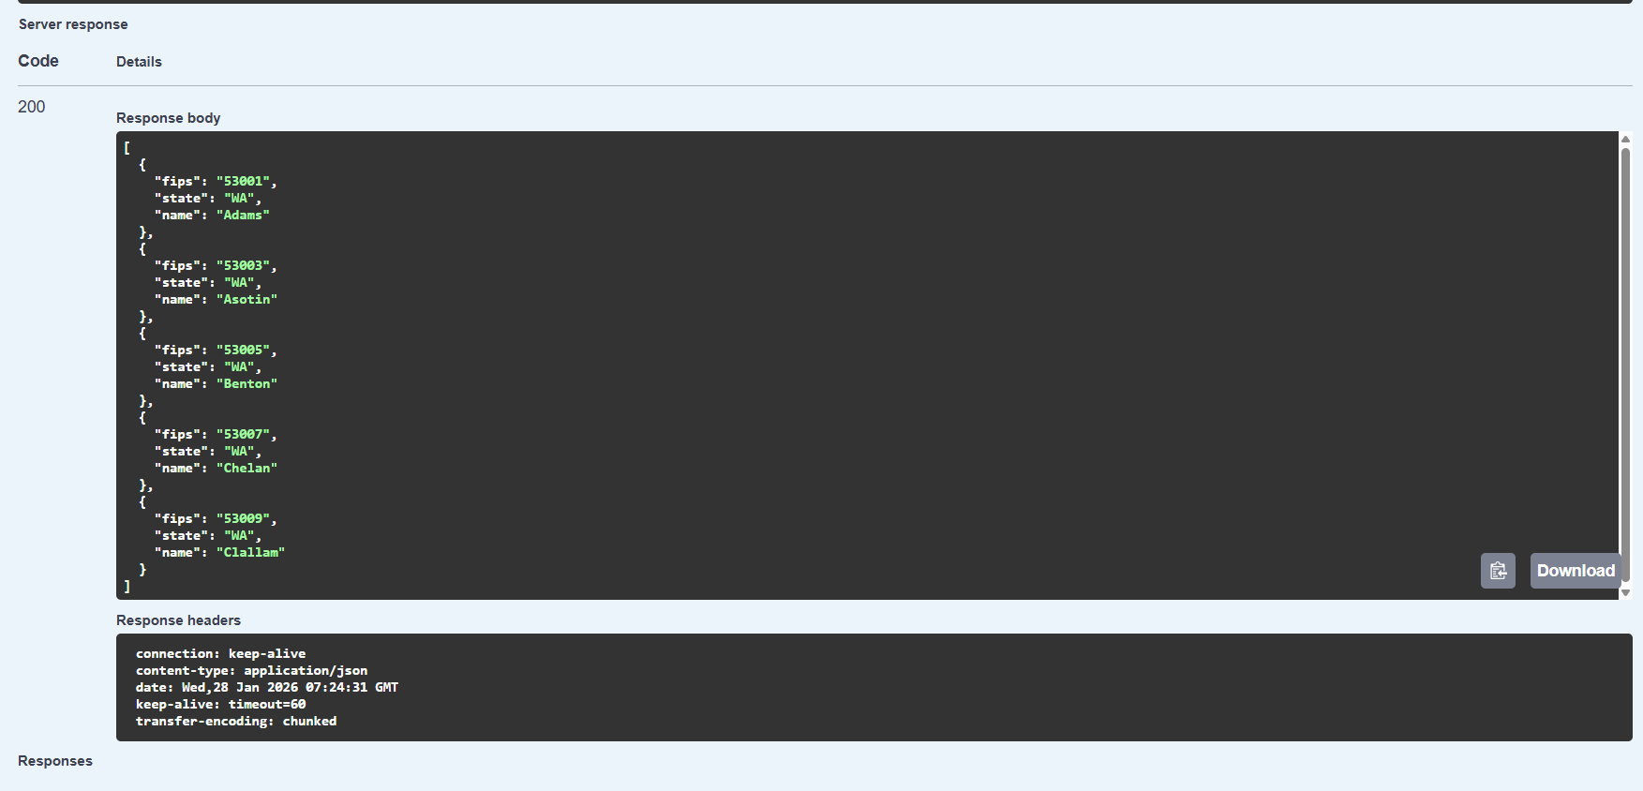
State-Based Search (q=WA)
- This screenshot demonstrates a state-only search performed using the Swagger UI.
When the query parameter length is two characters, the application treats it as a state code and returns a list of matching counties ordered alphabetically, as expected.
- 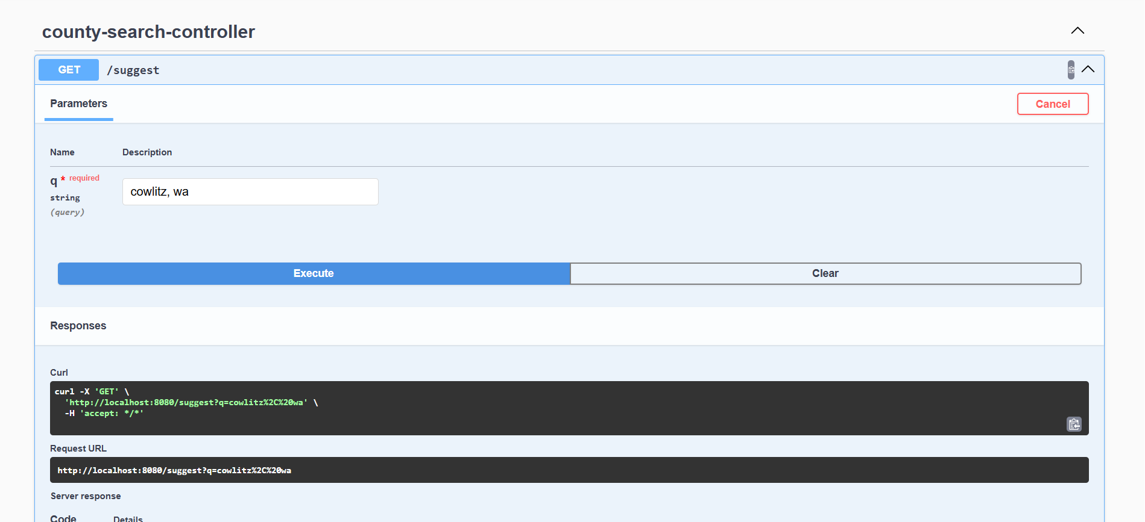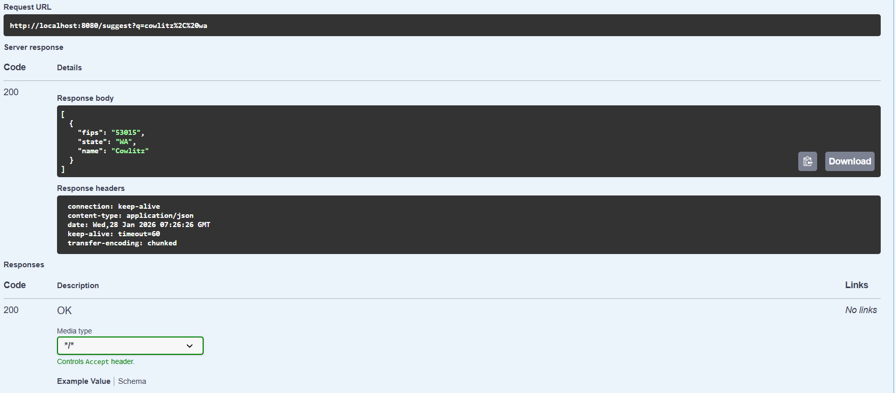
County Name and State Search (q=cowlitz, wa)
This screenshot shows a combined county name and state search.
The query is parsed to extract both county name and state, and the application returns the exact matching county, demonstrating correct handling of structured search input.

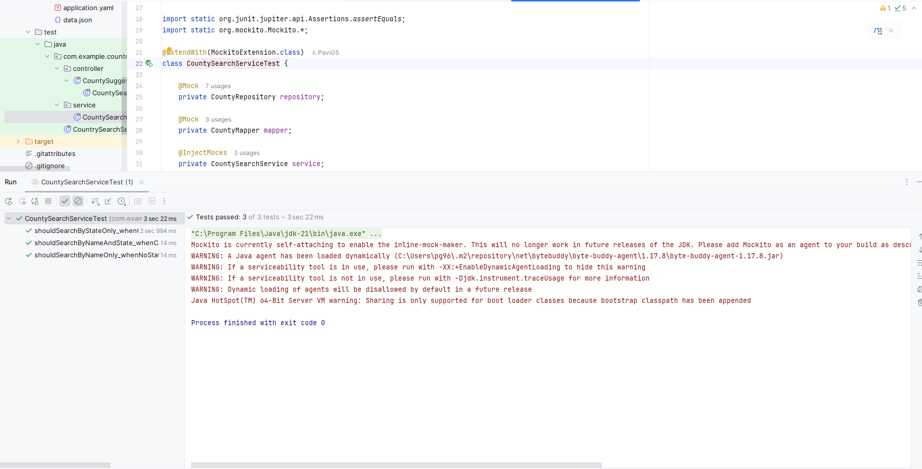
Test Execution Results
This screenshot confirms the successful execution of all unit and controller tests.
The tests validate the business logic, API behavior, and error handling, ensuring the application behaves correctly under different search scenarios.
✅ Summary
These screenshots collectively demonstrate the complete workflow of the application, including startup, data loading, API functionality, validation logic, and automated testing, reflecting a production-ready backend implementation.

