TELCO CUSTOMER CHURN
INTELLIGENCE DASHBOARD
PROJECT REPORT
Data Analytics • Predictive Analytics • Business Intelligence

Field | Details
Student Name | Pavithra N
Email | pavithranh22@gmail.com
Internship | IBM SkillsBuild / FutureTech by BharatCares
Project | Telco Customer Churn Intelligence Dashboard
Academic Year: 2026

1. Project Introduction

1.1 Project Title
Telco Customer Churn Intelligence Dashboard

1.2 Problem Statement
Telecommunication companies depend on a stable customer base and recurring service revenue. When customers discontinue their services, the organization loses future revenue and may need additional customer-acquisition effort. This project converts customer-level telecom data into descriptive insights, churn-driver analysis, churn probabilities, risk tiers and practical retention actions.

1.3 Project Objectives
- Clean and prepare the telecom customer dataset for reliable analysis.
- Measure the main customer and churn KPIs.
- Identify customer attributes associated with higher or lower churn.
- Develop a Logistic Regression model for churn-probability estimation.
- Classify customers into Low, Medium and High operational risk tiers.
- Build an interactive Streamlit dashboard.
- Translate analytical findings into practical customer-retention actions.

1.4 Project Overview
The application follows a complete analytics workflow: raw telecom data is cleaned and prepared, key performance indicators are calculated, churn patterns are analyzed, a Logistic Regression model estimates churn probability, and customers are grouped into operational risk tiers. The final Streamlit interface presents four decision-oriented views: Executive Overview, Churn Drivers, Customer Risk & Model, and Risk • Opportunity • Action.

1.5 Overall Project Workflow
The project moves from data preparation to descriptive analysis, predictive analytics, risk prioritization and business action.
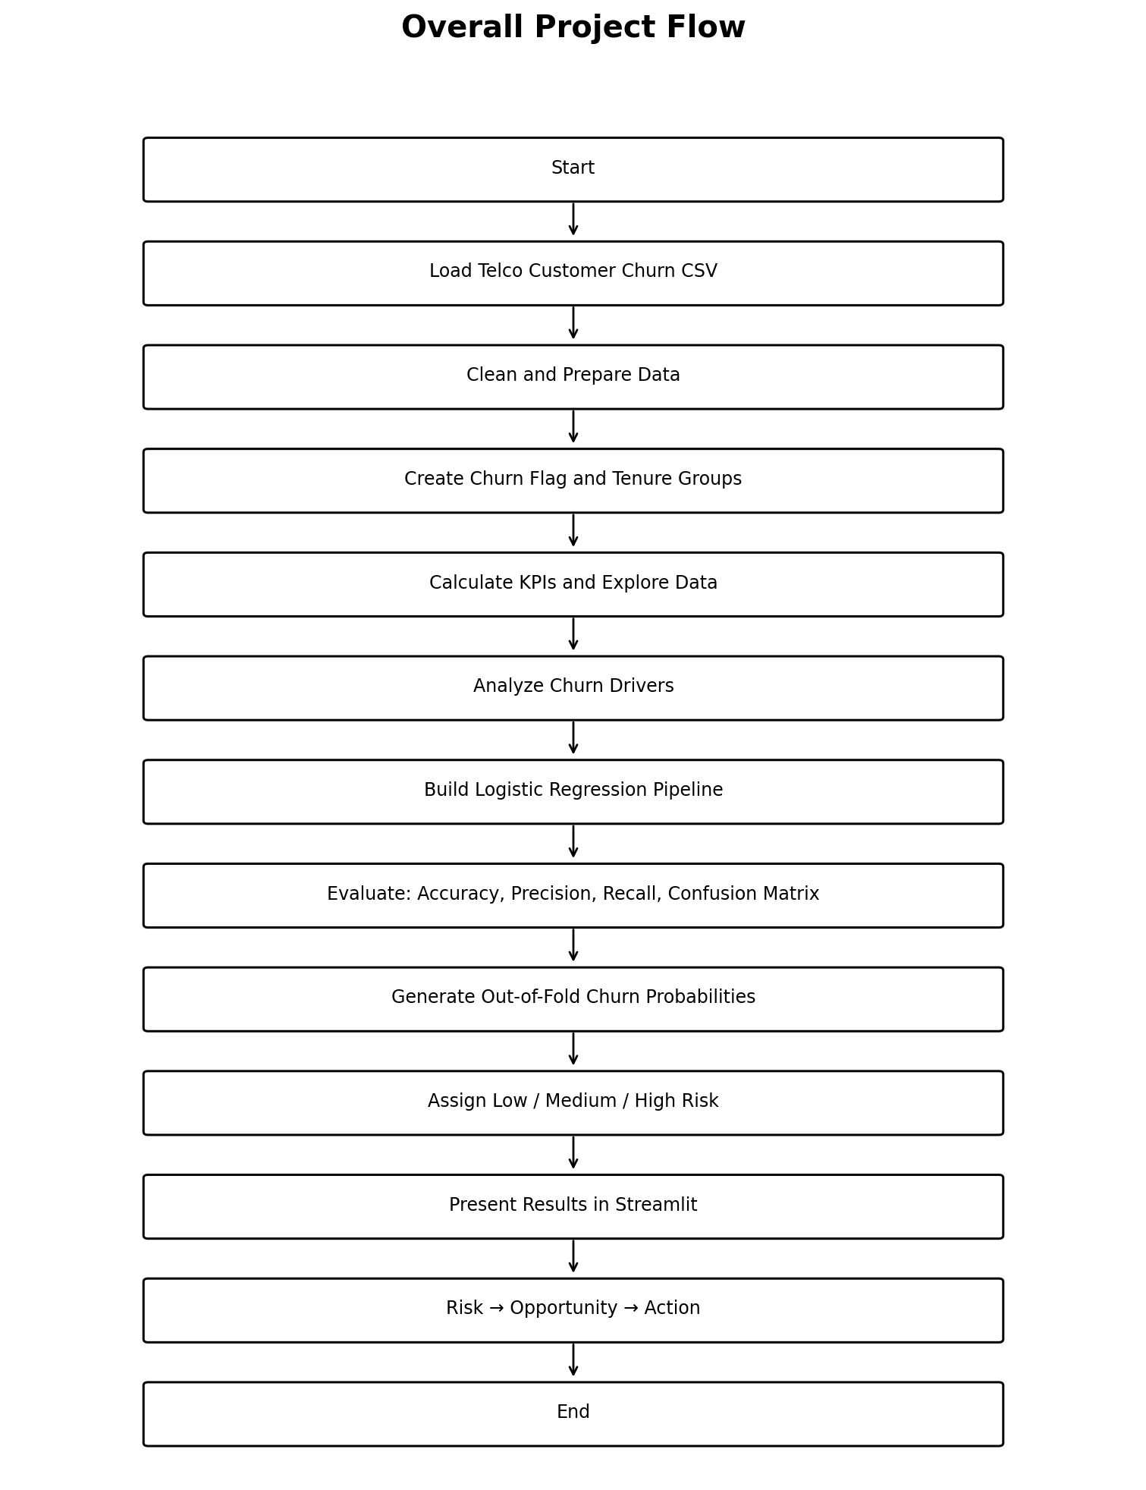
Figure 1.1: Project workflow
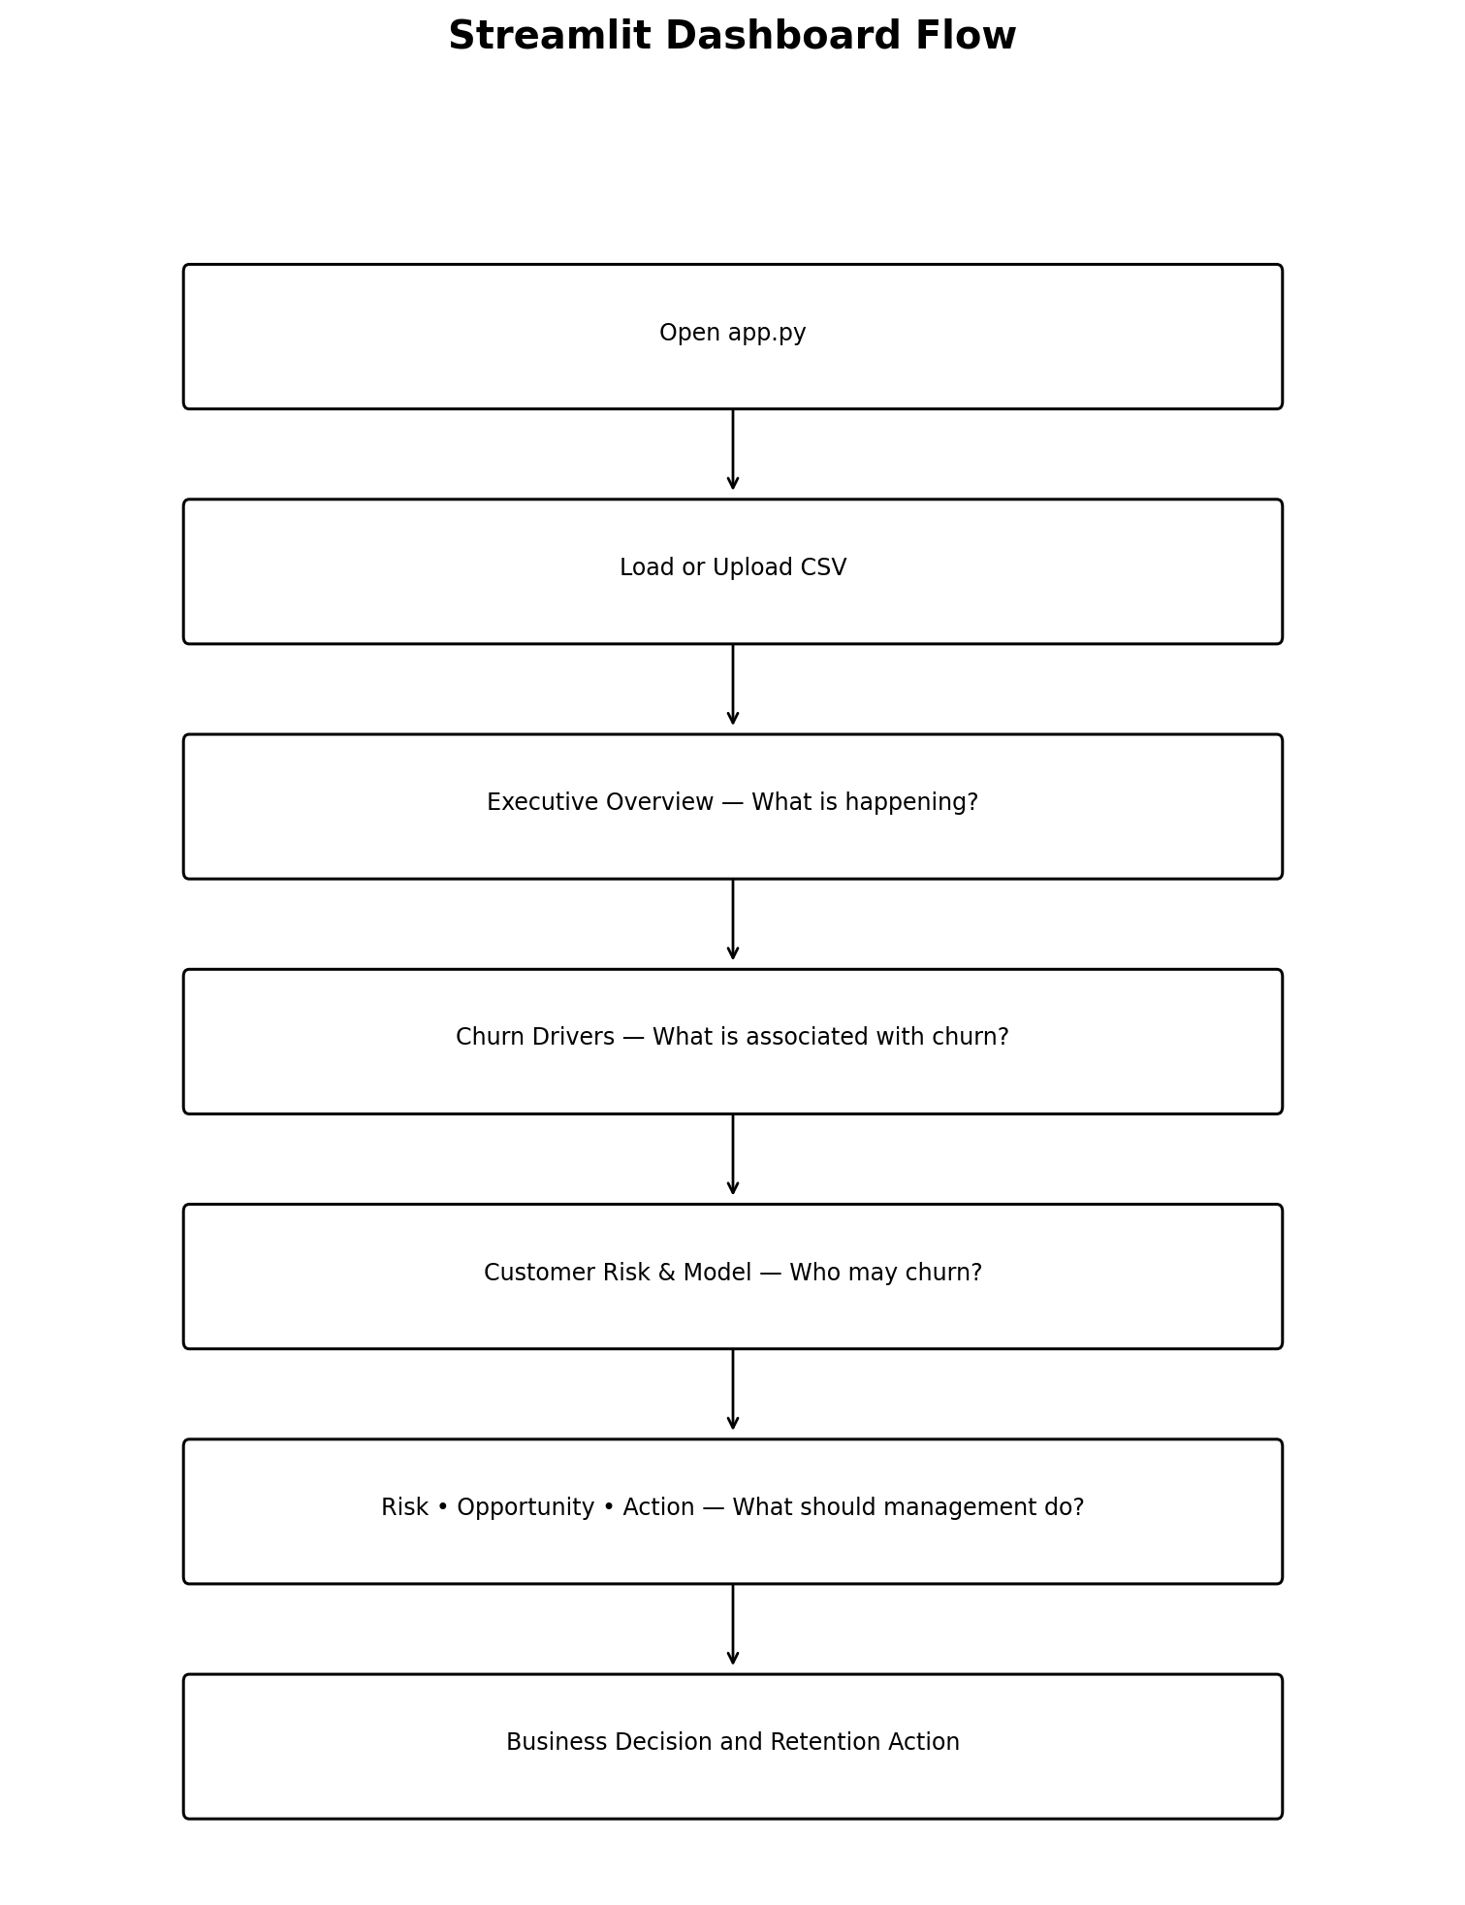
Figure 1.2: Dashboard decision workflow

2. Dataset

2.1 Dataset Description
The project uses the IBM sample Telco Customer Churn dataset. It contains customer-level information covering demographics, account characteristics, subscribed services, billing information, tenure and churn status. The application expects the CSV file named WA_Fn-UseC_-Telco-Customer-Churn.csv.
Dataset Item | Details
Records | 7,043 customers
Columns | 21
Target variable | Churn (Yes/No)
CSV filename | WA_Fn-UseC_-Telco-Customer-Churn.csv
Source | Kaggle – IBM Telco Customer Churn sample

2.2 Number of Records and Columns
The dataset contains 7,043 customer records and 21 columns. Each record represents one customer.

2.3 Target Variable
The target variable is Churn with values Yes and No. The application creates ChurnFlag as a numerical representation for model training.

2.4 Important Numerical Features
- tenure – duration of the customer's relationship with the company.
- MonthlyCharges – monthly amount charged to the customer.
- TotalCharges – total charges associated with the customer.

2.5 Important Categorical Features
- Contract
- InternetService
- PaymentMethod
- TechSupport
- OnlineSecurity
- Partner and Dependents
- SeniorCitizen and other customer/account attributes

2.6 Dataset Preparation
- Load the CSV using pandas.
- Standardize/strip column names and remove duplicate customer IDs.
- Convert TotalCharges to numeric format.
- Handle blank TotalCharges values using available MonthlyCharges and tenure information.
- Create ChurnFlag and tenure groups.
- Exclude customerID and churn-derived fields from model features to prevent target leakage.

3. Technologies Used
Technology | Version / Role | Purpose
Python | Programming language | Application logic and analytics
Streamlit | 1.39.0 | Interactive dashboard
Pandas | 2.2.3 | Data loading and processing
NumPy | 1.26.4 | Numerical operations
Scikit-learn | 1.5.2 | Preprocessing, Logistic Regression and evaluation
Plotly | 5.24.1 | Interactive visualizations
Git / GitHub | Version control | Source management and submission

3.1 requirements.txt
The requirements.txt file records the Python dependencies required to reproduce the application environment: Streamlit 1.39.0, pandas 2.2.3, NumPy 1.26.4, scikit-learn 1.5.2 and Plotly 5.24.1.

4. app.py – Complete Implementation
The app.py file contains the main implementation for data loading, cleaning, analysis, predictive modeling, customer risk scoring and the Streamlit interface.

4.1 Application Configuration
The application defines the expected dataset filename and operational risk thresholds.

4.2 Data Loading
The application loads the expected CSV with pandas and supports CSV upload through the Streamlit sidebar.

4.3 Data Cleaning
The application prepares columns, removes duplicate customer IDs, converts TotalCharges to numeric form and handles blank values.

4.4 ChurnFlag and TenureGroup
ChurnFlag is created from Churn for model training and TenureGroup is created for lifecycle analysis.

4.5 Target Leakage Prevention
customerID, Churn, ChurnFlag and TenureGroup are excluded from model features.

4.6 Numerical Preprocessing
Numerical variables are scaled inside the scikit-learn preprocessing pipeline.

4.7 Categorical Preprocessing
Categorical variables are one-hot encoded for Logistic Regression.

4.8 Machine-Learning Pipeline
Preprocessing and Logistic Regression are combined in a scikit-learn pipeline.

4.9 Train-Test Split
The model uses an 80/20 stratified split.

4.10 Class Balancing
The Logistic Regression model uses class balancing.

4.11 Logistic Regression
The model estimates the probability of binary churn.

4.12 Model Evaluation
Accuracy, precision, recall and a confusion matrix are calculated.

4.13 Cross-Validation for Risk
Five-fold cross-validation generates out-of-fold churn probabilities for customer risk scoring.

4.14 Risk Classification
Probabilities are mapped to Low (<40%), Medium (40–70%) and High (≥70%) tiers.

4.15 Active High-Risk Customers
Active customers with high predicted risk are surfaced for retention prioritization.

4.16 Churn Driver Analysis
Churn rates are compared across contract, internet service, payment method, support, security, tenure and other attributes.

4.17 Model Coefficients
Strong Logistic Regression coefficients are used to display important model drivers.

4.18 Streamlit Interface
Streamlit provides navigation, filters, upload control, KPI cards, charts, tables and decision views.

4.19 Overall Code Architecture
The application follows load → clean → analyze → model → evaluate → score → visualize → action.

4.20 Relationship to the Internship Workflow
The project follows the practical analytics progression of data preparation, questions and insights, prediction, dashboard presentation and final decision/action. It uses a telecom dataset and telecom-specific features rather than the e-commerce dataset demonstrated in the masterclass examples.

5. Dashboard – Step-by-Step Explanation
The dashboard is organized around four management questions: What is happening? What is associated with churn? Who may churn? What should management do?

5.1 Dashboard Navigation and Controls
The sidebar provides navigation among the four pages, a CSV upload control and filters for Contract and Internet Service. These controls allow users to examine selected customer segments.

5.2 Executive Overview
This page answers “What is happening?” and presents the main customer-base KPIs.
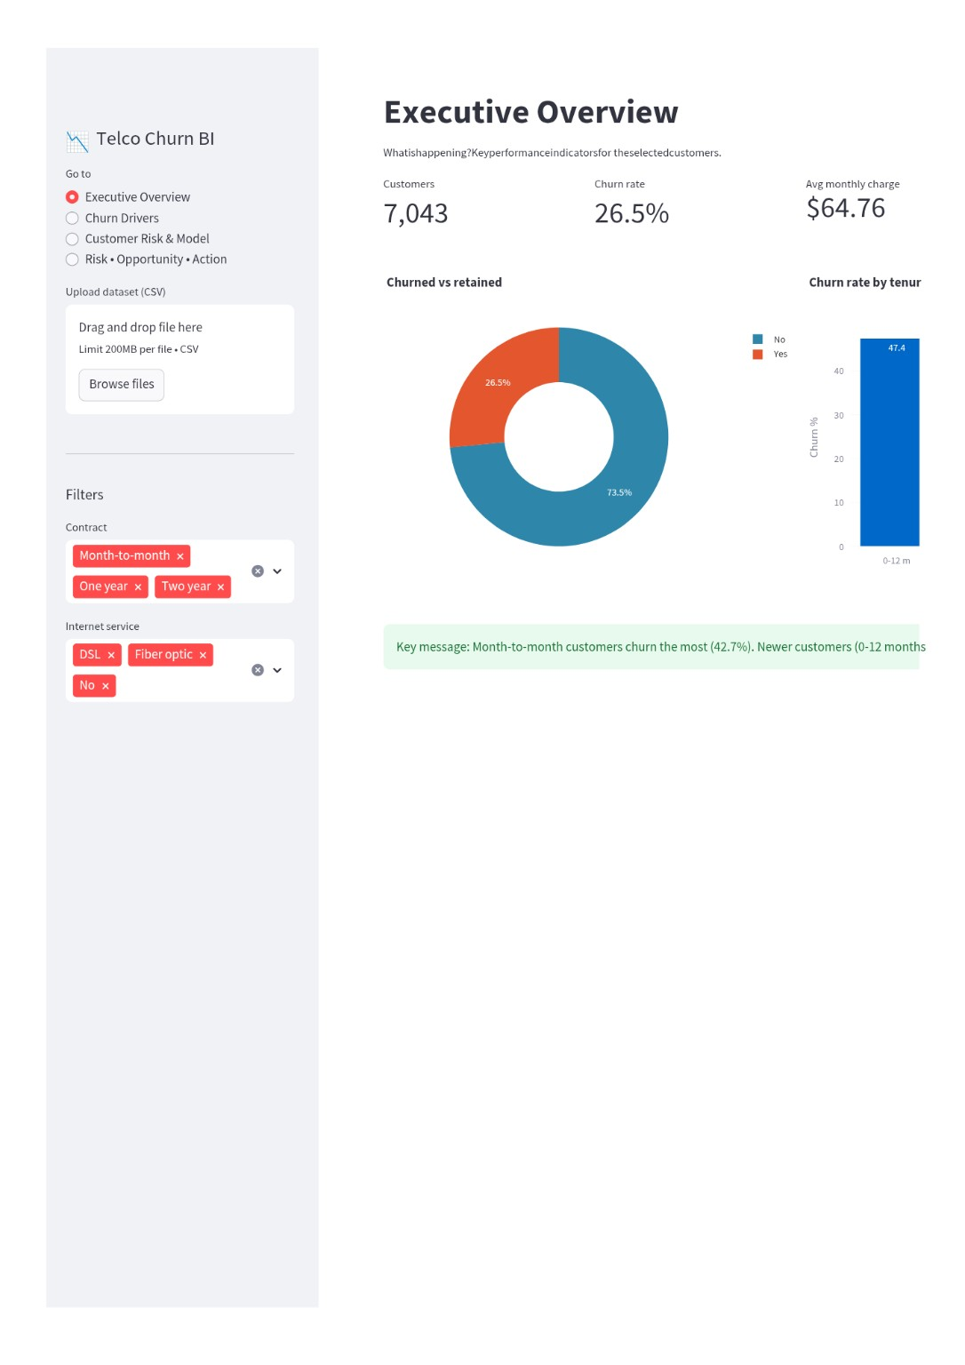
Figure 5.2: Executive Overview dashboard
The supplied dashboard shows 7,043 customers, a 26.5% churn rate and an average monthly charge of approximately $64.76. The donut chart shows 73.5% retained and 26.5% churned. The tenure view highlights the higher churn observed among newer customers. The page provides a concise management-level summary before deeper analysis.

5.3 Churn Drivers
This page answers “What is associated with churn?” and compares churn across customer attributes.
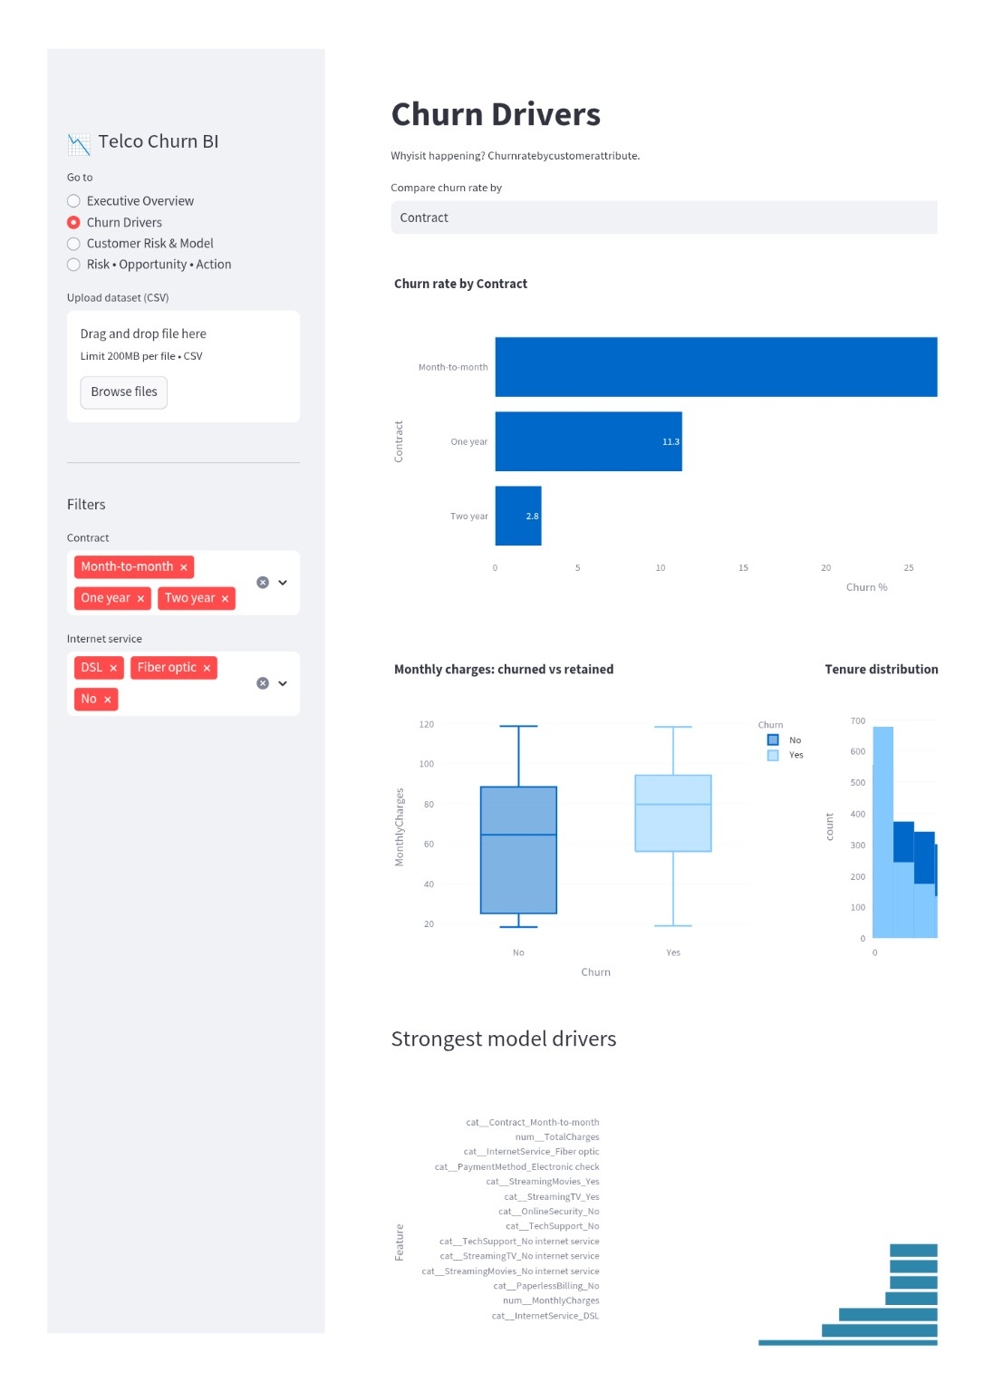
Figure 5.3: Churn Drivers dashboard
The dashboard shows approximately 42.7% churn for month-to-month contracts, 11.3% for one-year contracts and 2.8% for two-year contracts. It also includes monthly-charge distributions, tenure distribution and strongest model drivers. These findings describe associations and should not be treated as proof of causation.

5.4 Customer Risk & Model
This page answers “Who may churn?” and presents model performance together with customer risk tiers.
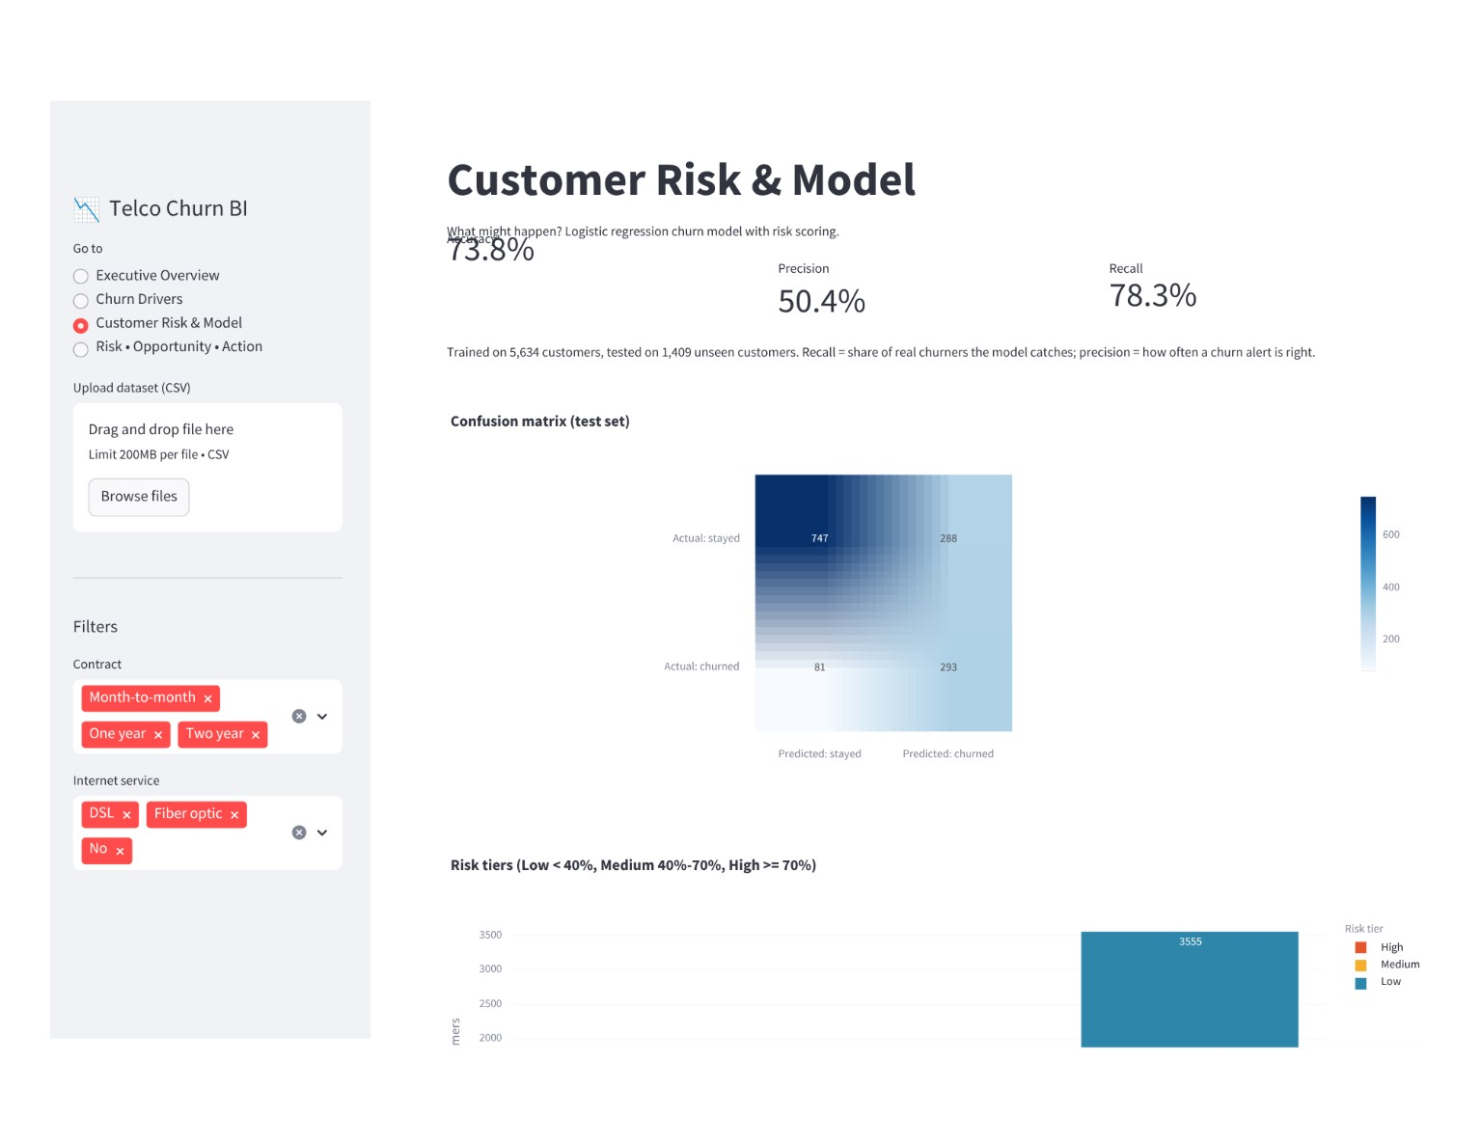
Figure 5.4: Customer Risk & Model dashboard
The supplied dashboard reports approximately 73.8% accuracy, 50.4% precision and 78.3% recall. The test-set confusion matrix shows 747 stayed customers correctly classified as stayed, 288 stayed customers classified as churned, 81 churned customers classified as stayed and 293 churned customers correctly classified as churned.

5.5 High-Risk Customer View
The high-risk customer view makes the model actionable by listing active customers with high predicted churn probability.
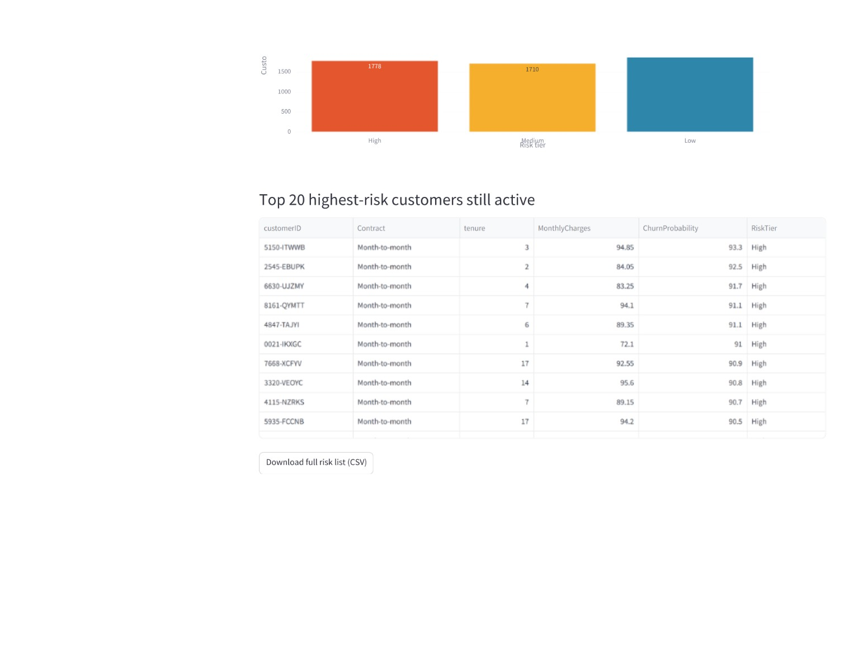
Figure 5.5: Risk tiers and highest-risk active customers
The view lists customer ID, contract, tenure, monthly charges, churn probability and risk tier, and provides a CSV download option. This allows a retention team to prioritize customers rather than applying the same intervention to everyone.

5.6 Risk • Opportunity • Action
This page answers “What should management do?” by converting analytical findings into risk, opportunity and action.
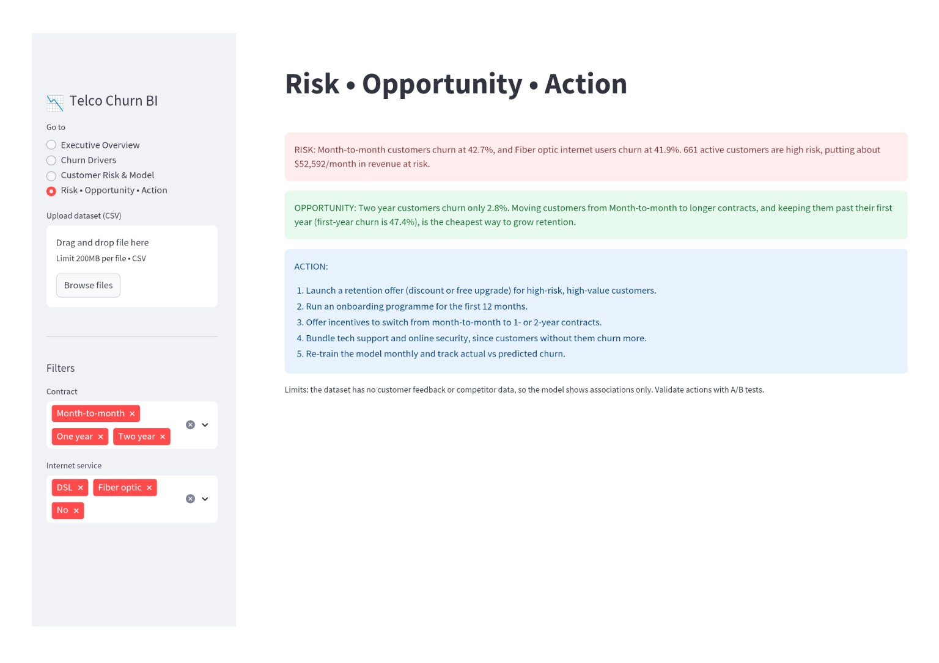
Figure 5.6: Risk • Opportunity • Action dashboard
The supplied dashboard highlights 42.7% churn among month-to-month customers, 41.9% among fiber-optic users, 661 active customers classified as high risk and approximately $52,592 per month in revenue at risk as a dashboard proxy. It highlights approximately 2.8% churn for two-year customers and 47.4% churn for first-year customers. Recommended actions include targeted retention offers, first-year onboarding, suitable incentives toward longer contracts, relevant service bundles and ongoing model monitoring.

6. Predictive Model and Evaluation

6.1 Model Selection
Logistic Regression is used for binary churn classification. It provides predicted probabilities and interpretable coefficients and is integrated with preprocessing in a scikit-learn pipeline.

6.2 Model Evaluation
Metric | Documented Result | Meaning
Accuracy | 73.8% | Overall proportion of correct predictions
Precision | 50.4% | Share of predicted churn alerts that were actually churn
Recall | 78.3% | Share of actual churners detected by the model

6.3 Confusion Matrix
The test-set confusion matrix contains 747 true negatives, 288 false positives, 81 false negatives and 293 true positives. These values explain how the model's classification decisions contribute to the reported evaluation metrics.

7. Customer Risk Scoring
Risk Tier | Probability Range | Operational Interpretation
Low | < 40% | Lower predicted churn risk
Medium | 40%–<70% | Moderate predicted churn risk
High | ≥ 70% | Higher predicted churn risk and higher intervention priority
These thresholds are operational rules used to prioritize customers; they are not presented as universal probability-calibration standards.

7.1 Active High-Risk Customers
The application surfaces active customers with high predicted churn probability so that retention activity can be prioritized at customer level.

8. Key Business Insights
- Overall churn is approximately 26.5%.
- Month-to-month customers show substantially higher churn than one-year and two-year contract customers.
- The dashboard shows approximately 47.4% churn for the 0–12 month tenure group.
- Two-year customers show approximately 2.8% churn in the contract comparison.
- Fiber-optic users show approximately 41.9% churn on the decision page.
- The predictive model can prioritize active customers for intervention.
- The dashboard connects descriptive analysis, predictive analytics and business action.

9. Recommendations
- Prioritize high-risk, high-value active customers for targeted retention offers.
- Strengthen onboarding and engagement during the first 12 months.
- Offer suitable incentives for customers who may benefit from moving from month-to-month to longer contracts.
- Consider relevant service bundles such as technical support and online security.
- Monitor actual churn against predicted churn and retrain the model when new data becomes available.
- Validate retention interventions through controlled A/B testing before treating them as proven causal strategies.

10. Limitations
- The dataset does not contain customer feedback or competitor information.
- The model identifies associations and does not prove causation.
- Risk thresholds are operational prioritization rules.
- The dashboard's revenue-at-risk value is a proxy based on monthly charges associated with high-risk active customers.
- Recommendations should be validated with experiments and future customer data.

11. How to Run
- Install dependencies with: pip install -r requirements.txt
- Place WA_Fn-UseC_-Telco-Customer-Churn.csv beside app.py, or upload it using the sidebar.
- Start the application with: streamlit run app.py
- Open the local Streamlit URL displayed by the terminal.

12. GitHub Project Structure
Recommended repository structure:
telco-customer-churn-dashboard/
├── app.py
├── requirements.txt
├── README.md
├── WA_Fn-UseC_-Telco-Customer-Churn.csv
└── docs/
└── Telco_Customer_Churn_Project_Report.docx
The raw dataset should only be committed if permitted by the internship submission rules and applicable dataset terms. The README documents the dataset source and how to run the application.

13. Conclusion
The Telco Customer Churn Intelligence Dashboard integrates descriptive analytics, churn-driver analysis, predictive modeling, customer risk scoring and business recommendations in one Streamlit application. It moves from raw customer data to information, insight, risk prioritization and action. The dashboard gives management a clear view of the scale of churn, the attributes associated with churn, the customers who may need attention and practical retention actions.

14. Project Files
File | Purpose
app.py | Complete Streamlit application, analytics and machine-learning implementation
requirements.txt | Python dependencies and versions
README.md | Project overview, dataset information, approach and run instructions
WA_Fn-UseC_-Telco-Customer-Churn.csv | Input dataset used by the application
Project report | Formal project documentation

