Online Quiz Application using 3-Tier Architecture in AWS
This project demonstrates the deployment of a 3-Tier Web Application using Amazon Web Services. The application is deployed using Amazon EC2 instances inside a Amazon VPC network architecture.
The architecture separates the system into three layers:
- Web Tier – Handles user interface
- Application Tier – Handles business logic
- Database Tier – Stores application
Architecture Overview
User Browser
│
▼
Web Server (Public Subnet)
│
▼
Application Server (Private Subnet)
│
▼
Database Server (Private Subnet)

VPC
Step 1: Create VPC
Navigate to VPC → Create VPC
Configuration:
Parameter | Value
Name | quiz-vpc
IPv4 CIDR | 10.0.0.0/16
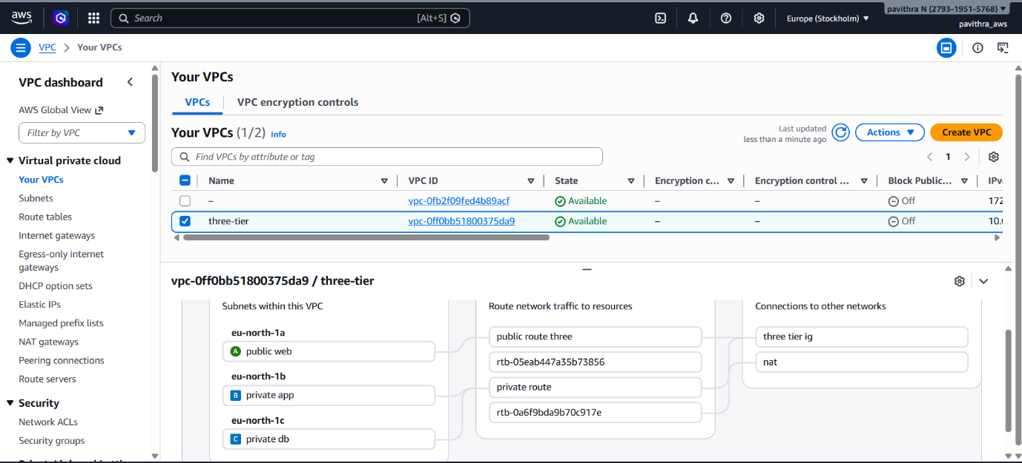
Subnets
Step 2: Create Subnets
Create three subnets.
Public Subnet (Web Server)
Parameter | Value
Name | public-subnet
CIDR | 10.0.1.0/24
Private Subnet (App Server)
Parameter | Value
Name | app-private-subnet
CIDR | 10.0.2.0/24
Private Subnet (Database Server)
Parameter | Value
Name | db-private-subnet
CIDR | 10.0.3.0/24

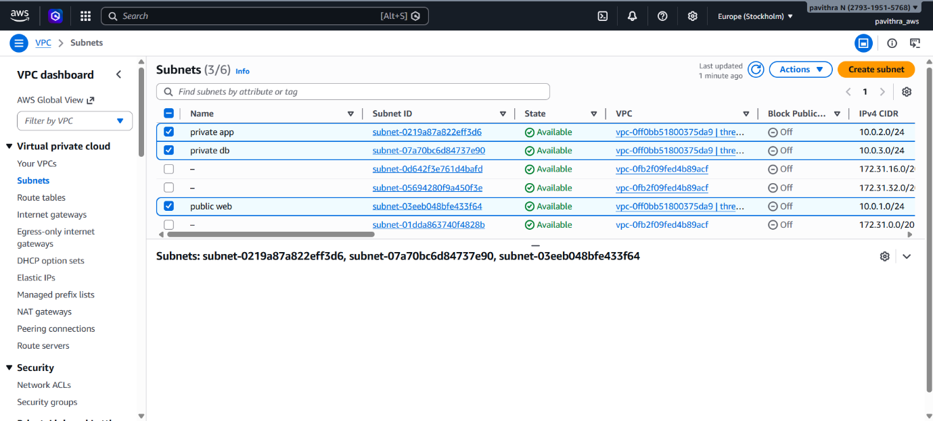

Internet Gateway
Step 3: Create Internet Gateway
Create an Internet Gateway.
Name: quiz-igw
Attach it to quiz-vpc.
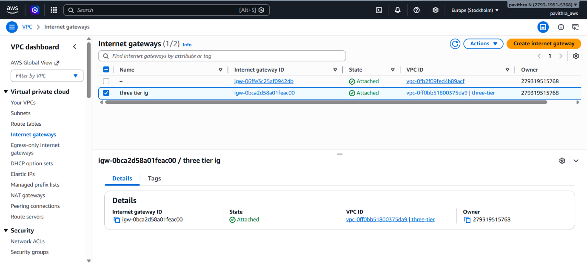

Route Tables
Step 4: Create Route Tables
Public Route Table
Create :public-route-table
Add route:
Destination | Target
0.0.0.0/0 | Internet Gateway
Associate with: public-subnet
Private Route Table
Create:private-route-table
Associate with: app-private-subnet
db-private-subnet
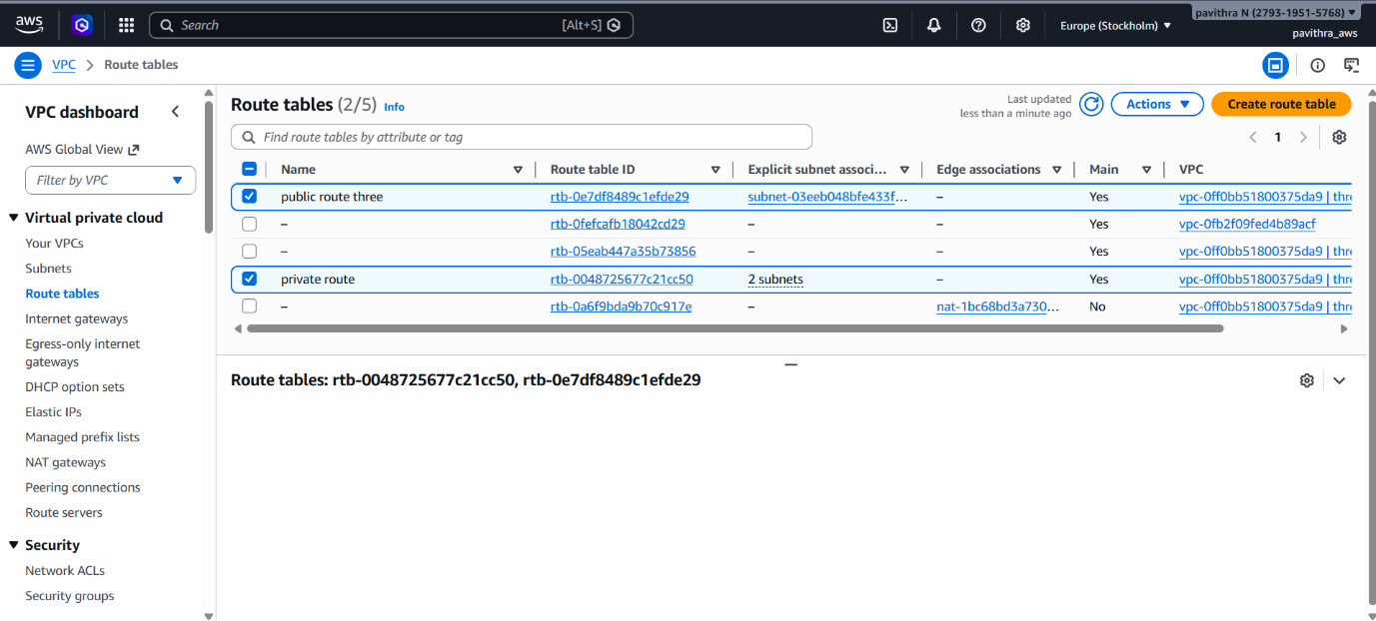

NAT Gateway
Step 5: Create NAT Gateway
Create NAT Gateway.

Add route in private route table:
Destination | Target
0.0.0.0/0 | NAT Gateway
This allows private instances to access the internet for updates.
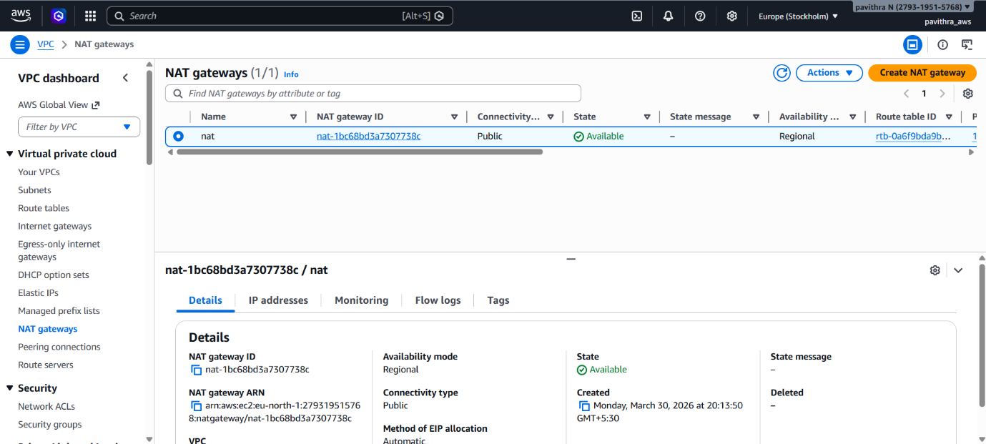

Elastic IP
Allocate elastic IP
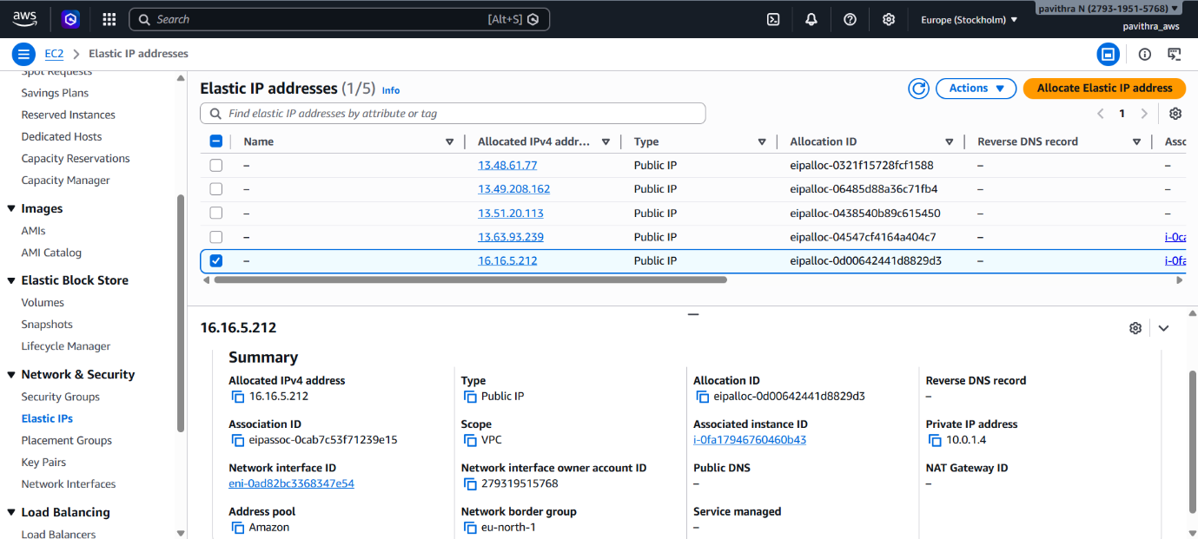

Security Groups
Step 6: Create Security Groups
Web Server Security Group
Inbound Rules:
Type | Port | Source
SSH | 22 | My IP
HTTP | 80 | 0.0.0.0/0

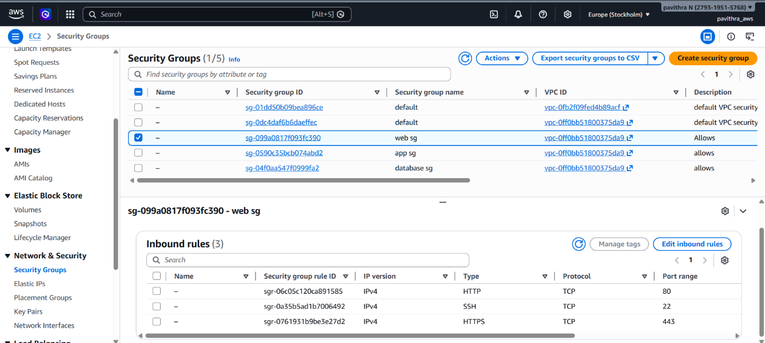

Application Server Security Group
Inbound Rules:
Type | Port | Source
SSH | 22 | Web Server SG
Custom TCP | 5000 | Web Server SG
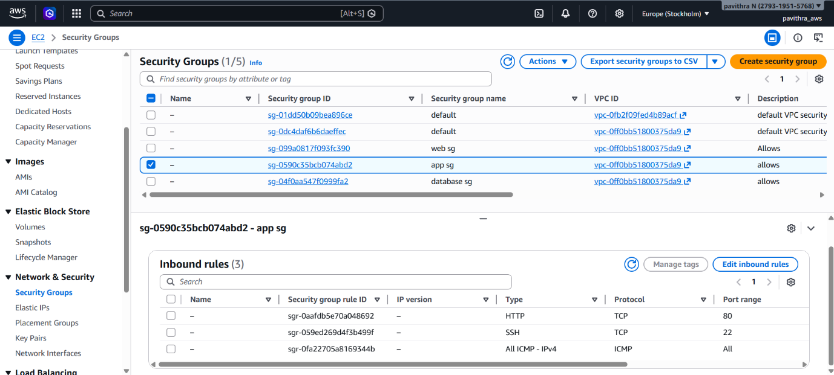

Database Server Security Group
Inbound Rules:
Type | Port | Source
MySQL | 3306 | App Server SG
SSH | 22 | Web Server SG
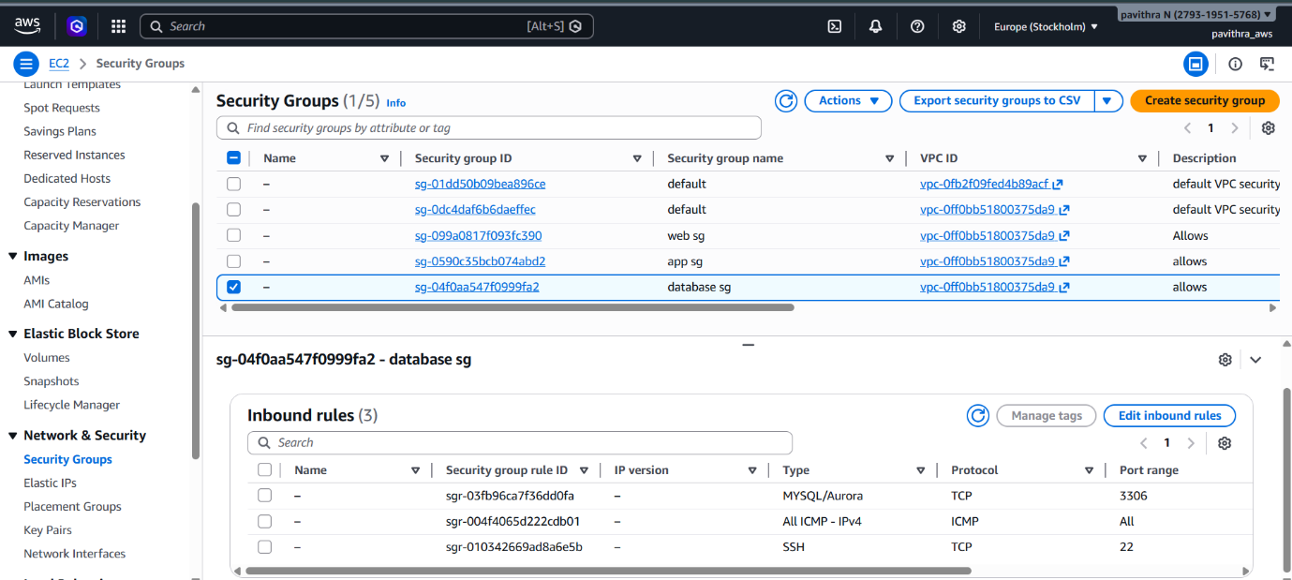

Step 7: Launch EC2 Instances
Create three Amazon EC2 instances.
Web Server
Parameter | Value
Name | quiz-web
Subnet | public-subnet
Public IP | Enabled
Security Group | web-sg
Key Pair | three.pem
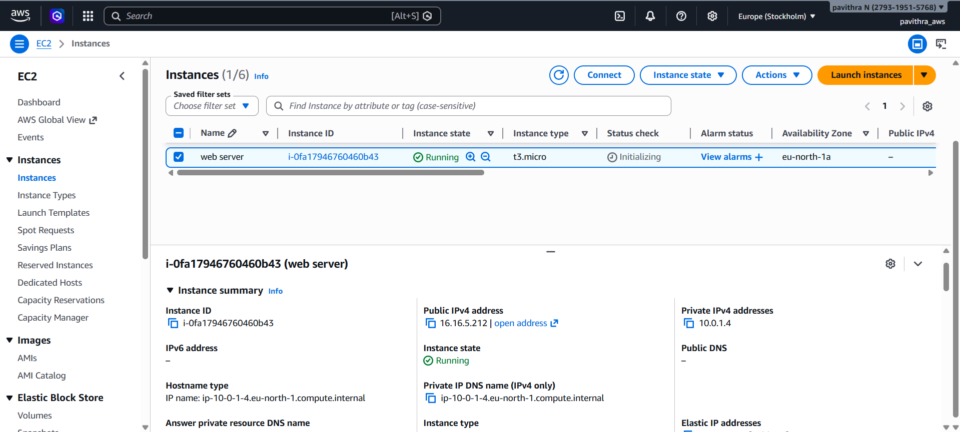

Application Server
Parameter | Value
Name | quiz-app
Subnet | app-private-subnet
Security Group | app-sg
Key Pair | three.pem
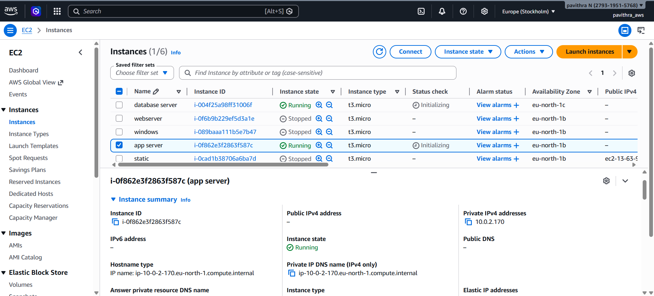
Database Server
Parameter | Value
Name | quiz-db
Subnet | db-private-subnet
Security Group | db-sg
Key Pair | three.pem
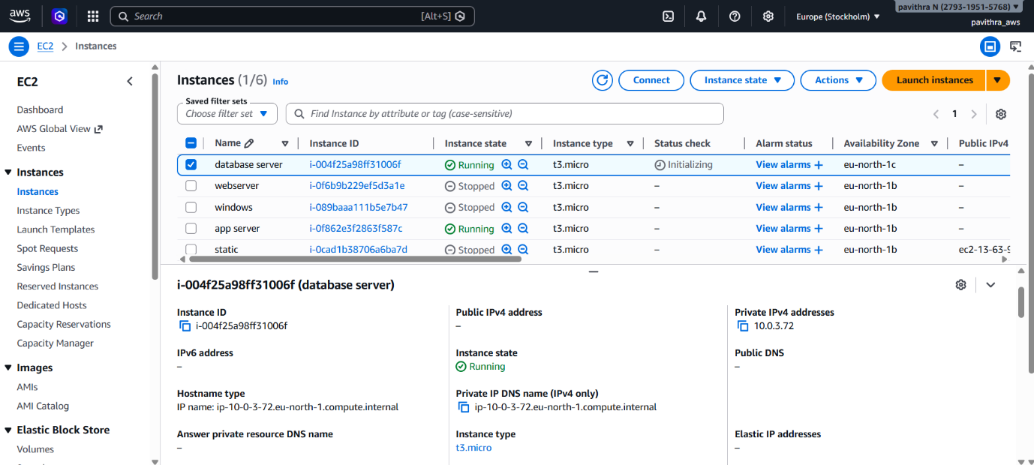

Step 8: Connect to Web Server
From your local machine run:
ssh -i three.pem ec2-user@WEB_PUBLIC_IP
Example:
ssh -i three.pem ec2-user@54.xx.xx.xx

Step 9: Web Server Setup
Install Apache and PHP:
sudo yum update -y
sudo yum install php php-mysqlnd httpd -y
sudo systemctl start httpd
sudo systemctl enable httpd
Create application file:
sudo nano /var/www/html/index.php

PHP Quiz Application Code
<?php
$conn = new mysqli("10.0.3.72", "appuser", "AppPass@123", "my_app_db");
echo "<html><body style='font-family: Arial; text-align: center; background-color: #eef2f3; padding: 30px;'>";
echo "<div style='background: white; display: inline-block; padding: 30px; border-radius: 15px; box-shadow: 0 10px 20px rgba(0,0,0,0.2); width: 60%;'>";
echo "<h1 style='color: #2c3e50;'>🚀 AWS 3-Tier Quiz App</h1><hr>";
$sql = "SELECT * FROM quiz";
$result = $conn->query($sql);
if ($result->num_rows > 0) {
echo "<form id='quizForm'>";
while($row = $result->fetch_assoc()) {
echo "<div style='text-align: left; margin-bottom: 20px; border-bottom: 1px solid #eee; padding-bottom: 10px;'>";
echo "<b>Q" . $row["id"] . ": " . $row["question"] . "</b><br><br>";
echo "<input type='radio' name='q".$row["id"]."' value='A'> A) " . $row["option_a"] . "<br>";
echo "<input type='radio' name='q".$row["id"]."' value='B'> B) " . $row["option_b"] . "<br>";
echo "<input type='hidden' id='ans".$row["id"]."' value='".$row["answer"]."'>";
echo "</div>";
}
echo "<button type='button' onclick='checkResults()' style='background:#27ae60;color:white;padding:12px 25px;border:none;border-radius:5px;'>Submit My Quiz</button>";
echo "</form>";
echo "<h2 id='resultDisplay'></h2>";
}
?>
<script>
function checkResults(){
let score=0;
let total=3;
for(let i=1;i<=total;i++){
let selected=document.querySelector('input[name="q'+i+'"]:checked');
let correct=document.getElementById('ans'+i).value;
if(selected && selected.value===correct){
score++;
}
}
document.getElementById('resultDisplay').innerHTML="Your Score: "+score+" / "+total;
alert("Quiz Submitted! Your Score: "+score+" / "+total);
}
</script>
<?php
echo "</div></body></html>";
?>

Step 10: Copy Key to Web Server
To access private servers from the web server:
nano three.pem
Paste the key content and set permission:
chmod 400 three.pem

Step 11: Connect to Application Server
From Web Server run:
ssh -i three.pem ec2-user@10.0.2.170
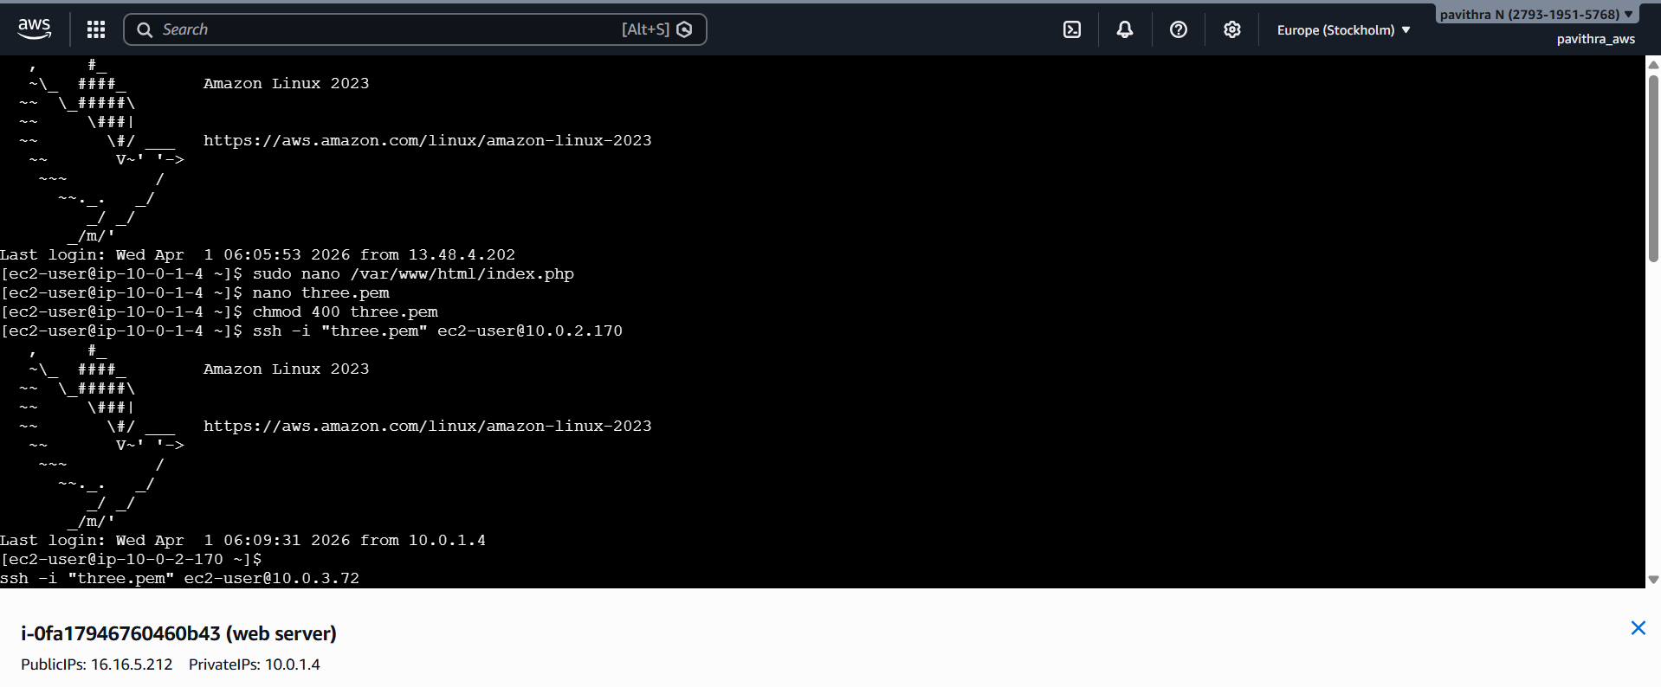
Step 12: App Server Setup
Install packages:
sudo yum update -y
sudo yum install httpd php php-mysqlnd -y
sudo systemctl start httpd
sudo systemctl enable httpd
Step 13: Connect to Database Server
From App Server run:
ssh -i three.pem ec2-user@10.0.3.72
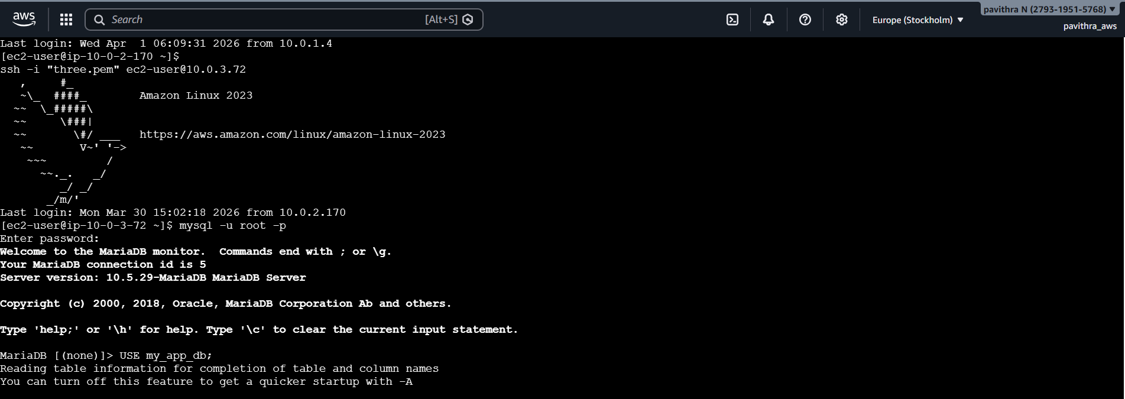
Step 14: Database Server Setup
Install MariaDB
sudo yum update -y
sudo yum install mariadb-server -y
sudo systemctl start mariadb
sudo systemctl enable mariadb
Login to database:
mysql -u root -p
Create database:
CREATE DATABASE my_app_db;
USE my_app_db;
Create table:
CREATE TABLE quiz (
id INT AUTO_INCREMENT PRIMARY KEY,
question VARCHAR(255),
option_a VARCHAR(100),
option_b VARCHAR(100),
answer VARCHAR(10)
);
Insert quiz questions:
INSERT INTO quiz (question, option_a, option_b, answer) VALUES
('What is AWS?', 'Cloud Provider', 'Operating System', 'A'),
('Which tier is Database?', 'Tier 1', 'Tier 3', 'B'),
('Is this a 3-Tier Arch?', 'Yes', 'No', 'A');
Create database user:
CREATE USER 'appuser'@'%' IDENTIFIED BY 'AppPass@123';
GRANT ALL PRIVILEGES ON my_app_db.* TO 'appuser'@'%';
FLUSH PRIVILEGES;
Exit database:
EXIT;
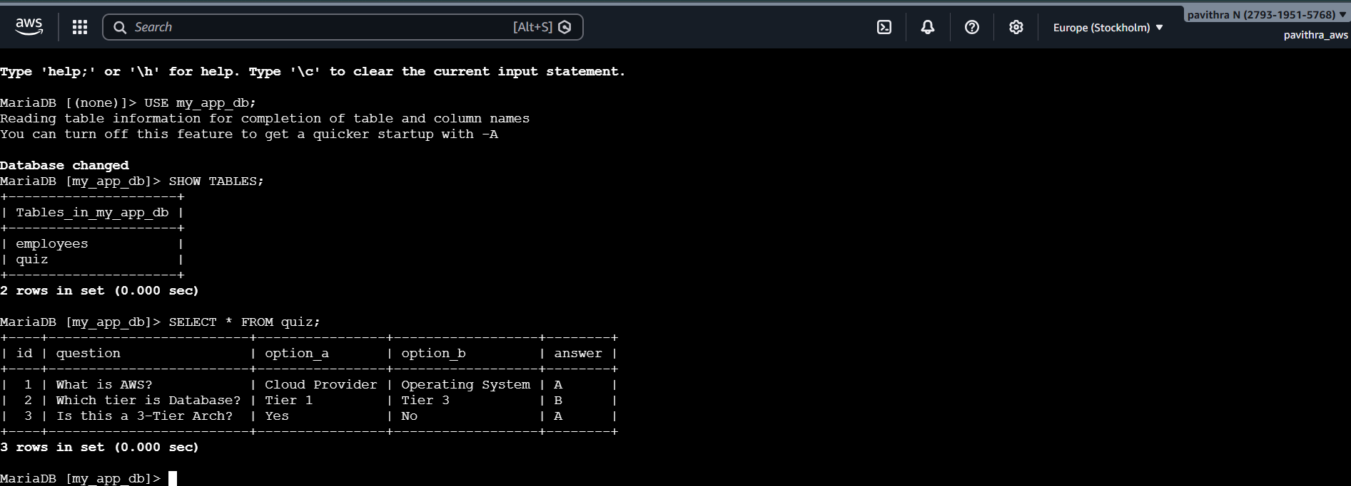

Final Output
Open browser and enter:
http://WEB_SERVER_PUBLIC_IP
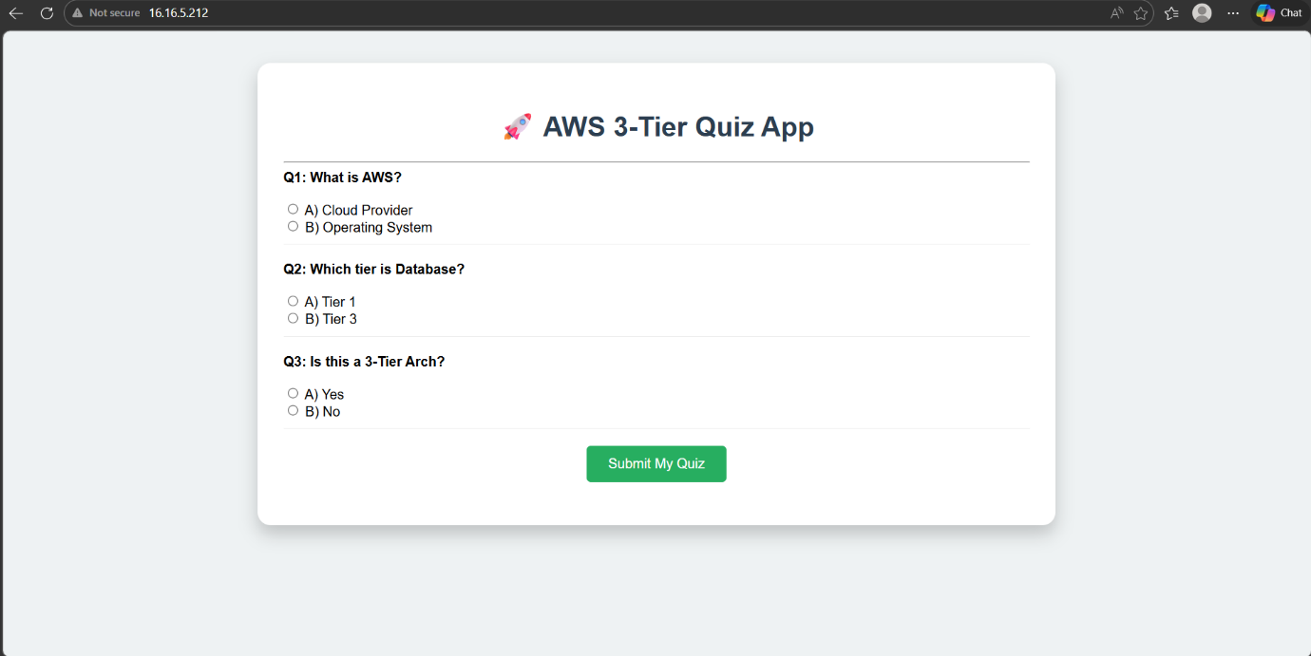
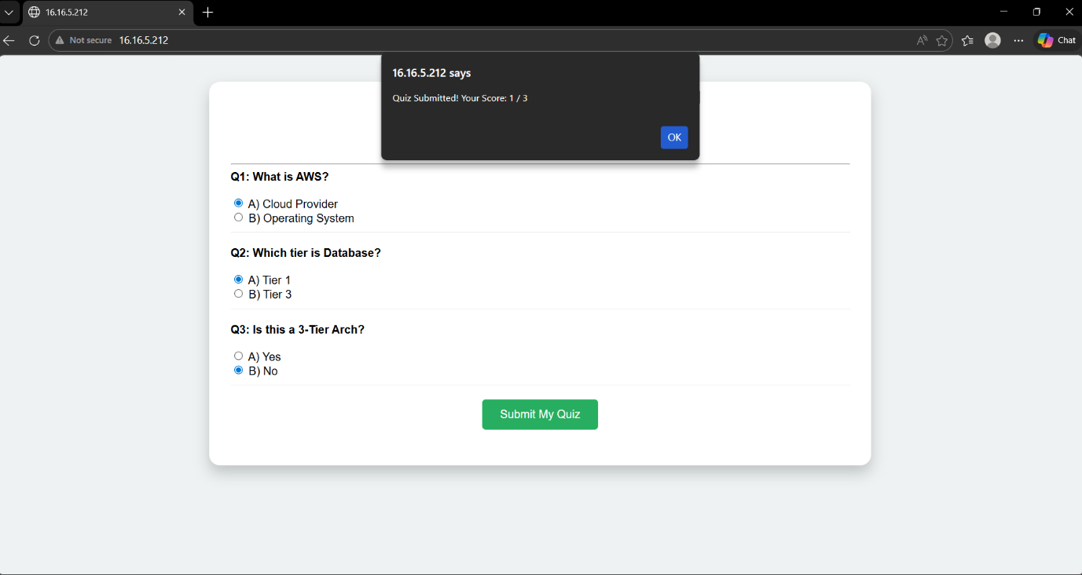
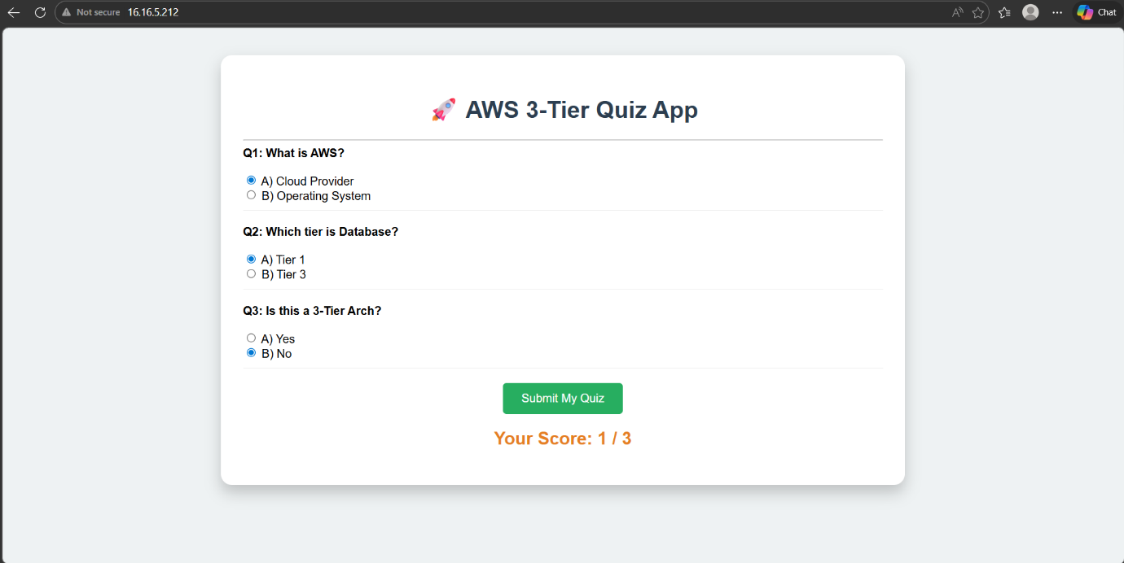
The user will see the AWS 3-Tier Quiz Application and can attempt the quiz and view the score.

