

**Enterprise Applications Development**

**Assignment 1**

**Hibernate frameworks**

**Final Report**

**DIT: -** IT14129940

**Name: -** Pathirathna P.P.W

**Batch: -** SE-WE

Web application is developed using both hibernate and Spring framework on netbeans id. This web application is about a very small human resources application where we can managing an employee’s roles and tasks.

**ER Diagram**

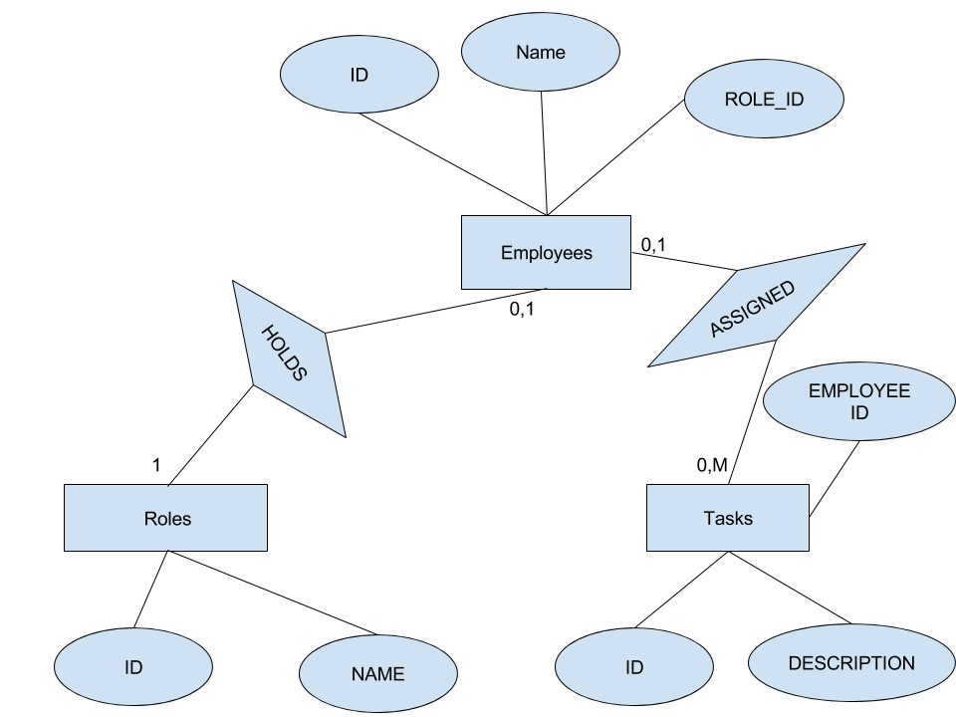

Hibernate configurations

Here I have done database configurations, configurations to create database every time deploy the application and table mappings.

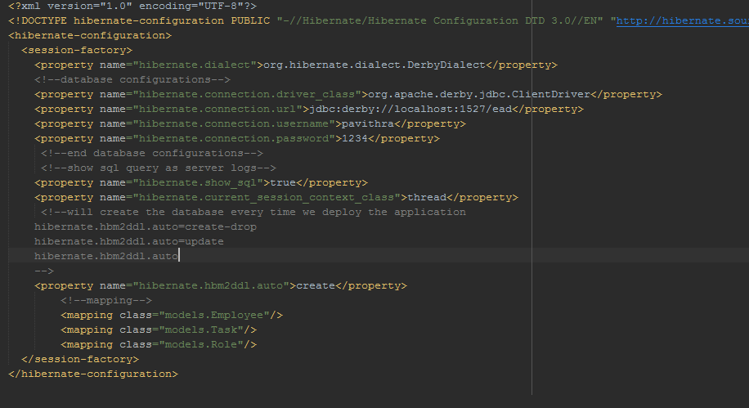

There are 3 main model class. Since hibernate provide JPA (Java Persistence API) implementation I have used PA annotations for mapping

* Employee
* Role
* Task

Employee class

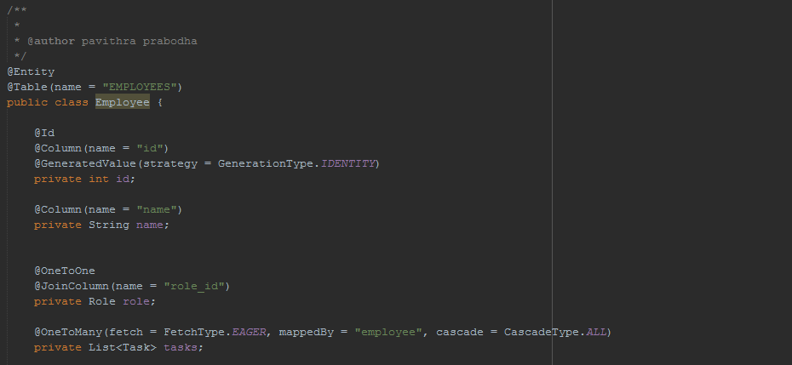

The name of the table is employees. There are 3 main columns id witch is the primary key (auto generated value). Name and the role_id witch is the primary key of the ROLE table.

ROLE class

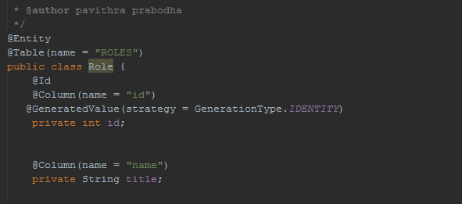

This is also the same as employee class. Name of the table is ROLES and there are 2 columns namely id (auto generated primary key of the table) and name.

Tasks class

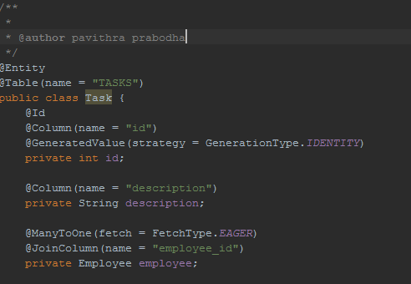

Tasks table also have a auto generated primary key called id and a column for description of the task. Also have another column to keep a reference of the employee called employee_id

I have implemented getters and setters for all these model classes. The web application has 3 main pages employees, roles and tasks for each these pages there is a respected controller class. They are mapped in the dispatcher-servlet.xml file.

Depending on the HTTP methods the controller will call the respected function in the data access object to get, save, update, delete depending on the request

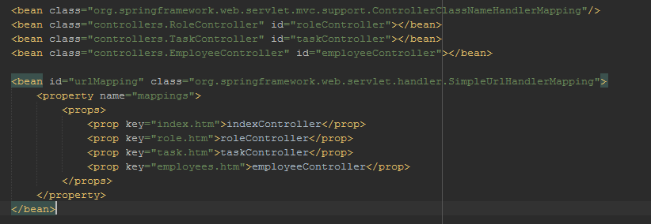

RoleController class

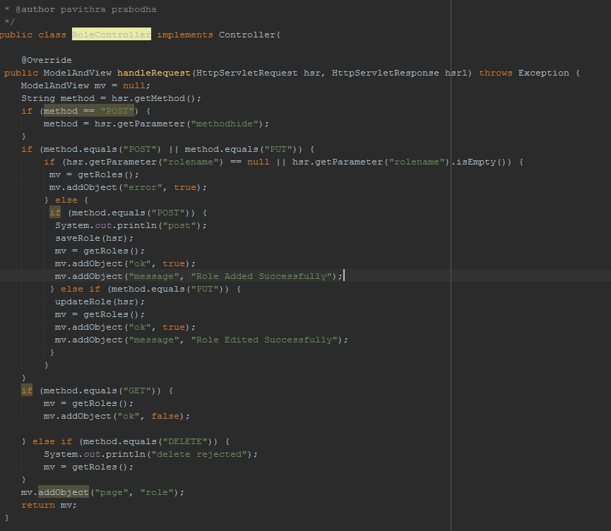

EmployeeController class

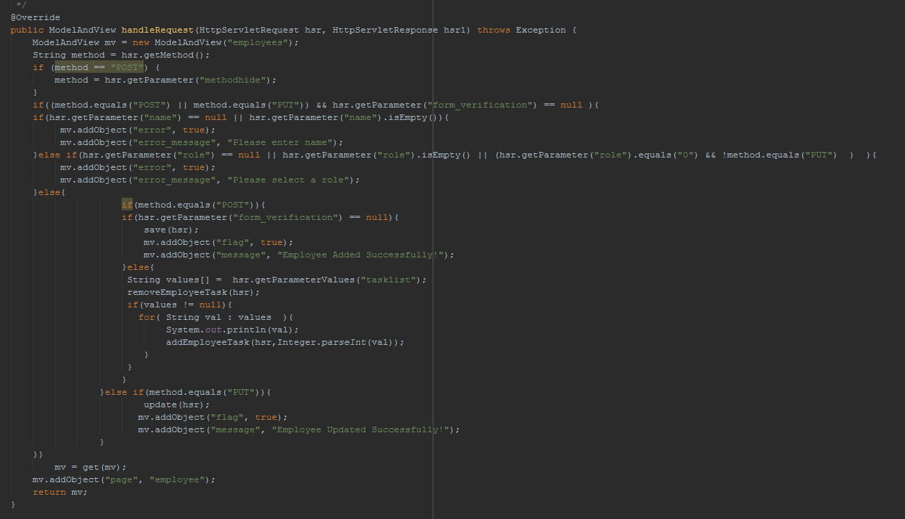

TaskController class

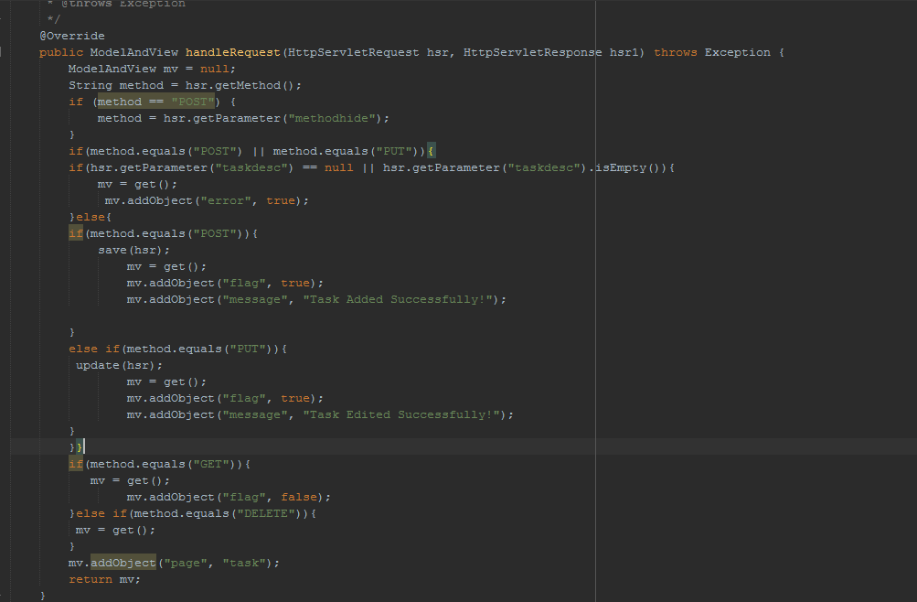

I have developed 3 DAO class to access data from the database. One for each model class I created.

There I have wrote functions update, delete, insert, get data to the database using both hibernate queries and SQL queries (createSQLQuery) as well

EmployeeDAO

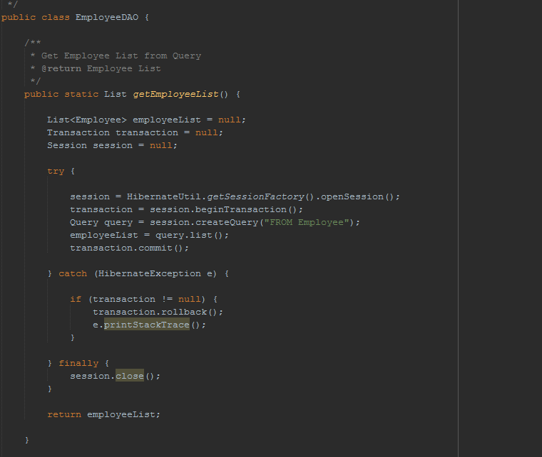

RoleDAO

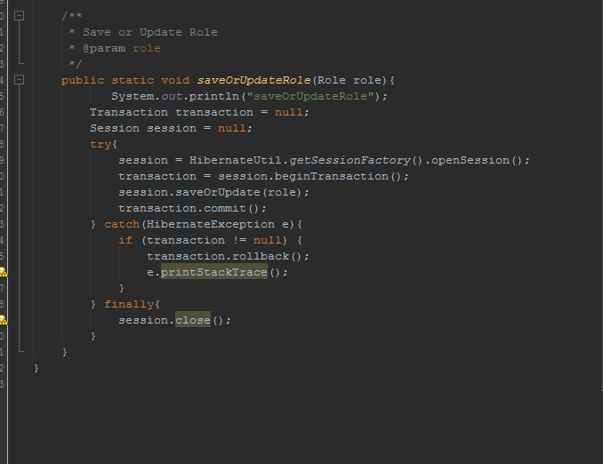

TaskDAO

