Level 5 → Level 6

The goal is to find a file somewhere inside inhere that is:
- Human-readable
- Exactly 1033 bytes
- Not executable

Login into the level 5
Enter your Level 4 → 5 password
Check the directory : ls
You should see: inhere
Find the correct file , The easiest command is : find inhere -type f -size 1033c ! -executable
find inhere : that search inside the inhere and all its subdirectories
-type f : search only for regular files
-size 1033c : Find files exactly 1033 bytes in size. c means bytes
! -executable : find files that are not executable
Check that it is human-readable
Use: file inhere/maybehere07/.file2
You should see something similar to: ASCII text
Read the File to get the password
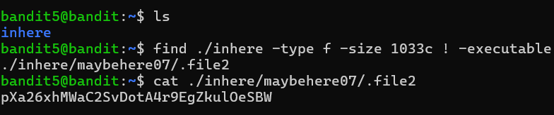
The password given is for Level 6.

