Level 15 to Level 16

🎯 Goal
For Level 16, you must submit the Level 15 password to port 30001 on localhost using SSL/TLS encryption.
Login as bandit15
Enter your Level 15 password.
Connect to port 30001 using SSL and run :
openssl s_client -connect localhost:30001
You will see lots of certificate information. Don't worry about it.
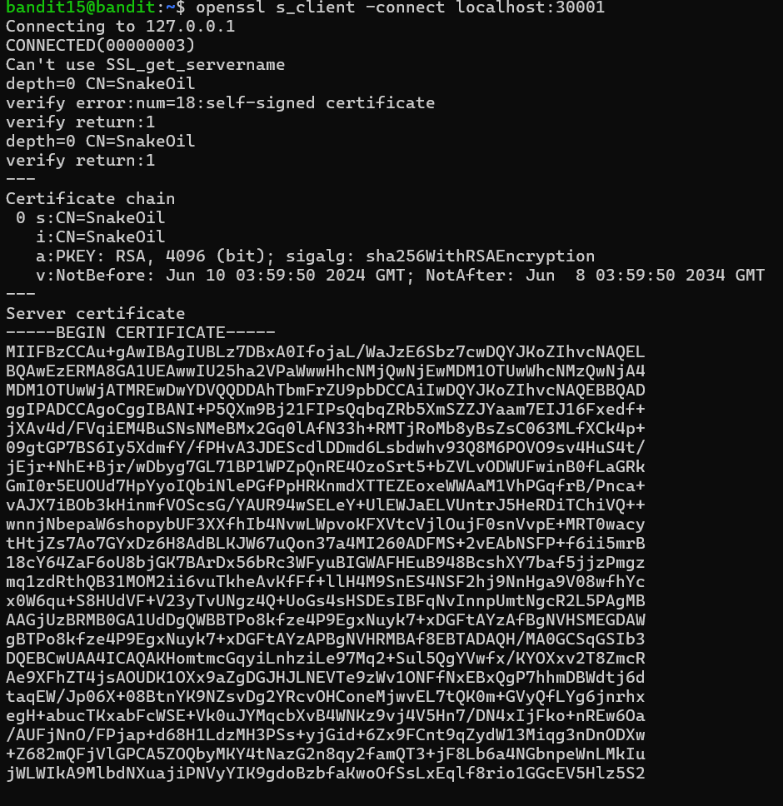

Enter the Level 15 password and press enter
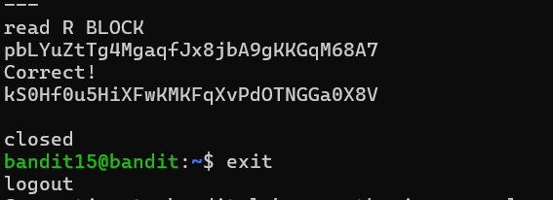

You should get:
Correct!
<Level 16 password>

