Level 14 to Level 15

🎯 Goal
The password for Level 15 can be obtained by sending the current Level 14 password to port 30000 on localhost
Login as bandit14
Paste the password
Send the password to port 30000 Use nc (Netcad):
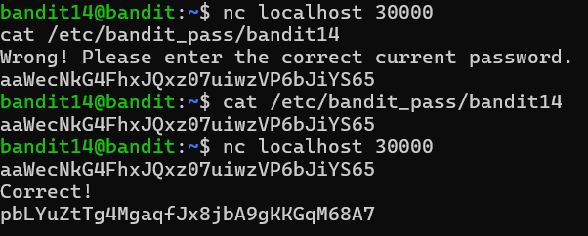

If correct, you'll get: Correct!
<password for level 15>

