Level 6 → Level 7

The goal is to find a file somewhere on the server with all three properties:
- Owned by user (bandit7 )
- Owned by group (bandit6 )
- Exactly 33 bytes in size

Login to Level 6
Enter your Level 5 → 6 password
Find the password file : find / -type f -user bandit7 -group bandit6 -size 33c 2>/dev/null
What does the command mean?
find / : Search from /, the root directory
-type f : Search only for regular files
-user bandit7 : The file must be owned by user bandit7
-group bandit6 : The file must belong to group bandit6
-size 33c : The file must be exactly 33 bytes. c means bytes
2>/dev/null : Hides permission-denied error messages while searching the whole filesystem
Read the file
If your result is : /var/lib/dpkg/info/bandit7.password
Then run : cat /var/lib/dpkg/info/bandit7.password
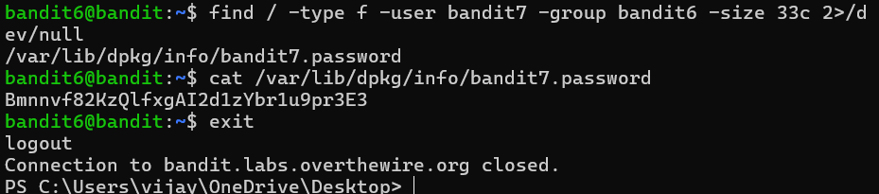
The password is given for Level 7

