Level 13 to Level 14

Goal: The password for Level 14 is stored in /etc/bandit_pass/bandit14. You are given an SSH private key instead of the password.
Login to Level 13
Enter your Level 13 password.
Check the files : ls
You should see: sshkey.private
Copy the private key to your computer :
scp -P 2220 bandit13@bandit.labs.overthewire.org:~/sshkey.private .
Enter your Level 13 password.
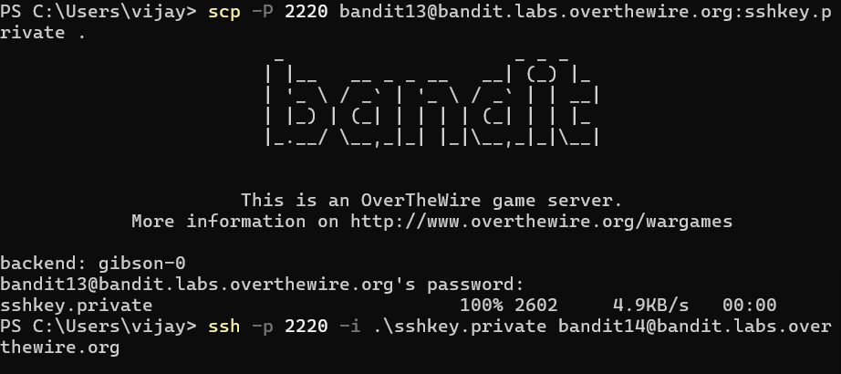

You should get something like : sshkey.private 100% ...
Login as Level 14 using the key : ssh -i .\sshkey.private -p 2220 bandit14@bandit.labs.overthewire.org
You should now see: bandit14@bandit:~$
🎉 You are now Level 14!
Get the Level 14 password : cat /etc/bandit_pass/bandit14
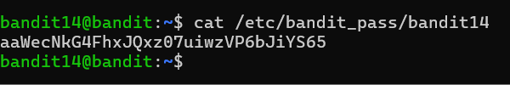

This displays the password for Level 14.

