Level 12 to Level 13

🎯 Level Goal
The password for Level 13 is inside data.txt.
However, data.txt is a hex dump of a file that has been compressed multiple times. We need to:
- Reverse the hex dump.
- Identify the file type.
- Decompress it.
- Repeat until we reach the password
Login to Level 12
Enter your Level 11 → 12 password.
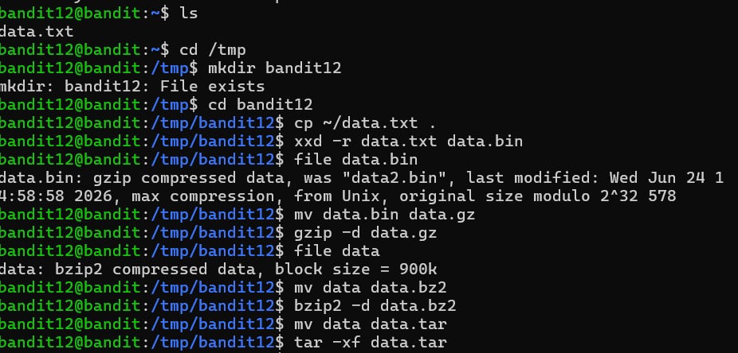

Check the file : ls
You should see:data.txt
Read the content : cat data.txt
You'll see hexadecimal data such as:
00000000: 1f8b 0808 ...
00000010: 6269 6e00 ...
This tells us it is a hexdump
Create a temporary directory : mktemp -d
Copy your directory path exactly because yours will be different.
cp data.txt /tmp/tmp.abc123
cd /tmp/tmp.abc123
Reverse the hexdump
Use xxd -r: xxd -r data.txt data
Now check the file:file data
Decompress the gzip file : mv data data.gz
Then : gzip -d data.gz
Check : ls
Then : file data
Keep checking with file :
If it says bzip2 compressed data
mv filename filename.bz2
bzip2 -d filename.bz2
If it says POSIX tar archive
tar -xf filename
Then check the extracted file:
ls
file <newfile>
When file finally says something like:ASCII text
Then run : cat <filename>
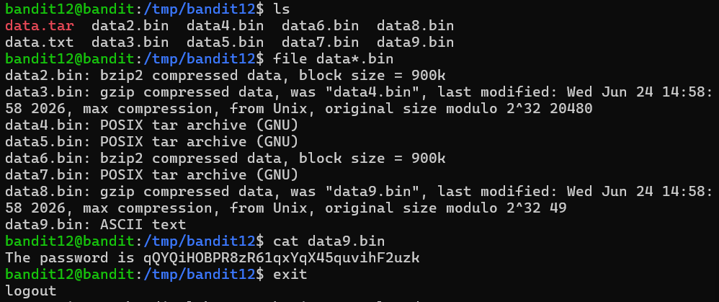
The password given is for Level 13

