Level 11 → Level 12

🎯 Level Goal
The password for the next level is stored in data.txt, where all lowercase and uppercase letters have been rotated by 13 positions.
Login to Level 11
Enter the Level 10 → 11 password when asked.
Check the file : ls
You should see:data.txt
Now display it: cat data.txt
You will see something similar to: Gur cnffjbeq vf 5Gr8L4qetPEsPk8htqjhRK8XSP6x2RHh
This looks strange because it is ROT13 encoded.
Decode using tr : cat data.txt | tr 'A-Za-z' 'N-ZA-Mn-za-m'
What does this mean?
- cat data.txt → reads the file.
- | → sends the output to the next command.
- tr → translates characters.
- A-Za-z → all uppercase and lowercase letters.
- N-ZA-Mn-za-m → rotates the letters by 13 positions.

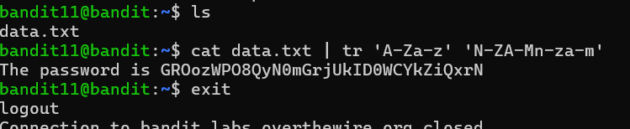
The password is given for Level 12

