Level 7 to Level 8

The goal is :
To find the password that is stored in a file called data.txt next to the word millionth
Login to Bandit Level 7
Enter the password obtained from Level 6 → Level 7
Check the files : ls
You will see:data.txt
Find the word millionth : grep millionth data.txt
The command will display Password : millionth [PASSWORD]
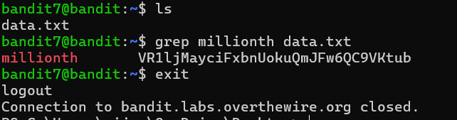
The password is given for Level 8

