Level 2- Level 3

The file is located in the home director
Enter the password obtained from Level 1 → Level 2
List the Files
You should see : --spaces in this filename—
Read the File using cat : cat ”./filename”
• cat → displays the file contents.
• "..." → keeps the spaces together as one filename.
• ./ → tells Linux that this is a file in the current directory.
• The filename is exactly --spaces in this filename--.
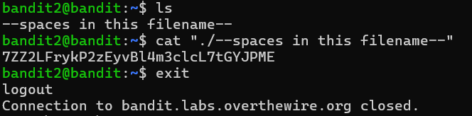
The password is given for the Level 3.

