Level 4 to Level 5
🎯 Level Goal
The password for the next level is stored in the only human-readable file inside the inhere directory
Login into the level 4
Enter your Level 3 → 4 password
Check the directory : ls
You should see: inhere
Enter the inhere directory: cd inhere
List the files : ls
There are several files since we need to find the only human-readable file use the file command : file ./*
The output shows that one file is ASCII text, while the others are data
Now read that file: ./-file07
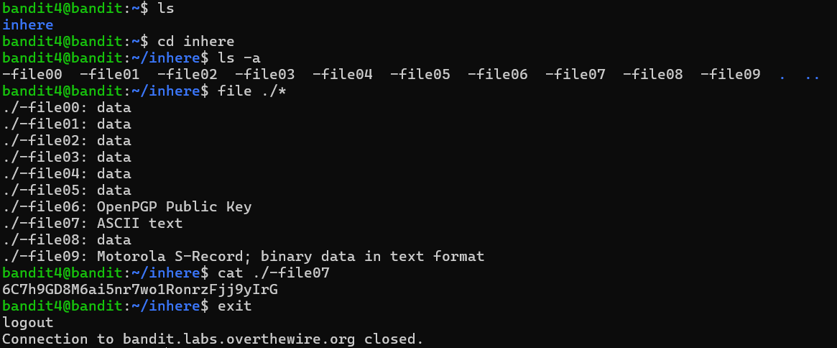
The password given is for Level 5.

