Level 10 to Level 11

🎯 Objective
Find the password for Bandit Level 11.
The password is stored in data.txt and is Base64 encoded.
Login to Level 10
Enter the password from Level 9 → Level 10.
Check the file : ls
You will see: data.txt
Read the file : cat data.txt
You will get a long encoded string : Decode Base64
base64 -d data.txt
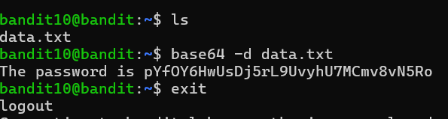
The password is given for Level 11.

