Level 0 – Level 1
Log into the Bandit server and find the password for Level 01.
ssh → use SSH connection
bandit0 → username
bandit.labs.overthewire.org → Bandit server
-p 2220 → connect through port 2220
Think of a port like a door number.
Bandit tells you to use door 2220, not the usual SSH door 22.
It asks for permission give Yes
After logging in, list the files in the home directory:
ls
There is a file called: readme
read the file using: cat
cat readme
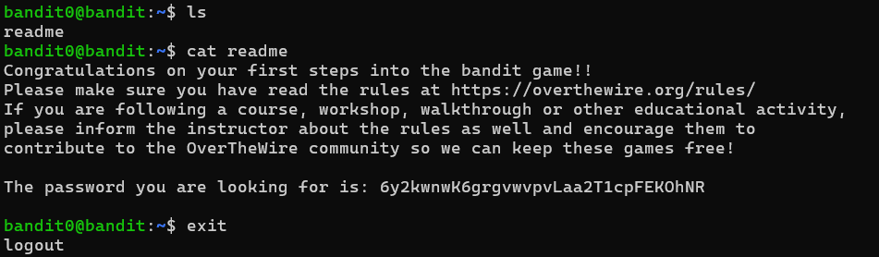
The output gives the password for Bandit Level 1
Then exit the current level

