Level 3 → Level 4

Login in into level 3
Enter your Level 2 → 3 password
List the directory : ls
Change the directory into inhere : cd inhere
Show all the hidden files : ls -a
You may see something like: . .. …Hiding-From-You
Read the hidden file to get the password : Cat < “…Hiding-From-You”

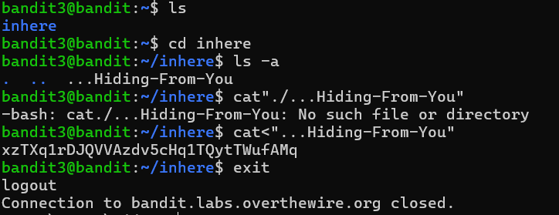
The Password given is for Level 4.

