

COGNITIVE COMPUTING AND NATURAL LANGUAGE PROCESSING

CCA 3 COMPONENT-BLOG

NLP-Based Interview Evaluation Using Semantic Similarity and AI-Based Proctoring

Author Name: PAVITHRA SUNILKUMAR
PRN: 1032231924 | ROLL NO. 57
PANEL: AIDS(A)

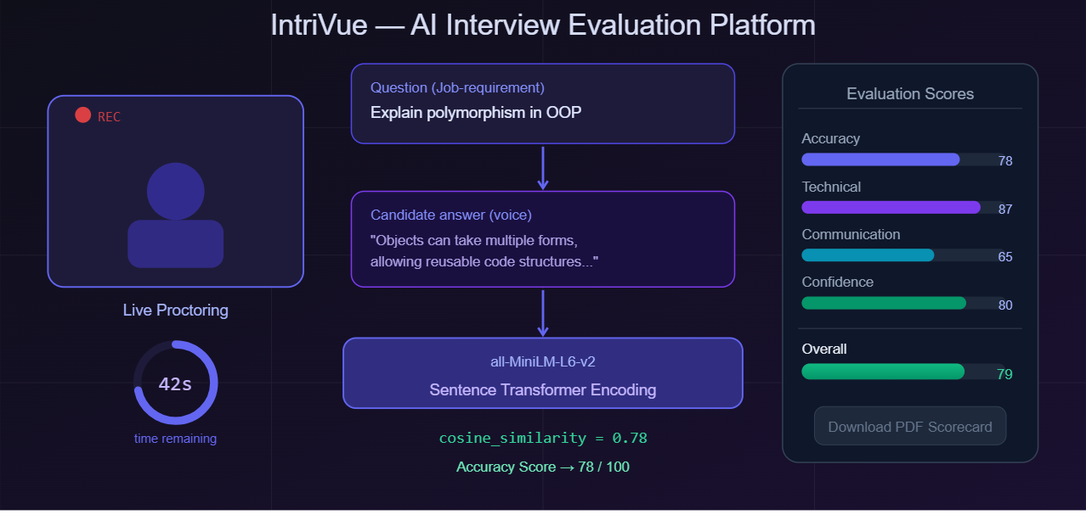
AI-powered interview platform showing live proctoring, score evaluation, and results dashboard

Introduction
Getting ready for a technical interview is one of the most stressful parts of a student's final year. Most people practise by answering questions in front of a mirror or asking a friend to quiz them — but neither approach gives any structured feedback on whether the answer was technically correct, clearly communicated, or delivered with confidence. This gap between how students practise and how interviews actually work motivated me to build IntriVue, an AI-powered mock interview platform that uses Natural Language Processing to evaluate spoken answers automatically.
At the heart of this platform is NLP-based semantic evaluation. Rather than checking whether a candidate used specific keywords, the system measures the meaning of what they said and compares it to the expected answer using mathematical similarity — a technique called semantic similarity. The platform also uses browser-based webcam proctoring and voice input to simulate real interview conditions.
This topic is important because AI-driven recruitment tools are already being deployed by companies worldwide. Understanding how semantic NLP evaluation works from the inside gives students a genuine advantage — both as candidates who know how to answer well, and as developers who can build such systems themselves.

Main Content

Definition
Semantic similarity refers to how closely two pieces of text convey the same idea or meaning, even if they use different words or sentence structures. It focuses on understanding the intent and context behind the text rather than just matching exact terms.Two sentences can use completely different vocabulary and still be semantically similar if they convey the same idea [1].
NLP-Based Interview Evaluation refers to the use of Natural Language Processing techniques to automatically score and analyse a candidate’s spoken or typed answer during an interview session. Instead of a human evaluator, an NLP model assesses the response across dimensions such as technical accuracy, communication quality, and confidence.
AI-Based Proctoring in this context means using browser-native technologies — specifically the webcam and microphone — to simulate real interview conditions. The candidate answers questions on camera within a time limit, just as they would in an actual interview.
Sentence Transformers are a family of models built on top of BERT (Bidirectional Encoder Representations from Transformers) [2]. They are fine-tuned using a Siamese Network architecture where pairs of sentences are processed through the same encoder and their resulting embeddings are trained to reflect semantic closeness [1].

Working / Concept

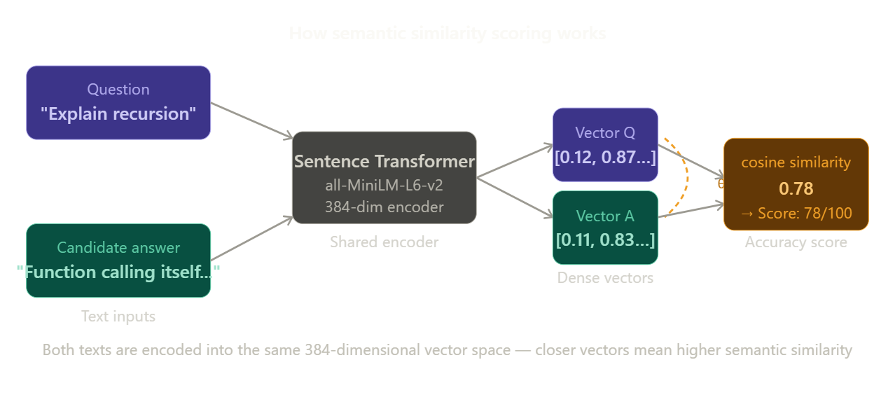
Both inputs are encoded into 384-dimensional vectors; cosine similarity produces the accuracy score
IntriVue is built as a three-service architecture: a React frontend, a Node.js backend, and a Python FastAPI AI service. The workflow for a single interview session proceeds as follows:
- The user uploads their resume PDF and pastes the job description. The AI service parses the PDF using pdfplumber [6] and extracts skills from both documents, then identifies the skill gap — skills required in the job description that are absent from the resume.
- Eight questions are generated using a 3-3-2 strategy: 3 resume-based, 3 job-requirement-based, and 2 skill-gap questions. This ensures the interview probes both what the candidate knows and what they still need to learn.
- The candidate answers each question verbally within 60 seconds. The webcam remains active throughout and the voice input is transcribed in real time using the Web Speech API [7].
- Each answer is sent to the AI service, which encodes both the question and the answer into 384-dimensional vectors using the Sentence Transformer model all-MiniLM-L6-v2 [3]. Cosine similarity between these vectors produces the Accuracy score.
- After all 8 answers, five scores are aggregated and a results dashboard is shown with a radar chart, bar chart, strengths, weaknesses, and a downloadable PDF scorecard generated by ReportLab [8].
The cosine similarity formula used for accuracy scoring is:
cosine_similarity(A, B) = (A · B) / (‖A‖ × ‖B‖)
A score of 1.0 means the two sentences are identical in meaning; near 0 means unrelated. In practice, a well-articulated correct answer scores between 0.60 and 0.85, which maps to 60–85 out of 100 on the accuracy scale.
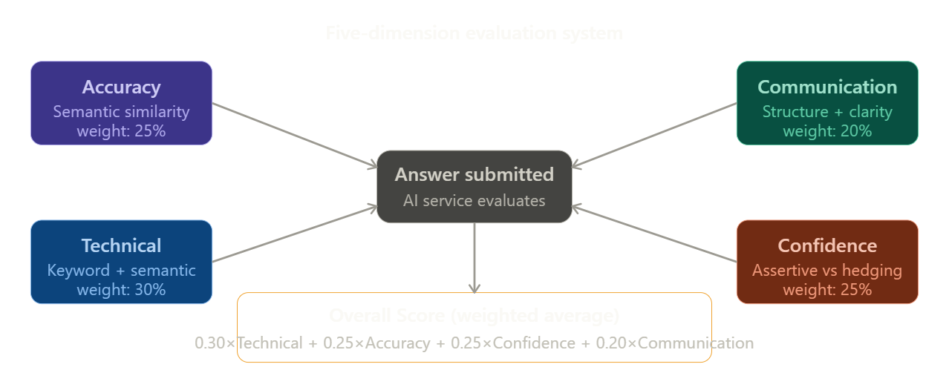
Each answer is evaluated across five dimensions; Technical carries the highest weight at 30%
The five scoring dimensions and their weights in the Overall score are:
- Accuracy (25%) – Cosine similarity between the answer and the question embeddings [1]
- Technical (30%) – Keyword density of domain terms plus semantic overlap with job description skills
- Communication (20%) – Word count, sentence completeness, and signposting phrases such as “firstly,” “however,” and “in conclusion”
- Confidence (25%) – Ratio of assertive language (“I built,” “I designed”) to hedging language (“I think,” “maybe”)
- Overall – Weighted average: 0.30×Technical + 0.25×Accuracy + 0.25×Confidence + 0.20×Communication

Advantages
- Meaning-aware evaluation: Unlike keyword matching, semantic similarity correctly scores paraphrased answers. A candidate who explains recursion without using the word ‘recursion’ still gets a fair score.
- Multi-dimensional feedback: The five-score system separates technical knowledge from communication ability. A candidate can score 85 on Accuracy but 40 on Communication — this is specific, actionable feedback.
- Personalised to the candidate: Questions are generated from the candidate’s own resume and their target job description, so every interview is unique and relevant.
- Real interview conditions: The 60-second timer, active webcam accessed via the MediaDevices API [7], and live voice input simulate actual interview pressure and build the right habits.
- Scalable and accessible: Being browser-based, the platform requires no installation. Any student with a webcam and internet connection can practise as many times as needed.
- Downloadable scorecard: The PDF report generated by ReportLab [8] can be saved and reviewed later, making it a useful tool for tracking improvement across multiple sessions.

Applications
- Campus placement preparation: Students can practise domain-specific interviews across Computer Science, Finance, Data Science, Business, Arts, and Marketing tailored to target companies.
- HR screening automation: Companies can use semantic evaluation pipelines to conduct a first round of interview screening at scale, reducing the time burden on human interviewers for entry-level roles.
- Online course assessments: E-learning platforms can replace written quizzes with spoken NLP-evaluated assessments, testing not just knowledge but the ability to articulate it clearly.
- Language and communication training: The communication and confidence scores can be used independently for spoken English or public speaking courses.
- Skill gap analysis for career counselling: The skill gap detection component can be used as a standalone tool to help students identify which competencies to develop before applying for a specific role.

Example / Case Study
To illustrate how IntriVue works in practice, consider a Computer Science student applying for a backend developer role. Their resume lists: Python, Flask, SQL, and Git. The job description requires: Python, Docker, Kubernetes, CI/CD, Flask, and REST APIs.
The skill gap detected is: [Docker, Kubernetes, CI/CD, REST APIs]. IntriVue generates 8 questions — 3 from the resume (e.g., “Describe how you have used Flask to build a backend service”), 3 from the job description (e.g., “What are the key benefits of containerising an application?”), and 2 from the skill gap (e.g., “Can you explain what Kubernetes is and what problem it solves?”).
The candidate answers the Kubernetes question by saying: “Kubernetes is a system that manages containers running across multiple machines. It handles things like restarting failed containers and balancing traffic across instances.”
The Sentence Transformer [1] encodes both the question and this answer into 384-dimensional vectors. The cosine similarity comes out to 0.71, giving an Accuracy score of 71. The answer contains relevant technical terms (containers, traffic balancing, restarting), giving a Technical score of 68. The answer is concise but lacks signposting, giving a Communication score of 55. The confident phrasing with no hedging gives a Confidence score of 80.
Overall = 0.30×68 + 0.25×71 + 0.25×80 + 0.20×55 = 20.4 + 17.75 + 20.0 + 11.0 = 69.15 ≈ 69 / 100
The results dashboard shows this score with a radar chart highlighting Communication as the weakest dimension. The generated weakness reads: “Your answers are technically sound but could benefit from a more structured delivery — try using signposting phrases like ‘firstly’ and ‘in conclusion’ to improve clarity.” This is the kind of targeted feedback that a practice session with a friend would never produce.

Conclusion
IntriVue demonstrates that NLP-based semantic evaluation is a practical and effective approach for automated interview assessment. By using Sentence Transformers [1] to compare the meaning of answers rather than their surface words, the system handles the natural variation in human speech fairly and robustly.
Key learning points from building and studying this system:
- Embedding-based similarity is fundamentally more powerful than keyword matching for tasks involving human language, because it captures meaning rather than form [1][2].
- Interview evaluation is multi-dimensional. Separating accuracy, technical depth, communication, and confidence gives candidates specific, actionable feedback rather than a single vague score.
- Personalisation matters. A question set built from the candidate’s own resume and target job description is far more useful than a generic question bank.
- Real interview pressure cannot be replicated by text boxes alone. The combination of webcam via the MediaDevices API [7], voice input via the Web Speech API [7], and a countdown timer changes how a candidate performs and practises.
- NLP techniques like Sentence Transformers are not limited to interview tools — they power search engines, recommendation systems, question answering, and most of modern production AI.

References
Research Papers
- Reimers, N., & Gurevych, I. (2019). Sentence-BERT: Sentence Embeddings using Siamese BERT-Networks. In Proceedings of the 2019 Conference on Empirical Methods in Natural Language Processing (EMNLP). Association for Computational Linguistics. https://arxiv.org/abs/1908.10084
- Devlin, J., Chang, M. W., Lee, K., & Toutanova, K. (2019). BERT: Pre-training of Deep Bidirectional Transformers for Language Understanding. In Proceedings of NAACL-HLT 2019 (pp. 4171–4186). Association for Computational Linguistics. https://arxiv.org/abs/1810.04805
- Wang, W., Wei, F., Dong, L., Bao, H., Yang, N., & Zhou, M. (2020). MiniLM: Deep Self-Attention Distillation for Task-Agnostic Compression of Pre-Trained Transformers. Advances in Neural Information Processing Systems (NeurIPS 2020). https://arxiv.org/abs/2002.10957
Libraries and Tools
- Reimers, N. (2019). sentence-transformers: Multilingual Sentence, Paragraph, and Image Embeddings using BERT & Co. [Software library]. Retrieved from https://www.sbert.net
- Ramirez, S. (2018). FastAPI: A modern, fast web framework for building APIs with Python 3.7+ based on standard Python type hints [Software framework]. Retrieved from https://fastapi.tiangolo.com
- Singer-Vine, J. (2016). pdfplumber: Plumb a PDF for detailed information about each text character, rectangle, and line [Software library]. Retrieved from https://github.com/jsvine/pdfplumber
Web Standards and Documentation
- Mozilla Developer Network. (2023). Web Speech API and MediaDevices.getUserMedia(). MDN Web Docs. Mozilla Foundation. Retrieved from https://developer.mozilla.org/en-US/docs/Web/API/Web_Speech_API and https://developer.mozilla.org/en-US/docs/Web/API/MediaDevices/getUserMedia
- ReportLab Group. (2022). ReportLab PDF Library User Guide (Version 3.6). ReportLab. Retrieved from https://www.reportlab.com/docs/reportlab-userguide.pdf
- Pedregosa, F., et al. (2011). Scikit-learn: Machine Learning in Python. Journal of Machine Learning Research, 12, 2825–2830. Retrieved from https://scikit-learn.org

