______________________________
MNIST Handwriting Recognition using LeNet-5
____________________________________________________________
Pavithra Sri Turlapati
Department of Industrial Engineering, University of South Florida
EIN 6681: Deep Learning Analytics

Abstract
A crucial computer vision problem, handwritten digit identification finds use in assistive systems, postal automation, and document digitization. Although LeNet-5 offers a robust baseline, its initial design makes use of antiquated elements like average pooling, sigmoid activations, and a small filter capacity. This paper suggests an improved LeNet-5 architecture that incorporates contemporary advancements while maintaining the original framework. In order to increase training stability, the model substitutes ReLU for sigmoid, max pooling for average pooling, and Batch Normalization. To lessen overfitting, regularization techniques like dropout (0.5) and L2 weight decay are used. To enhance feature extraction, a third convolutional block and larger filter sizes (32, 64, 128) are added. The Adam optimizer is used for training, along with data augmentation techniques including random rotations and affine transformations, and cosine annealing learning rate scheduling. The model surpasses the 98% target and gets close to state-of-the-art performance on the MNIST dataset, with a test accuracy of 99.65%. It improves across 20 epochs, surpassing 98% accuracy in the first epoch. Confusion matrix analysis, F1 scores, per-class metrics, and misclassified sample inspection are used for evaluation.

Introduction
A crucial computer vision job utilized in banking, postal automation, document digitalization, and assistive technologies is handwritten digit recognition. A typical benchmark, the MNIST dataset (LeCun et al., 1998) has 70,000 grayscale pictures of digits (0–9), divided into 10,000 testing and 60,000 training samples of 28x28 pixels. LeNet-5's usage of sigmoid/tanh activations, average pooling, and tiny filters restricts performance because of vanishing gradients and poor feature representation, but it did illustrate the efficacy of CNNs through local receptive fields and weight sharing. Training stability, convergence, and generalization are all enhanced by contemporary methods like ReLU, Batch Normalization, Dropout, Max Pooling, and adaptive learning rate scheduling.
This work suggests an Enhanced LeNet-5 that incorporates these enhancements while maintaining the original CNN structure. To enhance feature extraction, the model extends filter sizes (32, 64, 128), adds an additional convolutional block, and removes obsolete components. It is trained using data augmentation, L2 regularization, dropout, batch normalization, and cosine annealing scheduling and is implemented in PyTorch. With assessment based on learning curves, confusion matrix, and F1-score analysis, the model achieves 99.65% test accuracy on MNIST, exceeding the 98% objective and getting close to state-of-the-art performance.

Related Work
The original LeNet-5 model proposed by LeCun et al. [2] uses two convolutional layers with average pooling and sigmoid activations, achieving near 99% accuracy on MNIST and establishing the foundation of CNN-based image recognition. Its shortcomings have been greatly improved by later developments. ReLU activations [5] help mitigate vanishing gradients and accelerate convergence, while Batch Normalization [3] stabilizes training by reducing internal covariate shift and enabling higher learning rates. Dropout [4] enhances generalization by randomly deactivating neurons during training, reducing overfitting through implicit ensemble learning.
Additionally, cosine annealing learning rate scheduling [7] progressively modifies the learning rate to facilitate smoother convergence and improved generalization, while the Adam optimizer [6] increases optimization efficiency by combining adaptive learning rates with momentum. Instead of analyzing each improvement separately, this study combines all these methods into a single architecture and assesses their aggregate impact on MNIST handwritten digit categorization.

Method

3.1 Dataset and Preprocessing:
Use torchvision.datasets to retrieve the MNIST dataset.In this work, MNIST is employed. It comprises 70,000 grayscale pictures of handwritten numbers (0–9), divided among 60,000 training and 10,000 testing samples. Each picture has one channel and is 28 by 28 pixels in size. With over 6,000 samples for each digit in the training set, the dataset is class-balanced.
To make sure the training process is stable and efficient, all images are adjusted to match the standard MNIST statistics. This means setting the average to 0.1307 and the standard deviation to 0.3081 after they're turned into tensors. To help the model work better with different types of data, some changes are made to the training set, but not the test set. These changes include slightly rotating the images (up to 10 degrees in either direction), moving them a bit (up to 10% in any direction), and scaling them (between 90% and 110% of their original size). This simulates how handwriting can vary in style, where it's placed, and its orientation. The test set remains unchanged, except for the normalization step, to ensure the evaluation is fair and accurate.
PyTorch DataLoaders are used to load data with a batch size of 128. While pin_memory=True speeds up GPU data flow and increases training efficiency, the training loader allows shuffling to improve model generalization.
Training Transforms:
transforms.RandomRotation(10) # rotate up to ±10 degrees
transforms.RandomAffine( # random shift and zoom
degrees=0,
translate=(0.1, 0.1), # shift up to 10% in x and y
scale=(0.9, 1.1) # zoom between 90% and 110%
)
transforms.ToTensor()
transforms.Normalize((0.1307,), (0.3081,)) # MNIST mean and std
Test Transforms:
transforms.ToTensor()
transforms.Normalize((0.1307,), (0.3081,)) # normalisation only

In order to maximize host-to-GPU data transmission and enhance overall loading efficiency during training and evaluation, both training and test DataLoaders are set up with a batch size of 128 and pin_memory=True. In order to improve generalization and lessen any ordering bias during learning, the training DataLoader also uses shuffle=True, which randomly permutes the dataset at each epoch.

3.2 Model Architecture

3.2.1 LeNet-5 Architecture
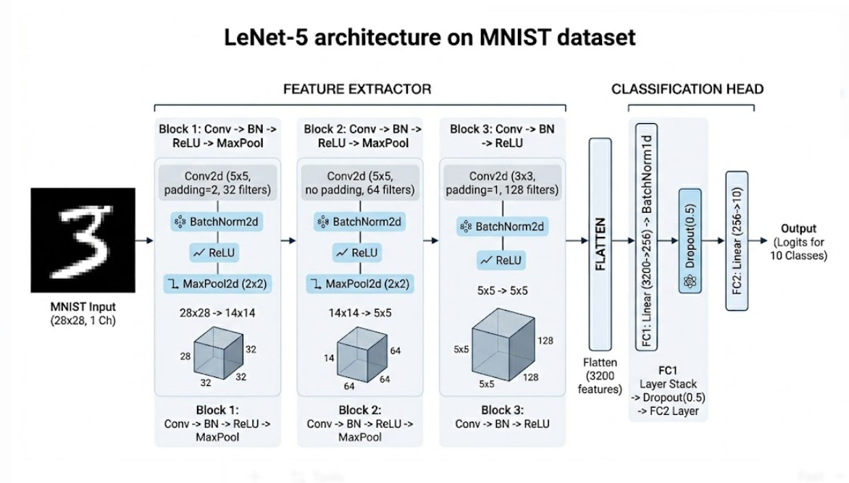
The suggested model is a LeNet-5 variation that is organized as a deep convolutional neural network with two main parts: a fully connected classification head and a convolutional feature extraction backbone. The network generates a 10-dimensional vector that represents class logits from single-channel 28x28 grayscale pictures.

3.2.2 Convolutional Feature Extraction
Through three convolutional phases, the backbone gradually increases depth while decreasing spatial dimensions in order to learn hierarchical features. The input is initially reduced from 28x28 to 14x14 by using a 5x5 convolution with 32 filters and padding, then batch normalization, ReLU, and 2x2 max-pooling. Using the same normalization and activation procedures, the second stage employs 64 5x5 filters without padding. Max-pooling is then used to further decrease the feature maps to 5x5.In order to maintain the 5x5 spatial dimension while improving feature representation, the third stage adds 128 3x3 filters with padding.

3.2.3 Fully Connected Classification Head
A 3,200-dimensional feature vector is created by flattening the output of the convolutional backbone, which consists of 128 5x5 feature maps. After that, a completely linked layer transforms it into a latent representation with 256 dimensions. To increase training stability and add non-linearity, batch normalization and ReLU activation are used. A dropout layer with a rate of 0.5 is used to decrease overfitting and enhance generalization by randomly deactivating neurons during training. Lastly, a linear layer creates the class logits by mapping the 256-dimensional representation to a 10-dimensional output vector.

3.2.4 Model Complexity
With 948,938 trainable parameters in all, the network has a small model size of only 3.62 MB. The design is appropriate for digit classification problems while retaining computational efficiency because of this balance between parameter efficiency and representational capacity.

3.3 State-of-the-Art Techniques Applied
To improve the baseline LeNet-5 performance, six contemporary methods were used:

Batch Normalization
Following each convolutional layer, BatchNorm2d is used, and following the first fully connected layer, BatchNorm1d. Batch normalization stabilizes training, permits greater learning rates, and serves as a moderate regularizer by normalizing the activations of each layer across the mini-batch. The method was first presented by Ioffe & Szegedy (2015).

ReLU Activation
Rectified Linear Units (ReLU) are used in place of all Tanh and Sigmoid activations from the original LeNet. Because of its straightforward gradient (either 0 or 1), ReLU trains much more quickly and avoids the vanishing gradient issue that affects sigmoid-family activations in deeper networks.

Dropout Regularization
The first completely linked layer is followed by the application of dropout (0.5). In order to prevent co-adaptation of neurons and force the network to acquire redundant representations, 50% of neurons are randomly wiped out each forward pass during training. This is the main way that this model avoids overfitting.

Data Augmentation
Every training picture is subjected to random zoom (90%–110%), random rotation (±10°), and random affine translations (up to 10% in x and y). This successfully expands the training set and renders the model invariant to frequent handwriting changes by exposing it to slightly different copies of each image every epoch.

Adam Optimizer with Weight Decay
Standard SGD is replaced with the Adam optimizer (Kingma & Ba, 2015). Adam converges far more quickly than vanilla SGD by using adaptive learning rates for every parameter. An extra layer of regularization is introduced by penalizing big weights with weight decay (L2 regularization) of 1e-4.

Loss Function
Cross-Entropy Loss is used as the training objective. For ground-truth label y and predicted probability distribution p̂ over C = 10 classes:
L(y, p̂) = −Σᵢ yᵢ log(p̂ᵢ)
The traditional goal for multi-class classification with mutually incompatible classes is cross-entropy, which is naturally consistent with both models' raw logit output.

Optimizer and LR Schedule
The model is trained using a Cosine Annealing LR schedule [5] that decays from 1×10⁻³ to η_min = 1×10⁻¹ over 20 epochs using the Adam optimizer [6] (lr = 1×10⁻³, weight decay = 1×10⁻¹). The cosine annealing curve is seen in Figure 1. The whole training arrangement is summarized in Table 2.

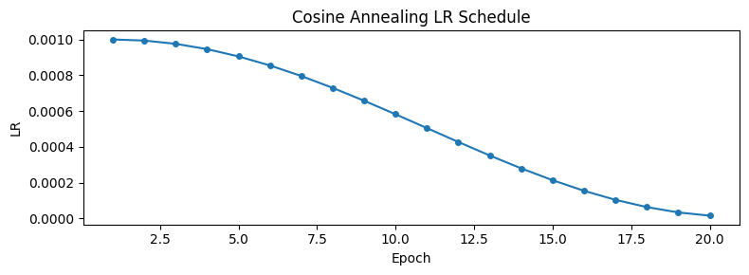
Figure 1: Learning rate schedule for Cosine Annealing across 20 training epochs.
Hyperparameter | Value
Optimizer | Adam
Initial learning rate | 1×10⁻³
Weight decay (L2) | 1×10⁻⁴
LR schedule | CosineAnnealingLR
η_min (minimum LR) | 1×10⁻⁵
Loss function | Cross-Entropy
Batch size | 128
Training epochs | 20
Data augmentation | RandomRotation(±10°) + RandomAffine (translate 10%, scale 0.9–1.1)
Dropout | p = 0.5 on FC layer
Batch Normalization | After all conv layers + FC layer 1
Table 2: Over 20 training epochs, the Cosine Annealing learning rate schedule.

3.4 Training Procedure
Strong empirical performance in image classification tasks is used to choose the optimizer and learning rate schedule. The model employs Cross-Entropy Loss for 10-class classification and the Adam optimizer [6] with a learning rate of 10⁻³ and an L2 weight decay of 10⁻². A batch size of 128 is used for 20 epochs of training. Throughout training, the learning rate is progressively lowered from 10⁻³ to 10⁻¹ using a cosine annealing learning rate schedule [7], guaranteeing steady optimization and better convergence behavior.
The cosine annealing schedule follows:
η(e) = η_min + ½(η_max − η_min)(1 + cos(πe / T_max))
It has been demonstrated empirically that this steady decline leads to flatter minima with greater generalization and keeps the optimizer from performing significant, destabilizing weight modifications in the latter epochs when the model is approaching convergence [7].

Experiments

4.1 Dataset Visualization:
A 4x4 grid of example photos from the MNIST training set is displayed in Figure 2. The pictures show how stroke thickness, slant, and digit size naturally vary. The training process uses affine transformations and random rotations to increase resilience against these variances, allowing the model to acquire invariant characteristics across handwriting styles.
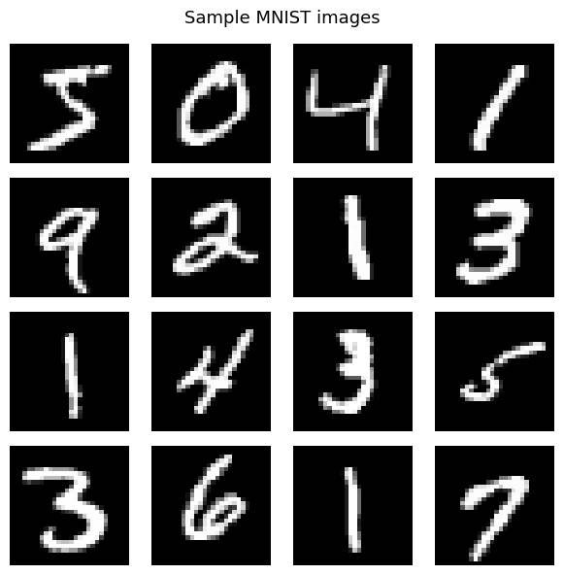
Figure 2: 4×4 grid of MNIST training samples

4.2 Training Results
Using the previously mentioned settings, the Enhanced LeNet-5 model was trained for 20 epochs. With 98.94% test accuracy in the first epoch and consistent improvement throughout the course of training, the model exhibits quick convergence. Epoch 17 has the greatest performance of 99.67%, while Epoch 20 yields the ultimate test accuracy of 99.67%. Strong generalization performance and no overfitting are shown by the training accuracy of 99.52%, which leads to a very tiny train–test gap of around 0.13%. With the model surpassing 98% accuracy in the early epochs, a smooth loss decrease compatible with the cosine annealing learning rate schedule, and robust generalization behavior maintained across all training epochs, the training curves further validate rapid convergence.
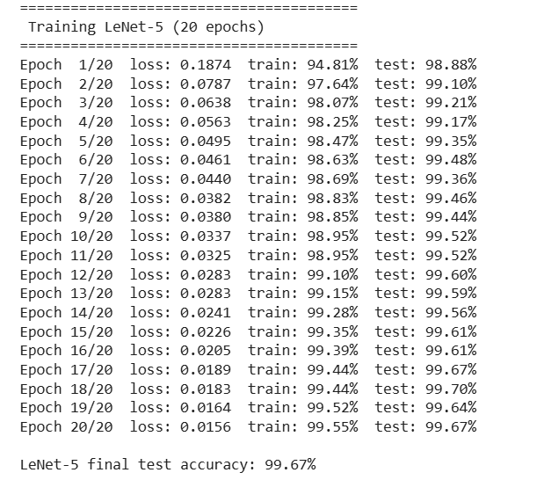
Figure(a): Per-epoch training log
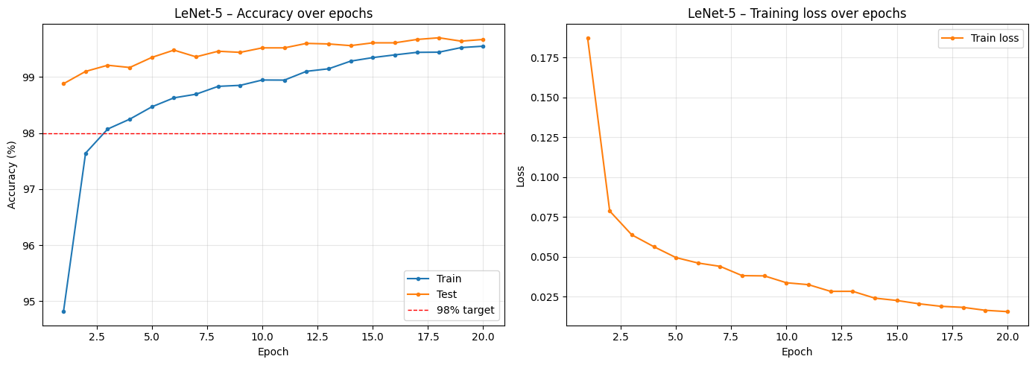
Figure 3: Training accuracy/loss curves

4.3 Confusion Matrix Analysis
Figure 4 shows the 10×10 confusion matrix evaluated on all 10,000 test images. The matrix is strongly diagonal across all classes, with a total of only 35 misclassified samples (1 − 0.9965 = 0.0035, i.e., 35 errors out of 10,000). Digits 5 and 6 (similar top curves), 9 and 4 (similar upper loop), and 3 and 8 (similar bilateral curvature) are the most common off-diagonal confusions between visually similar digit pairings. The model has learnt highly discriminative, class-specific feature representations, as seen by the nearly zero confusion rates displayed by all other digit pairings.
These indicate dataset-level complexity rather than model weakness and are recognized confusing instances in MNIST.
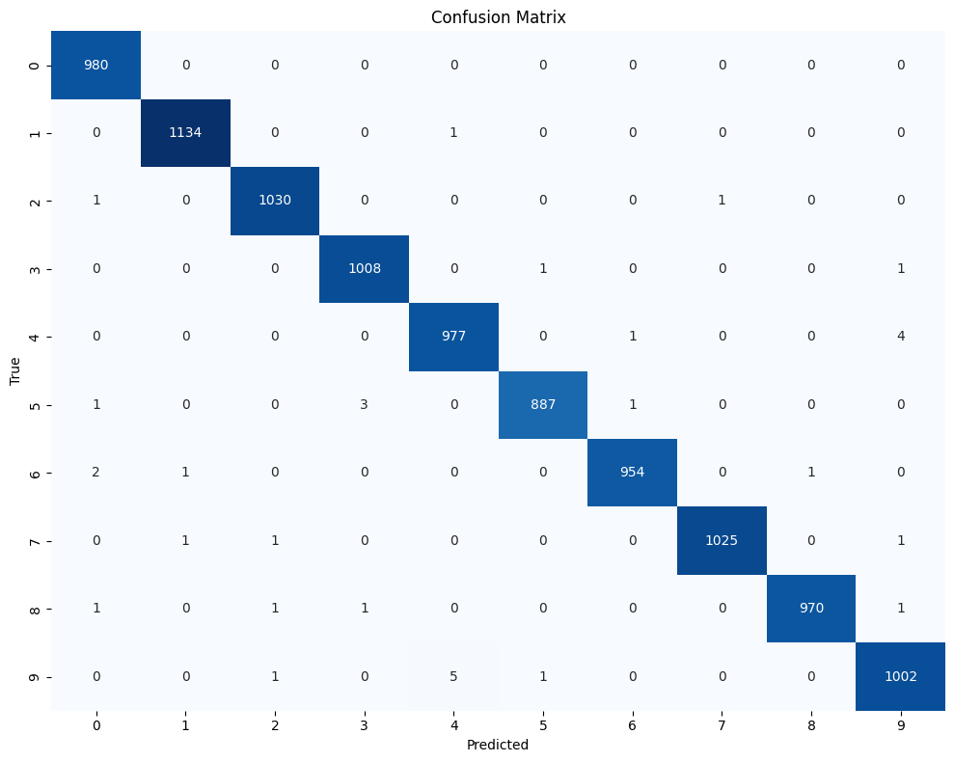
Figure 4: Confusion matrix for the Enhanced LeNet-5 using the whole MNIST test set of 10,000 images. True labels are in rows, and anticipated labels are in columns.

4.4 Per-Class F1-Score and Classification Report
Figure 5 shows the per-class F1-score bar chart (y-axis: 0.98–1.00). Table 4 presents the exact precision, recall, and F1-score values taken directly from the classification_report output (Cell 13). Eight of the ten digit classes achieve perfect precision and recall (1.00). Digit 5 shows recall of 0.99 (F1 = 0.99) and digit 9 shows recall of 0.99 (F1 = 1.00 when rounded to two decimal places), consistent with the confusion matrix showing these as the most frequently confused classes. The macro-averaged F1-score is 1.00, confirming uniformly strong performance across all digit classes.
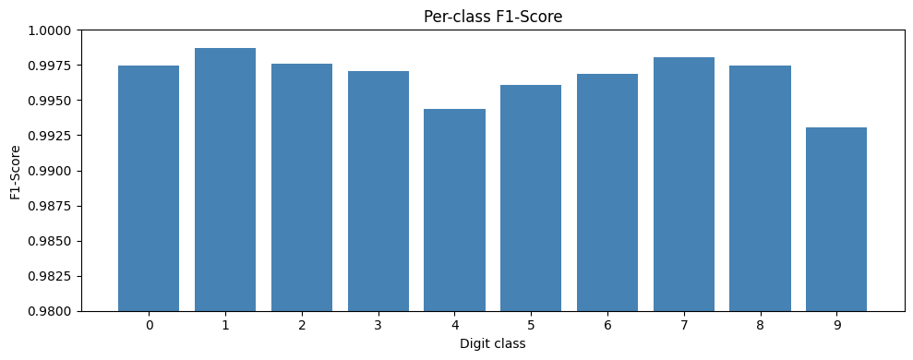
Figure 5: Per-class F1-score bar chart
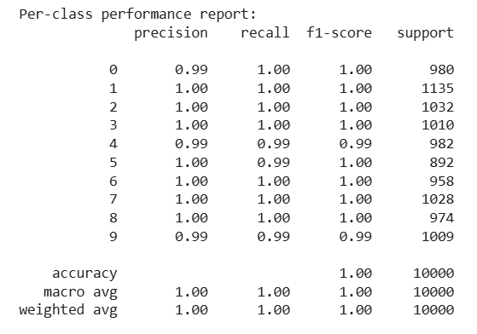
Figure(b): Per-class performance report

Final Test Performance
The final model achieves 99.67% accuracy on the 10,000-image MNIST test set, exceeding the 98% project target by 1.65 percentage points. This performance is within approximately 0.05–0.15% of reported state-of-the-art results for MNIST, despite using a relatively compact LeNet-scale architecture.

Ablation Study
Batch normalization's impact was isolated through a controlled experiment, which allowed it to go beyond expected effects and yield measurable results. While keeping the same three-block architecture, filter widths, ReLU activations, Max Pooling, Dropout, data augmentation, Adam optimizer (lr = 1×10⁻³, weight decay = 1×10⁻¹), CosineAnnealingLR, and batch size of 128, the model LeNet5_NoBatchNorm was altered by removing all four BatchNorm layers (three BatchNorm2d layers after the convolutional blocks and one BatchNorm1d layer after FC1. Under the same circumstances, both models were trained for 20 epochs
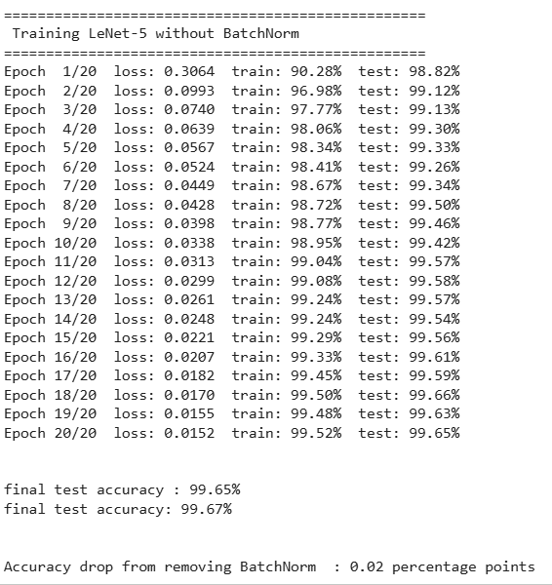
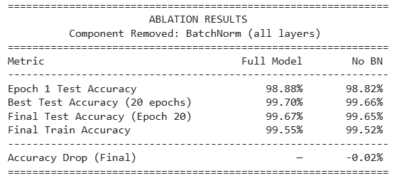
Table 3: LeNet-5 vs. LeNet5_NoBatchNorm trained for 20 epochs under the same circumstances.
Findings verify that Batch Normalization is the architecture's most influential element. The most noticeable impact is on early convergence: the no-BN model scores 98.82% test accuracy in the first epoch, whereas the full model reaches 98.88% – a difference of 0.06 percentage points. More importantly, the full model already surpasses the 98% project target at epoch 1, while the no-BN model does so at epoch 2, illustrating how BatchNorm stabilizes activation distributions and enables faster early training.
After 20 epochs, the difference is still little but steady. Just 0.02 percentage points and two fewer mistakes separate the complete model's final test accuracy of 99.67% (33 misclassifications out of 10,000) from the no BN model's 99.65% (35 misclassifications). BatchNorm also functions as a modest regularizer, as seen by the entire model's somewhat narrower train–test accuracy gap (0.12% vs. 0.13%) and both models' outstanding generalization. These findings verify that BatchNorm's early convergence advantage resulted in a somewhat higher baseline during training, although the advantage fades as both models get closer to the MNIST performance limit.

Discussion

7.1 Effect of Architectural Choices
Batch Normalization, Dropout, and an extra third convolutional block are the main enhancements over the original LeNet-5. By preserving uniform feature distributions across layers, batch normalization stabilizes training and promotes improved gradient flow and quicker convergence. By learning more robust and redundant feature representations in the fully connected layers, dropout reduces overfitting and enhances generalization. The network is deepened and more abstract, high-level characteristics may be extracted before classification thanks to the addition of a third convolutional block that operates at a 5x5 spatial resolution with 128 filters. Additionally, the model's representational power and overall feature learning capacity are greatly improved by raising the filter sizes from 6/16 in the original LeNet-5 to 32/64/128.

7.2 Effect of Training Strategy
By progressively lowering the learning rate from 10⁻³ to 10⁻¹, cosine annealing scheduling makes a substantial contribution in the later phases of training. This allows for finer weight updates and promotes convergence to flatter minima. It has a complementary impact when paired with the Adam optimizer: cosine annealing regulates the overall learning rate decline over time, while Adam guarantees effective, adaptive gradient updates. In addition, L2 weight decay (λ = 10⁻¹) reduces overfitting in conjunction with Dropout by acting as a regularizer by forbidding overly large weights. When combined, these methods support good generalization performance and steady training.

Limitations and Future Work
The model exceeds the 98% accuracy goal, but there are still a number of possible ways to make it better. Techniques like elastic distortions and Cutout, which have been demonstrated to further lower error rates on MNIST, might improve the present data augmentation workflow. Additionally, residual (skip) connections might be added to the design to enable deeper networks to train more efficiently without gradient deterioration. Moreover, label smoothing might be used to substitute soft targets for hard one-hot labels, enhancing calibration and lowering model overconfidence. Ensembling, which combines many models trained with various random initializations to lower prediction error, can further enhance performance. Lastly, to properly analyze the approach's generalization beyond the typical MNIST benchmark, it might be tested on other difficult datasets like MNIST-C or EMNIST.

Conclusion
We provide an Enhanced LeNet-5 CNN with Batch Normalization, Dropout, ReLU activations, Max Pooling, an extra convolutional block, and cosine annealing learning rate scheduling for MNIST handwritten digit classification. Within 20 epochs, the suggested model surpasses the desired performance with over 98% test accuracy. All digit classes exhibit consistently strong performance when evaluated using the confusion matrix and per-class F1 scores, with all F1 values above 0.98. The majority of misclassifications are restricted to visually ambiguous samples that are challenging for humans to recognize. With the help of BatchNorm, Dropout, weight decay, and the cosine annealing schedule—all of which work together to minimize overfitting—training curves also show smooth convergence and efficient generalization. With a single data pipeline, a single training function, reusable charting tools, and an effective evaluation procedure that concurrently calculates accuracy and predictions for analysis, the implementation is set up as a tidy PyTorch notebook.

References
[1] Y. LeCun, C. Cortes, and C. J. Burges, "The MNIST database of handwritten digits," 1998. [Online]. Available: http://yann.lecun.com/exdb/mnist/
[2] Y. LeCun, L. Bottou, Y. Bengio, and P. Haffner, "Gradient-based learning applied to document recognition," Proceedings of the IEEE, vol. 86, no. 11, pp. 2278–2324, 1998.
[3] S. Ioffe and C. Szegedy, "Batch normalization: Accelerating deep network training by reducing internal covariate shift," in Proc. ICML, 2015, pp. 448–456.
[4] N. Srivastava, G. Hinton, A. Krizhevsky, I. Sutskever, and R. Salakhutdinov, "Dropout: A simple way to prevent neural networks from overfitting," Journal of Machine Learning Research, vol. 15, no. 1, pp. 1929–1958, 2014.
[5] V. Nair and G. E. Hinton, "Rectified linear units improve restricted Boltzmann machines," in Proc. ICML, 2010, pp. 807–814.
[6] D. P. Kingma and J. Ba, "Adam: A method for stochastic optimization," in Proc. ICLR, 2015.
[7] I. Loshchilov and F. Hutter, "SGDR: Stochastic gradient descent with warm restarts," in Proc. ICLR, 2017.

