UNIT – 3
LEETCODE EXERCISE
1. Combine Two Tables
Table: Person
Column Name | Type
PersonId | int
FirstName | varchar
LastName | varchar

PersonId is the primary key column for this table.

Table: Address
Column Name | Type
AddressId | int
PersonId | int
City | varchar
State | varchar

AddressId is the primary key column for this table.
Problem Summary
Write a SQL query for a report that provides the following information for each person in the Person table, regardless if there is an address for each of those people:
FirstName, LastName, City, State.
SQL Schema
CREATE TABLE Person (personId INT PRIMARY KEY,lastName VARCHAR(255),firstName VARCHAR(255));
CREATE TABLE Address (addressId INT PRIMARY KEY,personId INT,city VARCHAR(255),state VARCHAR(255));
INSERT INTO Person (personId, lastName, firstName) VALUES
(1, 'Wang', 'Allen'),
(2, 'Alice', 'Bob');
INSERT INTO Address (addressId, personId, city, state) VALUES
(1, 2, 'New York City', 'New York'),
(2, 3, 'Leetcode', 'California');

Person
personId | lastName | firstName
1 | Wang | Allen
2 | Alice | Bob
Address
addressId | personId | city | state
1 | 2 | New York City | New York
2 | 3 | Leetcode | California
MySQL Solution
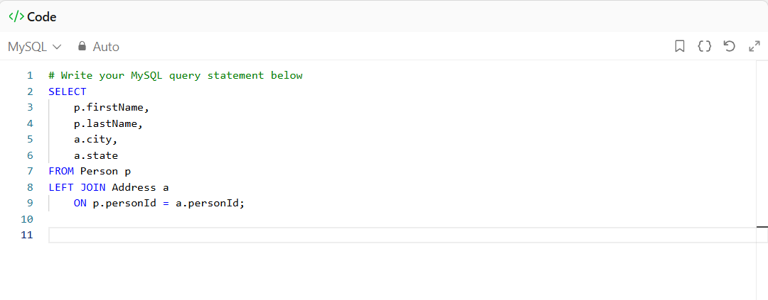
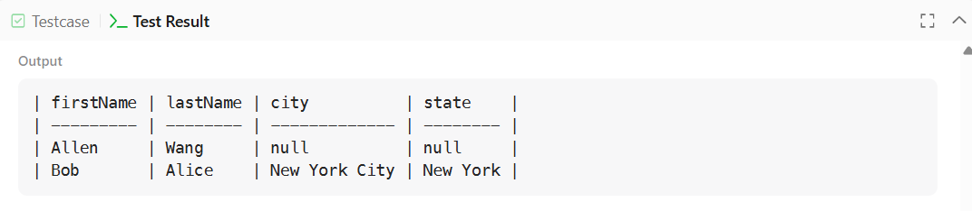

2. Employees Earning More Than Their Managers
Table: Employee
Column Name | Type
id | int
name | varchar
salary | int
managerId | int

id is the primary key column for this table.
Problem Summary
Write a solution to find the employees who earn more than their managers.
SQL Schema
CREATE TABLE Employee (id INT PRIMARY KEY,name VARCHAR(255),salary INT,managerId INT);
INSERT INTO Employee (id, name, salary, managerId) VALUES
(1, 'Joe', 70000, 3),
(2, 'Henry', 80000, 4),
(3, 'Sam', 60000, NULL),
(4, 'Max', 90000, NULL);
Employee
id | name | salary | managerId
1 | Joe | 70000 | 3
2 | Henry | 80000 | 4
3 | Sam | 60000 | NULL
4 | Max | 90000 | NULL

MySQL Solution
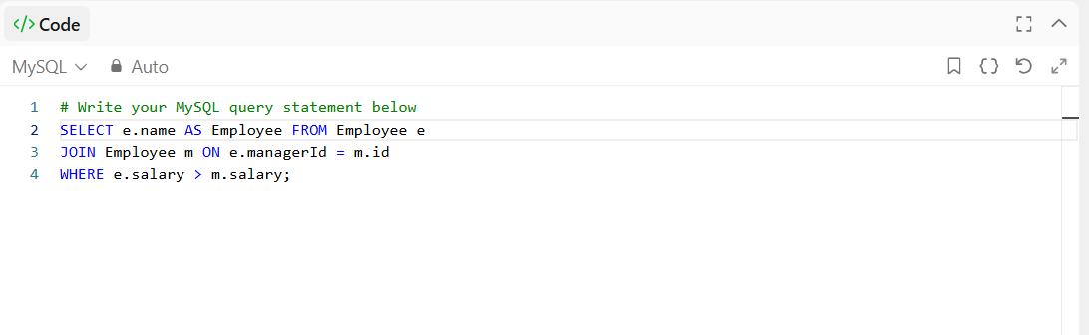
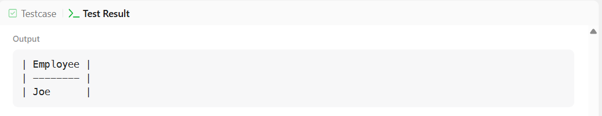

3. Customer Who Visited but Did Not Make Any Transactions
Table: Visits
Column Name | Type
visit_id | int
customer_id | int

visit_id is the primary key column for this table.
Table: Transactions
Column Name | Type
transaction_id | int
visit_id | int
amount | int

transaction_id is the primary key column for this table.
Problem Summary
Write a solution to find the IDs of the users who visited without making any transactions and the number of times they made these types of visits.
SQL Schema
Create table If Not Exists Visits(visit_id int, customer_id int)
Create table If Not Exists Transactions(transaction_id int, visit_id int, amount int)
Truncate table Visits
insert into Visits (visit_id, customer_id) values ('1', '23')
insert into Visits (visit_id, customer_id) values ('2', '9')
insert into Visits (visit_id, customer_id) values ('4', '30')
insert into Visits (visit_id, customer_id) values ('5', '54')
insert into Visits (visit_id, customer_id) values ('6', '96')
insert into Visits (visit_id, customer_id) values ('7', '54')
insert into Visits (visit_id, customer_id) values ('8', '54')
Truncate table Transactions
insert into Transactions (transaction_id, visit_id, amount) values ('2', '5', '310')
insert into Transactions (transaction_id, visit_id, amount) values ('3', '5', '300')
insert into Transactions (transaction_id, visit_id, amount) values ('9', '5', '200')
insert into Transactions (transaction_id, visit_id, amount) values ('12', '1', '910')
insert into Transactions (transaction_id, visit_id, amount) values ('13', '2', '970')

Visits
visit_id | customer_id
1 | 23
2 | 9
4 | 30
5 | 54
6 | 96
7 | 54
8 | 54
Transactions
transaction_id | visit_id | amount
2 | 5 | 310
3 | 5 | 300
9 | 5 | 200
12 | 1 | 910
13 | 2 | 970
MySQL Solution
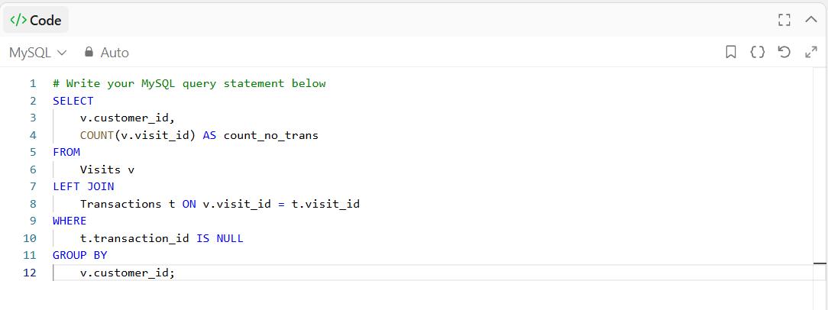
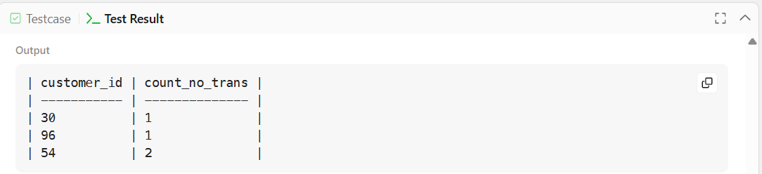

4. Rising Temperature
Table: Weather
Column Name | Type
Id | int
RecordDate | date
Temperature | int

id is the primary key column for this table.
Problem Summary
Write a solution to find all dates' id with higher temperatures compared to its previous dates (yesterday).
SQL Schema
Create table If Not Exists Weather (Id int, RecordDate date, Temperature int);
Truncate table Weather;
insert into Weather (Id, RecordDate, Temperature) values ('1', '2015-01-01', '10');
insert into Weather (Id, RecordDate, Temperature) values ('2', '2015-01-02', '25');
insert into Weather (Id, RecordDate, Temperature) values ('3', '2015-01-03', '20');
insert into Weather (Id, RecordDate, Temperature) values ('4', '2015-01-04', '30');
Weather
Id | RecordDate | Temperature
1 | 2015-01-01 | 10
2 | 2015-01-02 | 25
3 | 2015-01-03 | 20
4 | 2015-01-04 | 30

MySQL Solution
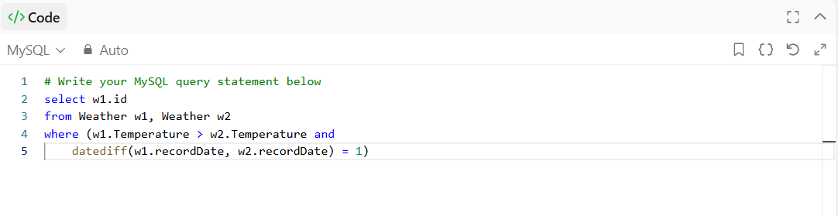
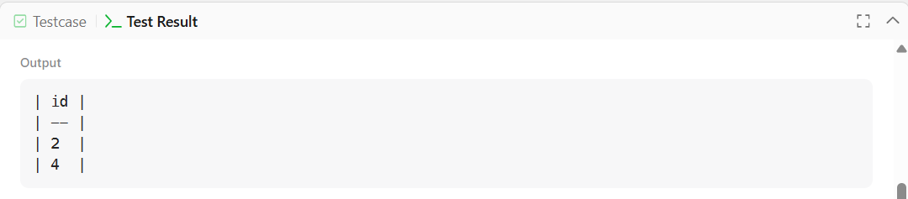

5. Managers with at Least 5 Direct Reports
Table: Employee
Column Name | Type
Id | int
Name | varchar
Department | varchar
mangerId | int

Id is the primary key column for this table.
Problem Summary
Write a solution to find managers with at least five direct reports.
SQL Schema
Create table If Not Exists Employee (id int, name varchar(255), department varchar(255), managerId int)
Truncate table Employee
insert into Employee (id, name, department, managerId) values ('101', 'John', 'A', NULL)
insert into Employee (id, name, department, managerId) values ('102', 'Dan', 'A', '101')
insert into Employee (id, name, department, managerId) values ('103', 'James', 'A', '101')
insert into Employee (id, name, department, managerId) values ('104', 'Amy', 'A', '101')
insert into Employee (id, name, department, managerId) values ('105', 'Anne', 'A', '101')
insert into Employee (id, name, department, managerId) values ('106', 'Ron', 'B', '101')

Employee
id | name | department | managerId
101 | John | A | NULL
102 | Dan | A | 101
103 | James | A | 101
104 | Amy | A | 101
105 | Anne | A | 101
106 | Ron | B | 101

MySQL Solution
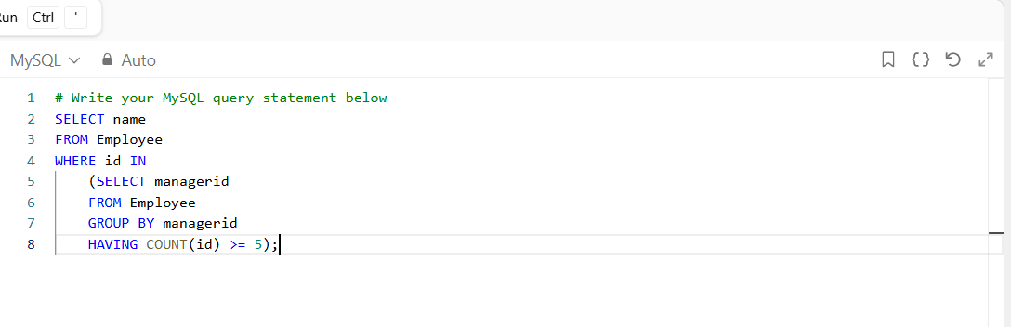
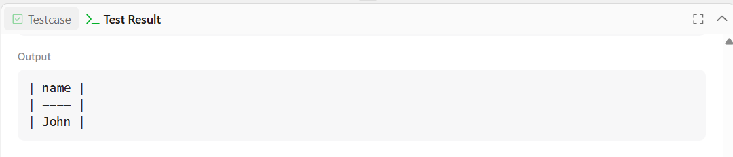

6. Average Time of Process per Machine
Table: Activity
Column Name | Type
machine_id | int
process_id | int
activity_type | enum
timestamp | float

machine_id is the primary key column for this table.
Problem Summary
Write a solution to find the average time each machine takes to complete a process.
SQL Schema
Create table If Not Exists Activity (machine_id int, process_id int, activity_type ENUM('start', 'end'), timestamp float)
Truncate table Activity
insert into Activity (machine_id, process_id, activity_type, timestamp) values
('0', '0', 'start', '0.712'),
('0', '0', 'end', '1.52'),
('0', '1', 'start', '3.14'),
('0', '1', 'end', '4.12'),
('1', '0', 'start', '0.55'),
('1', '0', 'end', '1.55'),
('1', '1', 'start', '0.43'),
('1', '1', 'end', '1.42'),
('2', '0', 'start', '4.1'),
('2', '0', 'end', '4.512'),
('2', '1', 'start', '2.5'),
('2', '1', 'end', '5');

Activity
machine_id | process_id | activity_type | timestamp
0 | 0 | start | 0.712
0 | 0 | end | 1.52
0 | 1 | start | 3.14
0 | 1 | end | 4.12
1 | 0 | start | 0.55
1 | 0 | end | 1.55
1 | 1 | start | 0.43
1 | 1 | end | 1.42
2 | 0 | start | 4.1
2 | 0 | end | 4.512
2 | 1 | start | 2.5
2 | 1 | end | 5
MySQL Solution
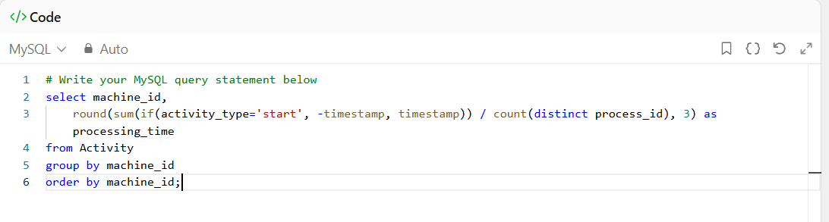
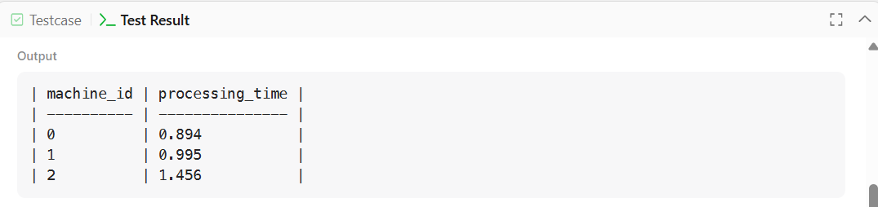

7. Product Sales Analysis I
Table: Sales
Column Name | Type
sale_id | int
product_id | int
year | int
quantity | int
price | int

sale_id,year is the primary key column for this table.

Table: Product
Column Name | Type
product_id | int
product_name | varchar

product_id is the primary key column for this table.
Problem Summary
Write a solution to report the product_name, year, and price for each sale_id in the Sales table.
SQL Schema
Create table Sales (sale_id int, product_id int, year int, quantity int, price int);
Create table Product (product_id int, product_name varchar(10));
Truncate table Sales;
insert into Sales (sale_id, product_id, year, quantity, price) values ('1', '100', '2008', '10', '5000');
insert into Sales (sale_id, product_id, year, quantity, price) values ('2', '100', '2009', '12', '5000');
insert into Sales (sale_id, product_id, year, quantity, price) values ('7', '200', '2011', '15', '9000');
Truncate table Product;
insert into Product (product_id, product_name) values ('100', 'Nokia');
insert into Product (product_id, product_name) values ('200', 'Apple');
insert into Product (product_id, product_name) values ('300', 'Samsung');

Sales
sale_id | product_id | year | quantity | price
1 | 100 | 2008 | 10 | 5000
2 | 100 | 2009 | 12 | 5000
7 | 200 | 2011 | 15 | 9000
Product
product_id | product_name
100 | Nokia
200 | Apple
300 | Samsung
MySQL Solution
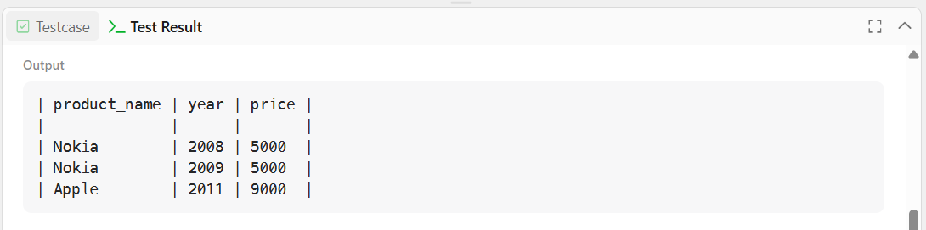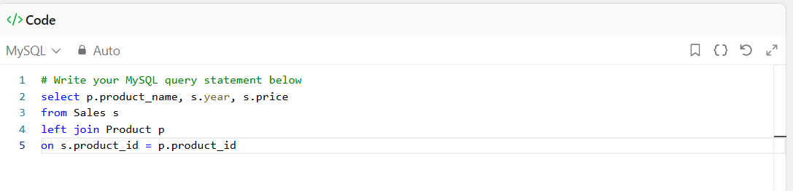

8. Product Sales Analysis II
Table: Sales
Column Name | Type
sale_id | int
product_id | int
year | int
quantity | int
price | int

sale_id,year is the primary key column for this table.

Table: Product
Column Name | Type
product_id | int
product_name | varchar

product_id is the primary key column for this table.
Problem Summary
Write an SQL query that reports the total quantity sold for every product id.
SQL Schema
Create table Sales (sale_id int, product_id int, year int, quantity int, price int);
Create table Product (product_id int, product_name varchar(10));
Truncate table Sales;
insert into Sales (sale_id, product_id, year, quantity, price) values ('1', '100', '2008', '10', '5000');
insert into Sales (sale_id, product_id, year, quantity, price) values ('2', '100', '2009', '12', '5000');
insert into Sales (sale_id, product_id, year, quantity, price) values ('7', '200', '2011', '15', '9000');
Truncate table Product;
insert into Product (product_id, product_name) values ('100', 'Nokia');
insert into Product (product_id, product_name) values ('200', 'Apple');
insert into Product (product_id, product_name) values ('300', 'Samsung');

Sales
sale_id | product_id | year | quantity | price
1 | 100 | 2008 | 10 | 5000
2 | 100 | 2009 | 12 | 5000
7 | 200 | 2011 | 15 | 9000
Product
product_id | product_name
100 | Nokia
200 | Apple
300 | Samsung
MySQL Solution
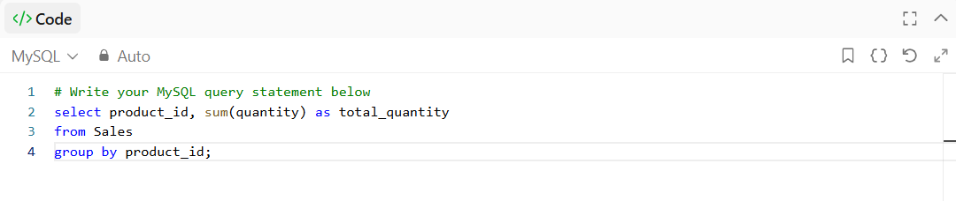
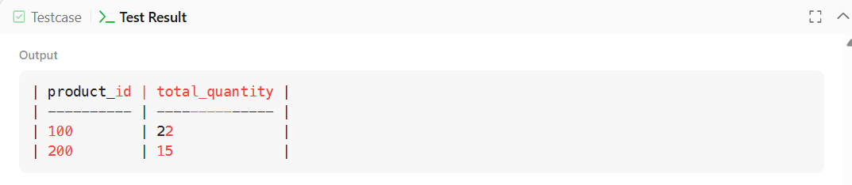

9. Students and Examinations
Table: Students
Column Name | Type
student_id | int
student_name | varchar
student_id is the primary key column for this table.

Table: Subjects
Column Name | Type
subject_name | varchar
subject_name is the primary key column for this table.
Table: Examinations
Column Name | Type
student_id | int
subject_name | varchar
Problem Summary
Write an SQL query to find the number of times each student attended each exam.
Order the result table by student_id and subject_name.
SQL Schema
Create table If Not Exists Students (student_id int, student_name varchar(20));
Create table If Not Exists Subjects (subject_name varchar(20));
Create table If Not Exists Examinations (student_id int, subject_name varchar(20));
Truncate table Students;
insert into Students (student_id, student_name) values ('1', 'Alice');
insert into Students (student_id, student_name) values ('2', 'Bob');
insert into Students (student_id, student_name) values ('13', 'John');
insert into Students (student_id, student_name) values ('6', 'Alex');
Truncate table Subjects;
insert into Subjects (subject_name) values ('Math');
insert into Subjects (subject_name) values ('Physics');
insert into Subjects (subject_name) values ('Programming');
Truncate table Examinations;
insert into Examinations (student_id, subject_name) values ('1', 'Math');
insert into Examinations (student_id, subject_name) values ('1', 'Physics');
insert into Examinations (student_id, subject_name) values ('1', 'Programming');
insert into Examinations (student_id, subject_name) values ('2', 'Programming');
insert into Examinations (student_id, subject_name) values ('1', 'Physics');
insert into Examinations (student_id, subject_name) values ('1', 'Math');
insert into Examinations (student_id, subject_name) values ('13', 'Math');
insert into Examinations (student_id, subject_name) values ('13', 'Programming');
insert into Examinations (student_id, subject_name) values ('13', 'Physics');
insert into Examinations (student_id, subject_name) values ('2', 'Math');
insert into Examinations (student_id, subject_name) values ('1', 'Math');

Students
student_id | student_name
1 | Alice
2 | Bob
13 | John
6 | Alex
Subjects
subject_name
Math
Physics
Programming

Examination
student_id | subject_name
1 | Math
1 | Physics
1 | Programming
2 | Programming
1 | Physics
1 | Math
13 | Math
13 | Programming
13 | Physics
2 | Math
1 | Math

MySQL Solution
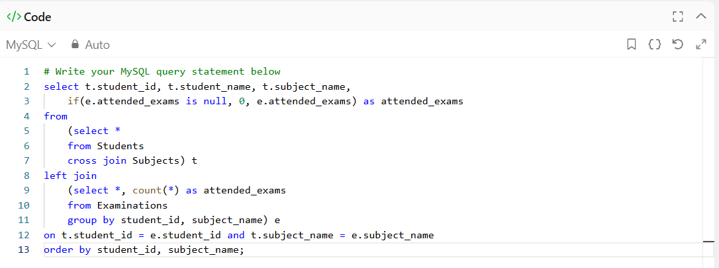
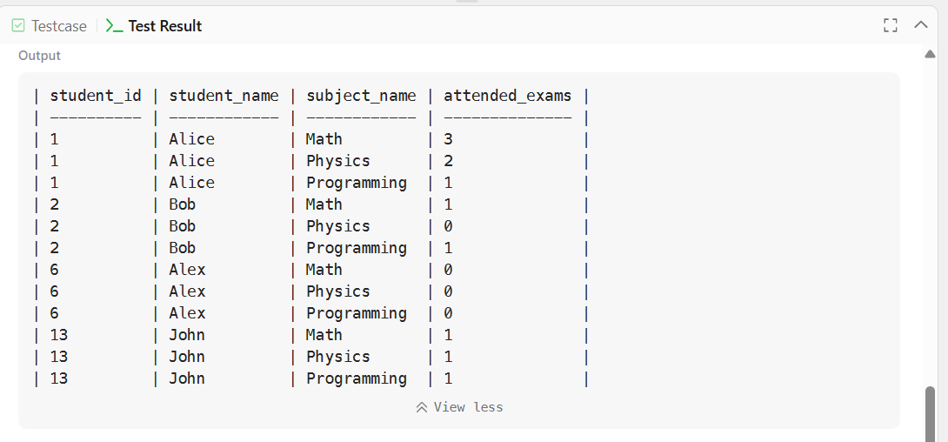

10. Department Highest Salary
Table: Employee
Column Name | Type
id | int
name | varchar
salary | int
departmentId | int

id is the primary key column for this table.

Table: Department
Column Name | Type
id | int
name | varchar

id is the primary key column for this table.
Problem Summary
Write a solution to find employees who have the highest salary in each of the departments.
SQL Schema
Create table If Not Exists Employee (id int, name varchar(255), salary int, departmentId int);
Create table If Not Exists Department (id int, name varchar(255));
Truncate table Employee;
insert into Employee (id, name, salary, departmentId) values ('1', 'Joe', '70000', '1');
insert into Employee (id, name, salary, departmentId) values ('2', 'Jim', '90000', '1');
insert into Employee (id, name, salary, departmentId) values ('3', 'Henry', '80000', '2');
insert into Employee (id, name, salary, departmentId) values ('4', 'Sam', '60000', '2');
insert into Employee (id, name, salary, departmentId) values ('5', 'Max', '90000', '1');
Truncate table Department;
insert into Department (id, name) values ('1', 'IT');
insert into Department (id, name) values ('2', 'Sales');
Employee
id | name | salary | departmentId
1 | Joe | 70000 | 1
2 | Jim | 90000 | 1
3 | Henry | 80000 | 2
4 | Sam | 60000 | 2
5 | Max | 90000 | 1

Department
id | name
1 | IT
2 | Sales
MySQL Solution
