REPORT ON

E-PRINTING PRESS WEBSITE

project submitted in partial fulfillment of the requirements of the degree
BACHELOR OF TECHNOLOGY
IN
COMPUTER SCIENCE AND ENGINEERING
Submitted by
P. Pavitra Devi(O170907)
P.Durga Pravallika(O170877)
V.Janaki Rao (O170841 )
Y.Silpa Devi(O170815)
P.Sai Kiran (O170838)
Under the supervision of
Ms.J.Mrudula



Department of Computer Science and Engineering
RAJIV GANDHI UNIVERSITY OF KNOWLEDGE TECHNOLOGIES A.P
RGUKT Ongole Campus,
may– 2022-2023

1
BONAFIDE CERTIFICATE


This is to certify that the project report entitled E-PRINTING PRESS WEBSITE submitted by P.Pavitra Devi with Roll No:O170907, P.Durga Pravallika with Roll No:O170877,V.Janaki Rao with Roll No:O170841,Y.Silpa Devi with Roll No:O170815,P.Sai Kiran with Roll No:O170838 in partial fulfilment of the requirement for the award of Bachelor of Technology in Computer Science and Engineering is a record of bonafide project work carried out under my supervision during the academic year 2022-23.

I am indebted to Ms.J.Mrudula, my project guide for conscientious guidance and encouragement to accomplish this
project.
I am extremely thankful and pay my gratitude to Mr.B.Sampath babu, (I/C) HOD CSE, for her valuable guidance and support on the completion of this project.

The report hasn’t been submitted previously in part or in full to this or any other university or institution for the award of any degree.

Mr.B.Sampath babu Ms. J.Mrudhula,
HOD CSE (I/C) Department of CSE,
Department of CSE, RGUKT, ONGOLE
RGUKT, ONGOLE.

2
DEPARTMENT OF COMPUTER SCIENCE AND ENGINEERING,

RAJIV GANDHI UNIVERSITY OF KNOWLEDGE TECHNOLOGIES,
ONGOLE CAMPUS, JANUARY 2023.

CERTIFICATE

This is to certify that the project report entitled “ E-PRINTING PRESS WEBSITE ” submitted by P.Pavitra Devi with Roll No: O170907, P.Durga Pravallika with Roll No:O170877,V.Janaki Rao with Roll No:O170841,Y.Silpa Devi with Roll No:O170815,P.Sai Kiran with Roll No:O170838 in partial of fulfillment of requirement for the award of Bachelor of Technology in Computer Science and Engineering is a record of bonafide project work carried out under my supervision during the academic year 2022-23.
The report hasn’t been submitted previously in part or in full to this or any other university or institution for the award of any degree.

Mr. B.Sampath Babu, Ms.J.Mrudula
HOD CSE (I/C ) Department of CSE,
Department of CSE, RGUKT-ONGOLE.
RGUKT- ONGOLE.

3
APPROVAL SHEET

This report entitled “E-PRINTING PRESS WEBSITE” by P.Pavitra Devi with Roll No: O170907, P.Durga Pravallika with Roll No: O170877,V.Janaki Rao with Roll No:O170841,Y.Silpa Devi with Roll No:O170815,P.Sai Kiran with Roll No:O170838 is Ms.J.Mrudula approved for the degree of Bachelor of Technology in COMPUTER SCIENCE AND ENGINEERING

Examiner

___

Supervisor

Chairman

Date:

Place:

4
DECLARATION

I declare that this written submission represents my ideas in my own words and where other ideas or words have been included, I have adequately cited and referenced the original sources. I also declare that I have adhered to all principles of academic honesty and integrity and have not misrepresented or fabricated or falsified any idea/data/fact/source in my submission. I understand that any violation of the above will be cause for disciplinary action by the Institute and can also evoke penal action from the sources which have thus not been properly cited or from whom proper permission has not been taken when needed.

Signature

Name: P.Pavitra Devi(o170907)

Name: P.Durga Pravallika(o170877)

Name:V.Janaki Rao(o170841)

Name: Y.Silpa Devi(o17815)

Name:P.Sai kiran(o170838) __________________

Date:________________

5
ACKNOWLEDGEMENT

I am highly indebted to Ms.J.Mrudula for her guidance and constant supervision as well as for providing necessary information regarding the project and also for their kind cooperation, encouragement and their support in completing the project.

I would like to express my special gratitude and thanks to our
COMPUTER SCIENCE AND ENGINEERING branch Mr.B.SAMPATH BABU H.O.D (I/C) and Director of Ongole-RGUKT Prof. B.JAYARAMI REDDY for giving me such attention and time.

I have taken efforts in this project. However, it could not have been possible without the kind support and help of many individuals and RGUKT.We would like to extend my sincere thanks to all of them.

My thanks and appreciation also go to my colleagues in developing theproject and people who have willingly helped me out with their abilities.

With Sincere Regards
P. Pavitra Devi(O170907)
P.Durga Pravallika(O170877)
V.Janaki Rao (O170841 )
Y.Silpa Devi(O170815)
P.Sai Kiran (O170833)

Date: ______________________

6

Index

Abstract 8
Introduction 9
Purpose 10
Existing System & Proposed System 10
Requirement Specification 11
Modules 12
Homepage 12
Admin 12
User 13
Order 13
History 13
Advantages 13-14
Technologies used 14-16
Use Case Diagrams 16
ER-Diagram 17
Source Code with Outputs 18-52
Conclusion 53
Future Enhancement 53
References 54

7

ABSTRACT

In the existing Offline Xerox shop System, we go to the nearby shop for
taking print outs which is time consuming process and sometimes economically high
too.
Online Printing Press system is internet-based Web application where
user can create their account by providing valid credentials. User can upload files
(Photos or Documents) and provide the number of copies required, based upon the
selection, price will be displayed and the discount will be applied based on the order.
Uploaded Documents will be updated in the database and based on the
location they had mentioned order will be sent to the nearby publisher along with the
details
Printed documents will be sent to the end user to the entered address
during order by using Courier Services available.

8
INTRODUCTION

- The main objective of the proposed system is to reduce human intervention in taking offline printing and easier printing by having a Web application for this purpose.

- Our Web application will help the end user to save their time in printing the necessary documents by going physically to the Printing Shop. End user doesn’t need to wait near the shops and getting the printed products directly delivered to the mentioned address.

- This approach takes all the documents uploaded by the user either document or photograph and type of printing whether Color or Black and White copy is needed and price will be displayed accordingly.

- Order details along with the uploaded documents are sent to the respective publisher Gmail Id registered to the website.

- Printed documents are sent to the addresses of the customers by using by courier services such as DTDC, Delhivery, Speed Post etc.

9
Purpose

The purpose of E-Printing Press Web application will help the end user to save their time in printing the necessary documents by going physically to the Printing Shop. End user doesn’t need to wait near the shops and getting the printed products directly delivered to them entioned address.

Existing System

In existing system end user needs to go to the nearby centre for taking hard copies of documents. In this case user have to wait for longer durations and have to travel to avail the services. In some cases, we need to use external drives to share the documents with the Xerox shop vendor. At the end, they can get their documents

Proposed System

In proposed system end user can create an account and provide soft copies of required documents, then documents will be sent to their respective publisher based on location. This approach can save end users time consumption waiting near the Xerox Shop and services can be availed irrespective of the availability of printing press nearby there.

10
Requirement Specification

Hardware Configuration

Client side:
Ram : 512 Mb
Hard disk : 10GB
Processor : 1.0 GHz
Server Side:
Ram : 1GB
Hard disk : 20GB
Processor : 2.0 GHz

Software Requirements

Front end - HTML, CSS, Bootstrap

Backend - Django

Database Server – SQLite.

Web Browser – Chrome, Mozilla Firefox

OS - Ubuntu, Windows.

Software - Visual Studio Code

11
MODULES

- Homepage
- Admin
- User
- Order
- History

Modules Description:-

Homepage

The Homepage includes the basic UI structure of website. This includes a navigation bar menu which is dynamic based upon user session. Navigation bar contains HOME LOGIN and SIGNUP fields for the anonymous users and HOME LOGOUT HISTORY for the logged in users.

The homepage also includes Prices button which is used to display the printing cost of various types of papers and colours and Order now button is available in the homepage which navigates to the order page

Admin

Admin is the superuser who has control over the users and the orders received. Admin has access all over the website and holds the sensitive information of a website. Admin can edit the product details and update the users to the website.

12
User

User module is provided with registration and login options. If user doesn’t have an account, he/she can register by giving necessary credentials like a unique USERNAME, NAME, EMAIL ADDRESS, MOBILE NO. If the user already had an account user can login using those details.

If the user doesn’t remember password, he/she can reset the password using OTP generated and the same changed password will be reflected in the database too.

History

In the History module previously placed orders of the user will be displayed which are extracted from the database.

Order
After logging in user can access the ORDER module. In Order page user needs to provide VALID DETAILS LIKE NAME, EMAIL ADDRESS ,NO OF COPIES and FILE should be uploaded.
If the user enters valid data he will be redirected to confirmation page where the details entered and prices will be shown and asks for confirmation. Then once the user clicks on PLACE ORDER button an EMAIL will be sent to respective publisher based upon the address entered.

Adavntages of Proposed Technology

For Organization:-

1.Using E- Printing Press organizations can get more orders which most of them will be bulk orders which inturn will provide them good turnover than offline method.

13
2) As we are hosting a website online, it is a much efficient way for storing and retrieving information for the printing process. Organizations need to focus on quality users who can provide quantified orders.
3) Users will be sharing the files through Upload page and those can be retrieved easily rather than formal ways where we need to use external drivers for extracting data from users for printing purpose.
4)E-Printing press help organiztions to provide better customer service.
5) E-Printing press website helps publishers to get more orders which are financially high.

For Customers:-

1)It provides 24/7 availability, customer can enquire about a product or service and place order any time,any where from any location.
2)E-Printing press application provides users with more options to select the cheaper and better options than going by man.
3)E-Printing press helps in reducing the cost of products if the user needs bulk copies of documents which may be more costly when done offline.
4) E-Printing press provides better service and users need not to go anywhere else for availing the services.

Technologies and Tools Used

- FRONTEND : HTML , CSS , BootStrap,

- BACKEND : DJANGO

- DATABASE : SQLite

- ENVIRONMENT: Visual Studio Code.
14

HTML

means Hypertext Markup Language. This language is used in creating web pages. This language also supports other languages such CSS, PHP, JAVASCRIPT, etc. in creating interactive and responsive pages on the pages. HTML5 is just an updated version of the HTML. It supports new features, new attributes, new HTML elements, full CSS3 support, video and audio, 2D/3D graphics that help users and also help web developers to create new features easily on the website

CSS

CSS is simply referred to as Cascading Style Sheets.CSS is used to define styles for web pages, including the design, layout, and variations in the display for different devices and screen sizes.

The general structure of CSS Basic syntax:

selector{property: value}

CSS can be used in a separate style sheet or used in the webpage

JavaScript

Javascript is a high-level language which could be used independently or inculcated into the webpage. It can be used to, handle requests and responses and also add dynamic behavior and also store information on a website.
Syntax:
<script =”javascript” type=” text/javascript” >

JavaScript code
</script>

15
Bootstrap

Bootstrap is the most popular HTML, CSS, and JavaScript framework for developing responsive, mobile-first websites.
It includes HTML and CSS based design templates for typography, forms, buttons, tables, navigation, modals, image carousels, etc. It also gives you support for JavaScript plugins.

Use Case Diagrams

Use case diagrams model behavior within a system and helps the developers understand of what the user require. The stick man represents what’s called an actor. Use case diagram can be useful for getting an overall view of the system and clarifying that can do and more importantly what they can’t do. Use case diagram consists of use cases and actors and shows the interaction between the use case and actors.

- The purpose is to show the interactions between the use case and actor.
- To represent the system requirements from user’s perspective.
- An actor could be the end-user of the system or an external system.

16

Use case for E-Printing Press website
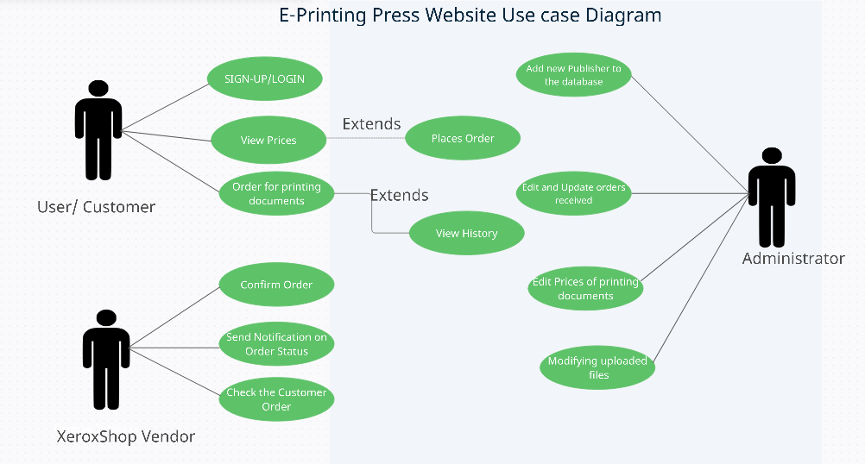
Use case Daigram for Top-Level

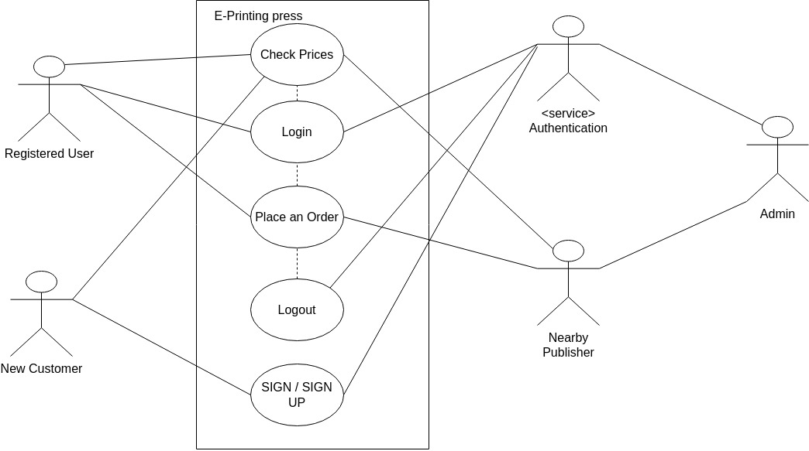
17

Source Code

Base.html

<!DOCTYPE html>
{%load static%}
<html lang="en">
<head>
<meta charset="utf-8">
<meta name="viewport" content="width=device-width, initial-scale=1">
<title>{% block title %}{% endblock %}</title>

{% block links %}{% endblock %}
<style>
*{
margin:0px;
padding:0px;
box-sizing: border-box;
font-family: 'Poppins', sans-serif;
}
nav{
width: 100%;
height: 75px;
background-color: #3D0649;
line-height: 75px;
padding:0px 100px;

z-index: 1;
}
nav ul{
float: right;
}
nav ul li{
display: inline-block;
list-style: none;}
18
nav ul li a{
color:#FFFF;
text-decoration: none;
font-size: 15px;
font-weight: 150;
text-transform: uppercase;
padding:0px 32px;
margin-top: 0px;
}
nav ul li a:hover{
color:#c0d96f;
}
nav ul li .active{
color:#c0d96f;
}
{% block style %}{% endblock %}
</style>

</head>
<body>

<nav>
<ul>

<li>
<li> <a href="/">Home</a></li>
{% if not user.is_authenticated %}
<li> <a href="/login">login</a></li>
<li> <a href="/signup">signup</a></li>
{% else %}
<li> <a href="/logouthand">logout</a></li>
<li> <a href="/history">history</a></li>
{% endif %}
</ul>
</nav>
{% block body %}{% endblock body %}

19
<script src="https://cdn.jsdelivr.net/npm/bootstrap@5.2.1/dist/js/bootstrap.bundle.min.js" integrity="sha384-u1OknCvxWvY5kfmNBILK2hRnQC3Pr17a+RTT6rIHI7NnikvbZlHgTPOOmMi466C8" crossorigin="anonymous"></script>
</body>
</html>

index.html

<!DOCTYPE html>
{% extends 'base.html' %}
{%load static%}

{% block links %}
<link rel="stylesheet" href="https://cdn.jsdelivr.net/npm/bootstrap@4.0.0/dist/css/bootstrap.min.css" integrity="sha384-Gn5384xqQ1aoWXA+058RXPxPg6fy4IWvTNh0E263XmFcJlSAwiGgFAW/dAiS6JXm" crossorigin="anonymous">
<script src="https://code.jquery.com/jquery-3.2.1.slim.min.js" integrity="sha384-KJ3o2DKtIkvYIK3UENzmM7KCkRr/rE9/Qpg6aAZGJwFDMVNA/GpGFF93hXpG5KkN" crossorigin="anonymous"></script>
<script src="https://cdn.jsdelivr.net/npm/popper.js@1.12.9/dist/umd/popper.min.js" integrity="sha384-ApNbgh9B+Y1QKtv3Rn7W3mgPxhU9K/ScQsAP7hUibX39j7fakFPskvXusvfa0b4Q" crossorigin="anonymous"></script>
<script src="https://cdn.jsdelivr.net/npm/bootstrap@4.0.0/dist/js/bootstrap.min.js" integrity="sha384-JZR6Spejh4U02d8jOt6vLEHfe/JQGiRRSQQxSfFWpi1MquVdAyjUar5+76PVCmYl" crossorigin="anonymous"></script>
<link href="https://cdn.jsdelivr.net/npm/bootstrap@5.2.1/dist/css/bootstrap.min.css" rel="stylesheet" integrity="sha384-iYQeCzEYFbKjA/T2uDLTpkwGzCiq6soy8tYaI1GyVh/UjpbCx/TYkiZhlZB6+fzT" crossorigin="anonymous">
{% endblock links %}
20

{% block title %}homepage{% endblock title %}
{% block style %}

body{
background-image: url("{%static 'boxstylewriting.jpg'%}");
background-repeat: no-repeat;
background-size:100%;
height:100%;
}
{% endblock style %}
{% block body %}

<div>
<!-- {{var}}-->
{% if var%}
<div class="alert alert-success alert-dismissible fade show" role="alert">
<strong>Message: </strong>{{var}}
<button type="button" class="close" data-dismiss="alert" aria-label="Close">
<span aria-hidden="true">&times;</span>
</button>
</div>
</div>
{% endif %}
<div>
<br><br><br>
</div>
<a href="/prices" style="text-decoration:none; font-size:14px; text-align:center; margin: 0px auto; display:table;"><button type="submit" class=" btn btn-submitin btn-lg full-width btn btn-primary" id="login-submit" name="login" onClick="check_u_and_p()"><span id="login-text">View Prices</span>
<span id="login-load" style="display:none;"><i class="fa fa-circle-o-notch fa-spin"></i> Loading...</span></button></a>

<div>
<br><br><br>
</div>
21
<button><a href="/login" style="text-decoration:none; font-size:14px; text-align:center; margin: 0px auto; display:table;"><button type="submit" class=" btn btn-submitin btn-lg full-width btn-primary" id="login-submit" name="login" onClick="check_u_and_p()"><span id="login-text">Order Now</span>

{% else %}
<a href="/order" style="text-decoration:none; font-size:14px; text-align:center; margin: 0px auto; display:table;"><button type="submit" class=" btn btn-submitin btn-lg full-width btn-primary" id="login-submit" name="login" onClick="check_u_and_p()"><span id="login-text">Order Now</span>
<span id="login-load" style="display:none;"><i class="fa fa-circle-o-notch fa-spin"></i> Loading...</span></button></a>

{% endif %}

{% endblock body %}

OUTPUT

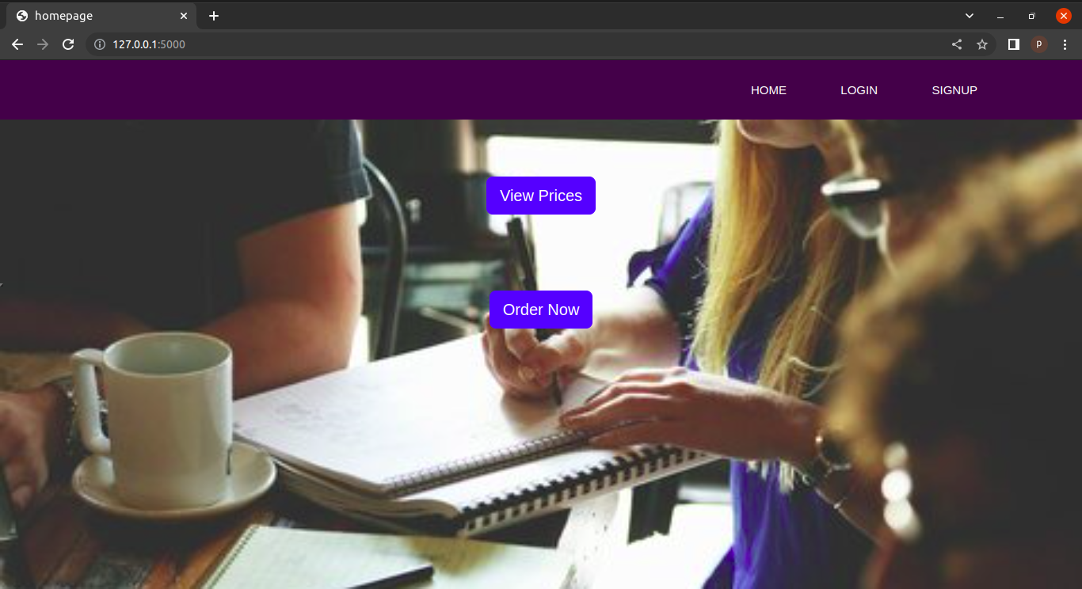

22

Prices.html

<!DOCTYPE html>

{% extends 'base.html' %}
{% block title %}prices{% endblock title %}
{% block style %}
html {
font-family: "helvetica neue", helvetica, arial, sans-serif;
}

thead th,
tfoot th {
font-family: "Rock Salt", cursive;
}

th {
letter-spacing: 2px;
}

td {
letter-spacing: 1px;
}

tbody td {
text-align: center;
}

tfoot th {
text-align: right;
}
table {
table-layout: fixed;
width: 100%;
border-collapse: collapse;
border: 3px solid purple;
}
23

thead th:nth-child(1) {
width: 30%;}

thead th:nth-child(2) {
width: 20%;
}

thead th:nth-child(3) {
width: 15%;
}

thead th:nth-child(4) {
width: 35%;
}

th,
td {
padding: 20px;
}
{% endblock style %}
{% block links %}{% endblock links %}
{% block body %}

<table>

<thead>
<tr>
<th scope="col">Paper Type</th>
<th scope="col">Colour</th>
<th scope="col">Price</th>
</tr>
</thead>
<tbody>
<tr>
<th scope="row">A4</th>
<td>Black and White</td>
<td>3</td></tr>
<tr>
24
<th scope="row">Book</th>
<td>Black and white</td>
<td>3</td>
</tr>
<tr>

<th scope="row">Picture</th>
<td>Black and white</td>
<td>10</td>
</tr>
<tr>
<th scope="row">A4</th>
<td>Colour</td>
<td>10</td>
</tr>
<tr>
<th scope="row">Book</th>
<td>Colour</td>
<td>10</td>
</tr>
<tr>
<th scope="row">Picture</th>
<td>Colour</td>
<td>60</td>
</tr>

</tbody>

</table>
{% endblock body %}

25

OUTPUT

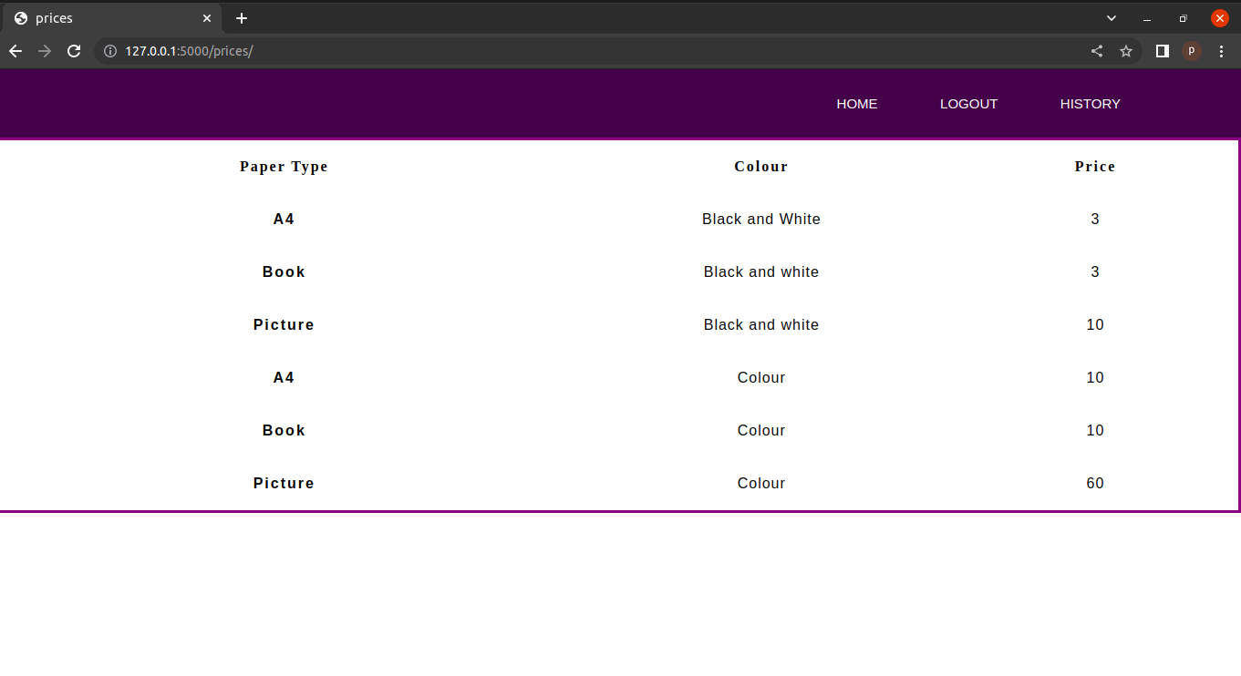
forms.py

from django.forms import ModelForm
from .models import op

class orderform(ModelForm):
class Meta:
model=op
exclude = ['name_of_pub','date','price','discount','payment','user_name']
def __init__(self,*args,**kwargs):
super(orderform,self).__init__(*args,**kwargs)
self.fields['mobile'].widget.attrs.update({'class':'mob'})
self.fields['no_of_copies'].widget.attrs.update({'class':'mob'})
self.fields['no_of_pages'].widget.attrs.update({'class':'mob'})

login.html
<!DOCTYPE html>
{% extends 'base.html' %}
{% block title %}login page{% endblock title %}
{% block links %}
{%load static%}
26
<link rel="stylesheet" href="{% static 'bootstrap.min.css' %}">
<link href="https://cdn.jsdelivr.net/npm/bootstrap@5.2.1/dist/css/bootstrap.min.css" rel="stylesheet" integrity="sha384-iYQeCzEYFbKjA/T2uDLTpkwGzCiq6soy8tYaI1GyVh/UjpbCx/TYkiZhlZB6+fzT" crossorigin="anonymous">
<link rel="stylesheet" href="{% static 'main/css/custom.css' %}">

{% endblock links %}

{% block style %}

.vh10{
font-size: 30px;
}
.divider:after,
.divider:before {
content: "";
flex: 1;
height: 1px;
background: #eee;
}
.h-custom {
height: calc(100% - 73px);
}
@media (max-width: 450px) {
.h-custom {
height: 100%;
}
}
{% endblock style %}
{% block body %}
{%load static%}
<section class="vh-100">
<div class="container-fluid h-custom fs-">
<div class="row d-flex justify-content-center align-items-center h-100 fw-bold " >
<div class="col-md-9 col-lg-6 col-xl-5">
<img src="https://mdbcdn.b-cdn.net/img/Photos/new-templates/bootstrap-
27
login-form/draw2.webp"
class="img-fluid" alt="Sample image">
</div>
<div class="col-md-8 col-lg-6 col-xl-4 offset-xl-1">
<form method="post" action="/loginhandle" class="material-form">
{% csrf_token %}

<div class="d-flex flex-row align-items-center justify-content-center justify-content-lg-start">
<p class="lead mb-0 me-3"><b style="font-size:24px !important">Log in with</b></p>
</div>
<p class="form-label" style="color:red";>{{msg}}</p>
<div class="form-outline mb-4">
<label class="form-label" for="login_uname">Username</label>
<input type="text" id="login_uname" name="login_uname" class="form-control form-control-lg"
placeholder="Enter a valid username" />
</div>
<div class="form-outline mb-3">
<label class="form-label" for="fpassword">Password</label>
<input type="password" id="password" name="password" class="form-control form-control-lg"
placeholder="Enter password" />
</div>
<div>
<a href="/forgot" class="text-body">Forgot password?</a>
</div>
<div class="text-center text-lg-start mt-4 pt-2">
<button type="submit" class="btn btn-primary btn-lg"
style="padding-left: 2.5rem; padding-right: 2.5rem;" id="login-submit" name="login" onClick="check_u_and_p()"><span id="login-text">Login</span>
<span id="login-load" style="display:none;"><i class="fa fa-circle-o-notch fa-spin"></i> Loading...</span></button>

<p class="medium fw-bold mt-2 pt-1 mb-0">Don't have an account? <a href="/signup"
class="link-danger">Register</a></p>
28
</div
</form>
</div>
</div>
</div>
</section>
{% endblock body %}

Output

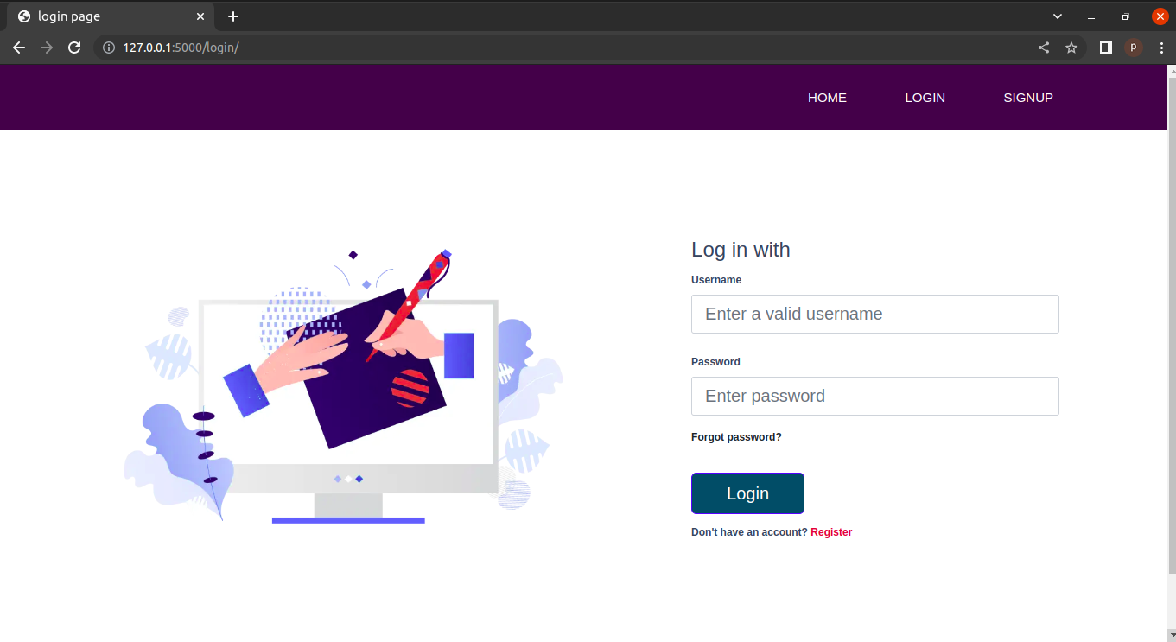

signup.html

<!DOCTYPE html>
{% extends 'base.html' %}
{%load static%}
{% block title %}signup{% endblock %}
{% block links %}
{%load static%}
<link rel="stylesheet" href="https://cdn.jsdelivr.net/npm/bootstrap@4.0.0/dist/css/bootstrap.min.css" integrity="sha384-Gn5384xqQ1aoWXA+058RXPxPg6fy4IWvTNh0E263XmFcJlSAwiGgFAW/dAiS6JXm" crossorigin="anonymous">
<script src="https://code.jquery.com/jquery-3.2.1.slim.min.js" integrity="sha384-KJ3o2DKtIkvYIK3UENzmM7KCkRr/rE9/Qpg6aAZGJwFDMVNA/
29
GpGFF93hXpG5KkN" crossorigin="anonymous"></script>
<script
src="https://cdn.jsdelivr.net/npm/popper.js@1.12.9/dist/umd/popper.min.js" integrity="sha384-ApNbgh9B+Y1QKtv3Rn7W3mgPxhU9K/ScQsAP7hUibX39j7fakFPskvXusvfa0b4Q" crossorigin="anonymous"></script>
<script src="https://cdn.jsdelivr.net/npm/bootstrap@4.0.0/dist/js/bootstrap.min.js" integrity="sha384-JZR6Spejh4U02d8jOt6vLEHfe/JQGiRRSQQxSfFWpi1MquVdAyjUar5+76PVCmYl" crossorigin="anonymous"></script>
<link href="https://cdn.jsdelivr.net/npm/bootstrap@5.2.1/dist/css/bootstrap.min.css" rel="stylesheet" integrity="sha384-iYQeCzEYFbKjA/T2uDLTpkwGzCiq6soy8tYaI1GyVh/UjpbCx/TYkiZhlZB6+fzT" crossorigin="anonymous">

<link rel="stylesheet" href="{% static 'main/css/custom.css' %}">

{% endblock links %}
{% block style %}

.vh10{
font-size: 30px;
}
.divider:after,
.divider:before {
content: "";
flex: 1;
height: 1px;
background: #eee;
}
.h-custom {
height: calc(100% - 73px);
}
@media (max-width: 450px) {
.h-custom {
height: 100%;
}
{% endblock style %}
{% block body %}
30
{% for message in messages %}
<div class="alert alert-warning alert-dismissible fade show" role="alert">
<p style="font-size: large; padding:0%"> <strong>Message:</strong>{{message}}</p>
<button type="button" class="close" data-dismiss="alert" aria-label="Close">
<span aria-hidden="true">&times;</span>
</button>
</div>
{% endfor %}
<section class="vh-100">
<div class="container-fluid h-custom ">
<div class="row d-flex justify-content-center align-items-center h-100 " >
<div class="col-md-9 col-lg-6 col-xl-5">
<img src="https://mdbcdn.b-cdn.net/img/Photos/new-templates/bootstrap-login-form/draw2.webp"
class="img-fluid" alt="Sample image">
</div>
<div class="col-md-8 col-lg-6 col-xl-4 offset-xl-1">
<form method="post" action="/signuphandle" class="material-form">
{% csrf_token %}

<div class="d-flex flex-row align-items-center justify-content-center justify-content-lg-start">
<p class="lead mb-0 me-3"><b style="font-size:24px !important">Sign Up</b></p>
</div>
<p class="form-label" style="color:red";>{{var}}</p>
<div class="form-outline mb-4">
<label class="form-label" for="name">User name</label>
<input type="text" id="name" name="name" class="form-control form-control-lg"
placeholder="Enter unique username" />

</div>
<div class="form-outline mb-4">
<label class="form-label" for="fName">First name</label>
31
<input type="text" id="fName" name="fName" class="form-control form-control-lg"
placeholder="Enter first username" />

</div>
<div class="form-outline mb-4">
<label class="form-label" for="lName">Last name</label>
<input type="text" id="lName" name="lName" class="form-control form-control-lg"
placeholder="Enter Last username" />

</div>
<div class="form-outline mb-4">
<label class="form-label" for="email">Email Address</label>
<input type="email" id="email" name="email" class="form-control form-control-lg"
placeholder="Enter email address" />

</div>
<div class="form-outline mb-4">
<label class="form-label" for="mobile">Phone no</label>
<input type="tel" id="mobile" name="mobile" class="form-control form-control-lg"
placeholder="Enter mobile no" />

</div>

<div class="form-outline mb-4">
<label class="form-label" for="password1">Enter Password</label>
<input type="password" id="password1" name="password1" class="form-control form-control-lg"
placeholder="Enter Password" />

</div>
<div class="form-outline mb-3">
<label class="form-label"

32
for="password2">ConfirmPassword</label>
<input type="password" id="password2" name="password2" class="form-control form-control-lg"
placeholder="Confirm password" />
</div>
<button type="submit" class=" btn btn-primary btn-lg full-width btn-primary" id="login-submit" name="login" onClick="check_u_and_p()"><span id="login-text">Submit</span>
<span id="login-load" style="display:none;"><i class="fa fa-circle-o-notch fa-spin"></i> Loading...</span></button>
</div>
</form>
</div>
</div>
</div>
</section>

{% endblock body %}
Output
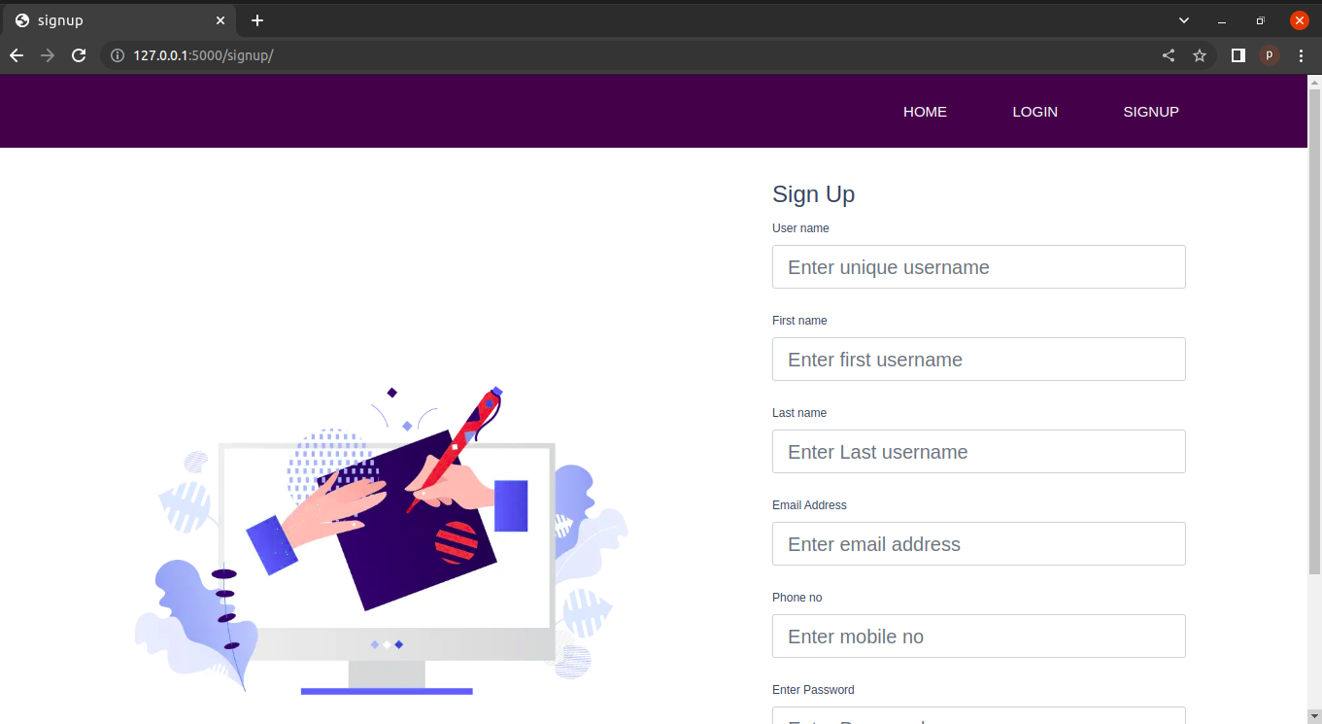

33
forgot.html
<!DOCTYPE html>
{% extends 'base.html' %}
{% block title %}login page{% endblock title %}
{% block links %}
{%load static%}
<link rel="stylesheet" href="{% static 'bootstrap.min.css' %}">
<link href="https://cdn.jsdelivr.net/npm/bootstrap@5.2.1/dist/css/bootstrap.min.css" rel="stylesheet" integrity="sha384-iYQeCzEYFbKjA/T2uDLTpkwGzCiq6soy8tYaI1GyVh/UjpbCx/TYkiZhlZB6+fzT" crossorigin="anonymous">
<link rel="stylesheet" href="{% static 'main/css/custom.css' %}">

{% endblock links %}

{% block style %}

.vh10{
font-size: 30px;
}
.divider:after,
.divider:before {
content: "";
flex: 1;
height: 1px;
background: #eee;
}
.h-custom {
height: calc(100% - 73px);
}
@media (max-width: 450px) {
.h-custom {
height: 100%;
}
}

{% endblock style %}
{% block body %}
34
{%load static%}
<section class="vh-100">
<div class="container-fluid h-custom fs-">
<div class="row d-flex justify-content-center align-items-center h-100 fw-bold " >
<div class="col-md-9 col-lg-6 col-xl-5">
<img src="https://mdbcdn.b-cdn.net/img/Photos/new-templates/bootstrap-login-form/draw2.webp"
class="img-fluid" alt="Sample image">
</div>
<div class="col-md-8 col-lg-6 col-xl-4 offset-xl-1">
<form method="post" action="/forgothandle" class="material-form">
{% csrf_token %}

<div class="d-flex flex-row align-items-center justify-content-center justify-content-lg-start">
<p class="lead mb-0 me-3"><b style="font-size:24px !important">Forgot Password</b></p>
</div>
<p class="form-label" style="color:red";>{{error}}</p>
<div class="form-outline mb-4">
<label class="form-label" for="user">Username</label>
<input type="text" id="user" name="user" class="form-control form-control-lg"
placeholder="Enter username" />

</div>

<div class="text-center text-lg-start mt-4 pt-2">
<button type="submit" class=" btn btn-primary btn-lg full-width btn-primary" id="login-submit" name="login" onClick="check_u_and_p()"><span id="login-text">Send OTP</span>
<span id="login-load" style="display:none;"><i class="fa fa-circle-o-notch fa-spin"></i> Loading...</span></button>
</div>
</div>
</form>
</div>
35
</div>
</div>
</section>
{% endblock body %}
<!--<!DOCTYPE html>
{%load static%}
<html lang="en">
<head>
<meta charset="utf-8">
<meta name="viewport" content="width=device-width, initial-scale=1">
<title>PrintingPress</title>
<link rel="stylesheet" href="{% static 'bootstrap.min.css' %}">
<link rel="stylesheet" href="{% static 'main/css/custom.css' %}">
<link href="https://cdn.jsdelivr.net/npm/bootstrap@5.2.1/dist/css/bootstrap.min.css" rel="stylesheet" integrity="sha384-iYQeCzEYFbKjA/T2uDLTpkwGzCiq6soy8tYaI1GyVh/UjpbCx/TYkiZhlZB6+fzT" crossorigin="anonymous">
<style>
*{
margin:0px;
padding:0px;
box-sizing: border-box;
font-family: 'Poppins', sans-serif;
}
nav{
width: 100%;
height: 75px;
background-color: #3D0649;
line-height: 75px;
padding:0px 100px;
position:fixed;
z-index: 1;
}
nav ul{
float: right;
}
nav ul li{
display: inline-block;
36
list-style: none;
}

nav ul li a{
color:#FFFF;
text-decoration: none;
font-size: 15px;
font-weight: 150;
text-transform: uppercase;
padding:0px 32px;
margin-top: 0px;
}
nav ul li a:hover{
color:#c0d96f;
}
nav ul li .active{
color:#c0d96f;
}
</style>
</head>
<body>
<nav>
<ul>
<li>
<li> <a href="/">Home</a></li>
{% if not user.is_authenticated %}
<li> <a href="/login">login</a></li>
<li> <a href="/signup">signup</a></li>
{% else %}
<li> <a href="logouthand/">logout</a></li>
<li> <a href="history/">history</a></li>
{% endif %}
</ul>
</nav>
<h1>Hello, world!</h1>
{{name}}
<div class="container">
<br/>
37
<br/>
<div class="well well1 " style="background:#FFFFFF; box-shadow: 0px 2px 4px 3px rgba(38, 51, 64, 0.4) !important; margin-bottom: 30px; height:100% !important">

<p style="font-size:14px "><b style="font-size:24px !important">Forgot password</b><br />

to continue to Xeroxshop.com</p>
58 Page of 78
<center><span id="user-availability-status" class="text-center"></span>
<span class='alert alert-danger center-block' id="empty-error" style="display:none;"> <i class='fa fa-times'></i> Please Enter Username and Password</span>
</center>
<form method="post" action="/forgothandle" class="material-form">
{% csrf_token %}
<p>{{error}}</p>
<div class="form-group ">
<input type="text" class="form-control na" placeholder="username" name="user" id="user" autofocus>

<span class="input-border"></span>
</span>
<br/>
<button type="submit" class=" btn btn-submitin btn-lg full-width btn-primary" id="login-submit" name="login" onClick="check_u_and_p()"><span id="login-text">Send OTP</span>
<span id="login-load" style="display:none;"><i class="fa fa-circle-o-notch fa-spin"></i> Loading...</span></button>
<br/>
</form>
</div>

</div>
<script
38
src="https://cdn.jsdelivr.net/npm/bootstrap@5.2.1/dist/js/bootstrap.bundle.min.js" integrity="sha384-
u1OknCvxWvY5kfmNBILK2hRnQC3Pr17a+RTT6rIHI7NnikvbZlHgTPOOmMi466C8" crossorigin="anonymous"></script>

</body>
</html>

Output
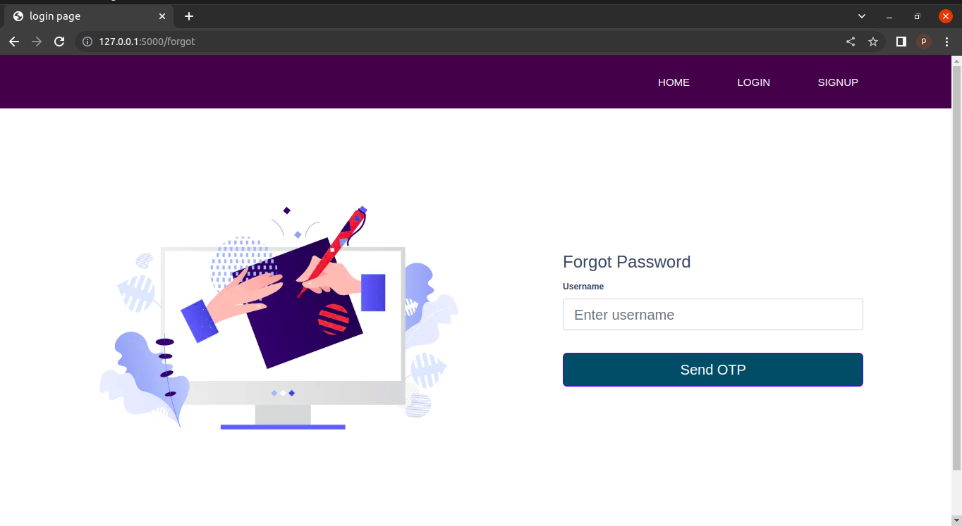
order.html

<!DOCTYPE html>
<html lang="en">
<head>
<meta charset="utf-8">
<meta name="viewport" content="width=device-width, initial-scale=1">
<title>PrintingPress</title>
<link href="https://cdn.jsdelivr.net/npm/bootstrap@5.2.1/dist/css/bootstrap.min.css" rel="stylesheet" integrity="sha384-iYQeCzEYFbKjA/T2uDLTpkwGzCiq6soy8tYaI1GyVh/UjpbCx/TYkiZhlZB6+fzT" crossorigin="anonymous">
39
<style>
*{
margin:0px;
padding:0px;
box-sizing: border-box;
font-family: 'Poppins', sans-serif;
}
nav{
width: 100%;
height: 75px;
background-color: #3D0649;
line-height: 75px;
padding:0px 100px;
position:fixed;
z-index: 1;
}
nav ul{
float: right;
}
nav ul li{
display: inline-block;
list-style: none;
}
nav ul li a{
color:#FFFF;
text-decoration: none;
font-size: 15px;
font-weight: 150;
text-transform: uppercase;
padding:0px 32px;

margin-top: 0px;
}
nav ul li a:hover{
color:#c0d96f;
}
nav ul li .active{
40
color:#c0d96f;
}
body {
font-family: Arial, Helvetica, sans-serif;
background-color: aliceblue;
margin: 0;
padding:0 0;
display: flex;
justify-content: center;
}

.page{
padding:5% 5%;
text-align: left;
background-color:white;
font-weight: bold;
word-spacing: 0%;
height:100%;
width:40%;

}
input[type=tel]{
width: 515px;
padding: 12px 20px;
margin: 8px 0;
display: inline-block;
border: 1px solid #ccc;
box-sizing: border-box;
}

.mob,select,input[type=file],input[type=text],input[type=tel],input[type=email],input[type=password] {
width: 100%;
padding: 12px 20px;
margin: 8px 0;
display: inline-block;
border: 1px solid #ccc;
box-sizing: border-box;}
41
.mob,select:focus,input[type=text]:focus,input[type=text]:focus,input[type=tel]:focus,input[type=email]:focus,input[type=password]:focus{
outline: none;
}
button {
background-color: #164e10;
color: white;
padding: 14px 20px;
margin-bottom: 20px;
margin: 8px 0;

border: none;
cursor: pointer;
width: 100%;
font-weight: bold;
}

button:hover {
opacity: 0.8;
}

.imgcontainer {
text-align: center;
margin: 24px 0 12px 0;
}
.container {
padding: 16px;
}
.in{
float:left;
}

</style>
</head>
<body>
42

<nav>
<ul>
<li>
<li> <a href="/">Home</a></li>
{% if not user.is_authenticated %}
<li> <a href="/login">login</a></li>
<li> <a href="/signup">signup</a></li>
{% else %}

<li> <a href="logouthand/">logout</a></li>
<li> <a href="history/">history</a></li>
{% endif %}
</ul>
</nav>
<div class="page">
<form action="/PageObjects" method="post" enctype="multipart/form-data">
{% csrf_token %}
<div class="imgcontainer">
<h2><b>Order</b></h2>
<p>{{var}}</p>
</div>
<div class="container text-center">
{% for entry in form %}
<div class="in">

{{entry.label_tag}}
<br>
</div>
<div class="le">
{{entry}}
</div>
{% endfor %}
<button type="submit" >Order now</button>
</script>
</div>

</form>
</div>
43
<script src="https://cdn.jsdelivr.net/npm/bootstrap@5.2.1/dist/js/bootstrap.bundle.min.js" integrity="sha384-u1OknCvxWvY5kfmNBILK2hRnQC3Pr17a+RTT6rIHI7NnikvbZlHgTPOOmMi466C8" crossorigin="anonymous"></script>

</body>
</html>

Output

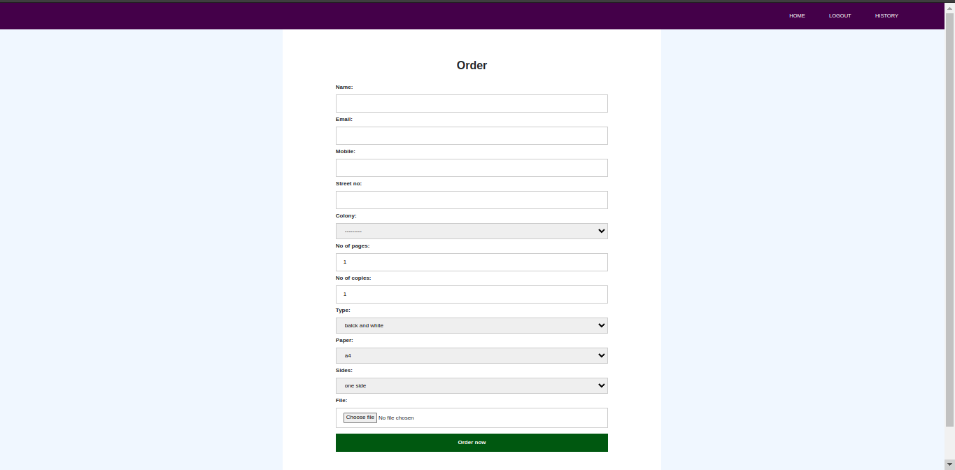
confirmorder.html

<!DOCTYPE html>
<html lang="en">
<head>
<meta charset="utf-8">
<meta name="viewport" content="width=device-width, initial-scale=1">
<title>PrintingPress</title>
<link
href="https://cdn.jsdelivr.net/npm/bootstrap@5.2.1/dist/css/bootstrap.min.css" rel="stylesheet" integrity="sha384-iYQeCzEYFbKjA/T2uDLTpkwGzCiq6soy8tYaI1GyVh/UjpbCx/TYkiZhlZB6+fzT" crossorigin="anonymous">
<style>
44
<style>
*{
margin:0px;
padding:0px;
box-sizing: border-box;
font-family: 'Poppins', sans-serif;
}
nav{
width: 100%;
height: 75px;
background-color: #3D0649;
line-height: 75px;
padding:0px 100px;
position:fixed;
z-index: 1;
}
nav ul{
float: right;
}
nav ul li{
display: inline-block;
list-style: none;
}
nav ul li a{
color:#FFFF;
text-decoration: none;
font-size: 15px;
font-weight: 150;
text-transform: uppercase;
padding:0px 32px;
margin-top: 0px;
}
nav ul li a:hover{
color:#c0d96f;
}
nav ul li .active{
color:#c0d96f;
}
45
<style>
</style>
html {
font-family: "helvetica neue", helvetica, arial, sans-serif;
}

thead th,
tfoot th {
font-family: "Rock Salt", cursive;
}

th {
letter-spacing: 2px;
}

td {
letter-spacing: 1px;
}

tbody td {
text-align: center;
}

tfoot th {
text-align: right;
}
</style>
<style>
table {
table-layout: fixed;
width: 100%;
border-collapse: collapse;
border: 3px solid purple;
}

thead th:nth-child(1) {
width: 30%;
}
46
thead th:nth-child(2) {
width: 20%;
}

thead th:nth-child(3) {
width: 15%;
}

thead th:nth-child(4) {
width: 35%;
}

th,
td {
padding: 20px;
}
</style>
</head>
<body>
<nav>
<ul>
<li>
<li> <a href="/">Home</a></li>
{% if not user.is_authenticated %}
<li> <a href="/login">login</a></li>
<li> <a href="/signup">signup</a></li>
{% else %}
<li> <a href="logouthand/">logout</a></li>
<li> <a href="history/">history</a></li>
{% endif %}
</ul>
</nav>

<div>
<table>
<tr>
<th colspan="2">Confirm Details
</th>
47
<tr>
</tr>
<td>name</td>
<td>{{name}}</td>
</tr>
<tr>
<td>email adress</td>
<td>{{email}}</td>

</tr>
<tr>
<td>mobile</td>
<td>{{mobile}}</td>
</tr>
<tr>
<td>address</td>
<td>{{address}}</td>
</tr>
<tr>
<td>no of pages</td>
<td>{{no_of_pages}}</td>
</tr>
<tr>
<td>no of copies</td>
<td>{{no_of_copies}}</td>
</tr>
<tr>
<td>type</td>
<td>{{type}}</td>
</tr>
<tr>
<td>paper</td>
<td>{{paper}}</td>
</tr>
<tr>
<td>sides</td>
<td>{{sides}}</td>
</tr>
48
<tr>
<td>Total amount</td>
<td>{{Price}}</td>
</tr>
<tr>
<td>Discount</td>
<td>{{Discount}}</td>
</tr>
<tr>
<td>amount</td>
<td>{{amount}}</td>
</tr>
<tr>
<td>file</td>
<td>{{file}}</td>
</tr>
</table>
<div class="text-center">
<a href="confirm/"><button class="btn btn-submitin btn-lg full-width btn-primary">place order</button></a>
</div>
</div>
<script src="https://cdn.jsdelivr.net/npm/bootstrap@5.2.1/dist/js/bootstrap.bundle.min.js" integrity="sha384-u1OknCvxWvY5kfmNBILK2hRnQC3Pr17a+RTT6rIHI7NnikvbZlHgTPOOmMi466C8" crossorigin="anonymous"></script>

</body>
</html>

49
Output
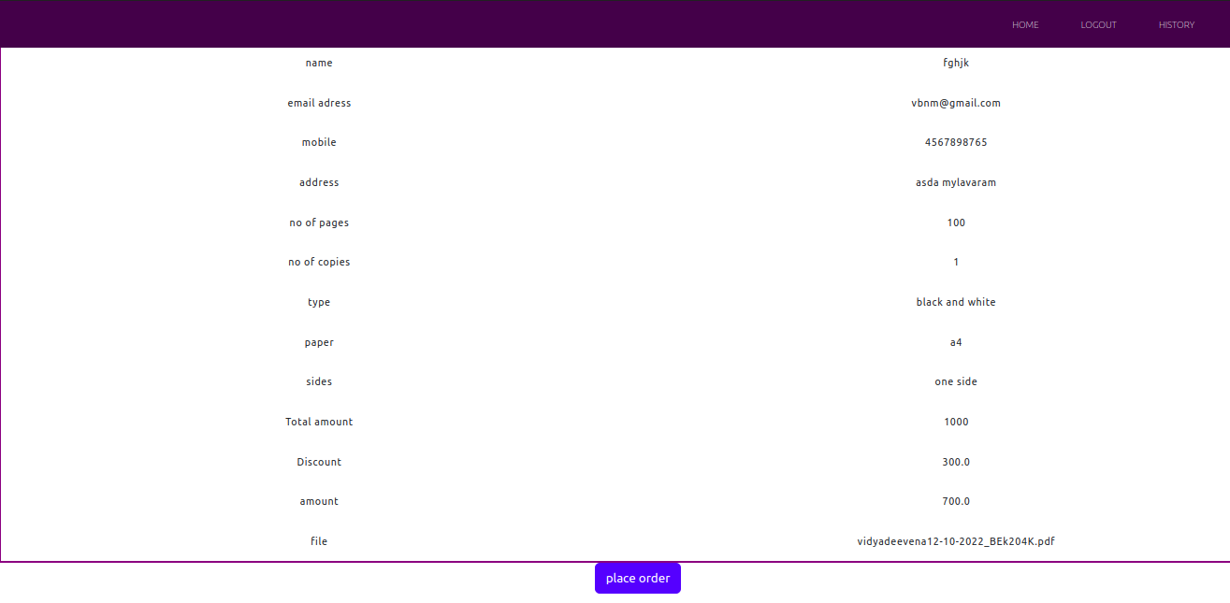

history.html

<!doctype html>
{% extends 'base.html' %}
{% block title %}history{% endblock title %}

{% block links %}
<link rel="stylesheet" href="https://cdn.jsdelivr.net/npm/bootstrap@4.0.0/dist/css/bootstrap.min.css" integrity="sha384- 73 Page of 78 Gn5384xqQ1aoWXA+058RXPxPg6fy4IWvTNh0E263XmFcJlSAwiGgFAW/dAiS6JXm" crossorigin="anonymous">
<script src="https://code.jquery.com/jquery-3.2.1.slim.min.js" integrity="sha384-KJ3o2DKtIkvYIK3UENzmM7KCkRr/rE9/Qpg6aAZGJwFDMVNA/GpGFF93hXpG5KkN" crossorigin="anonymous"></script>
<script src="https://cdn.jsdelivr.net/npm/popper.js@1.12.9/dist/umd/popper.min.js" integrity="sha384-ApNbgh9B+Y1QKtv3Rn7W3mgPxhU9K/ScQsAP7hUibX39j7fakFPskvXusvfa0b4Q" crossorigin="anonymous"></script>
<script src="https://cdn.jsdelivr.net/npm/bootstrap@4.0.0/dist/js/bootstrap.min.js" integrity="sha384-JZR6Spejh4U02d8jOt6vLEHfe/JQGiRRSQQxSfFWpi1MquVdAyjUar5+76PV
50
CmYl" crossorigin="anonymous"></script>
<link href="https://cdn.jsdelivr.net/npm/bootstrap@5.2.1/dist/css/bootstrap.min.css" rel="stylesheet" integrity="sha384-iYQeCzEYFbKjA/T2uDLTpkwGzCiq6soy8tYaI1GyVh/UjpbCx/TYkiZhlZB6+fzT" crossorigin="anonymous">
{% endblock links %}
{% block body %}
<table style="border:3px solid purple" class="table table-hover">
<thead>
<tr style="background-color: aqua;">
<th scope="col">File</th>
<th scope="col">No of Copies</th>
<th scope="col">Type</th>
<th scope="col">Paper</th>
<th scope="col">Sides</th>
<th scope="col">Amount</th>
<th scope="col">Vendor</th>
</tr>
</thead>
<tbody>
<!--{{dict}} -->
{% for i in dict %}
<tr>
<td scope="row">{{i.file}}</td>
<td scope="row">{{i.no_of_copies}}</td>
<td scope="row">{{i.type}}</td>
<td scope="row">{{i.paper}}</td>
<td scope="row">{{i.sides}}</td>

<td scope="row">{{i.payment}}</td>
<td scope="row">{{i.name_of_pub}}</td>
</tr>
{% endfor %}

</tbody>
</table>
{% endblock body %}

51
Output

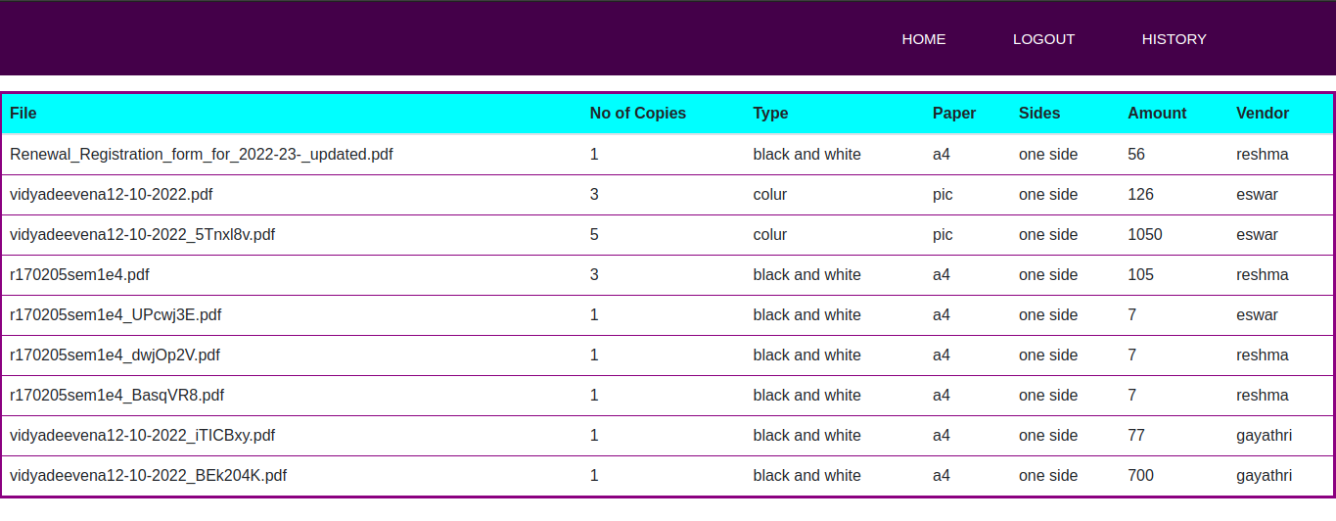

52
Conclusion

After careful observation, it has come to my conclusion that everything is becoming digital and has undeniably become an important part of our society. The world wide web is and will have a large part in our daily lives.
This web application provides user to take printed copies of the documents without manual interference and receiving Hard copies at doorstep. Online Printing press being web based needs to be thoroughly tested before implementation to find any security gaps.

Future Enhancement

- In the future we can add the Retailers modules for best quality purpose.
- We can add the machine Learning Algorithms for automated shopping in the store.
- We can add the return orders after the orders are delivered to the customer and the customer is not satisfied about their products.
- Maintaining retailers and Designers data are helpful in the improving the marketing tactics.

53
References

HTML & CSS
- HTML- W3schools
- CSS - W3Schools

BOOTSTRAP
- Bootstrap - W3schools

- https://getbootstrap.com/

DJANGO
- Django Documentaion

- https://www.youtube.com/playlist?list=PLu0W_9lII9ah7DDtYtflgwMwpT3xmjXY9

54

