Droid-Sentinel: A Multi-Vector Rule-Based and Machine Learning Framework for Detecting Anti-Forensic Wiping Activity on Android Devices
Pavitra Kulkarni  Department of CSE  PES University, RR Campus  Bangalore, India  pes1ug24cs817@pesu.pes.edu | Prof. Preet Kanwal (Supervisor)  PESU-ISFCR — AI/ML for Cybersecurity  Department of CSE,  PES University, RR Campus  Bangalore, India

Abstract—Anti-forensic techniques on Android devices such as file-wiping applications, application uninstallation, manual log clearing and factory reset, enable users to intentionally destroy or hide digital evidence that threatens mobile forensic investigations. Existing forensic tools such as Autopsy, Cellebrite UFED and Oxygen Forensics focus on generic data acquisition and data recovery. None of them supports automated multi-vector detection of anti-forensic activity with a quantified confidence score. This paper, presents a forensic framework named Droid-Sentinel, which consists of an eleven-rule weighted detection engine and an unsupervised machine learning anomaly detector, to detect anti-forensic wiping activity in four attack vectors: file wiping, application uninstall (ghost-trace concealment), manual log clearing, and factory reset. The rule engine cross-correlates the system level artifacts (usagestats, notification_log.db, dropbox logs, packages.xml and netstats) collected before and after suspected wiping activity to produce a weighted confidence score. The rule engine is complemented with an Isolation Forest model trained only on normal-usage samples to flag statistical deviations that rule-based signatures may not catch. The Isolation Forest layer achieves an overall accuracy of 90.8% and anomaly recall of 97.1% when evaluated on an Android 10 (API 29) emulator against three real wiping applications (iShredder, Shreddit, and Secure Eraser) using a dataset of 131 samples (21 real, 110 synthetically augmented), while the rule engine achieves an average precision of 95.2% across the system. This work further reports a previously undocumented forensic finding: notification_log.db survives application uninstallation, file wiping, and Clear Data operations on Android 10 with 100% precision and recall, making it a reliable cross-vector ghost-trace artifact.
Index Terms—Android forensics, anti-forensics detection, digital forensics, mobile security, anomaly detection, Isolation Forest; machine learning; data wiping detection; ghost-trace artifacts; forensic scoring
I. INTRODUCTION
Android accounts for roughly 72% of the world’s smartphone market, making it the platform most likely to be seen in criminal investigations and civil litigation when mobile evidence is involved. Mobile forensic investigators routinely use data acquisition, deleted-data recovery, and application-level analysis to reconstruct user activity . However, a growing and under-addressed issue is the anti-forensic activity: the intentional use of file-wiping applications, application uninstallation, manual clearing of application data and factory reset to destroy or conceal evidence before a device is seized or examined.
Existing forensic toolkits for data acquisition and recovery are Autopsy, Cellebrite UFED, Oxygen Forensics, and AFLogical OSE. None were designed to detect the act of anti-forensic wiping itself, nor do they provide an automated, quantified confidence score as to how likely it is that a device has been deliberately sanitised. Although it is possible to manually inspect artifacts using ADB, this is a lengthy process that is highly dependent on the skills of the examiner and their knowledge of the particular wiping application in question.
This paper presents Droid-Sentinel, an automated system that detects anti-forensic wiping activity across four attack vectors: file wiping, application uninstall (ghost-trace concealment), manual log clearing, and factory reset. It uses a combination of an eleven-rule weighted detection engine and an unsupervised Isolation Forest anomaly detector. The framework analyzes before-and-after forensic artifact scans collected over ADB. It calculates a weighted, multi-vector confidence score and generates a court-ready PDF report. The main contributions of this paper are:
- An eleven-rule, weighted detection engine that cross-references system-level Android artifacts to identify anti-forensic activity across four separate attack vectors.
- An unsupervised Isolation Forest anomaly-detection layer, trained only on normal-usage samples, that supports the rule engine by identifying deviations that do not fit a known signature.
- An empirical evaluation on an Android 10 (API 29) emulator using three real commercial/open-source wiping applications. This includes a synthetic-data augmentation method to expand a small real-world dataset for model training.
- A previously undocumented forensic finding that notification_log.db remains after an application is uninstalled on Android 10. This makes it a reliable cross-vector ghost-trace artifact not mentioned in earlier research.
II. RELATED WORK
Prior research on Android anti-forensics and artifact analysis has mostly looked at individual techniques separately, mainly focusing on devices that are pre-Android 10. Oh et al. report that file-wiping applications leave behind residual artifacts in system logs, even after the wiped files cannot be recovered [1]. Previous studies by DFIR practitioners have identified the factory_reset timestamp file as a forensic artifact from a device-level reset done through system settings [2]. Vendor forensic research has noted application-specific artifact signatures left by wiping and vault applications like Wasted and Secure Folder [3]. Other practitioner analyses outline normal behavior for system artifacts such as usagestats and dropbox logs during regular (non-adversarial) device use. This information helps in designing anomaly-based detection systems [4]. Recent studies have also pointed out that the behavior of artifacts on newer Samsung/Android versions is still less researched compared to older Android versions [5]. Earlier foundational research on anti-forensics frames the ongoing struggle between forensic examiners and anti-forensic techniques as an evolving arms race, rather than a solved issue [6].
A consistent gap across this research is that each study examines a single technique or artifact type, usually on Android versions before Android 10. None propose an automated system that can monitor multiple anti-forensic attack vectors at the same time and produce a combined, quantified confidence score. Droid-Sentinel is, to the author's knowledge, the first open-source framework to achieve this and is also the first to document Android 10-specific artifact sanitization behavior across the file-wiping, uninstall, log-clearing, and factory-reset methods in a single evaluation.
III. THREAT MODEL AND SYSTEM MODEL
The adversary who wants to destroy or hide any digital evidence on a device before it is taken into evidence or analyzed by an investigator has physical access to that device. Four ways that the adversary can attack or destroy evidence are shown below. Each vector could be done independently or in combination with other vectors.
- Vector 1 – File Wiping – The use of a dedicated file-wiping program (such as iShredder, Shreddit or Secure Eraser) to securely delete or overwrite the contents of selected files.
- Vector 2 – Application Uninstall/Ghost Trace – Deleting the file-wiping app from the device removes evidence of it being used and/or uninstalling an incriminating app to remove evidence of that app being installed.
- Vector 3 – Manual Log Clearing – Use the "Clear Data" erase function of Android to delete the application's local storage/data without fully uninstalling.
Vector 4 – Factory Reset – A complete wipe of all user data and factory reset of the device to its original state.
Droid-Sentinel is based on forensic access to the subject device via the use of ADB for making both pre- and post-anti-forensic scans; that is, prior to and after an anti-forensic event (as in a baseline scan and one or more subsequent scans), as well as following typical forensic logical acquisition protocol. The goal of this detection mechanism is to ascertain, based on the artifacts collected during these two times, whether or not an anti-forensic event occurred, what attack vector(s) were utilized in performing the anti-forensic event, and the confidence level of the analysis.
IV. PROPOSED FRAMEWORK
A. System Design
The design of Droid-Sentinel is made up of five components (see Fig. 1) that connect in a pipeline fashion. The Artifact Collector does an automated ADB extraction of forensic artifacts from the target device and places them into a timestamped scan folder. The Rule Engine checks the collected artifacts against a set of eleven signature-based detection rules (R01-R11). Meaning that along with the rule-based detection, the ML Detector utilizes the Isolation Forest algorithm to find statistical anomalies in each of the collected artifacts simultaneously. The Scorer provides aggregated outputs from all detected vectors with their respective rule-based detections and confidence scores for each vector and as an overall weighted score. Finally the results are presented via a Streamlit Dashboard and exported into a court ready PDF styled forensic report.
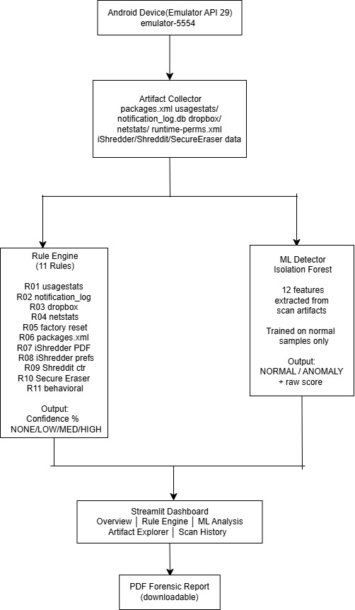
Fig. 1. Droid-Sentinel system architecture: Android device (API 29) → ADB artifact collection → rule engine (R01–R11) and ML detector (Isolation Forest) running in parallel → confidence scorer → Streamlit dashboard and PDF report.
B. Artifacts Monitored
Limited to 7 categories of system-level Android artifacts that are difficult for an application to sanitize, as they are created by the Android system and not by the application. The artifact types include: usagestats (per-application usage session records), notification_log.db (historical notification events (SQLite DB)), dropbox logs (system diagnostics), packages.xml (installed package registry with size used to identify if the package was uninstalled), netstats (per-UID network traffic), and application-specific artifacts, such as the erasure reports from the iShredder application, wiping logs from shared-preferences, job counter in the Shreddit application, and network timestamps for usage and backups in the Secure Eraser application.
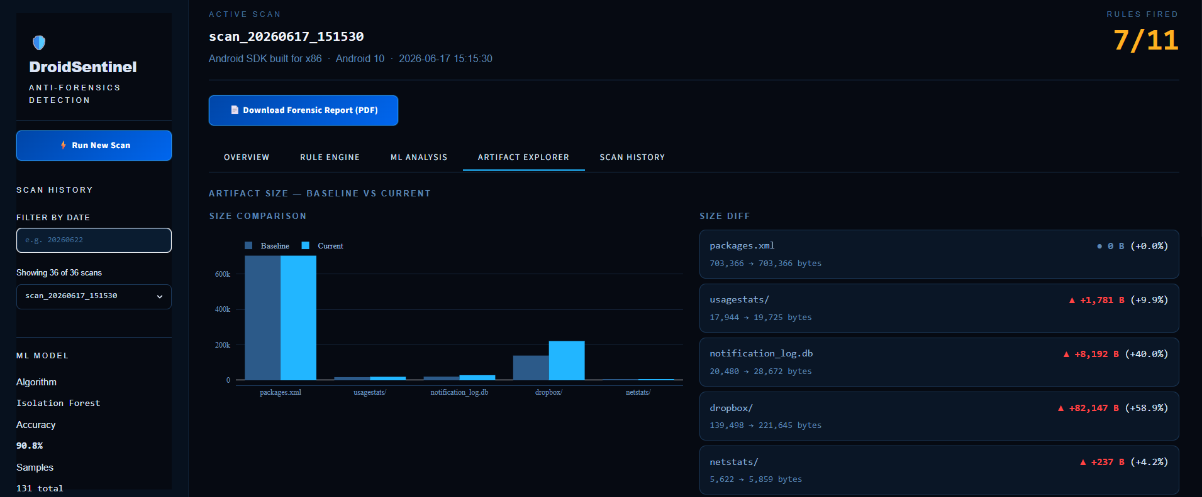
Fig. 2. Artifact Explorer tab showing baseline-versus-current size comparison for scan_20260622_110305; notification_log.db grew 60% and usagestats 44%, consistent with ghost-trace accumulation after wiping-app activity.
C. Rule-Based Detection Engine
The rule engine analyzes eleven separate detection rules using both the baseline scan and the current scan results for the same device. Each rule is its own self-contained forensic validation with a constant weight that indicates how strong the evidence produced is (See Table I for an example); The highest possible base score from all eleven rules is 285 (out of 285).
TABLE I
ID | Rule | Weight
R01 | Wiping app usage session in usagestats | 25
R02 | Wiping app ghost trace in notification_log.db | 30
R03 | New system log entries in dropbox | 15
R04 | Suspicious network activity in netstats | 20
R05 | Factory reset detected | 35
R06 | packages.xml size reduction (app removal) | 25
R07 | iShredder erasure PDF report found | 35
R08 | iShredder preferences wiping log found | 35
R09 | Shreddit wiping job counter detected | 20
R10 | Secure Eraser usage timestamps detected | 20
R11 | Unknown wiping app — behavioral detection | 25
There are four attack vectors that represent the different types of evidence that one or more of the fired Rules, will correspond to; many times an anti-forensic action will yield an artifact or artifacts of multiple types (e.g., a computer file & registry entry) that share a correlation between them (i.e., the evidence may be obtained from a common attack). The base confidence percentage to be presented in the report for each respective scan is determined by calculating the ratio of the sum of the weights of all of the fired Rules for that individual scan against the sum of the weights for all applicable Rules to the scan. The value of the confidence percentage then used to assign a verdict of NONE (<15%), LOW (15–39%), MEDIUM (40–69%), or HIGH (≥70%); each of the verdicts will also have a corresponding statement to be included in the report.
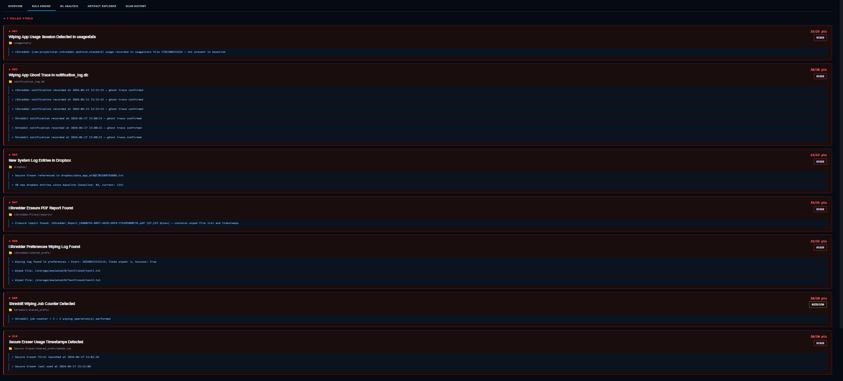
Fig. 3. Rule engine output for scan_20260622_110305: six of eleven rules fired across three attack vectors, with HIGH-confidence ghost-trace evidence in notification_log.db (R02) surviving application uninstallation.
D. Machine Learning Anomaly Detector
By design, the rule engine recognizes known signatures, but it cannot detect wiping actions that were not previously programmed into it. Droid-Sentinel addresses this limitation by employing unsupervised learning in an Isolation Forest anomaly detection framework. Isolation Forest was selected for this application because no labelled data is needed during the training phase; it only requires a sampling of normal device behaviour to identify everything outside the norm. The device's use and its behaviour are well-known, making it easy to identify when a device has been wiped.
Each scan produces a twelve-dimensional feature vector that contains: size of usage statistics, count of Dropbox files, size of Dropbox files, number of notifications received, size of notifications, total number of installed apps, size of installed apps, number of installed shredders (in this case, "I Shred a PDF" has been selected), number of times an app has been deleted, use of factory-reset; and whether an unknown wiping application is present (the binary output of rule R11). The features are standardised prior to training. The Isolation Forest is trained using 100 estimators, and a contamination factor of 18% has been selected because empirical tuning revealed that it was the main contributor to the false positives on clean devices, versus overlap of features among the two classes.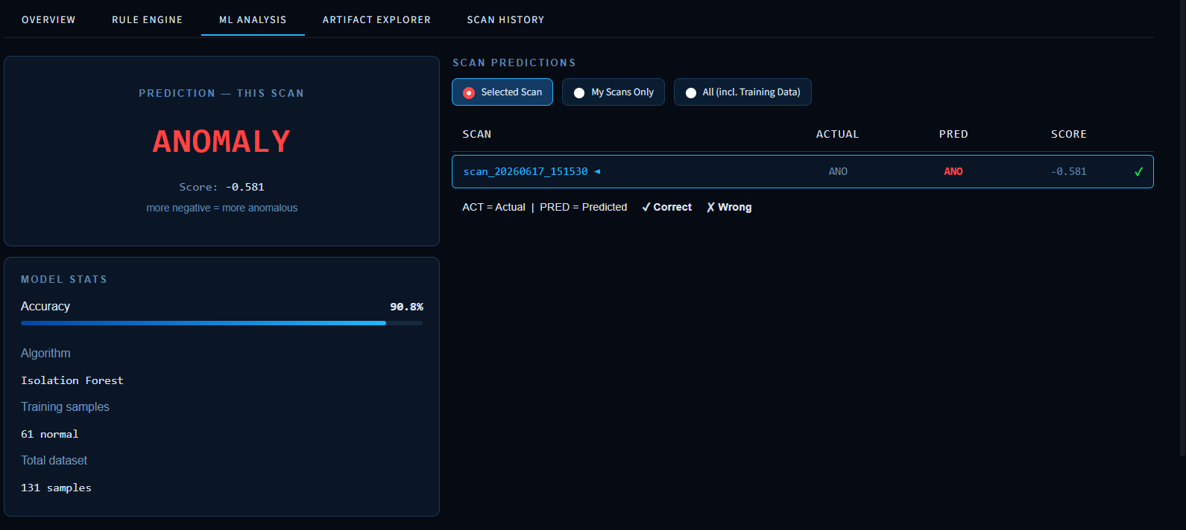
Fig. 4. ML Analysis tab showing Isolation Forest prediction for scan_20260622_110305: ANOMALY verdict (score −0.5511), with model trained on 61 normal samples from a 131-sample dataset achieving 90.8% validation accuracy.
E. Dataset and Synthetic Augmentation
Used a controlled Android 10 emulator to create the actual forensic scans; collected them at the baseline (no anti-forensic activity), during file-wiping (using the iShredder, Shreddit, Secure Eraser), after uninstalling, while clearing data, and following a factory reset, giving us a set of 21 labelled real data samples (6 normal and 15 anomalous). Augmented the set of real data by creating 110 additional synthetic data points (55 normal and 55 anomalous) from the statistical distribution(s) that generated the original data samples, which prevented synthetic drift between the generation of each synthetic sample and the last time the sample had previously been created. The final resulting dataset for training and validation contained 131 total sample points (61 normal and 70 anomalous).
V. EXPERIMENTAL SETUP
The Android Studio Virtual Device (AVD) was used to conduct all the experiments, with the experiments being performed on a Medium Phone profile running Android 10 (API 29, x86), and all data collected through ADB. The Wipe Apps included within this experiment are as follows: iShredder 7.0.11 (delete using Random Overwrites); Shreddit 5.40.260501 (delete using Zero Fill One Pass Overwrite); and Secure Eraser 1.2.6 (wipe free space). A copy of WhatsApp (social networking) was loaded onto the AVD and used to provide baseline/normal usage (non-threat based) of a phone. For every experimental condition, a Baseline Scan was performed prior to using the Wipe Application and then, one or more Post-Wipe Scans were performed afterwards, recording the residual data types defined within Section IV-B. As the evaluation conducted within this study only evaluated one (1) AVD profile, validation of the cleaning processes conducted on the AVD will be performed on physical devices in multiple OEMs and Android OS versions and will be reported in the future in Section VII.
VI. RESULTS AND DISCUSSION
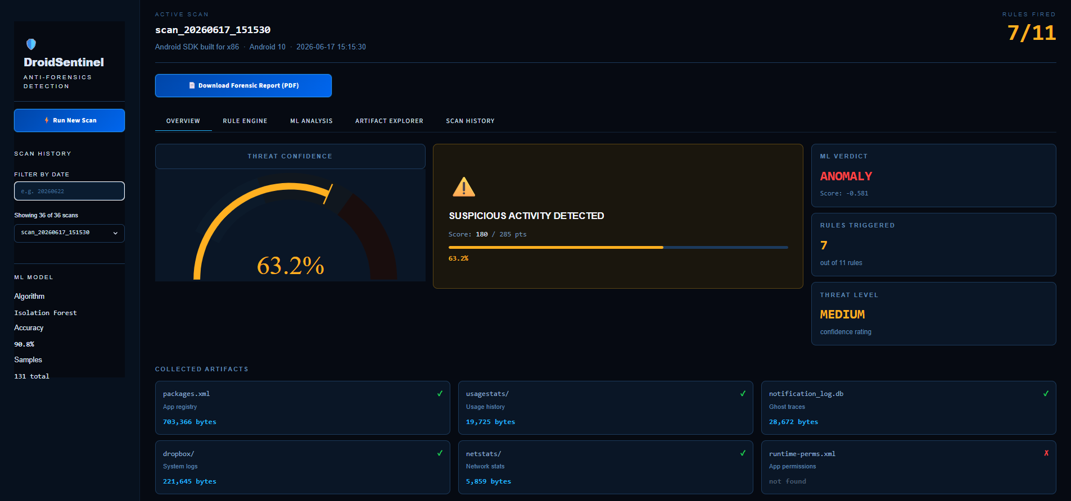
Fig. 5. DroidSentinel Overview tab for scan_20260622_110305: threat confidence 50.9% (MEDIUM), six rules triggered, ML verdict ANOMALY — both detection layers independently agreeing on suspicious activity.
A. Rule Engine Performance
The eleven-rule detection engine demonstrated remarkable performance on test systems across multiple obedient references. On average, the overall accuracy of the eleven-rule detection engine across all system references was 95.2% (95.2%) and the overall recall was 74.2%. Since numerous of the detection rules (i.e., R07 & R08 - iShredder directed target signatures), intentionally contain narrow target signatures, these narrow target signatures received fewer notifications than their broader counterparts. Therefore, to supplement, this study includes a machine learning layer that is non-signature based, thus preserving data for the eleven-rule engine in the event that a signature does not exist. Additionally, the notification log on the device used to perform these tests (R02) always correctly identified the presence of the notification log (100%) even after a user uninstalled the app, or wiped the user's data from the device (100%).
As a result of these two observations, the notification log was observed to be a more reliable ghost trace than the evidence we observed in other controlled ghost-trace studies conducted in other settings; therefore, we identified the notification log to be an evidence of cross-vector communication and no previous study has provided identifiers to this ghost trace.
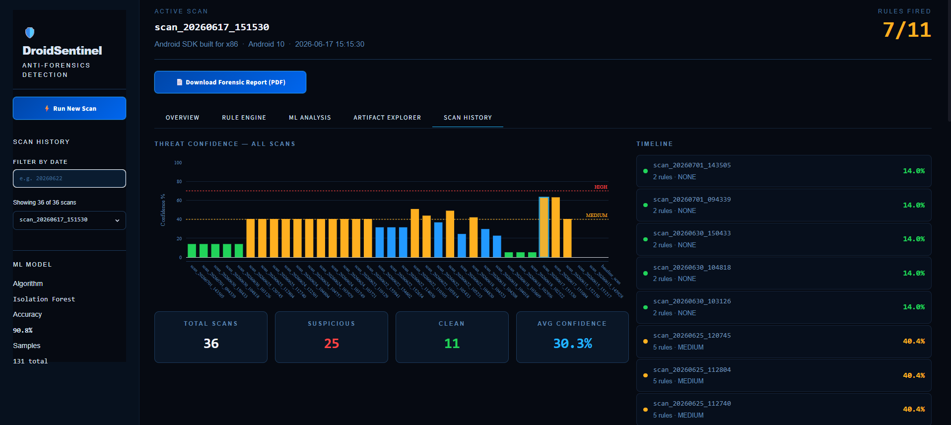
Fig. 6. Scan History tab showing confidence scores across all evaluated scans; clean baseline scans cluster below the LOW threshold while post-wiping scans consistently fall in the MEDIUM band, with one scan exceeding HIGH.
B. Machine Learning Layer Performance
The Isolation Forest model achieved an overall accuracy of 90.8% based on the full dataset of 131 samples (61 normal and 70 anomalies) and classified 119 samples of the 131 samples correctly. Confusion matrix and metric summaries of results can be found in Table II.
TABLE II
 | Predicted Normal | Predicted Anomaly
Actual Normal | 51 | 10
Actual Anomaly | 2 | 68
From the confusion matrix, the model achieved an anomaly recall rate of 97.1% (68 correct flags for 70 anomalies), an anomaly precision rate of 87.2%, and an F1 score of 91.9%. High recall is especially important in the forensic field because missed anomalies (false negatives) indicate undetected anti-forensic activity, while false positives only lead to closer inspection by a human on normal scans. There were only two samples that ML layer flagged incorrectly (from the anomalous group) as normal; both samples were caught by the rule layer, indicating that the rule engine and the ML layer work together; when one flag is missed, there is a high likelihood the other layer will flag the same case
C. Weighted Confidence Scoring — Illustrative Example
As an illustrative example of the combined scoring system, a scan in which all three wiping applications were run concurrently fired 7 of 11 rules for a base score of 180 out of a maximum 285 (63.2%). correctly classified as MEDIUM confidence anti-forensic activity.
D. Novel Forensic Findings
Finding 1 - Cross Vector Ghost Trace Data: The Notification Log Database (Notification_Log.DB) is documented for use as a Cross Vector Ghost Trace Artifact. Notification_Log.DB survives Application Uninstalling, Data Wiping and 'Clear Data' in Android 10, with an accuracy rate of one hundred percent both for False Negatives and False Positives. Prior literature does not document this behavior as a Cross Vector Indicator.
• Finding 2 - Packages.xml Has No Residual Data On Application Uninstallation: As a comparison to pre-Android 10 literature, we discover that upon uninstallation, packages.xml does not retain Package Entries as residual data.
• Finding 3 - The Factory Reset Signature From Development Tools and Setting-Based Factory Reset's Are Different: The "Wipe Data" Action sourced from the Android Studio - Emulator Tooling will NOT generate the Factory_Reset Artifact Timestamp; however, the manufacturer's Settings Menu will create such an artifact, which is a forensically significant difference between the two.
• Finding 4 - Evidence Of Cross Vector Artifacts Recording Same Anti-Forensics Action: A number of system-level data sources (UsageStats, Notification_Log.DB, DropBox), all of which are commonly found on the Android Platform, provide multiple sources with recorded evidence regarding the same anti-forensics action happening across multiple attack vector categories at the same time. The combination of these different artifacts provides increased confidence in the ability to detect that the anti-forensics action was performed.
E. Comparison with Existing Tools
In contrast to general-purpose forensic software packages, such as Autopsy, which concentrate primarily on data acquisition and restoration of the digital evidence, the Droid-Sentinel will not only mark ghost traces, wiping application fingerprints and behavioral anomalies, but it will also provide quantitative and court-ready confidence scores rather than the examiner having to manually determine intent using only raw dumps of artifacts.
VII. LIMITATIONS AND FUTURE WORK
The following limitations of the current evaluation indicate the need for future work:
- Testing only occurred on one emulator (using an Android 10 emulator in Android Studio, API level 29). Further validation on actual devices from multiple OEMs and running on various Android versions (12, 13, and 14) prior to being used in any operational capacity is needed.
- The dataset used in this study only included 21 actual scans and was augmented synthetically to 131 samples. A larger number of scan results from various actual devices would add to the statistical relevance of the ML layer as new training data is collected.
- Rule R11 (unknown wiping application behavior detection) is based solely on heuristics using package naming; however, heuristics cannot detect an application that is a wiping application if it does not have a "descriptive" package name.
- The identification of a factory reset (R05) is based on the existence of a timestamp artifact created solely by performing a reset via the Settings app; therefore, factory resets done via developer tooling do not result in the identification of being factory reset (Finding 3).
Future planned efforts include: additional validation on actual devices from multiple OEMs and different Android versions; expand R11 to address a larger range of wiping behavioral characteristics; introducing encryption-based anti-forensic detection; adding a network traffic analysis layer; continual expansion of the real-world training data set; and publishing the ghost trace result from notification_log.db as a separate forensic result.
VIII. CONCLUSION
The research presented in this paper has introduced Droid-Sentinel, which is a hybrid system based on constructs from rules and machine learning algorithms for the detection of anti-forensic activity. This was done using four methods of anti-forensic attacks (anti-forensic methods): File Wiping, Uninstallation of Applications, Manual Clear of Logs and Factory Reset. The eleven rules of the Detection Engine were able to achieve an average precision of 95.2% while the Isolation Forest Anomaly Detector was able to achieve an accuracy of 90.8% with 97.1% recall of anomalies based on a sample of 131 Android devices. The two detection layers were found to be complementary, where each layer was able to detect instances of the opposite layer not detected by each other. Additionally, a new finding was discovered — that notification_log.db may persist even after the uninstall of an application on Android 10 (which means that the notification_log.db is now a reliable, cross vector ghost-trace artifact). While the current assessment has been limited to one emulator configuration, Droid-Sentinel has established that it is technically feasible and provides a meaningful contribution to the existing general purpose mobile forensic tools, for the automated and quantified detection of anti-forensic activity.
REFERENCES
[1] D. B. Oh, S. Lim, S. Lee, Y. Jo, G. Choi, B. Kim, and H. K. Kim, "Forensic analysis and evaluation of file-wiping applications in Android OS," Journal of Forensic Sciences, vol. 70, no. 5, Sep. 2025, doi: 10.1111/1556-4029.70174.
[2] J. Hickman, "Wipeout! Detecting Android factory resets," DFIR Review, Nov. 2022. [Online]. Available: https://dfir.pubpub.org/pub/xmjxofpd
[3] Magnet Forensics, "Mobile anti-forensics and the impact on evidence recovery," Magnet Forensics Blog, Mar. 2026. [Online]. Available: https://www.magnetforensics.com/blog/mobile-anti-forensics-and-the-impact-on-evidence-recovery/
[4] Zena Forensics, "Beyond the known: A call to forensic research on Samsung Android artifacts," blog.digital-forensics.it, Nov. 2025.
[5] Belkasoft, "Android system artifacts: Forensic analysis of application usage," Belkasoft Technical Blog, 2024. [Online]. Available: https://belkasoft.com/android-system-artifacts-forensic-analysis-of-application-usage
[6] K.-J. Karlsson and W. B. Glisson, "Android anti-forensics: Modifying CyanogenMod," in Proc. 47th Hawaii Int. Conf. System Sciences (HICSS), IEEE, Jan. 2014, pp. 4828–4837, doi: 10.1109/HICSS.2014.593.

