**Identifying fraud users in e-commerce websites**

**Steps to Execute the Project**

**Prerequisites**: Install jupyter notebook and anaconda

**Step 1**: Open anaconda prompt in the project path

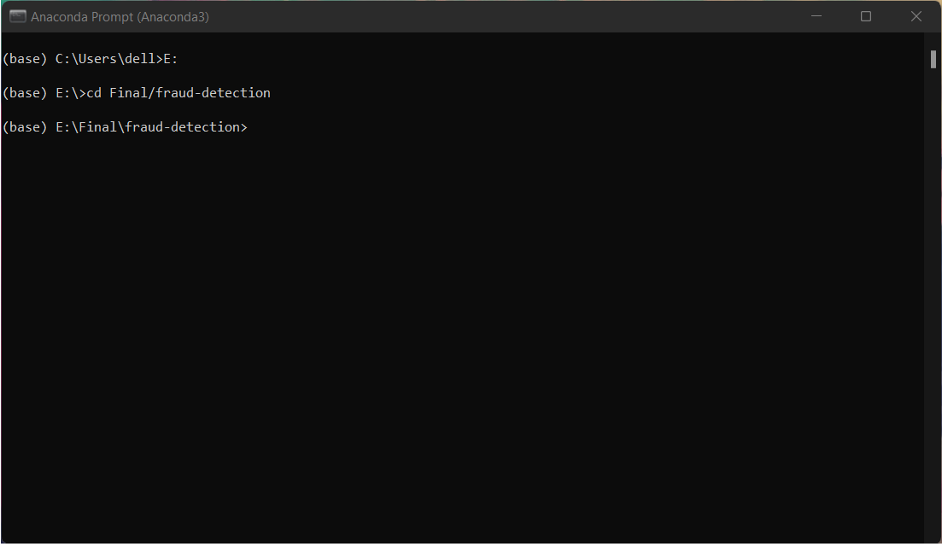

**Step 2**: Use the command "jupyter notebook" in the anaconda prompt

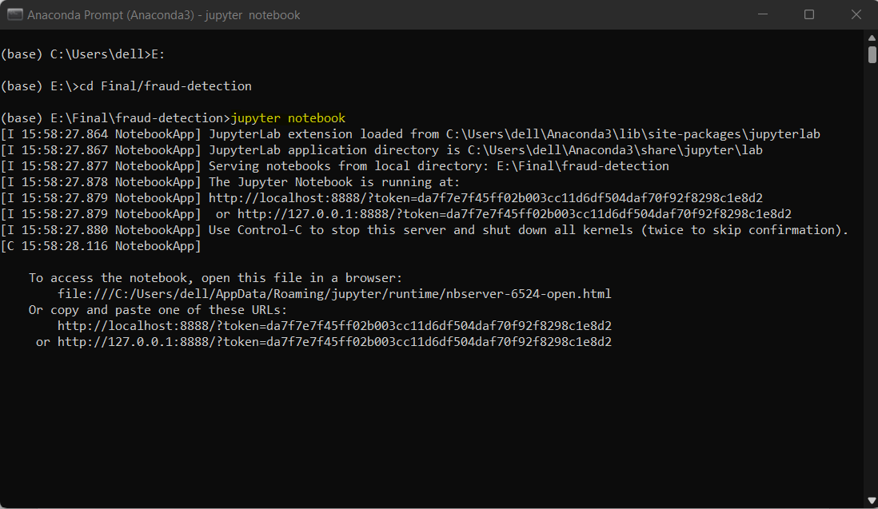

**Step 3**: Now the project folder will open in jupyter notebook in the browser

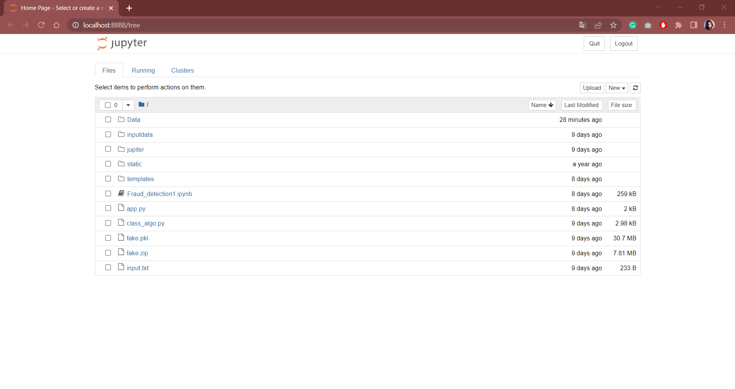

**Step 4**: Then open "Fraud_detection1.ipynb" and run each and every cell

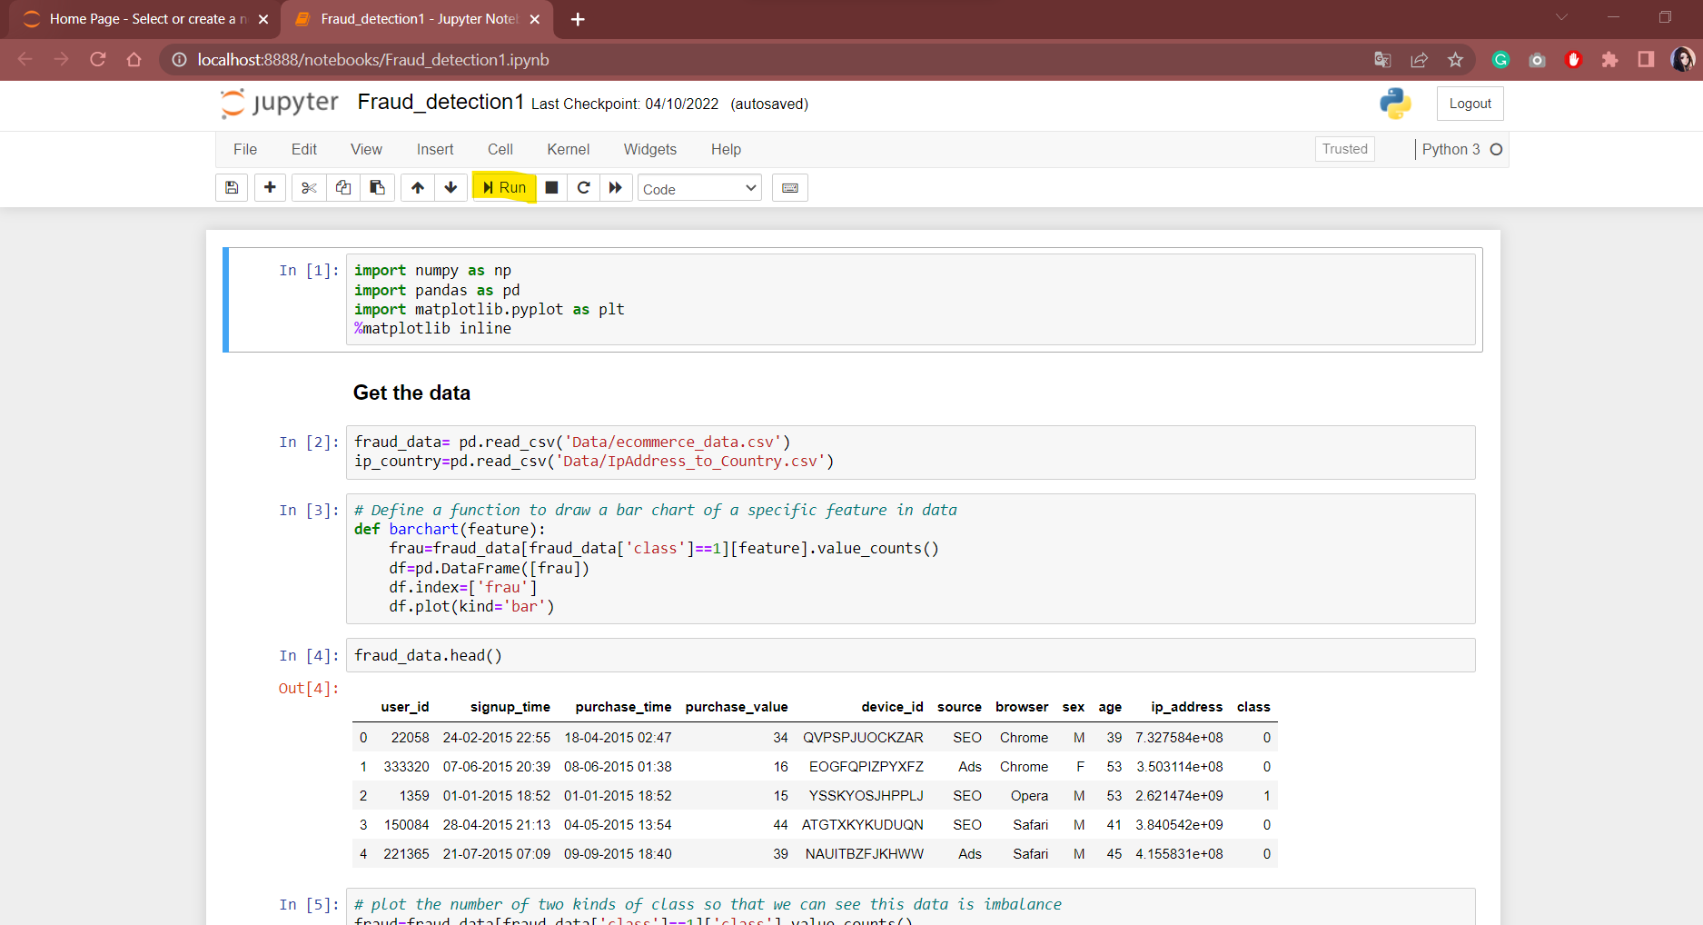

**Step 5**: Open another anaconda prompt in the project folder path without closing the previous one



**Step 6**: Type "app.py" in anaconda prompt and it gives an URL to open a webpage

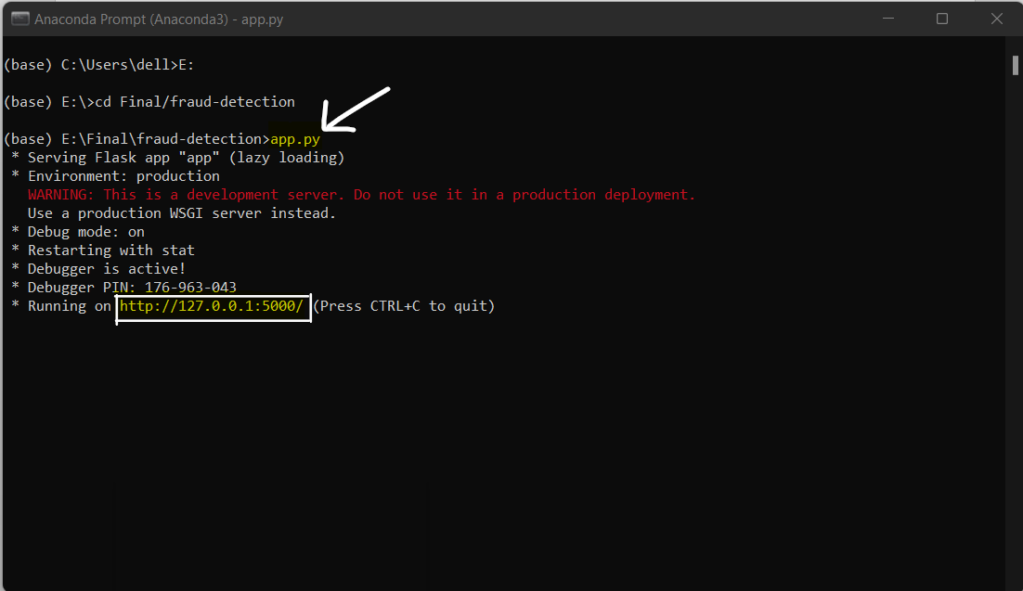

**Step 7**: Copy the URL displayed and paste it in a browser and web page will be opened there

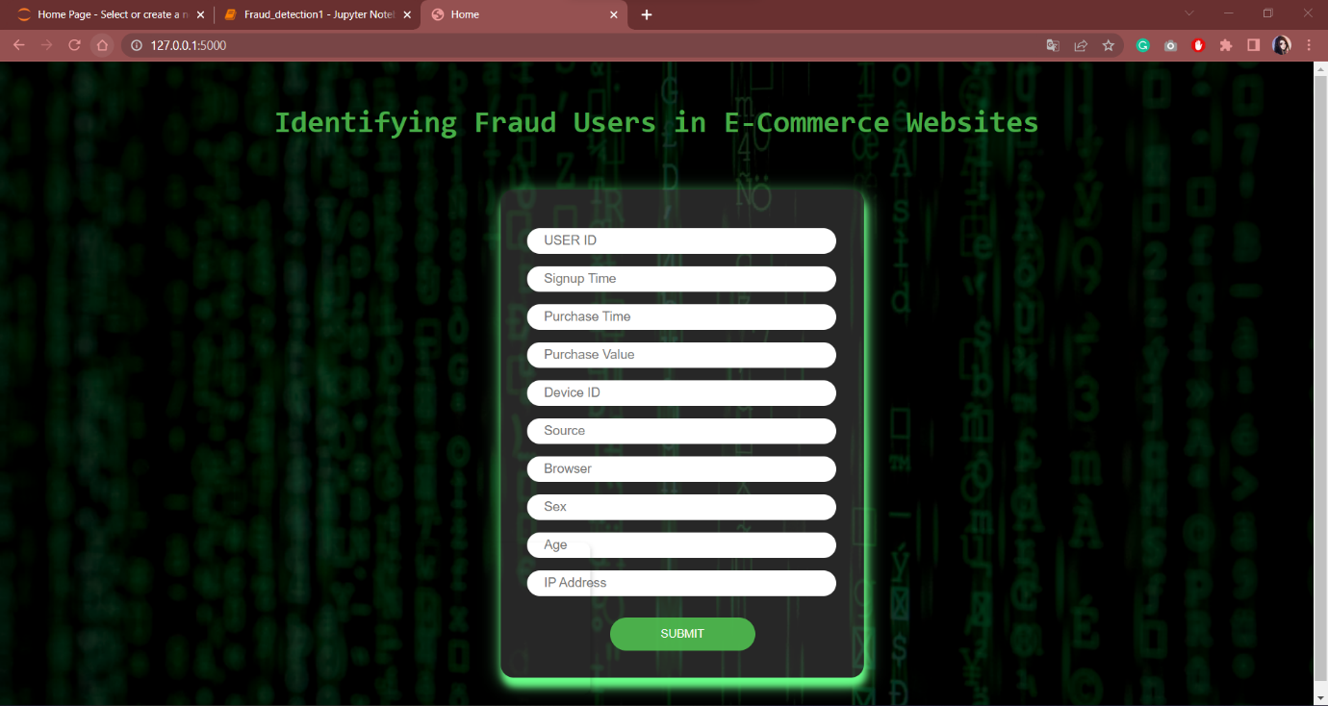

**Step 8**: Now enter all the details it is asking. The details are available in "input.txt" in project folder.

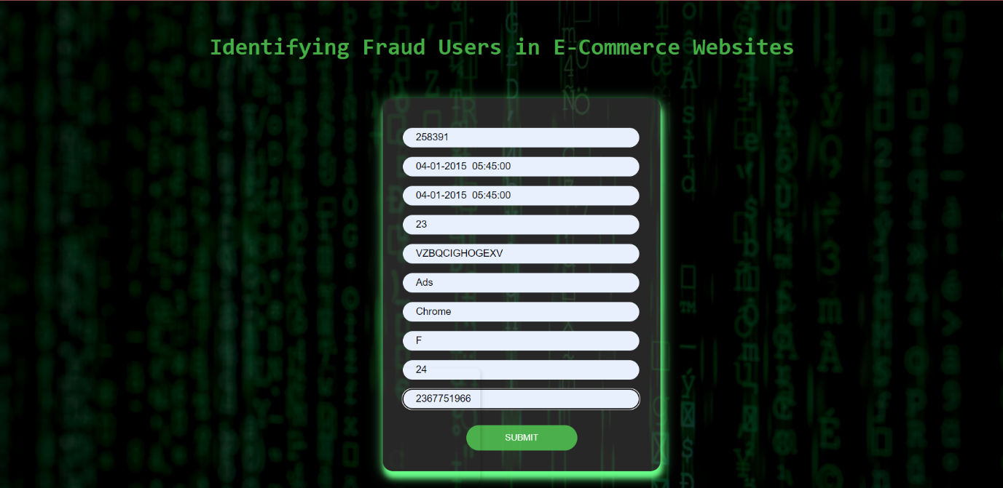

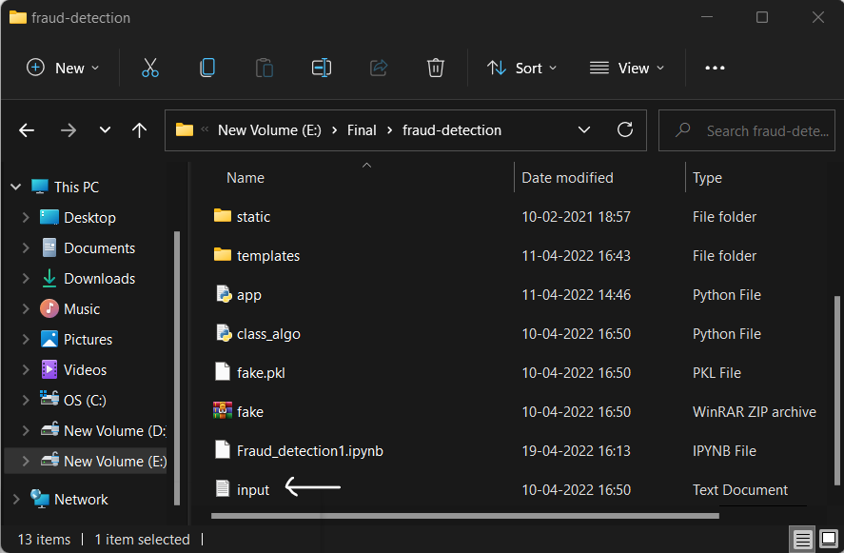

**Step 9**: Then click on submit and it displays whether the user is fraud or genuine.

