Software Requirements Specification (SRS)
Project: Academic Performance Analytics System
Version: 1.1
Authors: Pavitra, Preeti, Pranav, Ryona
Date: 14-10-2026
Status: Baseline SRS for planned implementation by 31-10-2026

Revision History
Version | Date | Author | Change summary | Approval
1.0 | 09-10-2026 | Team | Initial SRS with use-case diagrams and RTM
1.1 | 14-10-2026 | Team | Added APAS-F-004, F-015, F-025, F-034 (user administration, course/student records, threshold configuration, student trend view); added sections 1.5, 1.6 and 2.6; added suite-to-test mapping in section 6; updated RTM.

Approvals
Role | Name | Signature / Email | Date
Course Coordinator | Pending | Pending approval | Pending
Instructor | Pending | Pending approval | Pending

Table of Contents
1. Introduction
2. Overall description
3. External interface requirements
4. System features (detailed)
5. Non-functional requirements (detailed)
6. Quality attributes & Acceptance tests
7. System models and diagrams
8. Requirements Traceability Matrix (RTM)

1. Introduction

1.1 Purpose
This document is the Software Requirements Specification (SRS) for the Academic Performance Analytics System. It defines the functional and non-functional requirements, interfaces and verification criteria for a system that analyses student marks, attendance, assignments and examinations, provides dashboards and identifies students whose performance is declining or who need intervention.

1.2 Scope
The system covers data entry and import of marks, attendance, assignment and exam results; computation of analytics (averages, attendance percentage, completion rate, decline detection); at-risk student identification; role-based dashboards and reports; and intervention tracking. It excludes admissions, fee management, timetable scheduling and the institution's official grading and result-publication process.

1.3 Audience
Developers, QA engineers, faculty and academic administrators (end users), and course evaluators.

1.4 Definitions
SRS – Software Requirements Specification; RTM – Requirements Traceability Matrix; RBAC – Role-Based Access Control; CSV – Comma-Separated Values; TLS – Transport Layer Security; UI – User Interface; API – Application Programming Interface; WCAG – Web Content Accessibility Guidelines; At-risk student – a student whose attendance, marks or marks trend meets a configured intervention condition.

1.5 References
- ISO/IEC/IEEE 29148:2018, Systems and software engineering – Life cycle processes – Requirements engineering (supersedes IEEE Std 830-1998).
- W3C, Web Content Accessibility Guidelines (WCAG) 2.1.
- Institution's student data-protection and privacy policy (see 2.5).
- Software Architecture Document (SAD) and Software Test Plan (STP), Academic Performance Analytics System – companion team deliverables.

1.6 Document overview
Section 2 describes the product, users and constraints; Section 3 the external interfaces; Section 4 the detailed functional requirements; Section 5 the non-functional and security requirements; Section 6 the acceptance criteria and test suites; Section 7 the use-case models; and Section 8 the traceability matrix linking every requirement to a module and test case.

2. Overall description

2.1 Product perspective
A web-based application used by students, faculty and administrators. It stores academic data in a central database, runs analytics on that data, and presents the results as dashboards. It can send alerts through an e-mail notification service and accepts CSV imports from existing institutional records.

2.2 Major product functions
- Authenticate users and enforce role-based access
- Administer user accounts, course and student records, and risk thresholds
- Manage marks, attendance, assignment and exam data
- Compute averages, attendance percentage and assignment completion rate
- Detect declining performance trends
- Flag at-risk students with reasons
- Student, faculty and administrator dashboards
- Export performance reports (CSV / PDF)
- Alert faculty and track interventions

2.3 User roles and characteristics
- Student: views own performance; basic computer literacy.
- Faculty: enters data, monitors class performance and acts on at-risk alerts.
- Administrator / HoD: manages users and thresholds, views department-level summaries.

2.4 Operating environment
Server-side Python application with a relational database, accessed through modern web browsers on desktop and mobile devices over the institution network or the internet.

2.5 Constraints
Student data must be handled according to the institution's data-protection and privacy policy; the system must run on standard institutional server infrastructure; the project must be completed within the semester timeline using the team's agreed technology stack.

2.6 Assumptions and dependencies
Assumptions:
- Student lists and course allocations can be supplied as CSV files for the initial load.
- Faculty enter or import marks and attendance regularly, so analytics reflect current performance.
- Marks for different assessments of a course are compared on a common percentage-of-maximum scale for trend detection.
- Every user has a valid institutional e-mail address for alerts.
- Default thresholds (attendance 75%, marks 40%, trend window N = 3) are agreed with the institution and may be changed by an Administrator.
Dependencies:
- Availability of an SMTP service for at-risk alerts.
- Institutional server or cloud VM, database server and TLS certificates.
- The team's agreed technology stack (Python web framework and relational database).

3. External interface requirements

3.1 User interfaces
Responsive web UI with a clear menu per role, charts for trends and distributions, colour-blind-friendly palette and keyboard-accessible controls.

3.2 Hardware interfaces
No specialised hardware. Standard client devices (PC, tablet, phone) and a server or cloud virtual machine.

3.3 Software interfaces
- Relational database (e.g., SQLite for development, MySQL / PostgreSQL for deployment).
- CSV import / export interface for marks and attendance.
- E-mail notification service (SMTP) for at-risk alerts.

3.4 Communications
HTTPS (TLS 1.2+) for all client-server traffic; SMTP over TLS for notifications.

4. System features (detailed)
Each requirement includes an acceptance criterion and a reference test case. Functional IDs follow APAS-F-###. The system contains 24 functional requirements.

4.1 Authentication & Access Control
Description: Authenticate users and restrict data according to role.
Req ID | Requirement | Priority | Source | Acceptance criteria / Test case | Depends on
APAS-F-001 | The system shall authenticate users with a username and password before granting access. | High | Security / Admin | AC: Valid credentials open a session; invalid credentials are rejected with an error. Test: TC-Auth-01 | User database
APAS-F-002 | The system shall enforce role-based access (Student, Faculty, Administrator); a student shall only view their own records. | High | Security / Institution | AC: A student requesting another student's data receives access denied. Test: TC-Auth-02 | APAS-F-001
APAS-F-003 | The system shall lock an account for 15 minutes after 5 consecutive failed login attempts and record an audit event. | Medium | Security | AC: Sixth attempt is blocked and a message is shown. Test: TC-Auth-03 | APAS-F-001
APAS-F-004 | The system shall allow an Administrator to create, edit, deactivate and assign roles to user accounts (Student, Faculty, Administrator). | High | Admin / Institution | AC: A new user can log in with the assigned role; a deactivated user is refused login; non-administrators cannot open user management. Test: TC-Auth-04 | APAS-F-001, APAS-F-002

4.2 Academic Data Management
Description: Capture and validate marks, attendance, assignments and exam results.
Req ID | Requirement | Priority | Source | Acceptance criteria / Test case | Depends on
APAS-F-010 | The system shall allow Faculty to enter or upload (CSV) marks for each assessment of a course. | High | Faculty | AC: Uploaded marks appear against the correct students and course. Test: TC-Data-01 | APAS-F-015
APAS-F-011 | The system shall allow Faculty to record attendance per class session or import it from CSV. | High | Faculty | AC: Attendance entries are saved and counted in the student's total. Test: TC-Data-02 | APAS-F-015
APAS-F-012 | The system shall record assignment submissions (submitted / late / missing) and scores. | High | Faculty | AC: Each assignment status and score is stored per student. Test: TC-Data-03 | APAS-F-015
APAS-F-013 | The system shall record examination results (internal and end-semester) per student and subject. | High | Faculty / Exam cell | AC: Exam results are stored and visible in dashboards. Test: TC-Data-04 | APAS-F-015
APAS-F-014 | The system shall validate all entered data (marks within 0 to maximum, attended not greater than total, no duplicate entries) and reject invalid records with a message. | High | Quality | AC: Out-of-range or duplicate rows are rejected and reported. Test: TC-Data-05 | APAS-F-010..013
APAS-F-015 | The system shall allow an Administrator to maintain course and student records, including student enrolment in courses and assignment of Faculty to courses, with CSV import. | High | Admin / Institution | AC: Enrolled students appear in the course marks-entry list; each course has a responsible Faculty member; data for a student not enrolled in the course is rejected. Test: TC-Data-06 | APAS-F-004

4.3 Performance Analytics
Description: Compute metrics, detect decline and flag at-risk students.
Req ID | Requirement | Priority | Source | Acceptance criteria / Test case | Depends on
APAS-F-020 | The system shall compute each student's attendance percentage per course and overall. | High | Faculty | AC: 45 attended of 60 gives 75.00%. Test: TC-An-01 | APAS-F-011
APAS-F-021 | The system shall compute each student's average marks per course and overall. | High | Faculty | AC: Marks 70, 80, 90 give an average of 80.00. Test: TC-An-02 | APAS-F-010
APAS-F-022 | The system shall detect a declining trend when a student's marks decrease over the last N consecutive assessments (default N = 3, configurable). | High | Faculty / Mentors | AC: 80, 70, 60 is flagged as declining; 60, 70, 80 is not. Test: TC-An-03 | APAS-F-010
APAS-F-023 | The system shall flag a student as at-risk when attendance is below the attendance threshold (default 75%), average marks are below the marks threshold (default 40%), or a declining trend is detected, and shall list the reasons. | High | Faculty / Institution | AC: Each condition alone flags the student and the reason is shown. Test: TC-An-04 | APAS-F-020..022
APAS-F-024 | The system shall compute each student's assignment completion rate (submitted on time / total assigned). | Medium | Faculty | AC: 8 of 10 assignments gives 80%. Test: TC-An-05 | APAS-F-012
APAS-F-025 | The system shall allow an Administrator to configure the attendance threshold, marks threshold and trend window N, apply changed values to subsequent analytics runs, and record each change in the audit log. | Medium | Admin / HoD / Institution | AC: Changing the attendance threshold from 75% to 80% flags a student with 78% attendance on the next run; invalid values (negative, above 100%) are rejected. Test: TC-An-06 | APAS-F-022, APAS-F-023, APAS-F-002

4.4 Dashboards & Reports
Description: Present analytics to students, faculty and administrators.
Req ID | Requirement | Priority | Source | Acceptance criteria / Test case | Depends on
APAS-F-030 | The system shall provide a student dashboard showing marks, attendance, assignments, exam results and risk status. | High | Student | AC: Logged-in student sees only their own data. Test: TC-Dash-01 | APAS-F-020..024
APAS-F-031 | The system shall provide a faculty dashboard per course with class averages, marks distribution and the list of at-risk students. | High | Faculty | AC: At-risk list matches the flagging rules. Test: TC-Dash-02 | APAS-F-023
APAS-F-032 | The system shall provide an administrator summary at department level (average performance, at-risk count per course). | Medium | Administrator / HoD | AC: Totals match the underlying student data. Test: TC-Dash-03 | APAS-F-031
APAS-F-033 | The system shall export performance reports as CSV and PDF. | Medium | Faculty / Administrator | AC: Exported file content matches the dashboard. Test: TC-Dash-04 | APAS-F-031
APAS-F-034 | The system shall show a student a performance trend view (marks per assessment and attendance over time) for each course. | Medium | Student | AC: The chart shows the student's own marks in chronological order and matches stored data; another student's trend cannot be viewed. Test: TC-Dash-05 | APAS-F-021, APAS-F-022, APAS-F-030

4.5 Intervention Management
Description: Alert faculty and track actions taken for at-risk students.
Req ID | Requirement | Priority | Source | Acceptance criteria / Test case | Depends on
APAS-F-040 | The system shall notify the responsible faculty member (the Faculty assigned to the course under APAS-F-015) when a student is newly flagged as at-risk. | High | Faculty / Mentors | AC: Alert is generated within 1 minute of the flag. Test: TC-Int-01 | APAS-F-023, APAS-F-015
APAS-F-041 | The system shall allow Faculty to record intervention notes (action taken, date) against a flagged student. | Medium | Faculty | AC: Notes are saved and shown in the student's history. Test: TC-Int-02 | APAS-F-023
APAS-F-042 | The system shall track intervention status (Open, In progress, Resolved) for each flagged student. | Medium | Faculty / HoD | AC: Status changes are saved with timestamp and user. Test: TC-Int-03 | APAS-F-041

5. Non-functional requirements (detailed)
NFRs are measurable and tied to the test plan. IDs follow APAS-NF-###.
Req ID | Requirement | Category | Priority | Acceptance criteria / Measurement
APAS-NF-001 | Dashboards shall load within 3 seconds for 90% of requests with up to 500 students per course under normal load. | Performance | High | 90th percentile ≤ 3 s in load test. Test: TC-Perf-01
APAS-NF-002 | The system shall be available 99% of the time during the academic term, excluding scheduled maintenance. | Reliability | High | Uptime reports show ≥ 99%. Test: Ops report
APAS-NF-003 | The system shall support at least 5,000 students and 200 concurrent users without functional degradation. | Scalability | Medium | Load test with 200 concurrent users passes. Test: TC-Perf-02
APAS-NF-004 | The user interface shall be responsive (desktop and mobile) and conform to WCAG 2.1 AA where applicable. | Usability | Medium | Accessibility audit passes. Test: TC-UX-01
APAS-NF-005 | Audit logs of data changes and logins shall be retained for at least 1 year. | Audit / Retention | High | Archived logs can be retrieved. Test: TC-Ops-01
APAS-NF-006 | The analytics computations shall be unit-tested with at least 80% line coverage of the analytics module. | Maintainability | Medium | Coverage report ≥ 80%. Test: CI pipeline

5.1 Security

5.1.1 Security Objectives
SO-1 Confidentiality: Student academic records are visible only to the student concerned and to authorised faculty and administrators.
SO-2 Integrity: Marks, attendance and exam data cannot be altered without authorisation, and every change is traceable.
SO-3 Availability and accountability: Authorised users can access dashboards during the academic term, and all sensitive actions are attributable to a user.

5.1.2 Security Requirements
Req ID | Requirement (shall...) | Type | Priority | Acceptance criteria / Test case
APAS-SR-001 | All network communication shall use TLS 1.2 or higher. | Security | High | Plain HTTP connections are refused. Test: TC-Sec-01
APAS-SR-002 | Passwords shall be stored only as salted hashes (e.g., bcrypt); plaintext passwords shall never be stored or logged. | Security | High | Database inspection shows hashes only. Test: TC-Sec-02
APAS-SR-003 | Authorisation shall be enforced on the server side for every request, based on the user's role and ownership of the data. | Security | High | Direct URL / API access to another student's data is denied. Test: TC-Sec-03
APAS-SR-004 | All user input shall be validated and database queries shall be parameterised to prevent injection attacks. | Security | High | SQL injection and malformed-input tests fail safely. Test: TC-Sec-04
APAS-SR-005 | Every change to marks, attendance and exam records shall be written to an audit log (user, time, old value, new value). | Security | High | Edited record produces a log entry. Test: TC-Sec-05
APAS-SR-006 | User sessions shall expire after 15 minutes of inactivity. | Security | Medium | Session invalid after 15 min idle. Test: TC-Sec-06

6. Quality attributes & Acceptance tests
- Exit criteria for final acceptance: all high-priority functional requirements implemented and verified; no critical NFR or security failures; CI pipeline green on main; and the RTM updated with passed test cases and evidence. This SRS is the planned baseline, not a claim of current completion.
- Acceptance test suites: Authentication, Data Management, Analytics, Dashboards, Intervention, Performance, Security and Accessibility.
Test suite coverage (detailed test steps, data and expected results are defined in the Software Test Plan):
Suite | Test cases | Requirements covered | Method
Authentication | TC-Auth-01 to 04 | APAS-F-001 to F-004 | Functional (automated where possible)
Data Management | TC-Data-01 to 06 | APAS-F-010 to F-015 | Functional
Analytics | TC-An-01 to 06; CI pipeline | APAS-F-020 to F-025; APAS-NF-006 | Unit tests (>= 80% coverage) and functional
Dashboards | TC-Dash-01 to 05 | APAS-F-030 to F-034 | Functional
Intervention | TC-Int-01 to 03 | APAS-F-040 to F-042 | Functional
Performance | TC-Perf-01, TC-Perf-02 | APAS-NF-001, NF-003 | Load test
Security | TC-Sec-01 to 06 | APAS-SR-001 to SR-006 | Security tests
Accessibility & Operations | TC-UX-01, TC-Ops-01; Ops report | APAS-NF-002, NF-004, NF-005 | Accessibility audit, log retrieval check, uptime report

7. System models and diagrams

7.1 UML Use-Case diagrams
Diagram 1 – Data management and reporting (Faculty, Administrator):
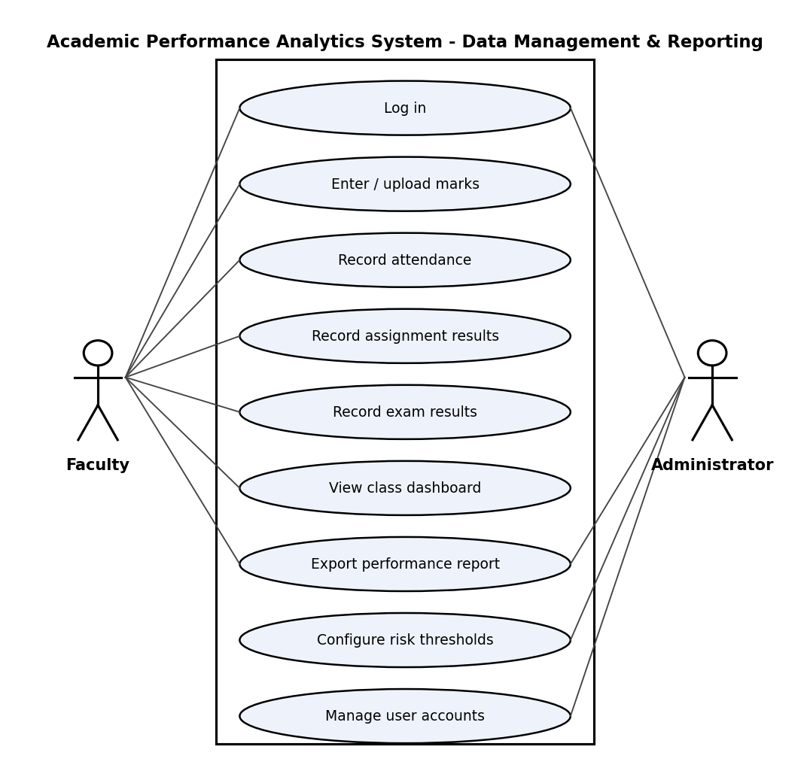

Diagram 2 – Monitoring and intervention (Student, Faculty, Administrator, Notification Service):
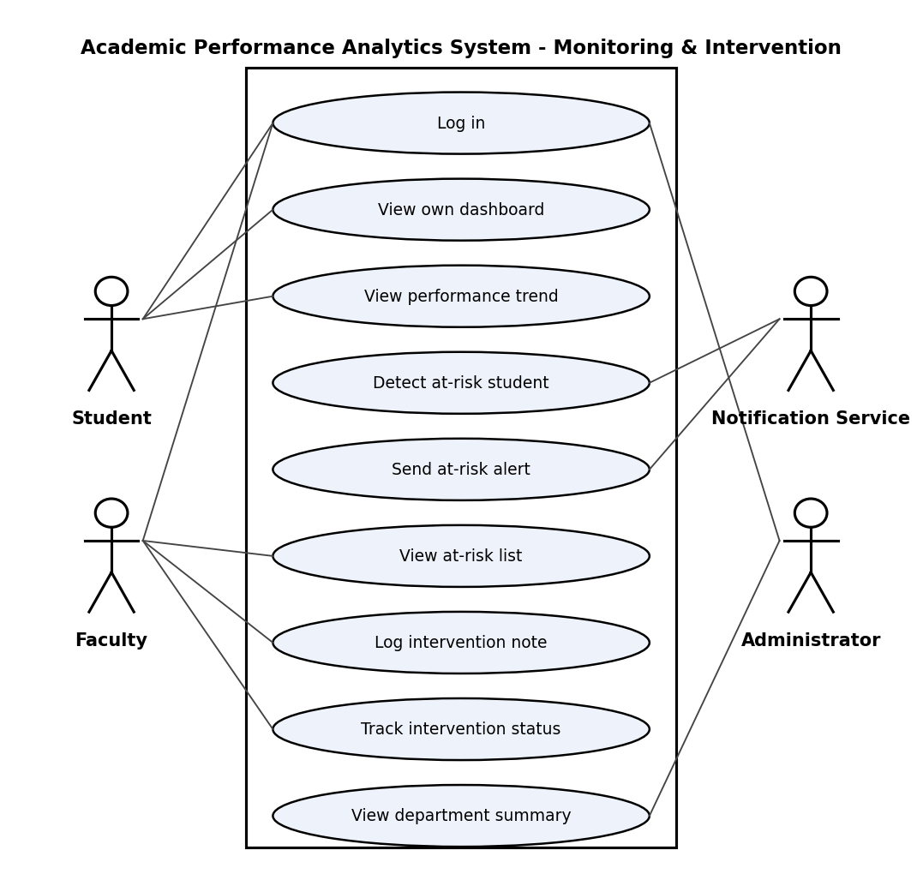

8. Requirements Traceability Matrix (RTM)
RTM status: Planned = included in the implementation baseline; In progress = implementation underway; Verified = tests passed and evidence recorded. Design-spec references will be linked once the SAD is complete.
Req ID | Requirement short | Sec. | Module | Test case(s) | Status | Comments
APAS-F-001 | authenticate users with a username and password before... | 4.1 | AuthModule | TC-Auth-01 | Planned | Planned: implement username/password authentication; verify valid login and rejection of invalid credentials with TC-Auth-01.
APAS-F-002 | enforce role-based access (Student, Faculty, Administrator) | 4.1 | AuthModule | TC-Auth-02 | Planned | Planned: enforce Student/Faculty/Administrator RBAC and student record ownership; verify unauthorized access is denied with TC-Auth-02.
APAS-F-003 | lock an account for 15 minutes after 5 consecutive failed... | 4.1 | AuthModule | TC-Auth-03 | Planned | Planned: lock account for 15 minutes after 5 consecutive failed attempts and log the event; verify with TC-Auth-03.
APAS-F-004 | allow an Administrator to create, edit, deactivate and assign roles to user accounts | 4.1 | AuthModule | TC-Auth-04 | Planned | Planned: administrator user management (create, edit, deactivate, assign role); verify new login, deactivated-user refusal and non-admin denial with TC-Auth-04.
APAS-F-010 | allow Faculty to enter or upload (CSV) marks for each... | 4.2 | DataModule | TC-Data-01 | Planned | Planned: faculty marks entry and CSV upload; verify marks map to the correct student, course and assessment with TC-Data-01.
APAS-F-011 | allow Faculty to record attendance per class session or... | 4.2 | DataModule | TC-Data-02 | Planned | Planned: record per-session attendance and support CSV import; verify saved attendance totals with TC-Data-02.
APAS-F-012 | record assignment submissions (submitted / late / missing)... | 4.2 | DataModule | TC-Data-03 | Planned | Planned: store assignment status (submitted/late/missing) and score per student; verify with TC-Data-03.
APAS-F-013 | record examination results (internal and end-semester) per... | 4.2 | DataModule | TC-Data-04 | Planned | Planned: store internal and end-semester exam results by student and subject; verify dashboard visibility with TC-Data-04.
APAS-F-014 | validate all entered data (marks within 0 to maximum,... | 4.2 | DataModule | TC-Data-05 | Planned | Planned: validate mark ranges, attendance totals and duplicate rows; reject invalid data with a clear message using TC-Data-05.
APAS-F-015 | maintain course and student records, enrolment and faculty-course assignment (with CSV import) | 4.2 | DataModule | TC-Data-06 | Planned | Planned: administrator maintains courses, student enrolment and faculty assignment; verify enrolled students appear for marks entry and non-enrolled data is rejected with TC-Data-06.
APAS-F-020 | compute each student's attendance percentage per course and... | 4.3 | AnalyticsModule | TC-An-01 | Planned | Planned: calculate attendance percentage per course and overall; verify 45/60 = 75.00% with TC-An-01.
APAS-F-021 | compute each student's average marks per course and overall | 4.3 | AnalyticsModule | TC-An-02 | Planned | Planned: calculate average marks per course and overall; verify 70, 80, 90 = 80.00 with TC-An-02.
APAS-F-022 | detect a declining trend when a student's marks decrease... | 4.3 | AnalyticsModule | TC-An-03 | Planned | Planned: implement configurable N consecutive assessment decreases (default N=3); verify 80,70,60 is declining and 60,70,80 is not with TC-An-03. Integration test must match the consecutive-decrease rule.
APAS-F-023 | flag a student as at-risk when attendance is below the... | 4.3 | AnalyticsModule | TC-An-04 | Planned | Planned: flag students for attendance below 75%, average marks below 40%, or declining trend; display each reason and test each condition separately with TC-An-04.
APAS-F-024 | compute each student's assignment completion rate... | 4.3 | AnalyticsModule | TC-An-05 | Planned | Planned: calculate on-time assignment completion rate; verify 8 of 10 = 80% and handle late/missing submissions with TC-An-05.
APAS-F-025 | configure attendance threshold, marks threshold and trend window N | 4.3 | AnalyticsModule | TC-An-06 | Planned | Planned: administrator-configurable thresholds applied to later analytics runs, changes audited; verify 75% to 80% change and rejection of invalid values with TC-An-06.
APAS-F-030 | provide a student dashboard showing marks, attendance,... | 4.4 | DashboardModule | TC-Dash-01 | Planned | Planned: student dashboard displays marks, attendance, assignments, exam results and risk status; verify the logged-in student sees only their own data with TC-Dash-01.
APAS-F-031 | provide a faculty dashboard per course with class averages,... | 4.4 | DashboardModule | TC-Dash-02 | Planned | Planned: faculty course dashboard shows class averages, marks distribution and at-risk list; compare list with analytics rules using TC-Dash-02.
APAS-F-032 | provide an administrator summary at department level... | 4.4 | DashboardModule | TC-Dash-03 | Planned | Planned: administrator/HoD department summary shows average performance and at-risk counts by course; reconcile totals against stored data with TC-Dash-03.
APAS-F-033 | export performance reports as CSV and PDF | 4.4 | DashboardModule | TC-Dash-04 | Planned | Planned: export dashboard performance reports to CSV and PDF; verify exported content matches dashboard data with TC-Dash-04.
APAS-F-034 | show student a performance trend view (marks and attendance over time) | 4.4 | DashboardModule | TC-Dash-05 | Planned | Planned: student trend chart per course; verify it matches stored data and is restricted to the student's own records with TC-Dash-05.
APAS-F-040 | notify the responsible faculty member when a student is... | 4.5 | InterventionModule | TC-Int-01 | Planned | Planned: notify responsible faculty within one minute when a student is newly flagged at-risk; verify alert generation with TC-Int-01. Faculty-to-course mapping comes from APAS-F-015.
APAS-F-041 | allow Faculty to record intervention notes (action taken,... | 4.5 | InterventionModule | TC-Int-02 | Planned | Planned: allow faculty to record intervention action and date; verify notes appear in student history with TC-Int-02.
APAS-F-042 | track intervention status (Open, In progress, Resolved) for... | 4.5 | InterventionModule | TC-Int-03 | Planned | Planned: track intervention as Open/In progress/Resolved with timestamp and user; verify saved transitions with TC-Int-03.
APAS-NF-001 | dashboards load within 3 s for 90% of requests (up to 500 students per course) | 5 | System-wide | TC-Perf-01 | Planned | Planned verification: load test with up to 500 students per course; 90th-percentile dashboard response time must be ≤3 seconds (TC-Perf-01).
APAS-NF-002 | available 99% of the time during the academic term | 5 | System-wide | Ops report | Planned | Planned verification: operational monitoring must demonstrate ≥99% availability during the academic term, excluding scheduled maintenance.
APAS-NF-003 | support at least 5,000 students and 200 concurrent users | 5 | System-wide | TC-Perf-02 | Planned | Planned verification: test at least 5,000 students and 200 concurrent users without functional degradation (TC-Perf-02).
APAS-NF-004 | responsive UI (desktop and mobile); WCAG 2.1 AA where applicable | 5 | System-wide | TC-UX-01 | Planned | Planned verification: test responsive desktop/mobile UI, keyboard access, and applicable WCAG 2.1 AA criteria (TC-UX-01).
APAS-NF-005 | retain audit logs of data changes and logins for at least 1 year | 5 | System-wide | TC-Ops-01 | Planned | Planned verification: confirm audit logs are retained for at least one year and can be retrieved (TC-Ops-01).
APAS-NF-006 | unit-test analytics module with at least 80% line coverage | 5 | System-wide | CI pipeline | Planned | Planned verification: CI coverage report for the analytics module must show at least 80% line coverage.
APAS-SR-001 | All network communication shall use TLS 1.2 or higher | 5.1 | Security | TC-Sec-01 | Planned | Planned verification: enforce TLS 1.2 or higher; plain HTTP connections must be refused (TC-Sec-01).
APAS-SR-002 | Passwords shall be stored only as salted hashes (e.g.,... | 5.1 | Security | TC-Sec-02 | Planned | Planned verification: store salted password hashes only; confirm plaintext passwords are neither stored nor logged (TC-Sec-02).
APAS-SR-003 | Authorisation shall be enforced on the server side for... | 5.1 | Security | TC-Sec-03 | Planned | Planned verification: enforce server-side authorization for every request and data ownership; test direct URL/API access denial (TC-Sec-03).
APAS-SR-004 | All user input shall be validated and database queries... | 5.1 | Security | TC-Sec-04 | Planned | Planned verification: validate input and parameterize database queries; SQL-injection and malformed-input tests must fail safely (TC-Sec-04).
APAS-SR-005 | Every change to marks, attendance and exam records shall be... | 5.1 | Security | TC-Sec-05 | Planned | Planned verification: changes to marks, attendance and exam records create audit entries containing user, time, old value and new value (TC-Sec-05).
APAS-SR-006 | User sessions shall expire after 15 minutes of inactivity | 5.1 | Security | TC-Sec-06 | Planned | Planned verification: expire sessions after 15 minutes of inactivity (TC-Sec-06).

