Software Architecture and Design Specification
Project: Academic Performance Analytics System (APAS)
Version: 1.0
Authors: Team 09 – Pranav Kalla (SAD owner), Pavitra Jain, Preeti Kalburgi, Ryona Ghosh
Date: 11-10-2026
Status: Draft

Revision History
Version | Date | Author | Change Summary
1.0 | 11-10-2026 | Pranav Kalla | Initial architecture and design: components, class model, 2 sequence diagrams, API design, STRIDE threat model, traceability to SRS v1.0

Approvals
Role | Name | Signature/Date
Course Coordinator
Repository / Integration Lead | Pavitra Jain
SAD Author | Pranav Kalla

Table of Contents
1. Introduction
2. Document Overview
3. Architecture (3.1 Goals & Constraints · 3.2 Stakeholders · 3.3 Component & Class Diagrams · 3.4 Component Descriptions · 3.5 Architecture Pattern · 3.6 Technology Stack · 3.7 Risks · 3.8 Traceability · 3.9 Security Architecture)
4. Design (4.1 Design Overview · 4.2 Sequence Diagrams · 4.3 API Design · 4.4 Error Handling, Logging & Monitoring · 4.5 UX Design · 4.6 Open Issues)
5. Appendices

1. Introduction

1.1 Purpose
This document specifies the software architecture and detailed design of the Academic Performance Analytics System (APAS). It explains how the requirements in the APAS SRS v1.0 are realised: the components and their responsibilities, the chosen architecture pattern, the data model, the key runtime interactions, the REST API, the security architecture and the error-handling approach.

1.2 Scope
APAS is a web application that analyses student marks, attendance, assignments and examinations, presents role-based dashboards and identifies students whose performance is declining or who need intervention. This document covers authentication and access control, academic data management, performance analytics, dashboards and reports, intervention management and notifications (SRS sections 4.1–4.5, 5 and 5.1).
Out of scope (as in the SRS): admissions, fee management, timetable scheduling, and the institution’s official grading and result-publication process.

1.3 Audience
Developers and the integration lead (to build and review modules), QA engineers (to derive integration and security tests), faculty and academic administrators (to validate that the design meets their needs), and course evaluators.

1.4 Definitions
Term | Meaning
APAS | Academic Performance Analytics System
At-risk student | A student whose attendance, average marks or marks trend meets a configured intervention condition (APAS-F-023)
Completion rate | Assignments submitted on time ÷ total assignments, as a percentage (APAS-F-024)
ADR | Architecture Decision Record
API / REST | Application Programming Interface / Representational State Transfer
DTO | Data Transfer Object – the JSON shape returned by an endpoint
ORM | Object-Relational Mapper (SQLAlchemy)
RBAC | Role-Based Access Control
STRIDE | Spoofing, Tampering, Repudiation, Information disclosure, Denial of service, Elevation of privilege
TLS | Transport Layer Security
CI | Continuous Integration (GitHub Actions running pytest)

2. Document Overview

2.1 How to use this document
Section 3 describes the architecture: goals, stakeholders, the component and class diagrams, the chosen pattern, the technology stack, risks, traceability to the SRS and the security architecture. Section 4 describes the design: the two main runtime flows as UML sequence diagrams, the API of three components, error handling and UX. Requirement IDs (APAS-F-###, APAS-NF-###, APAS-SR-###) are identical to the SRS so that each design element can be traced to a requirement and from there to a test case in the Test Plan.
The PlantUML sources of every diagram are stored in the repository under docs/sad/diagrams/ so they can be regenerated when the design changes.

2.2 Related Documents
- SRS – Software Requirements Specification, APAS v1.0 (docs/SRS_APAS.docx)
- STP – Software Test Plan, APAS v1.0 (prepared by Ryona Ghosh)
- RTM – Requirements Traceability Matrix (SRS section 8; design references in section 3.8 of this document)
- Repository – github.com/pavitragit09/academic-performance-analytics (code in src/, tests in tests/, CI in .github/workflows/ci.yml)

3. Architecture

3.1 Goals & Constraints
Goals
- Correct analytics: every metric (attendance %, average, trend, completion rate, exam summary, risk flag) is computed by one tested function, so dashboards and alerts always agree.
- Privacy: a student can see only their own data; faculty only their courses (APAS-F-002, APAS-SR-003).
- Performance: dashboards load within 3 s for 90% of requests with 500 students per course (APAS-NF-001); 200 concurrent users (APAS-NF-003).
- Availability of 99% during the academic term (APAS-NF-002).
- Maintainability: analytics module unit-tested with at least 80% line coverage, enforced in CI (APAS-NF-006).
- Traceability: every change to marks, attendance and exam data is audited and kept for at least 1 year (APAS-SR-005, APAS-NF-005).
Constraints
- Python on the server side (the team’s existing code base and CI use Python 3.12 and pytest).
- A relational database: SQLite for development, PostgreSQL for deployment (SRS 3.3).
- Student data handled according to the institution’s data-protection policy; open-source tools only.
- Four-person student team and a semester timeline, so the system must be simple to deploy and run.

3.2 Stakeholders & Concerns
Stakeholder | Main concerns | How the architecture addresses them
Students | Privacy of their records; a clear view of their own performance | Ownership check on every request; student dashboard (APAS-F-030)
Faculty | Fast data upload; accurate at-risk list; timely alerts | CSV import with row-level validation; single AnalyticsModule; alert within 1 minute (APAS-F-040)
Administrator / HoD | Department-level view; user and threshold management; compliance | Admin summary (APAS-F-032); configurable thresholds; audit log
Institution / Exam cell | Data integrity; accountability | Validation (APAS-F-014), audit log (APAS-SR-005), RBAC
Developers (Team 09) | Modularity; independent work; quick feedback | One module per concern, pure analytics functions, CI on every pull request
Course evaluators | Traceability from requirement to design to test | Section 3.8 and the SRS RTM use the same IDs

3.3 Component (UML) Diagram
Figure 1 shows the components grouped into the three layers. Figure 2 shows the domain class diagram that the DataModule persists through the ORM.
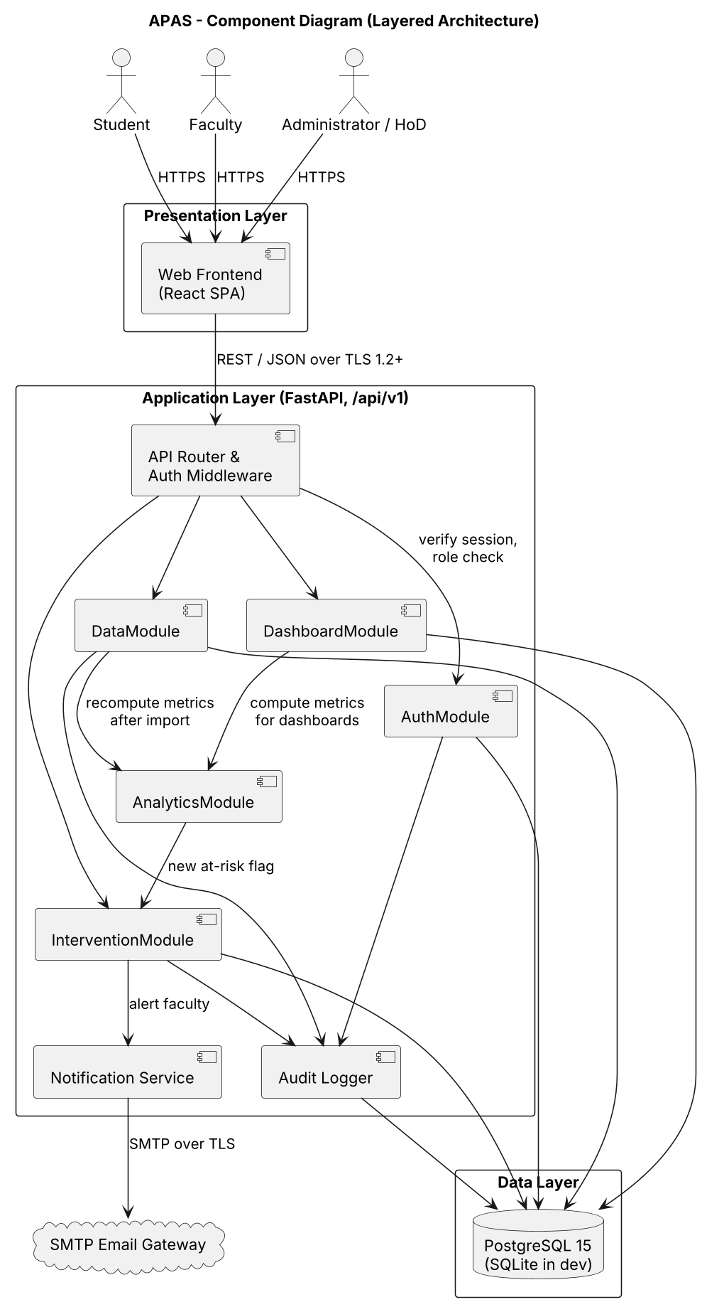
Figure 1 – APAS component diagram (source: docs/sad/diagrams/component-diagram.puml)

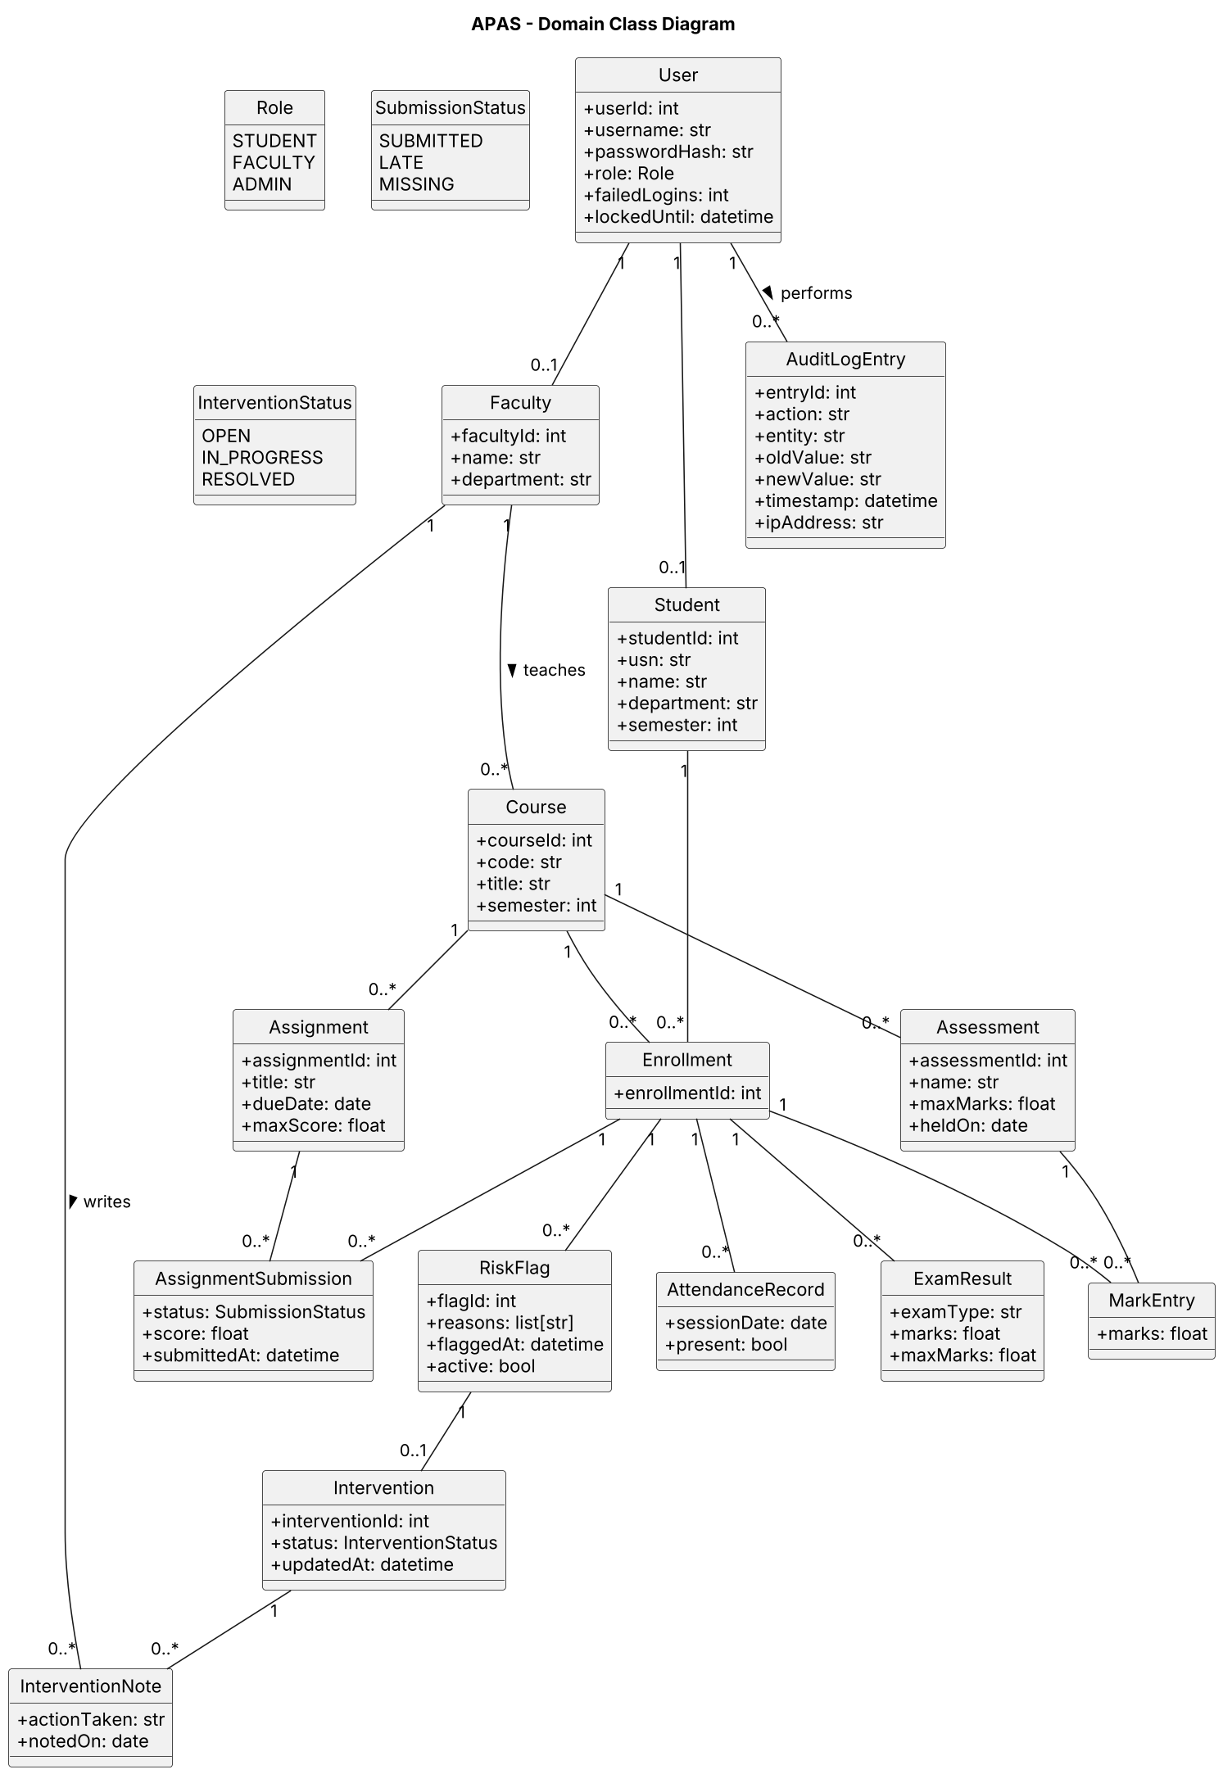
Figure 2 – APAS domain class diagram (source: docs/sad/diagrams/class-diagram.puml)

3.4 Component Descriptions
Component | Responsibility | Implementation
Web Frontend | Role-specific menus, data-upload forms, dashboards with charts (trend lines, distributions), intervention screens. Holds no business rules. | React single-page app, Chart.js
API Router & Auth Middleware | Single entry point under /api/v1. Checks the session on every request, applies rate limits, converts exceptions to the standard error body. | FastAPI routers and middleware
AuthModule | Login, logout, password hashing, session issue and 15-minute idle expiry, account lockout after 5 failures, role and ownership checks. | auth package; bcrypt
DataModule | Create, import (CSV) and validate marks, attendance, assignment submissions and exam results; reject invalid or duplicate rows; write audit entries; trigger re-evaluation. | data package; SQLAlchemy models from Figure 2
AnalyticsModule | Pure, stateless functions that compute every metric. No database or HTTP code, so each function is unit-tested in isolation. | src/analytics.py – attendance_percentage, average_marks, is_declining, risk_reasons, is_at_risk  src/trend.py – trend_slope, trend_label, drop_percentage, flag_declining_students  src/assignments.py – status_breakdown, completion_rate, low_completion_students  src/exam_summary.py – exam_summary
DashboardModule | Builds student, faculty and administrator dashboard DTOs by loading data and calling AnalyticsModule; exports reports as CSV and PDF. | dashboard package; ReportLab for PDF
InterventionModule | Opens an intervention when a student is newly flagged, stores notes and status (Open, In progress, Resolved), asks the Notification Service to alert faculty. | intervention package
Notification Service | Sends e-mail alerts asynchronously so that an upload request is not delayed; retries on failure. | FastAPI background tasks, SMTP over TLS
Audit Logger | Append-only record of logins, failed logins, data changes (old and new value), denied access and admin actions. | audit_log table, insert-only DB role
Database | Persistent storage of all entities in Figure 2. | PostgreSQL 15 (SQLite in development)
SMTP Email Gateway | External e-mail delivery. | Institution SMTP server; MailHog in testing

3.5 Chosen Architecture Pattern and Rationale
Pattern: layered (3-tier) architecture – Presentation layer (React frontend) → Application layer (FastAPI with one module per concern) → Data layer (relational database). Inside the application layer the AnalyticsModule is kept as a pure functional core: it receives plain values (lists of marks, statuses, counts) and returns results, while the other modules handle I/O.
Rationale
- Clear separation of concerns: UI, business rules and storage can be changed and tested independently.
- One place to enforce security: every request passes through the auth middleware and the AuthModule, which implements APAS-SR-003.
- Testability: the analytics functions already exist in the repository with unit tests that run in CI on every pull request; keeping them free of database code makes the 80% coverage target (APAS-NF-006) easy to reach.
- Fits the team: each member owns one analytics feature and can work on a separate branch without merge conflicts.
- Simple deployment as a single service plus a database, which meets the 99% availability goal at this scale.
Rejected alternative: microservices. Splitting analytics, data and dashboards into separately deployed services would add network calls, service discovery and distributed transactions without any benefit for a few thousand students. It would also make a single consistent view of marks and risk flags harder to guarantee.
Rejected alternative: client-side analytics. Computing metrics in the browser would expose other students’ data to the client and duplicate logic between dashboards and alerts.

3.6 Technology Stack & Data Stores
Layer / concern | Choice | Reason
Frontend | React 18, Chart.js, responsive CSS | Component reuse across three role dashboards; accessible charts
Backend | Python 3.12, FastAPI, Pydantic, SQLAlchemy 2 | Same language as the existing analytics code; automatic request validation and OpenAPI (Swagger) docs
Database | PostgreSQL 15 (production), SQLite (development and CI) | Relational data with clear relationships; free and open source
Authentication | bcrypt password hashes; server-side session token in an HttpOnly, Secure cookie; 15-minute idle timeout | Meets APAS-SR-002 and APAS-SR-006
Notifications | SMTP over TLS from a background task | Alert within 1 minute without slowing uploads (APAS-F-040)
Reports | csv module; ReportLab for PDF | APAS-F-033
Testing & CI | pytest, pytest-cov, GitHub Actions (job test), Locust for load tests | Required check on every pull request to main
Version control | GitHub; protected main; feature branches; pull request with 1 approval | Team workflow
Deployment | Docker container behind an Nginx reverse proxy that terminates TLS 1.2+ | APAS-SR-001; easy to run on institution servers

Data stores: one relational database holds the domain tables of Figure 2. The audit_log table is written through a database role that has INSERT and SELECT rights only. Uploaded CSV files are parsed in memory and not stored. Daily database backups are kept for the academic term.

3.7 Risks & Mitigations
Risk | Impact | Mitigation
Wrong or inconsistent analytics (e.g. dashboard and alert disagree) | Wrong students flagged | Single AnalyticsModule used by both; unit tests for every function; CI blocks merges on failures
Bad data in CSV imports | Wrong metrics | Row-level validation (APAS-F-014); invalid rows rejected and reported, valid rows saved
Unauthorised access to another student’s records | Privacy breach | Server-side ownership checks on every endpoint; denied attempts audited; security tests TC-Sec-03
E-mail server unavailable | Alerts missed | Asynchronous send with retries; alert also shown in the faculty dashboard
Slow dashboards for large courses | NF-001 not met | Indexes on (enrollment, assessment); aggregate queries; load test TC-Perf-01
Uneven team contribution / merge conflicts | Late delivery | One module and branch per member; small pull requests reviewed by a teammate
Requirement IDs drift between SRS, SAD and Test Plan | Broken traceability | Same APAS IDs in all three documents; RTM updated with every SRS change

3.8 Traceability to Requirements
Each SRS requirement is mapped to the component that implements it, the SAD section that designs it and, where it exists, the code in the repository.
Req ID | Requirement (short) | Component | SAD ref | Code / test
APAS-F-001 | Username/password login | AuthModule | 3.4, 3.9, 4.3.1 | –
APAS-F-002 | Role-based access; students see own data | AuthModule, API middleware | 3.9, 4.2 (Seq. 2) | –
APAS-F-003 | Lock after 5 failed logins for 15 min | AuthModule, Audit Logger | 3.9, 4.4 | –
APAS-F-010 | Enter / upload marks (CSV) | DataModule | 4.2 (Seq. 1), 4.3.2 | –
APAS-F-011 | Record / import attendance | DataModule | 4.3.2 | –
APAS-F-012 | Assignment submissions (submitted / late / missing) | DataModule, AnalyticsModule | 3.3 (Fig. 2), 4.3.2 | src/assignments.py
APAS-F-013 | Record exam results | DataModule | 4.3.2 | –
APAS-F-014 | Validate entered data | DataModule | 4.2 (Seq. 1), 4.4 | –
APAS-F-020 | Attendance percentage | AnalyticsModule | 3.4 | src/analytics.py; tests/test_analytics.py
APAS-F-021 | Average marks | AnalyticsModule | 3.4 | src/analytics.py; tests/test_analytics.py
APAS-F-022 | Declining trend detection | AnalyticsModule | 3.4 | src/trend.py; tests/test_trend.py
APAS-F-023 | At-risk flag with reasons | AnalyticsModule, InterventionModule | 4.2 (Seq. 1) | src/analytics.py; tests/test_analytics.py
APAS-F-024 | Assignment completion rate | AnalyticsModule | 3.4, 4.3.3 | src/assignments.py; tests/test_assignments.py
APAS-F-030 | Student dashboard | DashboardModule | 4.2 (Seq. 2), 4.3.3 | src/exam_summary.py (exam data)
APAS-F-031 | Faculty course dashboard | DashboardModule | 4.3.3 | src/exam_summary.py; tests/test_exam_summary.py
APAS-F-032 | Administrator department summary | DashboardModule | 4.3.3 | –
APAS-F-033 | Export CSV / PDF | DashboardModule | 4.3.3 | –
APAS-F-040 | Alert faculty on new at-risk flag | InterventionModule, Notification Service | 4.2 (Seq. 1) | –
APAS-F-041 | Intervention notes | InterventionModule | 4.3.4 | –
APAS-F-042 | Intervention status tracking | InterventionModule | 4.3.4 | –
APAS-NF-001 | Dashboard ≤ 3 s (90th percentile) | DashboardModule, Database | 3.6, 3.7 | TC-Perf-01
APAS-NF-002 | 99% availability | Deployment | 3.5, 3.6 | Ops report
APAS-NF-003 | 5,000 students, 200 concurrent users | All application modules | 3.5, 3.7 | TC-Perf-02
APAS-NF-004 | Responsive UI, WCAG 2.1 AA | Web Frontend | 4.5 | TC-UX-01
APAS-NF-005 | Audit logs kept ≥ 1 year | Audit Logger | 3.6, 4.4 | TC-Ops-01
APAS-NF-006 | ≥ 80% coverage of analytics | AnalyticsModule, CI | 3.5, 3.6 | .github/workflows/ci.yml
APAS-SR-001 | TLS 1.2+ | Reverse proxy, Notification Service | 3.6, 3.9 | TC-Sec-01
APAS-SR-002 | Salted password hashes | AuthModule | 3.9 | TC-Sec-02
APAS-SR-003 | Server-side authorisation | AuthModule, API middleware | 3.9, 4.2 (Seq. 2) | TC-Sec-03
APAS-SR-004 | Input validation, parameterised queries | DataModule, ORM | 3.9, 4.4 | TC-Sec-04
APAS-SR-005 | Audit every data change | Audit Logger | 3.9, 4.2 (Seq. 1) | TC-Sec-05
APAS-SR-006 | 15-minute session timeout | AuthModule | 3.9, 4.2 (Seq. 2) | TC-Sec-06

3.9 Security Architecture
Security objectives from the SRS: SO-1 confidentiality of student records, SO-2 integrity and traceability of academic data, SO-3 availability and accountability. The design uses defence in depth: TLS at the edge, authentication and authorisation in the application layer for every request, validation before any data reaches the database, and an append-only audit trail.
Threat model (STRIDE)
Threat | Example in APAS | Mitigation | Req
Spoofing | Attacker guesses a faculty password or reuses a stolen session | bcrypt hashes; lockout after 5 failures for 15 min; random session tokens in HttpOnly, Secure, SameSite cookies; 15-min idle expiry | F-001, F-003, SR-002, SR-006
Tampering | A student edits marks through a crafted request; SQL injection in a CSV field | Only Faculty of that course can write; Pydantic validation; ORM parameterised queries; TLS in transit | F-014, SR-001, SR-003, SR-004
Repudiation | Faculty denies changing a mark | Audit log with user, time, IP, old and new value; insert-only DB role; retained 1 year | SR-005, NF-005
Information disclosure | Student opens another student’s dashboard by changing the ID in the URL | Ownership check on every endpoint (403 + audit entry); no personal data in application logs; TLS 1.2+ | F-002, SR-001, SR-003
Denial of service | Repeated login attempts or very large CSV uploads | Rate limiting at the API; upload size limit (5 MB) and row limit; lockout; async e-mail | NF-001, NF-003
Elevation of privilege | Student calls an admin or faculty endpoint | Role required per route, checked on the server; default-deny; role changes only by Admin and audited | F-002, SR-003

Access-control matrix (summary)
Resource | Student | Faculty | Administrator
Own dashboard and records | Read | – | –
Course marks, attendance, assignments, exams | – | Read / write (own courses) | Read
Faculty course dashboard, at-risk list | – | Read (own courses) | Read
Department summary, reports export | – | Export own courses | Read / export
Interventions and notes | – | Read / write (own courses) | Read
Users, roles, thresholds | – | – | Read / write
Audit log | – | – | Read

4. Design

4.1 Design Overview
The application layer is organised as one Python package per component. Routers only parse requests and call a service function; services hold the business rules and call the AnalyticsModule for any calculation. This keeps the calculation logic in one tested place.
Main design decisions
- Pure analytics functions. Each metric is a small function that takes plain Python values and returns a number, label, list or dict, and raises ValueError for invalid input. The API layer converts ValueError into 422 VALIDATION_ERROR.
- Configurable thresholds. Attendance threshold (default 75%), marks threshold (default 40%), decline window (default 3) and trend tolerance (default 1.0) are passed as parameters, so an Administrator can change them without code changes.
- Event-driven re-evaluation. After any data import the DataModule re-evaluates only the affected students. A new at-risk flag opens an intervention and triggers an alert.
- Assignment completion (APAS-F-024). completion_rate(statuses, include_late=False) counts only on-time submissions by default, as the SRS states; include_late=True supports a lenient view. low_completion_students lists students below a threshold (default 75%) for the faculty dashboard.
- Standard error body for every failure (section 4.4), so the frontend handles errors in one place.

4.2 UML Sequence Diagrams

Sequence 1 – Faculty uploads marks, system re-evaluates risk and alerts
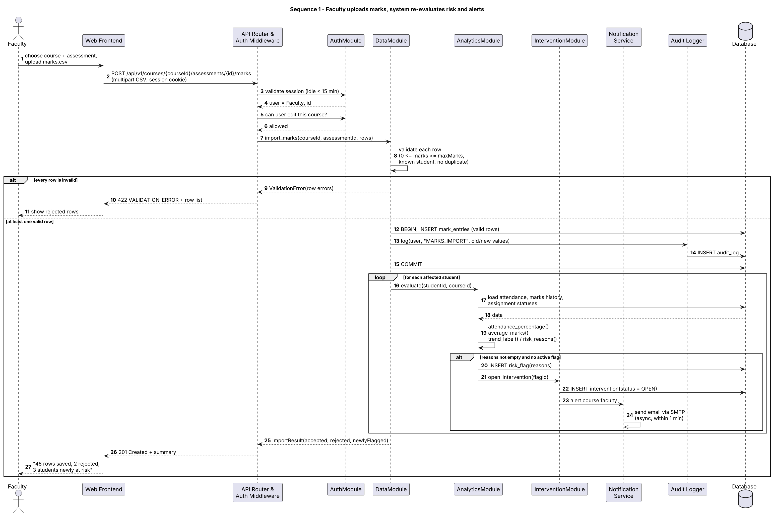
Figure 3 – Marks upload and at-risk detection (APAS-F-010, F-014, F-020–F-023, F-040, SR-003, SR-005)

Sequence 2 – Student views own performance dashboard
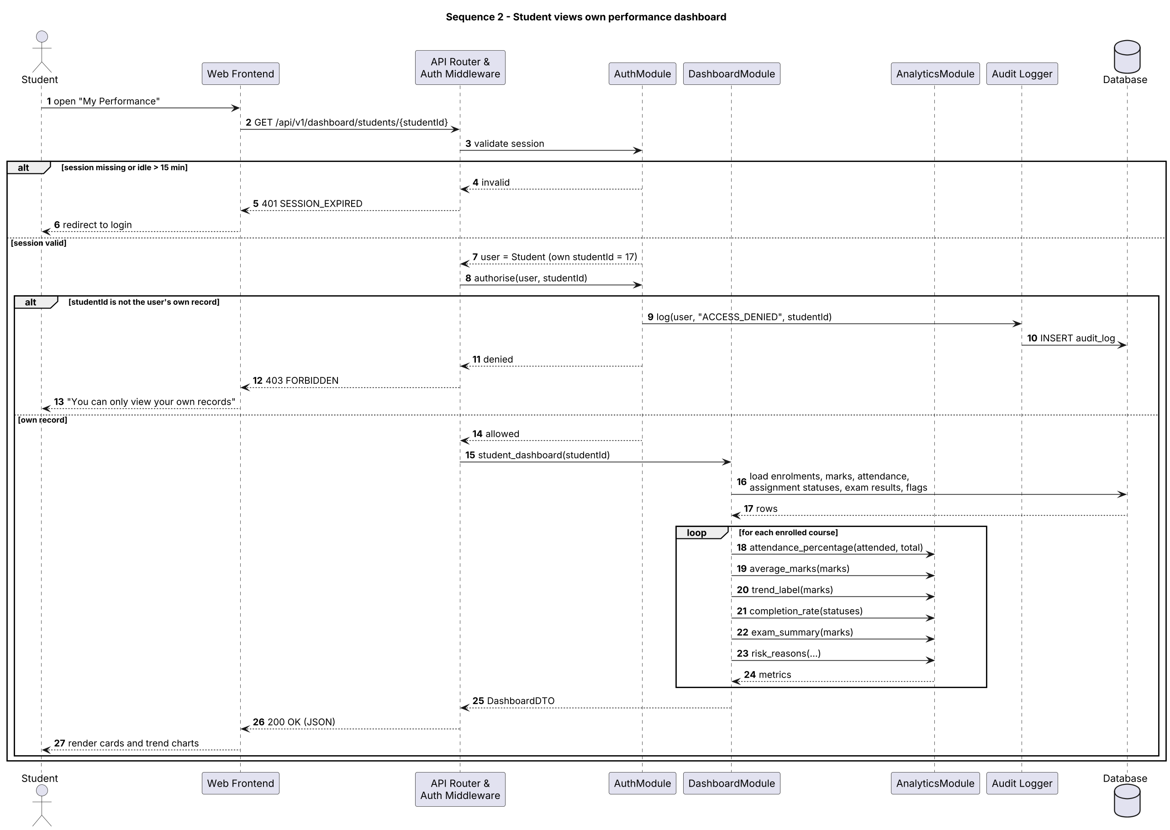
Figure 4 – Student dashboard with session and ownership checks (APAS-F-002, F-020–F-024, F-030, SR-003, SR-006)

Explanation of Sequence 1. A faculty member uploads a CSV of marks for one assessment. The middleware validates the session and the AuthModule confirms the faculty member teaches the course. The DataModule validates every row (range, known student, no duplicates); if no row is valid the request fails with 422 and the rejected rows are listed. Otherwise valid rows are saved in one transaction together with an audit entry. For each affected student the AnalyticsModule recomputes attendance, average, trend and risk reasons. If a student is newly at risk, a risk flag and an Open intervention are created and the Notification Service e-mails the faculty member asynchronously, meeting the 1-minute target of APAS-F-040. The response summarises accepted rows, rejected rows and newly flagged students.
Explanation of Sequence 2. A student opens their dashboard. If the session is missing or idle for more than 15 minutes the API returns 401 and the frontend redirects to login. If the student asks for an ID that is not their own, the AuthModule records the attempt in the audit log and the API returns 403. Otherwise the DashboardModule loads the student’s data and calls the AnalyticsModule for each course (attendance %, average, trend label, completion rate, exam summary and risk reasons) and returns one JSON DTO that the frontend renders as cards and charts.

4.3 API Design
All endpoints are under /api/v1, use JSON over HTTPS and require a valid session cookie except login. Errors use the standard body in section 4.4. Interfaces are given for four components; DataModule, DashboardModule/AnalyticsModule and InterventionModule are the core ones.

4.3.1 AuthModule
Field | Definition
Endpoint | /api/v1/auth/login
Method | POST
Request | { "username": "faculty.rao", "password": "••••••" }
Response | 200 { "userId": 12, "role": "FACULTY", "name": "A. Rao" } and Set-Cookie: session=<token>; HttpOnly; Secure
Errors | 401 INVALID_CREDENTIALS; 423 ACCOUNT_LOCKED (after 5 failures, 15 min); 429 RATE_LIMITED
Notes | Every attempt is written to the audit log. Requirements: APAS-F-001, F-003, SR-002.

Field | Definition
Endpoint | /api/v1/auth/logout
Method | POST
Request | (no body)
Response | 204 No Content; session invalidated
Errors | 401 UNAUTHENTICATED

4.3.2 DataModule
Field | Definition
Endpoint | /api/v1/courses/{courseId}/assessments/{assessmentId}/marks
Method | POST
Request | multipart/form-data with file=marks.csv (columns: usn, marks) or JSON { "entries": [ { "usn": "PES1UG24AM001", "marks": 42 } ] }
Response | 201 { "accepted": 48, "rejected": [ { "row": 7, "reason": "marks above maxMarks" } ], "newlyFlagged": ["PES1UG24AM014"] }
Errors | 400 BAD_FILE; 401 SESSION_EXPIRED; 403 FORBIDDEN (not this course’s faculty); 404 NOT_FOUND; 413 FILE_TOO_LARGE; 422 VALIDATION_ERROR (all rows invalid)
Notes | Requirements: APAS-F-010, F-014, SR-003, SR-004, SR-005.

Field | Definition
Endpoint | /api/v1/courses/{courseId}/attendance
Method | POST
Request | { "sessionDate": "2026-10-05", "present": ["PES1UG24AM001", ...], "absent": ["PES1UG24AM014"] } or CSV
Response | 201 { "recorded": 60 }
Errors | 403 FORBIDDEN; 409 DUPLICATE_ENTRY (session already recorded); 422 VALIDATION_ERROR
Notes | Requirements: APAS-F-011, F-014.

Field | Definition
Endpoint | /api/v1/assignments/{assignmentId}/submissions
Method | PUT
Request | { "submissions": [ { "usn": "PES1UG24AM001", "status": "submitted", "score": 9 }, { "usn": "PES1UG24AM014", "status": "missing" } ] }
Response | 200 { "updated": 60 }
Errors | 403 FORBIDDEN; 404 NOT_FOUND; 422 VALIDATION_ERROR (status not in submitted / late / missing, score out of range)
Notes | Requirements: APAS-F-012, F-014.

Field | Definition
Endpoint | /api/v1/courses/{courseId}/exams
Method | POST
Request | { "examType": "ESA", "maxMarks": 100, "results": [ { "usn": "PES1UG24AM001", "marks": 71 } ] }
Response | 201 { "accepted": 60, "rejected": [] }
Errors | 403 FORBIDDEN; 409 DUPLICATE_ENTRY; 422 VALIDATION_ERROR
Notes | Requirements: APAS-F-013, F-014.

4.3.3 DashboardModule (using AnalyticsModule)
Field | Definition
Endpoint | /api/v1/dashboard/students/{studentId}
Method | GET
Request | (path parameter only)
Response | 200 { "studentId": 17, "courses": [ { "code": "UE24CS341A", "attendancePct": 82.5, "averageMarks": 64.0, "trend": "declining", "assignmentCompletionPct": 80.0, "assignments": { "submitted": 8, "late": 1, "missing": 1 }, "atRisk": true, "riskReasons": ["declining marks trend"] } ] }
Errors | 401 SESSION_EXPIRED; 403 FORBIDDEN (not own record); 404 NOT_FOUND
Notes | Requirements: APAS-F-020–F-024, F-030, SR-003.

Field | Definition
Endpoint | /api/v1/dashboard/courses/{courseId}
Method | GET
Request | query: ?attendanceThreshold=75&marksThreshold=40&window=3 (optional)
Response | 200 { "courseId": 4, "classAverage": 61.2, "exam": { "count": 60, "highest": 96, "lowest": 18, "average": 61.2, "pass_rate": 88.33 }, "atRisk": [ { "usn": "PES1UG24AM014", "reasons": ["low attendance"] } ], "lowCompletion": ["PES1UG24AM022"] }
Errors | 403 FORBIDDEN (not the course’s faculty or an admin); 404 NOT_FOUND; 422 VALIDATION_ERROR (threshold outside 0–100, window < 2)
Notes | Uses exam_summary, risk_reasons, low_completion_students. Requirements: APAS-F-023, F-024, F-031.

Field | Definition
Endpoint | /api/v1/dashboard/departments/{deptId}
Method | GET
Request | (path parameter only)
Response | 200 { "department": "CSE (AI & ML)", "courses": [ { "code": "UE24CS341A", "average": 61.2, "atRiskCount": 7 } ] }
Errors | 403 FORBIDDEN (Admin / HoD only)
Notes | Requirement: APAS-F-032.

Field | Definition
Endpoint | /api/v1/reports/courses/{courseId}
Method | GET
Request | query: ?format=csv | pdf
Response | 200 file download (text/csv or application/pdf) with the same figures as the course dashboard
Errors | 403 FORBIDDEN; 404 NOT_FOUND; 422 VALIDATION_ERROR (unknown format)
Notes | Requirement: APAS-F-033.

4.3.4 InterventionModule
Field | Definition
Endpoint | /api/v1/interventions?courseId={id}&status=OPEN
Method | GET
Request | query filters: courseId, status
Response | 200 [ { "interventionId": 31, "usn": "PES1UG24AM014", "reasons": ["low attendance"], "status": "OPEN", "updatedAt": "2026-10-11T10:02:00+05:30" } ]
Errors | 403 FORBIDDEN
Notes | Requirement: APAS-F-042.

Field | Definition
Endpoint | /api/v1/interventions/{id}/notes
Method | POST
Request | { "actionTaken": "Met student; agreed weekly doubt-clearing sessions", "notedOn": "2026-10-11" }
Response | 201 { "noteId": 88 }
Errors | 403 FORBIDDEN; 404 NOT_FOUND; 422 VALIDATION_ERROR (empty action)
Notes | Requirement: APAS-F-041.

Field | Definition
Endpoint | /api/v1/interventions/{id}/status
Method | PATCH
Request | { "status": "IN_PROGRESS" }
Response | 200 { "interventionId": 31, "status": "IN_PROGRESS", "updatedBy": 12, "updatedAt": "..." }
Errors | 403 FORBIDDEN; 404 NOT_FOUND; 409 INVALID_STATUS_TRANSITION (e.g. RESOLVED → OPEN)
Notes | Allowed transitions: OPEN → IN_PROGRESS → RESOLVED. Requirement: APAS-F-042, SR-005.

4.4 Error Handling, Logging & Monitoring
Standard error body returned for every non-2xx response:
{ "error": { "code": "VALIDATION_ERROR", "message": "Row 7: marks above maxMarks", "details": [ ... ] } }
HTTP | Code | When
400 | BAD_FILE | Uploaded file is not valid CSV or has missing columns
401 | UNAUTHENTICATED / SESSION_EXPIRED / INVALID_CREDENTIALS | No session, idle more than 15 minutes, or wrong password
403 | FORBIDDEN | Wrong role or not the owner of the record (always audited)
404 | NOT_FOUND | Course, student, assessment or intervention does not exist
409 | DUPLICATE_ENTRY / INVALID_STATUS_TRANSITION | Record already exists; illegal intervention status change
413 | FILE_TOO_LARGE | Upload above 5 MB
422 | VALIDATION_ERROR | Input fails validation; any ValueError raised by an analytics function
423 | ACCOUNT_LOCKED | Five consecutive failed logins (locked for 15 minutes)
429 | RATE_LIMITED | Too many requests from one client
500 | INTERNAL_ERROR | Unexpected error; message is generic, details only in server logs

Logging. Application logs are structured JSON with timestamp, request ID, user ID, endpoint, status code and duration. Passwords, session tokens and students’ marks are never written to application logs. Data changes and access decisions go to the separate audit log (APAS-SR-005), retained for at least 1 year (APAS-NF-005).
Monitoring. Health endpoint /api/v1/health checked every minute; metrics for response time (90th percentile, target ≤ 3 s), error rate, failed logins, e-mail send failures and CI status on main. An alert is raised if the 90th percentile exceeds 3 s for 10 minutes or the error rate exceeds 2%.

4.5 UX Design
- Student: one page with a card per course showing attendance %, average, trend arrow (improving / stable / declining), assignment completion % and risk status with reasons in plain language.
- Faculty: course selector, class average and exam summary, marks distribution chart, sortable at-risk list with reasons, low-completion list, and buttons to upload data or open an intervention.
- Administrator / HoD: department table of courses with average and at-risk count; user and threshold management.
- Uploads: downloadable CSV template; after upload, a summary of accepted and rejected rows with the reason for each rejected row.
- Accessibility (APAS-NF-004): responsive layout from 360 px wide; WCAG 2.1 AA contrast; colour-blind-friendly palette with icons and text labels, not colour alone; full keyboard navigation.

4.6 Open Issues & Next Steps
- Confirm with faculty whether late submissions should count towards the completion rate; the default follows the SRS (on time only) and is configurable.
- Decide whether low assignment completion should become a fourth at-risk reason in APAS-F-023 (needs an SRS change).
- Implement the web layer (FastAPI routers, database models) and frontend in later sprints; the analytics core already exists with tests.
- Add pytest-cov to CI with a fail-under of 80% for the analytics module (APAS-NF-006).
- Future enhancements: SSO with the institution’s login, import from the existing student information system, SMS/WhatsApp alerts, predictive risk scoring.

5. Appendices
5.1 Glossary: APAS, ADR, API, CI, DTO, ORM, RBAC, REST, STRIDE, TLS, WCAG, at-risk student, completion rate (see section 1.4).
5.2 References: ISO/IEC/IEEE 42010 (architecture description); IEEE 29148 (requirements); APAS SRS v1.0; OWASP Top 10; OWASP ASVS; NIST SP 800-63B (passwords); WCAG 2.1.
5.3 Tools: PlantUML (diagrams, sources in docs/sad/diagrams/), draw.io, Swagger/OpenAPI (generated by FastAPI), pytest, GitHub Actions, Locust.

