Software Requirements Specification (SRS)
Project: Academic Performance Analytics System
Version: 1.0
Authors: Pavitra, Preeti, Pranav, Ryona
Date: 09-10-2026
Status: Draft

Revision History
Version | Date | Author | Change summary | Approval
1.0 | 09-10-2026 | Team | Initial SRS with use-case diagrams and RTM

Approvals
Role | Name | Signature / Email | Date
Course Coordinator
Instructor

Table of Contents
1. Introduction
2. Overall description
3. External interface requirements
4. System features (detailed)
5. Non-functional requirements (detailed)
6. Quality attributes & Acceptance tests
7. System models and diagrams
8. Requirements Traceability Matrix (RTM)

1. Introduction

1.1 Purpose
This document is the Software Requirements Specification (SRS) for the Academic Performance Analytics System. It defines the functional and non-functional requirements, interfaces and verification criteria for a system that analyses student marks, attendance, assignments and examinations, provides dashboards and identifies students whose performance is declining or who need intervention.

1.2 Scope
The system covers data entry and import of marks, attendance, assignment and exam results; computation of analytics (averages, attendance percentage, completion rate, decline detection); at-risk student identification; role-based dashboards and reports; and intervention tracking. It excludes admissions, fee management, timetable scheduling and the institution's official grading and result-publication process.

1.3 Audience
Developers, QA engineers, faculty and academic administrators (end users), and course evaluators.

1.4 Definitions
SRS – Software Requirements Specification; RTM – Requirements Traceability Matrix; RBAC – Role-Based Access Control; CSV – Comma-Separated Values; TLS – Transport Layer Security; UI – User Interface; API – Application Programming Interface; WCAG – Web Content Accessibility Guidelines; At-risk student – a student whose attendance, marks or marks trend meets a configured intervention condition.

2. Overall description

2.1 Product perspective
A web-based application used by students, faculty and administrators. It stores academic data in a central database, runs analytics on that data, and presents the results as dashboards. It can send alerts through an e-mail notification service and accepts CSV imports from existing institutional records.

2.2 Major product functions
- Authenticate users and enforce role-based access
- Manage marks, attendance, assignment and exam data
- Compute averages, attendance percentage and assignment completion rate
- Detect declining performance trends
- Flag at-risk students with reasons
- Student, faculty and administrator dashboards
- Export performance reports (CSV / PDF)
- Alert faculty and track interventions

2.3 User roles and characteristics
- Student: views own performance; basic computer literacy.
- Faculty: enters data, monitors class performance and acts on at-risk alerts.
- Administrator / HoD: manages users and thresholds, views department-level summaries.

2.4 Operating environment
Server-side Python application with a relational database, accessed through modern web browsers on desktop and mobile devices over the institution network or the internet.

2.5 Constraints
Student data must be handled according to the institution's data-protection and privacy policy; the system must run on standard institutional server infrastructure; the project must be completed within the semester timeline using the team's agreed technology stack.

3. External interface requirements

3.1 User interfaces
Responsive web UI with a clear menu per role, charts for trends and distributions, colour-blind-friendly palette and keyboard-accessible controls.

3.2 Hardware interfaces
No specialised hardware. Standard client devices (PC, tablet, phone) and a server or cloud virtual machine.

3.3 Software interfaces
- Relational database (e.g., SQLite for development, MySQL / PostgreSQL for deployment).
- CSV import / export interface for marks and attendance.
- E-mail notification service (SMTP) for at-risk alerts.

3.4 Communications
HTTPS (TLS 1.2+) for all client-server traffic; SMTP over TLS for notifications.

4. System features (detailed)
Each requirement includes an acceptance criterion and a reference test case. Functional IDs follow APAS-F-###. The system contains 20 functional requirements.

4.1 Authentication & Access Control
Description: Authenticate users and restrict data according to role.
Req ID | Requirement | Priority | Source | Acceptance criteria / Test case | Depends on
APAS-F-001 | The system shall authenticate users with a username and password before granting access. | High | Security / Admin | AC: Valid credentials open a session; invalid credentials are rejected with an error. Test: TC-Auth-01 | User database
APAS-F-002 | The system shall enforce role-based access (Student, Faculty, Administrator); a student shall only view their own records. | High | Security / Institution | AC: A student requesting another student's data receives access denied. Test: TC-Auth-02 | APAS-F-001
APAS-F-003 | The system shall lock an account for 15 minutes after 5 consecutive failed login attempts and record an audit event. | Medium | Security | AC: Sixth attempt is blocked and a message is shown. Test: TC-Auth-03 | APAS-F-001

4.2 Academic Data Management
Description: Capture and validate marks, attendance, assignments and exam results.
Req ID | Requirement | Priority | Source | Acceptance criteria / Test case | Depends on
APAS-F-010 | The system shall allow Faculty to enter or upload (CSV) marks for each assessment of a course. | High | Faculty | AC: Uploaded marks appear against the correct students and course. Test: TC-Data-01 | Course and student records
APAS-F-011 | The system shall allow Faculty to record attendance per class session or import it from CSV. | High | Faculty | AC: Attendance entries are saved and counted in the student's total. Test: TC-Data-02 | Course and student records
APAS-F-012 | The system shall record assignment submissions (submitted / late / missing) and scores. | High | Faculty | AC: Each assignment status and score is stored per student. Test: TC-Data-03 | Course and student records
APAS-F-013 | The system shall record examination results (internal and end-semester) per student and subject. | High | Faculty / Exam cell | AC: Exam results are stored and visible in dashboards. Test: TC-Data-04 | Course and student records
APAS-F-014 | The system shall validate all entered data (marks within 0 to maximum, attended not greater than total, no duplicate entries) and reject invalid records with a message. | High | Quality | AC: Out-of-range or duplicate rows are rejected and reported. Test: TC-Data-05 | APAS-F-010..013

4.3 Performance Analytics
Description: Compute metrics, detect decline and flag at-risk students.
Req ID | Requirement | Priority | Source | Acceptance criteria / Test case | Depends on
APAS-F-020 | The system shall compute each student's attendance percentage per course and overall. | High | Faculty | AC: 45 attended of 60 gives 75.00%. Test: TC-An-01 | APAS-F-011
APAS-F-021 | The system shall compute each student's average marks per course and overall. | High | Faculty | AC: Marks 70, 80, 90 give an average of 80.00. Test: TC-An-02 | APAS-F-010
APAS-F-022 | The system shall detect a declining trend when a student's marks decrease over the last N consecutive assessments (default N = 3, configurable). | High | Faculty / Mentors | AC: 80, 70, 60 is flagged as declining; 60, 70, 80 is not. Test: TC-An-03 | APAS-F-010
APAS-F-023 | The system shall flag a student as at-risk when attendance is below the attendance threshold (default 75%), average marks are below the marks threshold (default 40%), or a declining trend is detected, and shall list the reasons. | High | Faculty / Institution | AC: Each condition alone flags the student and the reason is shown. Test: TC-An-04 | APAS-F-020..022
APAS-F-024 | The system shall compute each student's assignment completion rate (submitted on time / total assigned). | Medium | Faculty | AC: 8 of 10 assignments gives 80%. Test: TC-An-05 | APAS-F-012

4.4 Dashboards & Reports
Description: Present analytics to students, faculty and administrators.
Req ID | Requirement | Priority | Source | Acceptance criteria / Test case | Depends on
APAS-F-030 | The system shall provide a student dashboard showing marks, attendance, assignments, exam results and risk status. | High | Student | AC: Logged-in student sees only their own data. Test: TC-Dash-01 | APAS-F-020..024
APAS-F-031 | The system shall provide a faculty dashboard per course with class averages, marks distribution and the list of at-risk students. | High | Faculty | AC: At-risk list matches the flagging rules. Test: TC-Dash-02 | APAS-F-023
APAS-F-032 | The system shall provide an administrator summary at department level (average performance, at-risk count per course). | Medium | Administrator / HoD | AC: Totals match the underlying student data. Test: TC-Dash-03 | APAS-F-031
APAS-F-033 | The system shall export performance reports as CSV and PDF. | Medium | Faculty / Administrator | AC: Exported file content matches the dashboard. Test: TC-Dash-04 | APAS-F-031

4.5 Intervention Management
Description: Alert faculty and track actions taken for at-risk students.
Req ID | Requirement | Priority | Source | Acceptance criteria / Test case | Depends on
APAS-F-040 | The system shall notify the responsible faculty member when a student is newly flagged as at-risk. | High | Faculty / Mentors | AC: Alert is generated within 1 minute of the flag. Test: TC-Int-01 | APAS-F-023
APAS-F-041 | The system shall allow Faculty to record intervention notes (action taken, date) against a flagged student. | Medium | Faculty | AC: Notes are saved and shown in the student's history. Test: TC-Int-02 | APAS-F-023
APAS-F-042 | The system shall track intervention status (Open, In progress, Resolved) for each flagged student. | Medium | Faculty / HoD | AC: Status changes are saved with timestamp and user. Test: TC-Int-03 | APAS-F-041

5. Non-functional requirements (detailed)
NFRs are measurable and tied to the test plan. IDs follow APAS-NF-###.
Req ID | Requirement | Category | Priority | Acceptance criteria / Measurement
APAS-NF-001 | Dashboards shall load within 3 seconds for 90% of requests with up to 500 students per course under normal load. | Performance | High | 90th percentile ≤ 3 s in load test. Test: TC-Perf-01
APAS-NF-002 | The system shall be available 99% of the time during the academic term, excluding scheduled maintenance. | Reliability | High | Uptime reports show ≥ 99%. Test: Ops report
APAS-NF-003 | The system shall support at least 5,000 students and 200 concurrent users without functional degradation. | Scalability | Medium | Load test with 200 concurrent users passes. Test: TC-Perf-02
APAS-NF-004 | The user interface shall be responsive (desktop and mobile) and conform to WCAG 2.1 AA where applicable. | Usability | Medium | Accessibility audit passes. Test: TC-UX-01
APAS-NF-005 | Audit logs of data changes and logins shall be retained for at least 1 year. | Audit / Retention | High | Archived logs can be retrieved. Test: TC-Ops-01
APAS-NF-006 | The analytics computations shall be unit-tested with at least 80% line coverage of the analytics module. | Maintainability | Medium | Coverage report ≥ 80%. Test: CI pipeline

5.1 Security

5.1.1 Security Objectives
SO-1 Confidentiality: Student academic records are visible only to the student concerned and to authorised faculty and administrators.
SO-2 Integrity: Marks, attendance and exam data cannot be altered without authorisation, and every change is traceable.
SO-3 Availability and accountability: Authorised users can access dashboards during the academic term, and all sensitive actions are attributable to a user.

5.1.2 Security Requirements
Req ID | Requirement (shall...) | Type | Priority | Acceptance criteria / Test case
APAS-SR-001 | All network communication shall use TLS 1.2 or higher. | Security | High | Plain HTTP connections are refused. Test: TC-Sec-01
APAS-SR-002 | Passwords shall be stored only as salted hashes (e.g., bcrypt); plaintext passwords shall never be stored or logged. | Security | High | Database inspection shows hashes only. Test: TC-Sec-02
APAS-SR-003 | Authorisation shall be enforced on the server side for every request, based on the user's role and ownership of the data. | Security | High | Direct URL / API access to another student's data is denied. Test: TC-Sec-03
APAS-SR-004 | All user input shall be validated and database queries shall be parameterised to prevent injection attacks. | Security | High | SQL injection and malformed-input tests fail safely. Test: TC-Sec-04
APAS-SR-005 | Every change to marks, attendance and exam records shall be written to an audit log (user, time, old value, new value). | Security | High | Edited record produces a log entry. Test: TC-Sec-05
APAS-SR-006 | User sessions shall expire after 15 minutes of inactivity. | Security | Medium | Session invalid after 15 min idle. Test: TC-Sec-06

6. Quality attributes & Acceptance tests
- Exit criteria for acceptance: all high-priority functional requirements implemented and verified, no critical NFR or security failures, CI pipeline green on main, and the RTM shows all mapped test cases passed.
- Acceptance test suites: Authentication, Data Management, Analytics, Dashboards, Intervention, Performance, Security and Accessibility.

7. System models and diagrams

7.1 UML Use-Case diagrams
Diagram 1 – Data management and reporting (Faculty, Administrator):
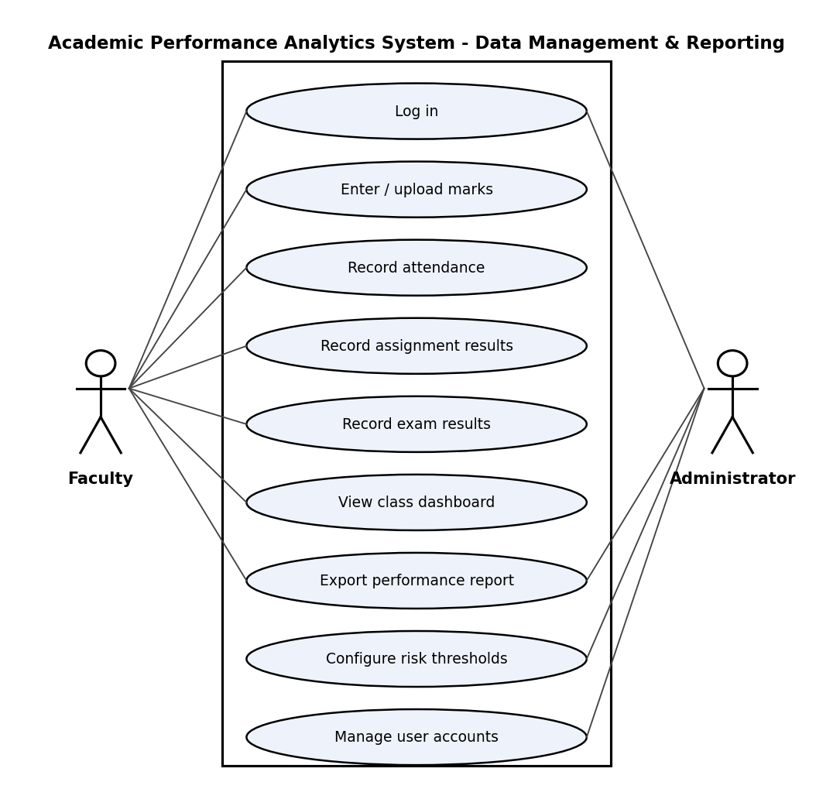

Diagram 2 – Monitoring and intervention (Student, Faculty, Administrator, Notification Service):
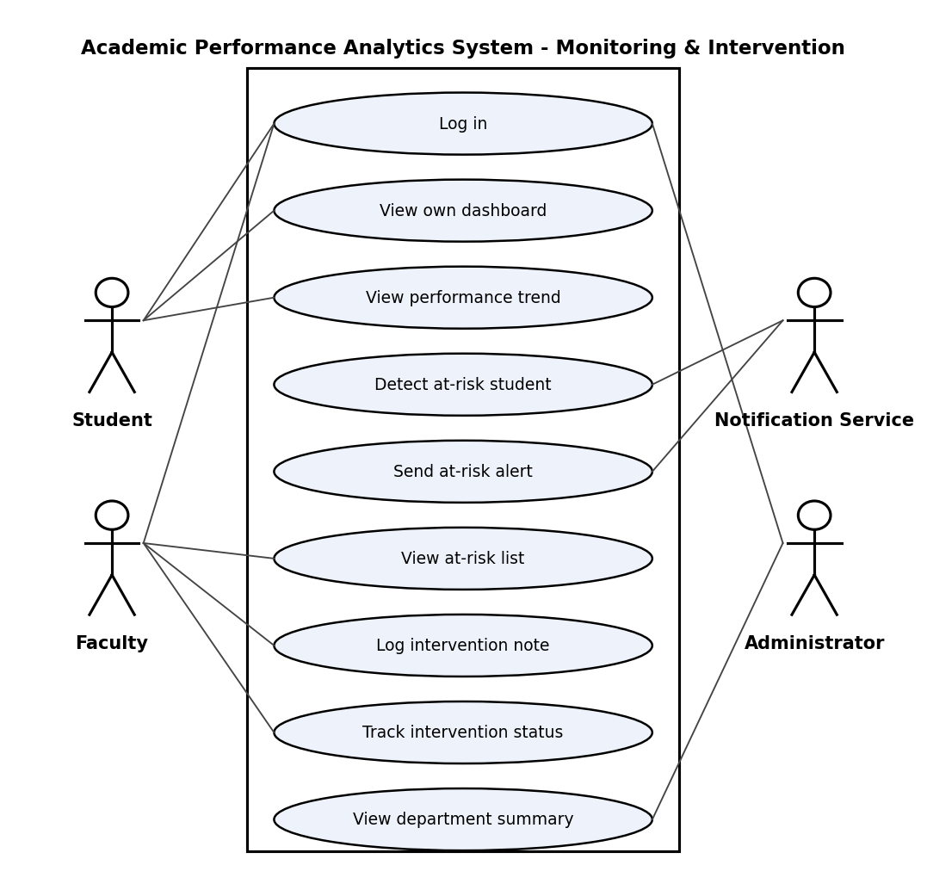

8. Requirements Traceability Matrix (RTM)
Status: N = Not started, P = In progress, A = Accepted. Design-spec references will be linked once the SAD is complete.
Req ID | Requirement short | Sec. | Module | Test case(s) | Status | Comments
APAS-F-001 | authenticate users with a username and password before... | 4.1 | AuthModule | TC-Auth-01 | N
APAS-F-002 | enforce role-based access (Student, Faculty, Administrator) | 4.1 | AuthModule | TC-Auth-02 | N
APAS-F-003 | lock an account for 15 minutes after 5 consecutive failed... | 4.1 | AuthModule | TC-Auth-03 | N
APAS-F-010 | allow Faculty to enter or upload (CSV) marks for each... | 4.2 | DataModule | TC-Data-01 | N
APAS-F-011 | allow Faculty to record attendance per class session or... | 4.2 | DataModule | TC-Data-02 | N
APAS-F-012 | record assignment submissions (submitted / late / missing)... | 4.2 | DataModule | TC-Data-03 | N
APAS-F-013 | record examination results (internal and end-semester) per... | 4.2 | DataModule | TC-Data-04 | N
APAS-F-014 | validate all entered data (marks within 0 to maximum,... | 4.2 | DataModule | TC-Data-05 | N
APAS-F-020 | compute each student's attendance percentage per course and... | 4.3 | AnalyticsModule | TC-An-01 | N
APAS-F-021 | compute each student's average marks per course and overall | 4.3 | AnalyticsModule | TC-An-02 | N
APAS-F-022 | detect a declining trend when a student's marks decrease... | 4.3 | AnalyticsModule | TC-An-03 | N
APAS-F-023 | flag a student as at-risk when attendance is below the... | 4.3 | AnalyticsModule | TC-An-04 | N
APAS-F-024 | compute each student's assignment completion rate... | 4.3 | AnalyticsModule | TC-An-05 | N
APAS-F-030 | provide a student dashboard showing marks, attendance,... | 4.4 | DashboardModule | TC-Dash-01 | N
APAS-F-031 | provide a faculty dashboard per course with class averages,... | 4.4 | DashboardModule | TC-Dash-02 | N
APAS-F-032 | provide an administrator summary at department level... | 4.4 | DashboardModule | TC-Dash-03 | N
APAS-F-033 | export performance reports as CSV and PDF | 4.4 | DashboardModule | TC-Dash-04 | N
APAS-F-040 | notify the responsible faculty member when a student is... | 4.5 | InterventionModule | TC-Int-01 | N
APAS-F-041 | allow Faculty to record intervention notes (action taken,... | 4.5 | InterventionModule | TC-Int-02 | N
APAS-F-042 | track intervention status (Open, In progress, Resolved) for... | 4.5 | InterventionModule | TC-Int-03 | N
APAS-NF-001 | Performance requirement | 5 | System-wide | TC-Perf-01 | N
APAS-NF-002 | Reliability requirement | 5 | System-wide | Ops report | N
APAS-NF-003 | Scalability requirement | 5 | System-wide | TC-Perf-02 | N
APAS-NF-004 | Usability requirement | 5 | System-wide | TC-UX-01 | N
APAS-NF-005 | Audit / Retention requirement | 5 | System-wide | TC-Ops-01 | N
APAS-NF-006 | Maintainability requirement | 5 | System-wide | CI pipeline | N
APAS-SR-001 | All network communication shall use TLS 1.2 or higher | 5.1 | Security | TC-Sec-01 | N
APAS-SR-002 | Passwords shall be stored only as salted hashes (e.g.,... | 5.1 | Security | TC-Sec-02 | N
APAS-SR-003 | Authorisation shall be enforced on the server side for... | 5.1 | Security | TC-Sec-03 | N
APAS-SR-004 | All user input shall be validated and database queries... | 5.1 | Security | TC-Sec-04 | N
APAS-SR-005 | Every change to marks, attendance and exam records shall be... | 5.1 | Security | TC-Sec-05 | N
APAS-SR-006 | User sessions shall expire after 15 minutes of inactivity | 5.1 | Security | TC-Sec-06 | N

