|  |  |
| --- | --- |
| **Ex. No. 6** | **JAVASCRIPT – TIMER FUNCTIONS AND OBJECTS** |
| **Date of Exercise** | 05-09-2022 |
| **Web Host Link** | <https://prabhu970.github.io/Experiment6/> |
| **YouTube Link** | [https://drive.google.com/file](https://drive.google.com/file/d/1_h5rVXTwj82vdZ7REPpv6nTMxI6omt1d/view?usp=share_link) |

**Aim:**

To create a web pages using various timer functions, events and objects in JavaScript.

**Description:**

**Timing Events**

The window object allows execution of code at specified time intervals. These time intervals are called timing events. The two key methods to use with JavaScript are:

* setTimeout(function, milliseconds)

Executes a function, after waiting a specified number of milliseconds.

EX: window.setTimeout(*function*,*milliseconds*);

* setInterval(function, milliseconds)

Same as setTimeout(), but repeats the execution of the function continuously.

Ex: window.setInterval(*function*,*milliseconds*);

* The clearTimeout() method stops the execution of the function specified in setTimeout().

Ex: window.clearTimeout(timeoutVariable)

**Date Object**

Date Object gives various methods to multiple ways to access date, month, year details.

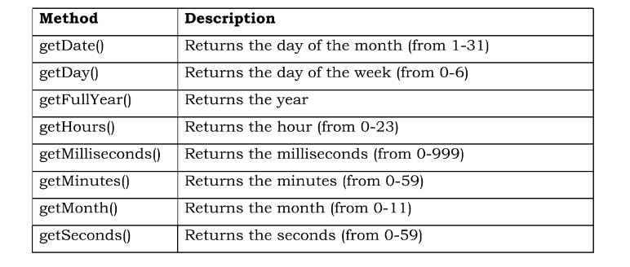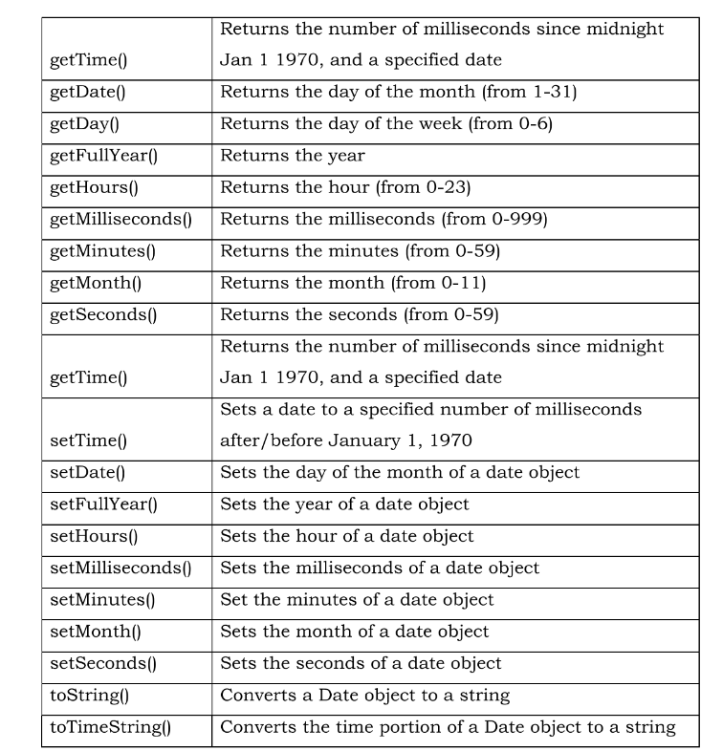

**Class and Object**

A class is a type of function, but instead of using the keyword function to initiate it, we use the keyword class, and the properties is assigned inside a constructor() method.

# Program:

Question: Write JavaScript code to display digital clock, change background color automatically, increase and decrease the size of the text, start and stop a car and create an array of objects.

<!DOCTYPE html>

<html lang="en">

<head>

    <meta charset="UTF-8">

    <meta http-equiv="X-UA-Compatible" content="IE=edge">

    <meta name="viewport" content="width=device-width, initial-scale=1.0">

    <title>Experiment 6</title>

    <script src="script.js"></script>

    <style>

        #clock {

            font-size: 3em;

            width: 200px;

            margin: 20px;

            text-align: center;

            border: 2px solid black;

            border-radius: 20px;

        }

        #carh {

            width: 250px;

        }

        #dynamic,

        #texte {

            font-size: 1em;

            width: 600px;

            height: 150px;

            margin: 20px;

            text-align: center;

            border: 2px solid black;

            border-radius: 20px;

        }

    </style>

</head>

<body>

    <div>

        <fieldset>

            <legend>

                <h2>Clock</h2>

            </legend>

            <div id="clock"></div>

        </fieldset>

        <fieldset>

            <legend>

                <h2>Dynamic Background</h2>

            </legend>

            <div id="dynamic"></div>

        </fieldset>

        <fieldset>

            <legend>

                <h2>Zoom in and Zoom out</h2>

            </legend>

            <div id="texte" onmouseover="incSIZE()" onmouseout="decSIZE()"> You can Maximize or Minimize this text</div>

        </fieldset>

    </div>

    <div height="100px">

        <fieldset>

            <legend>

                <h2>Car !?</h2>

            </legend>

            <img id="car" src="Car.jpg" width="150" height="100"

                style="position: relative; right: 0px; left: 0px; top: 0px;"></img>

            <input type="button" value="Reverse" onclick="initl()" style="position: relative; top:30px;" />

            <input type="button" value="Stop" onclick="stopCar()" style="position: relative; top:30px;" />

            <input type="button" value="Reset" onclick="resetcar()" style="position: relative; top:30px;" />

            <br><br><br>

        </fieldset>

        <fieldset>

            <legend>

                <h2>Student Details!</h2>

            </legend>

            <div id='Std1' style="width:70%; height:60px">Before 2000:<br></div>

            <div id='Std2' style="width:70%; height:60px">After 2000:<br></div>

            <input type="button" value="Click" onclick="display1()" />

        </fieldset>

    </div>

</body>

</html>

**JAVASCRIPT file**

function display() {

    let d = new Date();

    let hour = parseInt(d.getHours());

    let min = d.getMinutes();

    let sec = d.getSeconds();

    hour = hour < 10 ? "0" + hour : hour;

    min = min < 10 ? "0" + min : min;

    sec = sec < 10 ? "0" + sec : sec;

    document.getElementById('clock').innerHTML = hour + ':' + min + ':' + sec;

} setInterval(display, 1000);

function bgcolor() {

    var red = Math.floor(Math.random() * 255);

    var green = Math.floor(Math.random() * 255);

    var blue = Math.floor(Math.random() * 255);

    var color = "rgb(" + red + "," + green + "," + blue + ")";

    document.getElementById('dynamic').style.backgroundColor = color;

} setInterval(bgcolor, 1000);

function incSIZE() {

    document.getElementById("texte").style.fontSize = "3em";

}

function decSIZE() {

    document.getElementById("texte").style.fontSize = "1em";

}

var t;

var c;

var pos = 0;

function init() {

    t = setInterval('moveCar()', 100);

}

function initl() {

    c = setInterval('moveCarl()', 100);

}

function moveCar() {

    var car = document.getElementById('car');

    pos += 10;

    car.style.left = pos + 'px';

}

function moveCarl() {

    var car = document.getElementById('car');

    pos -= 10;

    if (pos >= 0) {

        car.style.left = pos + 'px';

    }

    else {

        pos = 0;

        return;

    }

}

function stopCar() {

    clearTimeout(t);

    clearTimeout(c);

    car.style.left = pos + 'px';

    car.style.right = pos + 'px';

}

function resetcar() {

    clearTimeout(t);

    clearTimeout(c);

    pos = 0

    car.style.left = pos + 'px';

}

function display1() {

    var dicg = [{ name: "Neil", r_No: "20cs1037", dob: "19-05-1922" },

    { name: "david", r_No: "20cs2041", dob: "19-06-2003" }];

    for (var i = 0; i < dicg.length; i++) {

        if (parseInt(dicg[i].dob.split("-")[2]) < 2000) {

            document.getElementById('Std1').innerHTML += "<b>Student Name: </b>" + dicg[i].name + ",<b> Register_Number: </b> "

                + dicg[i].r_No + ",<b> Date of Brith: </b>" + dicg[i].dob + "<br>";

        }

        else{

            document.getElementById('Std2').innerHTML += "<b>Student Name: </b>" + dicg[i].name + ",<b> Register_Number: </b> "

                + dicg[i].r_No + ",<b> Date of Brith: </b>" + dicg[i].dob + "<br>";

        }}}

**Output:**

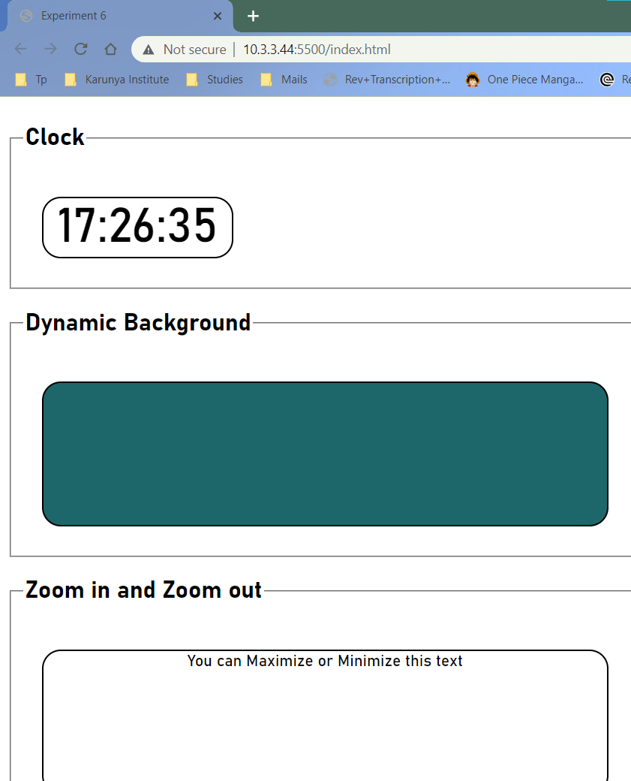

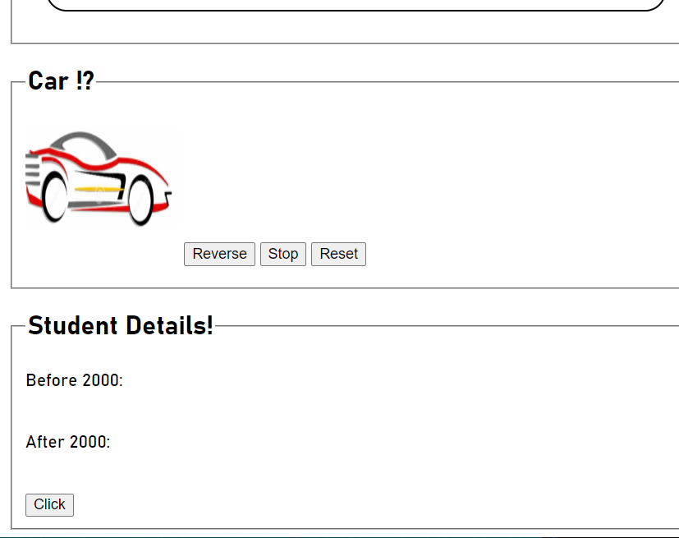

# Result:

The website has been successfully created using JavaScript timer functions and object.