Project Assignment – IS460: Robotic Process Automation
Course: IS460 - Robotic Process Automation
Student: Pavle Mitić
Student ID: 5559
Topic: Processing public product price data in the Republic of Serbia
Tool: n8n (workflow automation platform)

1. Introduction
The development of information systems and the growth of publicly available data have created a need for automated processing, analysis, and presentation. Robotic process automation (RPA) enables these tasks with minimal manual work and user intervention.
The goal of this project is to build an automated system for:
- downloading publicly available product price data in Serbia,
- storing the data,
- processing and analyzing it,
- interacting with the user via a chatbot.
The data is processed for different retail chains, and the user can choose the desired analysis through a simple chat interface.

2. Data and technologies used

2.1 Data source
Publicly available CSV price data for products in the Republic of Serbia is used, containing information such as:
- product name,
- product category,
- regular price,
- discounted price (if any),
- price list validity date,
- retailer name (Lidl, Dis).

2.2 Technologies and tools
- n8n – workflow automation platform
- HTTP Request – downloading CSV files
- File System (Read/Write Files) – storing and reading data from disk
- Extract from CSV – parsing CSV data
- JavaScript Code node – data processing and analysis
- AI Agent (Google Gemini) – communication with the user
- n8n chat interface – user interaction

3. System architecture
The system consists of two logical parts:

3.1 Data download and storage
In this phase:
- CSV files are downloaded via HTTP requests,
- Data is saved to the local file system,
- The process can be started:
  - manually (Execute workflow),
  - periodically (Schedule Trigger).
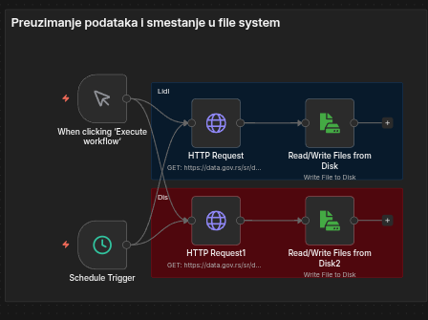
This part of the system enables regular data updates without manual downloads.

3.2 Chatbot system for data processing
The second part enables users to request data analysis via chat.

Execution flow:
- When chat message received The workflow activates each time the user sends a message.
- Switch (store selection) Based on user input, the store is selected:
  - Lidl

  - Dis
- Load CSV file Depending on the selected store, the corresponding CSV file is read from disk.
- Extract from CSV The CSV file is converted into a list of items (one row = one product).
- Switch (analysis selection) The user chooses the analysis type:
  - Top 10 discounts
  - Average price by category
- JavaScript Code node The appropriate analysis is executed on the data.
- AI Agent The analysis result is formatted and delivered to the user in a readable form.
- Respond to Chat The user receives the response in the chat.
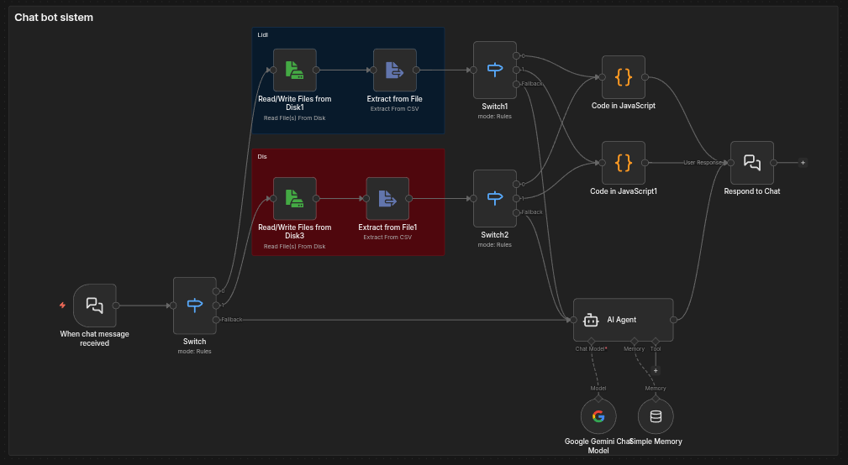

4. Implemented functionalities

4.1 Top 10 discounts
This functionality:
- finds products that have a discounted price,
- calculates the discount percentage,
- sorts products by discount size,
- shows the first 10 products with the highest discount.
The result is shown to the user as a textual list in the chat.

4.2 Average price by category
This functionality:
- groups products by category,
- uses the regular price of products,
- calculates the average price for each category,
- shows results sorted by average price in descending order.

This analysis helps the user see which product categories are most expensive on average.

5. User interaction
The user communicates with the system through a chatbot.

Selection format:
- 1 1 - Lidl, Top 10 discounts
- 1 2 - Lidl, Average price by category
- 2 1 - Dis, Top 10 discounts
- 2 2 - Dis, Average price by category
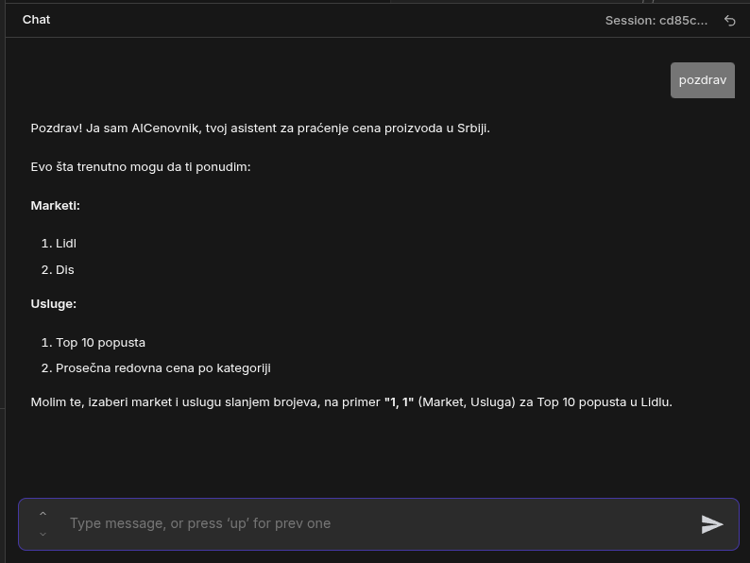
The chatbot enables continuous communication and responds to every user message in real time.

6. Advantages of the solution
- full automation of data download and processing,
- no manual work with CSV files,
- clear separation between data processing and AI communication,
- easily extensible solution (adding new stores or analyses),
- practical application of RPA concepts to a real problem.

7. Conclusion
As part of this project, a functional system for robotic process automation of public product price data in Serbia was implemented. The system enables downloading, storage, processing, and presentation of data through an intuitive chatbot interface.
The project demonstrates a practical use of RPA tools and concepts, as well as the integration of automation with modern AI models, resulting in an efficient and flexible solution.

