PROJECT
PETERA

Student:
Pavle Mitić

Niš November, 2025.

1.Project - Petera

1.1 Project definition

1.1.1 Introduction to the topic
This project task is the development of a web application called Petera, the main purpose of which is to connect pet owners with people who offer animal care services. This application solves the problem of finding a reliable and available keeper in the territory of different cities, allowing owners to quickly and easily find a verified person to whom they can entrust their pets.
The Petera application functions as a simple platform, which allows the registration of two different user roles: owners and sitterians.
While the owners have the possibility to search for ads and services, the sitterians on the other hand can create and publish their offers ie. pet sitting ads. This system also offers filtering by location so that users can find sitters in their city on the territory of Serbia.

1.1.2 Topic description
Petera is a pet care platform. Petera's main goal is to improve the way owners find babysitters, as well as to provide an easy way for babysitters to offer their services.
Petera enables the following functions, such as:
Pet owner
The owner creates his profile, enters the basic data and gets the possibility to search for a caretaker by city, price and type of animal that the caretaker accepts. The owner can:
- view all available sitter ads,
- open the detailed view of the ad,
- see the description of the sitter, its pictures, experience and reviews,
- schedule a save.
Pet sitter
A keeper represents a person who wants to offer animal care services. It has a special registration procedure that includes uploading a photo of an identity document, e.g. identity card. This functionality is essential for security and identity verification.
The sitterian gains the following abilities:
- create and edit your ads,
- sets the description, price and storage conditions,
- adds photos
- connect with the owner

1.1.4 Stakeholders
Pet owners
- They want a reliable person to look after their pet
- They are searching for sitter ads.
- They schedule a pick-up.
- They browse and post reviews

Pet sitters
- They offer babysitting services.
- They create ads.
- They attach a personal document for verification
- They get ratings and reviews.

System administrators (internal stakeholders)

- Manage user accounts
- They review and verify the sitterian's documents
- Respond to user reports
- They maintain the security of the platform
1.2 Detailed risk analysis

1.2.1 Risk identification
As part of the risk identification for the Petera project, the key functionalities of the system were analyzed as well as the way the team was organized during development. Based on that, the risks that can most threaten user safety, system stability, compliance with deadlines and quality of delivery have been singled out.
The table below shows the 6 most important risks, grouped by category (security, technical, project and external). Each risk is assigned a unique ID (R1–R6) to facilitate tracking of risks through further analysis.

ID CATEGORY RISK DESCRIPTION
R1 | Security | Leakage or unauthorized access to security sitter personal documents
R2 | Technical | Frontend and backend integration issues
R3 | Project | Inaccurate time estimates and scope expansion
R4 | Project | Insufficient resources / uneven distribution of work in the team
R5 | Security | Fake profiles and misuse of reviews
R6 | External | Changing requirements during development

1.2.2 Qualitative analysis

1.2.2.1 Assessment of probability and impact
P (probability), I (impact)
Risk | P | And
R1 - Document Leak | 3 | 5
R2 - FE/BE integration | 3 | 4
R3 - Bad estimates / scope creep | 4 | 5
R4 - Resources / work distribution | 3 | 4
R5 - Fake profiles / reviews | 4 | 4
R6 - Change request | 3 | 4

1.2.2.2 PI matrix
In the PI matrix, we show the distribution of risks according to probability (P) and impact (I).
Probability(P)/impact(I) | Low (1–2) | Medium (3) | Tall (4) | Critical (5)
Large (4–5) |  |  | R5 | R3
Medium (3) |  |  | R2,R4,R6 | R1
Small (1–2) |  |  |  | /
The PI matrix was used to rank the risks of the Peter project according to probability of occurrence (P) and impact on the project (I), on a scale of 1 to 5.
In the matrix, the most critical risk is R3 - inaccurate time estimates and scope expansion, because it has a combination of high probability and critical impact (P=4, I=5).
Next, R1- leakage or unauthorized access to personal documents of the sitter has a critical impact (I=5) due to the sensitivity of the data although its probability is estimated as medium (P=3). This risk requires the strictest security measures (access control, encryption and administrative moderation).
Risks R2 (integration), R4 (resources and work distribution) and R6 (requirement change) are classified in the high zone, because they have medium probability and high impact (P=3, I=4) and can significantly slow down development, especially in teamwork and sprint organization.

1.2.2.3 Calculation of RPN (Risk Priority Number)
Formula: RPN = P(probability) × I(impact)
Risk | P | And | RPN
R1 | 3 | 5 | 15
R2 | 3 | 4 | 12
R3 | 4 | 5 | 20
R4 | 3 | 4 | 12
R5 | 4 | 4 | 16
R6 | 3 | 4 | 12
Most critical by RPN:
R3 (20) Inaccurate time estimates and scope expansion
R5 (16) Fake profiles and abuse of reviews
R1 (15) Leakage or unauthorized access to security sitter's personal documents

1.2.3 Mitigation and contingency strategies
ID | Risk | Mitigation (prevention) | Contingency (if it happens)
R1 | Document leak | Limited access (admin only), secure storage | Disable upload
R2 | FE/BE integration | integration testing early | Restore stable version, fix problematic routes
R3 | Bad estimates | clear priorities, do not expand the scope in a sprint | Reduce scope, move less essential functions
R4 | Resources / distribution | Clear division of tasks, regular team agreement | Redistribute tasks, focus on the most important functions
R5 | Fake profiles/reviews | Owner verification | Deleting spam, banning accounts, manual checking
R6 | Change request | Record changes | Postpone to sprint

This chapter presents the mitigations and contingencies for the key risks of the Peter project. Mitigation represents short measures the team takes in advance to reduce the possibility of a problem, while contingency describes what we do if the risk does occur.
The goal is to ensure stable development, deadline control and user safety through clear and quick reactions to the most important risks.

1.3 System Design

1.3.1 Main project objectives

1.3.1.1.1 Financial goals
- Creating a sustainable business model
- Introducing an optional commission per transaction
- Long-term increase in income through growth in the number of users

1.3.1.1.2 Non-financial goals
- Increasing security and trust
- Connecting animal lovers
- Improving the quality of services through reviews

1.4 Requirements analysis

1.4.1 Functional requirements
- The application must allow owner and custodian registration.
- The sitter must go through verification.
- The keeper can create, edit and delete their ads.
- The owner can view the ads and watcher details.
- The application must allow filtering of sitters by city, price and type of pet.
- Owners can leave reviews for keepers.
- The application must display a keeper rating.

1.4.2 Non-functional requirements
- The application must be easy to use.
- The system must provide reliable protection for both parties.
- Fast loading and filtering of ads.
- The interface must be responsive on various screen sizes and mobile devices.
- The system must be available 24/7.

1.4.3. Definition of MVP (Minimum Viable Product)
Functionalities included in MVP:
- Registration of owners and custodians
- Owner verification (personal document upload)
- Creation of ads by custodians
- Overview of ads and reservations by the owner
- Search and filter ads by city and type of pet
Functionalities implemented later:
- Owner ratings and reviews
- View sitter rating
- More detailed user profiles
These functionalities were chosen for MVP because they enable basic system usage and concept testing with users. Other functionalities are additional and can be implemented after getting feedback and validating the core value of the application.

1.4.4 Modeling use case scenarios
- User registration
ID and name: | UC-1 User registration
Creator: | Peter's team | Creation date: | 02.12.2025
Primary actor: | User (owner or custodian) | Secondary actors: | System
Starter: | The user wants to create an account
Description: | The user enters data and creates an account. The custodian additionally adds an image of the personal document for verification.
Prerequisites: | PRE-1. The user has access to the application  PRE-2. The custodian has a valid document to upload
Postconditions: | POST-1. The system creates a user account  POST-2. The sitter switches to the status "waiting for verification"
Normal flow: | - K opens the application  - K selects account type (owner or custodian)  - K enters basic data (name, email, password)  - If it's a custodian - adds a document image (A1)  - K confirms the entry  - S creates an account and sends a confirmation
Alternative flows: | A1: Owner skips document upload - S does not allow registration
Exceptions: | E1: Incorrect email format - S displays a warning  E2: Document cannot be loaded - S displays an error
Priority: | Tall
Frequency of use: | Often
Business rules: | - The sitterian must add a valid document
Other information: | /
Assumptions: | Account successfully created

- Creating an ad (Owner)
ID and name: | UC-1 Creating an ad
Creator: | Peter's team | Creation date: | 02.12.2025
Primary actor: | Owner | Secondary actor: | System
Starter: | Caretaker wants to post an ad for caregiving
Description: | The keeper enters information about the ad and publishes it
Prerequisites: | PRE-1. The sitterian has a verified account  PRE-2. The sitter is logged in.
Postconditions: | POST-1. The ad is visible to the owners
Normal flow: | - The user is logging in.  - Select “Create Ad”  - Enter description, price, type of pet, picture  - È confirms the entry  - S saves the ad and confirms it in the list
Alternative flows: | A1: Č does not enter all mandatory data - S requests a supplement
Exceptions: | E1: Image in wrong format  E2: Internet connection interruption
Priority: | Tall
Frequency of use: | Often
Business rules: | BR-1: Price must be a numeric value
Other information: | /
Assumptions: | The sitter created the ad.

3. Search and filter ads
ID and name: | UC-3 Search and filter ads
Creator: | Petera's team | Creation date: | 02.12.2025
Primary actor: | Owner | Secondary actors: | System
Starter: | The owner wants to find a caretaker
Description: | The owner searches ads by location, price and type of pet
Prerequisites: | PRE-1. Owner has an account  PRE-2. There are active ads.
Postconditions: | POST-1. List of filtered sitters shown
Normal flow: | - V is available.  - V opens search  - V applies filters (city, price, pet type)  - S shows filtered ads
Alternative flows: | A1: No results - S displays the message “No savers for selected filters”
Exceptions: | E1: Error loading ad
Priority: | Tall
Frequency of use: | Often
Business rules: | BR-1: The price filter must have a range
Other information: | /
Assumptions: | The owner found the sitter.

4. Reservation of storage:

ID and name: | UC-4 Storage Reservation
Creator: | Petera's team | Creation date: | 02.12.2025
Primary actor: | Owner | Secondary actors: | Owner
Starter: | The owner wants to book a sitter
Description: | The owner reserves the safekeeping through an ad
Prerequisites: | PRE-1. Owner has an account  PRE-2. There is an active sitter ad
Postconditions: | POST-1. The reservation has been recorded  POST-2: The sitter gets a notification
Normal flow: | 1.V reviews the sitter's details  2. V clicks “Reserve”  3. Create a reservation  4. S informs the sitter
Alternative flows: | A1: The appointment is already taken - S shows alternative dates
Exceptions: | E1: Failed to save reservation
Priority: | Tall
Frequency of use: | Medium
Business rules: | BR-1: Reservations are recorded with date and time
Other information: | /
Assumptions: | The owner has successfully booked a safekeeping

- Ratings and reviews
ID and name: | UC-5 Ratings and Reviews
Creator: | Peter's team | Creation date: | 02.12.2025
Primary actor: | Owner | Secondary actors: | System
Starter: | The owner wants to rate the post-storage experience
Description: | Allows the owner to leave a rating and review
Prerequisites: | PRE-1. The owner has created an account and is logged into the system  PRE-2. There is a successfully completed booking between the owner and the custodian  PRE-3. The system allows entering ratings and reviews
Postconditions: | POST-1. Rating and reviews are saved in the system  POST-2. A rated sitter sees his updated average rating  POST-3. The review becomes visible to all owners on the sitterian's profile
Normal flow: | - V opens the app and goes to the list of all his completed bookings  - V chooses the sitter he wants to rate  - V opens the rating form  - V enters rating and comment  - V clicks “Send”  - Saves review  - Reviews are displayed on the keeper's profile
Alternative flows: | A1: The owner exits the process before submitting the rating  1. The owner closes the form before confirmation  2. The system does not store any data  3. The system returns the user to the sitter list
Exceptions: | E1: It is not possible to rate a sitter without prior booking  E2: Loss of internet connection while sending rating  E3: Invalid grade entered
Priority: | Tall
Frequency of use: | Medium
Business rules: | - Rating is enabled only for completed bookings.  - Ratings affect a sitter's average rating
Other information: | /
Assumptions: | The owner leaves a comment and rating

1.5 System Design

1.5.1 System architecture
Peter's application was developed as a modern full-stack web application based on Next.js 16, where frontend and server logic are unified in one code base. The application is implemented in TypeScript, while the UI is styled using TailwindCSS.

The data is stored in the PostgreSQL database (hosted on the Neon platform), and database access and schema definition are implemented using Drizzle ORM. Authentication and session management are implemented through BetterAuth, with accompanying tables (session, account, verification). The deployment of the application was realized on the Vercel platform, which enables simple scaling and fast delivery of new versions.

The system architecture is designed to be modular, scalable and easy to maintain: the UI layer is separated from the business logic, and the business logic from the data access layer (ORM + base).

1.5.1.1 Frontend architecture
The frontend of the application was developed within the Next.js framework (App Router) using React components. The UI is organized through pages (routes) and modular components that cover the main use cases: pet owners browse listings and send care requests, while keepers create and edit listings.
The main functional units of the frontend are:
- Auth pages (Login / Register) - user login and registration (BetterAuth)
- ListingsPage + Filters - view listings with filtering (city, type of service, type of pet, price)
- ListingDetails - display listing details (description, price per day, services, pets, pictures)
- Create/Edit Listing - forms for creating and editing sitterian listings
- BookingRequest - sending a reservation request (from–to dates, total price calculation)
- UI components - navigation, ad cards, toast messages, modal windows, forms
Components are modular and reusable, allowing easy addition of new functionality in subsequent versions (eg chat, availability calendar, sitterian verification).

1.5.1.2 Backend architecture
The backend logic is implemented within the Next.js application (server-side), through Next.js mechanisms (eg route handlers / server actions), without a separate Express server. The backend manages business logic and communication with the database through Drizzle ORM .
The system enables CRUD operations on key entities:
- User - information about users and roles (OWNER / SITTER)
- Sitter - sitter profile (bio), linked 1:1 to the user
- Listing - sitter ads (title, description, city, price per day)
- ListingImage - listing images (save in database as byte)
- ListingPet - which pets the sitterian accepts (enum pet)
- ListingService - what services the keeper offers (enum service)
- Booking - requests/reservations (dates, price, fee, status booking_status)
- Review - ratings and comments of the sitter by the owner
Authentication and Authorization:
Implemented using BetterAuth and supporting tables:
- session - sessions (token, expiry, userId, ipAddress, userAgent)
- account - connection of account and provider (providerId, access/refresh token, password)
- verification - verification flows (email verification, tokens and expiry)
This ensures that only authenticated users can access protected functions (eg creating ads, sending booking requests).
Structure of the backend part (logical):
- db/ - Drizzle configuration and schema (schema.ts)
- server routes / actions - business logic (creating ads, uploading images, booking flow)
- auth layer - BetterAuth integration and access control
Error handling is set up so that the user receives clear error and success messages (eg invalid date, insufficient privileges, image upload failure).

1.5.1.3 Database design
The database uses PostgreSQL and is designed relationally, with clear connections between tables. The model is adapted to the system of ads and reservations, with special tables for authentication (BetterAuth).
Enumerations (ENUM) in the database:
- user_role - user role
- city
- pet - type of pet
- service - type of service
- booking_status - booking status (eg PENDING)
Main tables (business part):
- user: id, name, email, phone, email_verified, role, created_at, updated_at
- sitter: id (FK on user.id), bio
- listing: id (uuid), sitter_id (FK), title, description, city, price_per_day, created_at
- listing_image: id, listing_id (FK), image (bytea), mime_type, order, created_at
- listing_pet: id, listing_id (FK), pet (ENUM)
- listing_service: id, listing_id (FK), service (ENUM)
- booking: id, listing_id (FK), owner_id (FK), start_date, end_date, price_per_day, fee_amount, total_amount, currency, status, created_at
- review: id, sitter_id (FK), owner_id (FK), rating, comment, created_at
Authentication Tables (BetterAuth):
- session: id, expires_at, token, user_id, ip_address, user_agent, timestamps + index session_userId_idx
- account: id, account_id, provider_id, user_id, token fields + index account_userId_idx
- verification: id, identifier, value, expires_at, timestamps + index verification_identifier_idx
This design allows:
- efficient filtering and display of ads (by city, service, pet, price_per_day)
- support for multiple images per ad with order
- complete course of booking through booking (dates, price, commission, status)
- review system for sitterians (review)
- trusted authentication and sessions through BetterAuth tables

1.5.2 UI/UX prototype
Link to figma: https://www.figma.com/design/8wnRmJ6pDh3FtFe40m2Hwp/PETERA?node-id=0-1&p=f&t=VYg8xb9NaabqGrGu-0

1.6 Implementation
1.6.1 Front-end

1.6.1.1 Advertisements
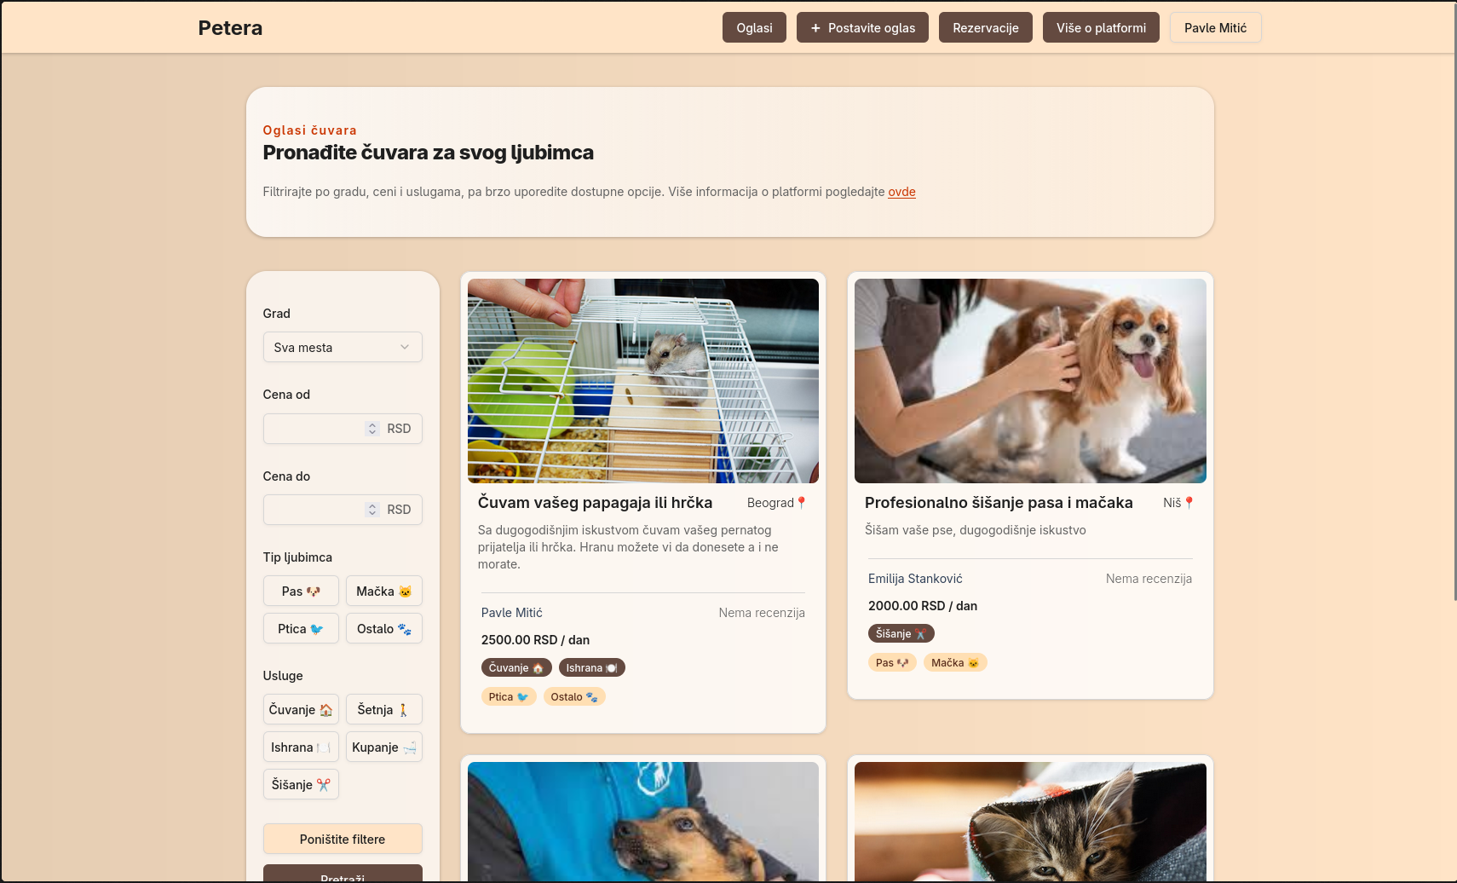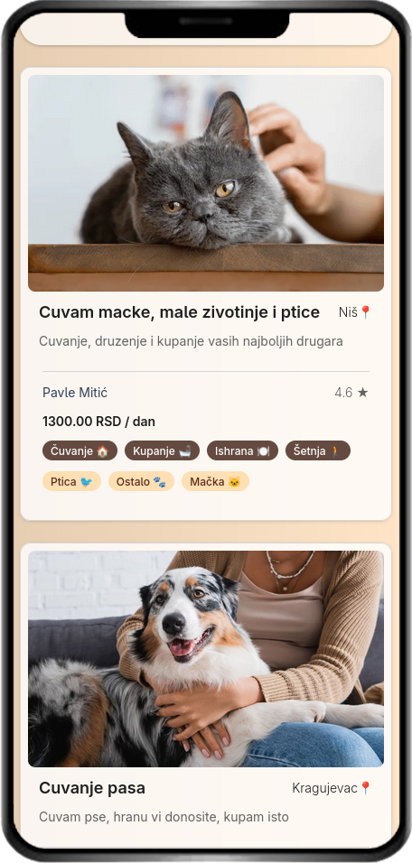

1.6.1.2 Selected Ad
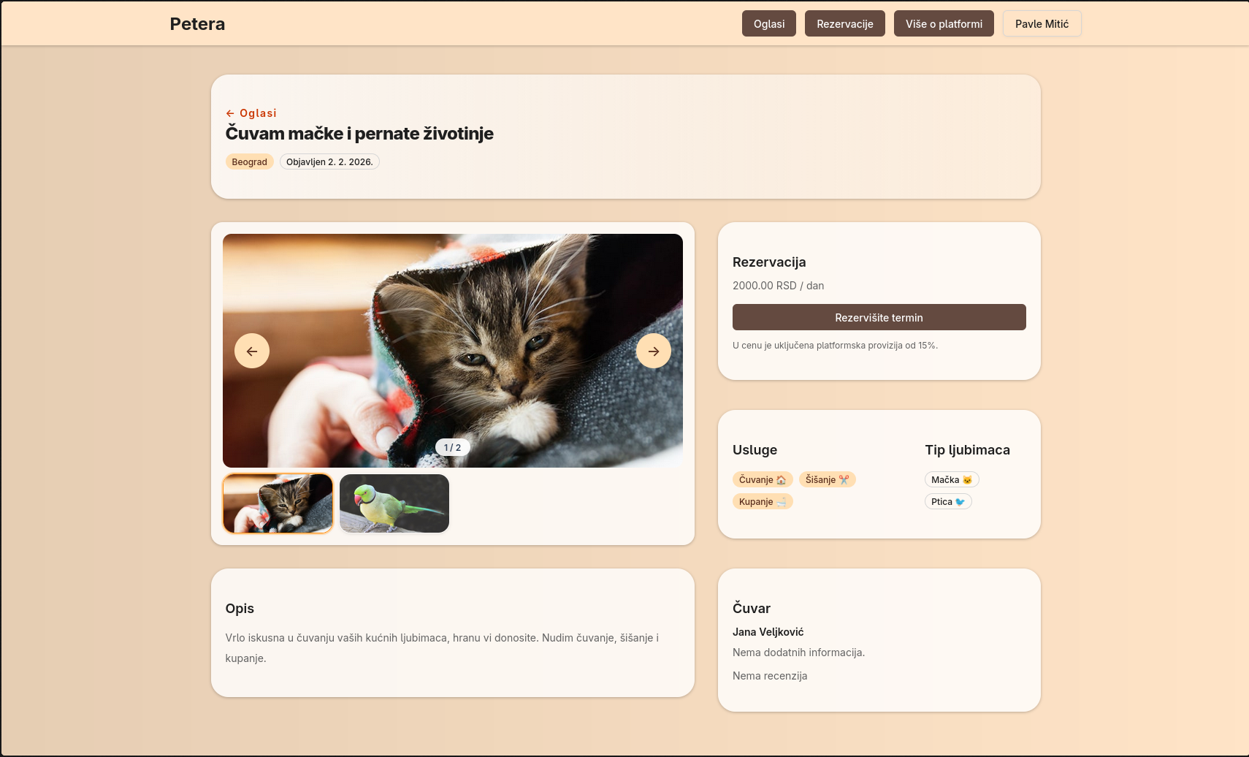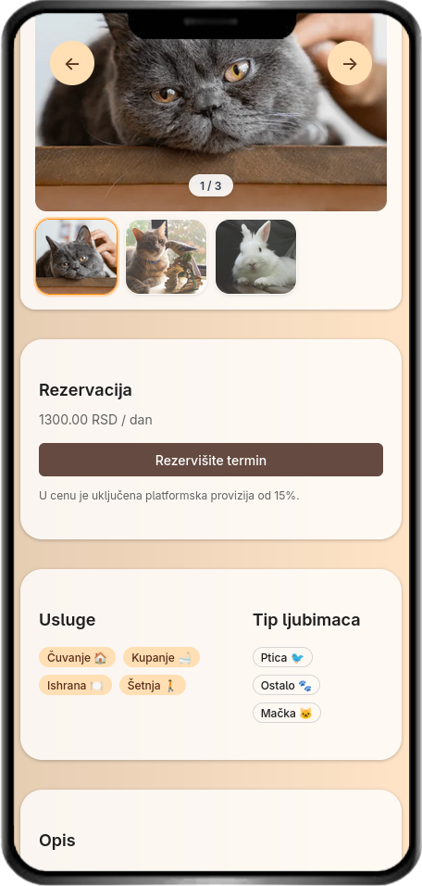

1.6.1.3 Adding Ads (Sitter)
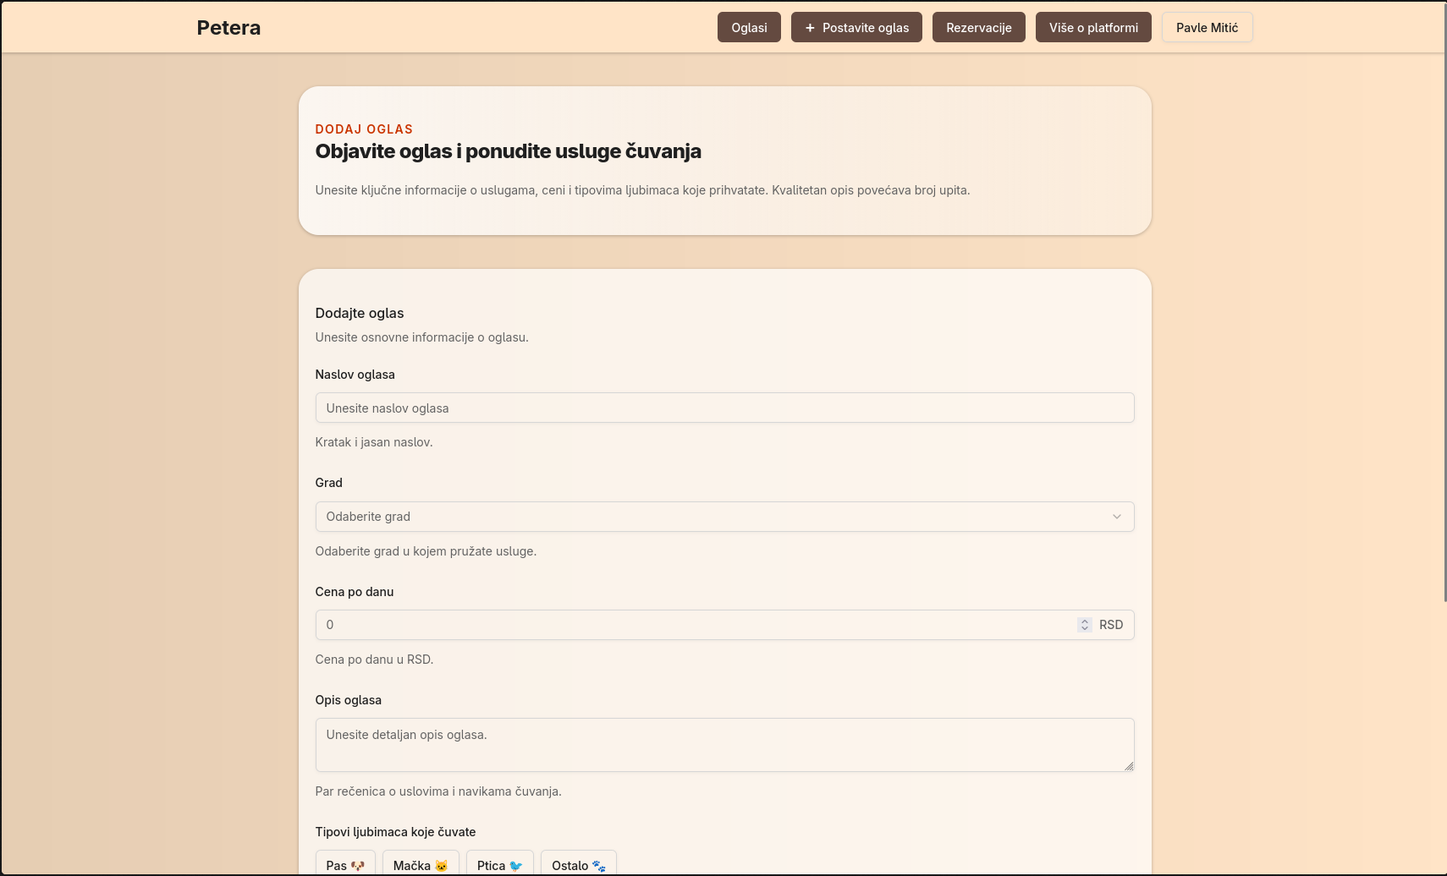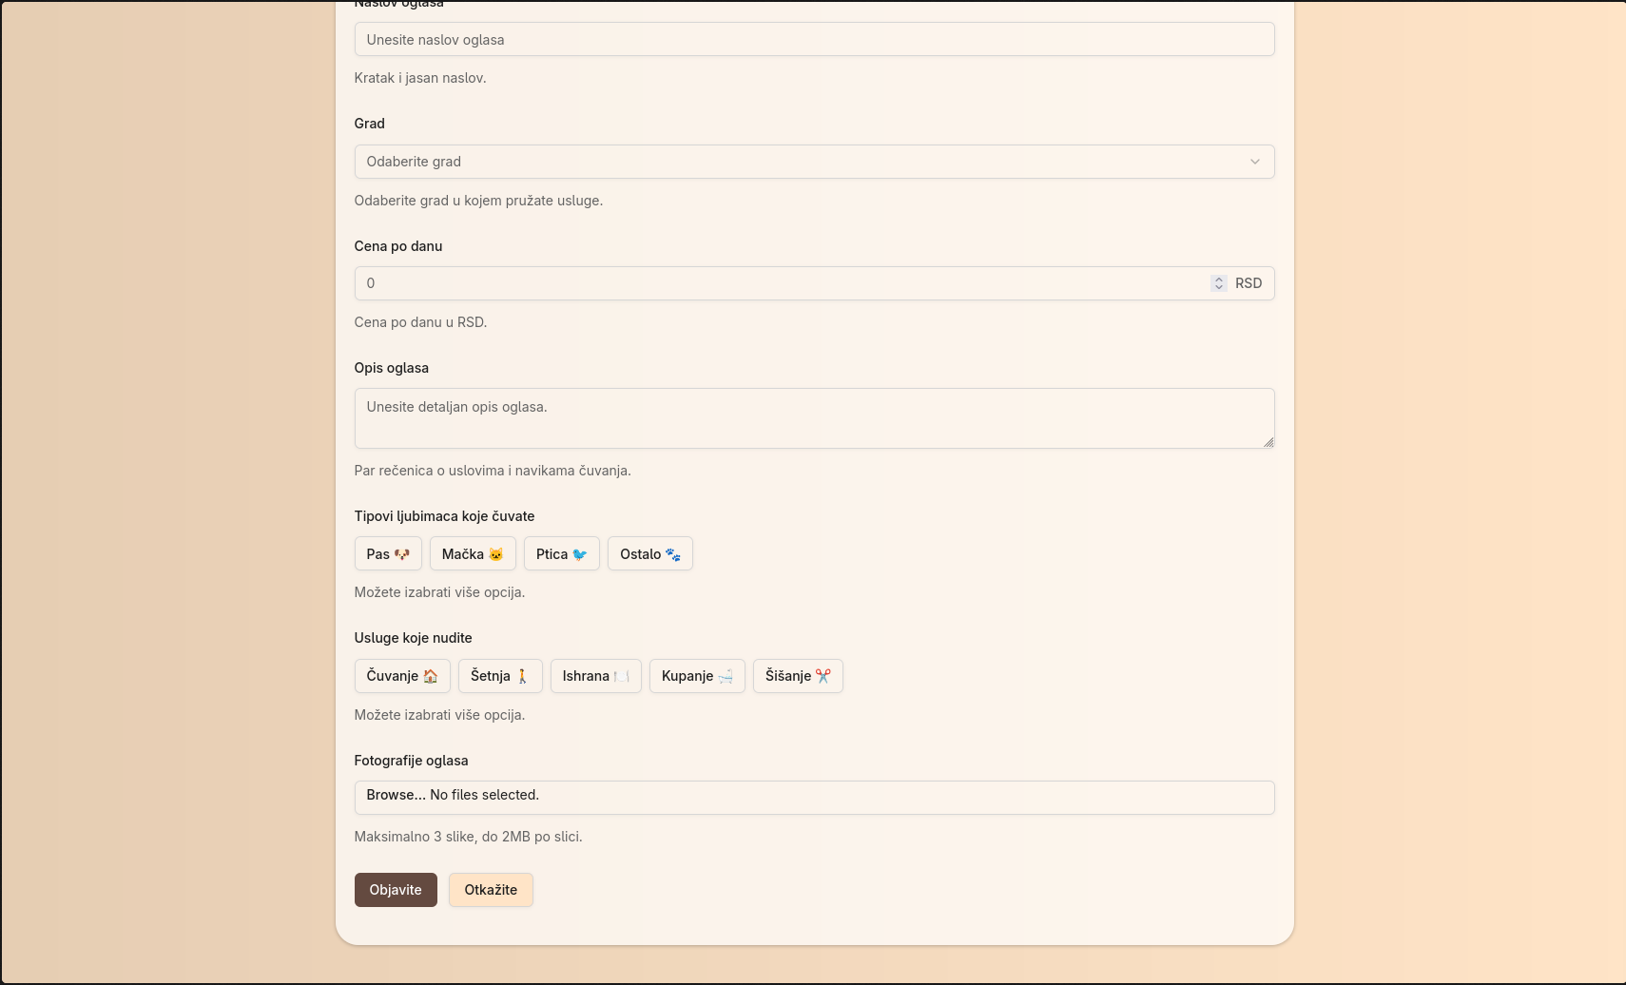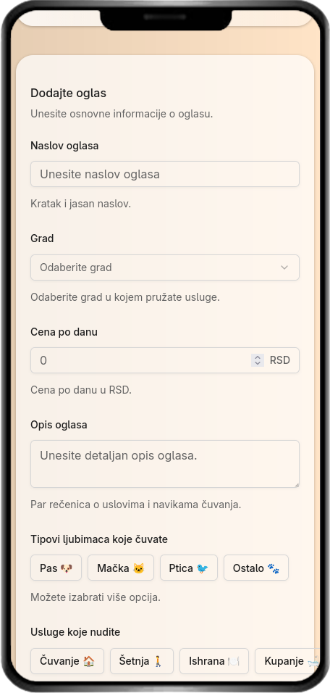

1.6.1.4 More about the platform
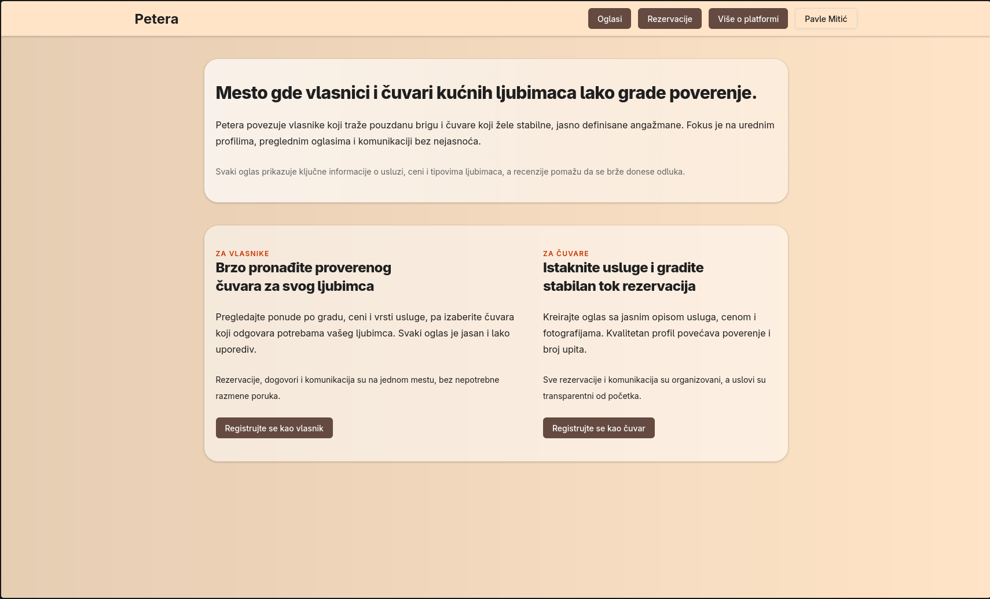

1.6.1.5 Sitter registration

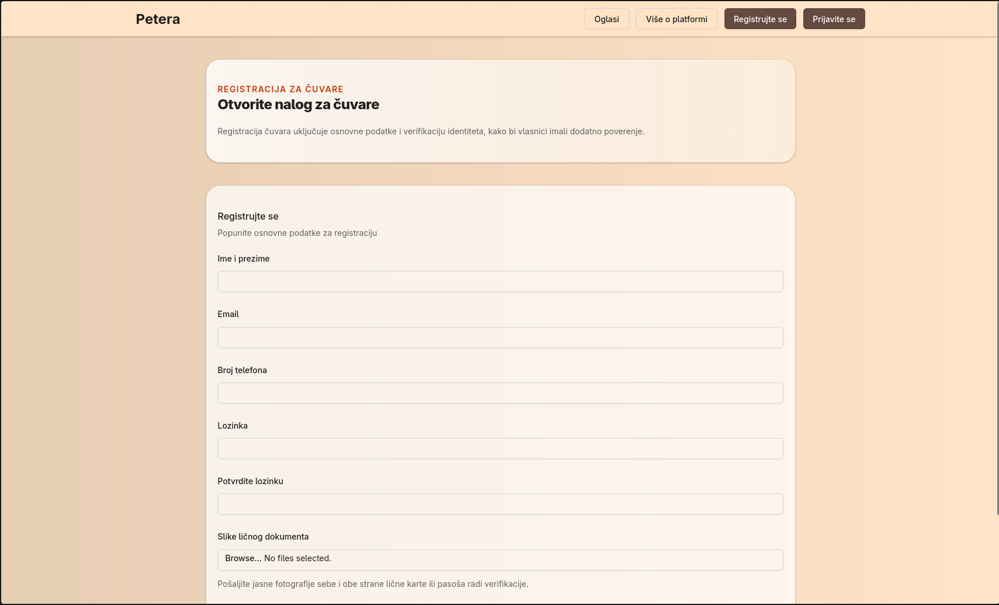

1.6.1.6 Owner registration

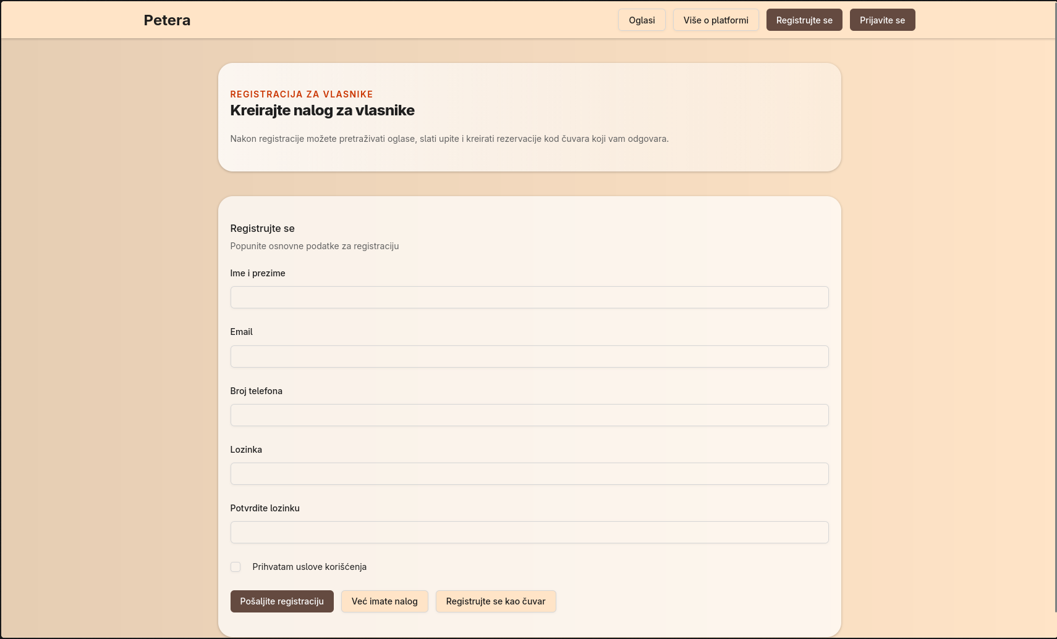

1.6.1.7 Login
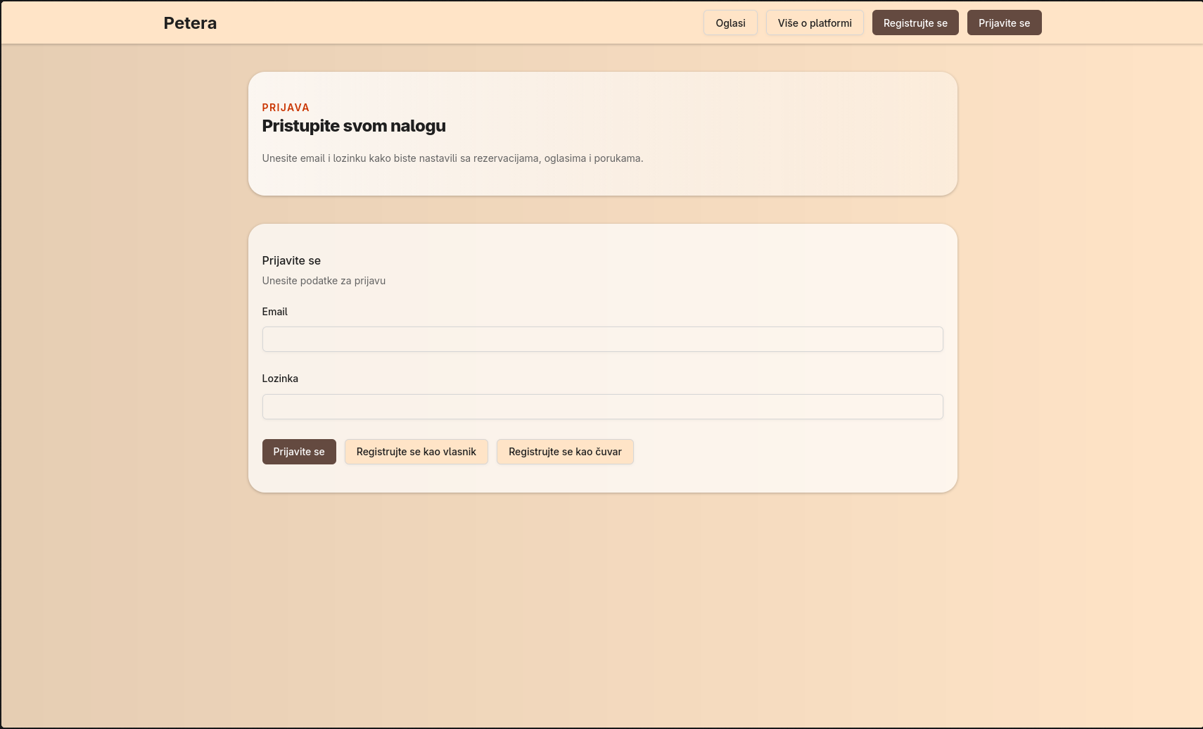

1.6.1.8 Creating a reservation
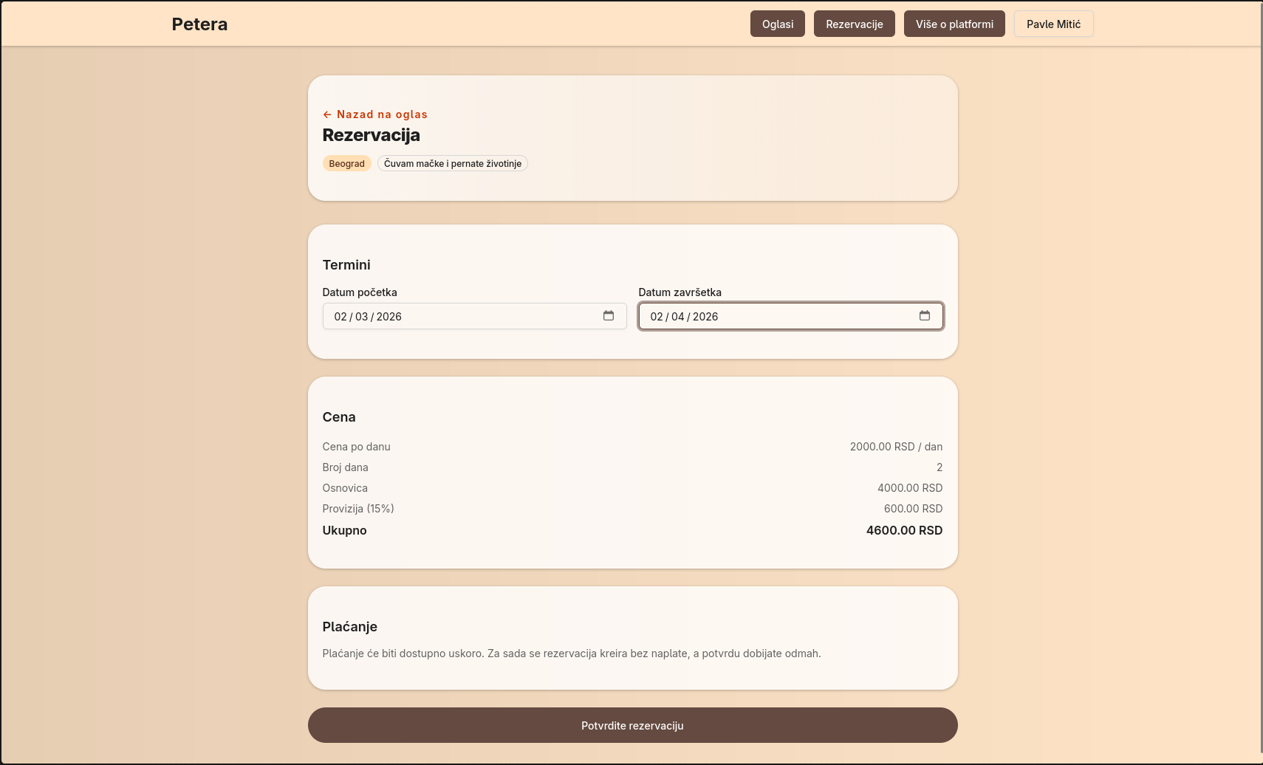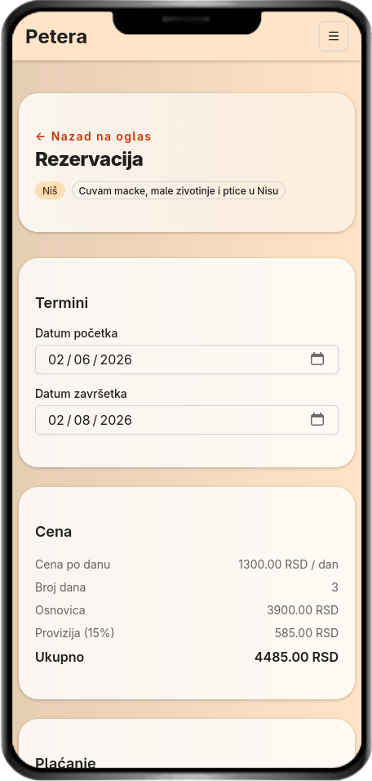

1.6.1.9 Reservation overview

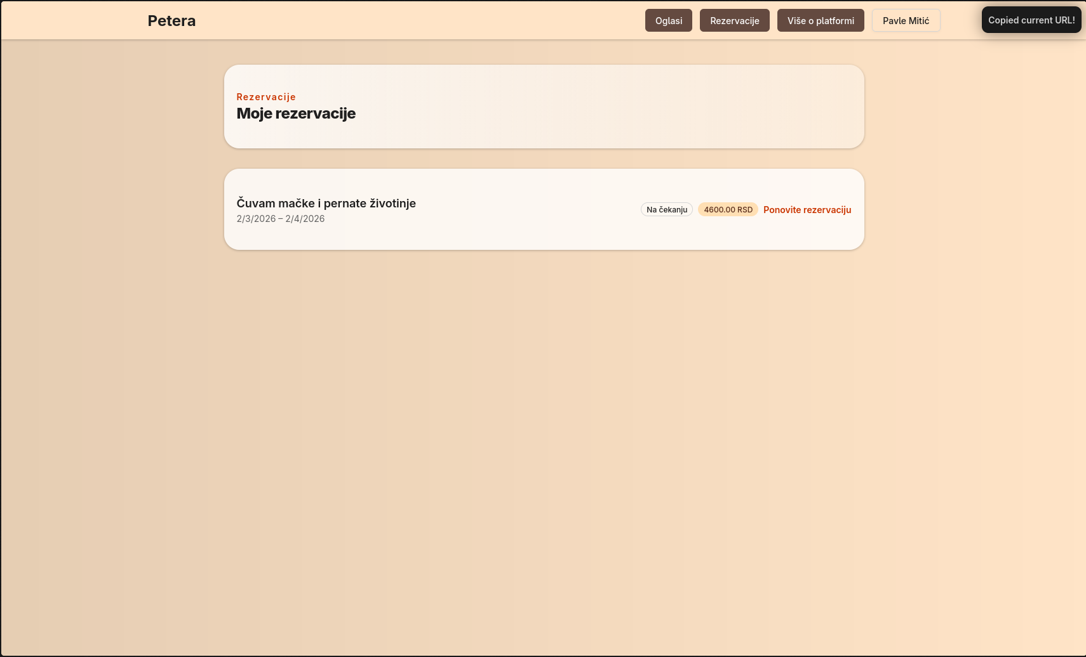

1.7 Testing
For testing, I aimed to confirm that the system above all works stably, that the key functionalities are correct and that the application is easy to use. In addition to technical functionality testing, a special focus is placed on usability and user acceptance of the system, because my application depends on trust and a clear user experience.

1.7.1 Usability Testing
I conducted usability testing to check how easily users could perform basic tasks without further explanation. I tested the scripts for both roles
Owners - Re-registration, search and filtering of sitterians, then viewing profiles, making reservations and leaving reviews
Custodians - Registration, uploading documents, creating ads.

1.7.2 User Acceptance testing
I conducted User Acceptance Testing to confirm that the system meets the expectations of end users and is ready for "real" use. Included here is the verification of the main system requirements through scenarios that represent real situations such as
- User can register as owner or custodian
- The owner can find a caretaker using filters (city, price, type of pet)
- Owners can create an ad
- The system displays reviews/ratings and prevents obvious abuses
UAT is considered successful because users are able to execute key flows without problems AND thus confirming that Petera is ready for final handover and demonstration

1.8 Ethics and ethical dilemmas

Petera as a platform that connects pet owners and carers has to build trust, The most important dilemmas are related to privacy and security, because the system processes sensitive data (e.g. the identity of the carer and verification documents), so it is an ethical obligation to collect only the necessary data and to store it safely. Then there is trust and transparency, where ratings and reviews should be realistic and based on real interaction to serve users, not manipulation. It is also necessary to limit fake profiles, spam and fake reviews, as well as enable the reporting of inappropriate behavior.

1.8.2.1 Protection of personal data
Peter's application complies with the Law on Copyright and Related Rights (Serbia), precisely because after the custodian enters (uploads) a personal document, the system displays a consent checkbox, where the custodian explicitly confirms that he consents to the processing and use of his data for the purpose of order verification. Without this consent, the verification process cannot be completed. This increases transparency and compliance with data protection principles, and the user has clear control over how their data is used.

1.9 Deployment

1.9.1 Application Deployment
The deployment of the Petera application was realized by hosting the application on the Vercel platform, which allows simple deployment and automatic updating of the application after changes in the code. The database is hosted on the Neon service (PostgreSQL), where all system data is stored. This combination enables stable operation of the application in the production environment and easy maintenance during development and testing.

1.9.2 Creation of user documentation
User documentation is created to make it easier for owners and keepers to use Petera without additional explanations. The documentation covers the basic steps: registration and login, creating and viewing profiles, searching and filtering sitterians, creating ads, sending messages, document verification process (with consent) and leaving reviews. In this way, users receive clear instructions, and the system becomes more accessible and easier to use.

1.10 References and attachments
GitHub repository: https://github.com/pavlemmm/petera
Figma prototype: https://www.figma.com/design/8wnRmJ6pDh3FtFe40m2Hwp/PETERA?node-id=0-1&p=f&t=VYg8xb9NaabqGrGu-0

