Welcome to the Animation Bank User Reference
Welcome to the Animation Bank User Reference. This reference contains detailed information about all the features and capabilities of Animation Bank.

Table of Contents:
Introduction 2
System Requirements 2
MaxScript Animation Bank Reference 2
Animation Bank Release History 2
Known Issues: 2
User Interface 3
Parameters Rollout 3

Introduction
Animation Bank - is a free plug-in for 3DS Max 8 which allows you to store different animations in a single .max file.
By other words: you may hold Stand, Walk, Jump, WeaponEquip animations in a single .max file, at the same time all other things like Skin, Physique and etc. will remain without changes.
Target audience of this plug-in is a Game Developers.

Key Features:
- Character Studio support
- All Standard max transform controllers.
- User Defined properties.
- MaxScript support.

Each account contains:
- Name of account.
- All objects transformations.
- All objects user defined properties.
- Time Line range and time line position.

IMPORTANT NOTE:
Animation Bank is still in development and testing stage. So we are strongly recommending testing this plug-in on your existing scenes before using in your art pipeline.

System Requirements
Discreet 3DS Max 8

MaxScript Animation Bank Reference
Properties
.AccountList : Array : Read
Gets a list of accounts.
.ActiveAccount : String : Read|Write
Gets/Sets the active account.
Example:
-- prints list of accounts
print $AnimationBank01.Account list
-- activates ”Stand_Idle” account
$AnimationBank01.ActiveAccount = ”Stand_Idle”

Animation Bank Release History

Tree Object v0.8

Animation Bank for 3dsmax 8 released

Known Issues:
- If you scene contains any Character Studio Bips you may get an error message like “R6025 - pure virtual function call” on 3dsmax exit (seems like it related to “Save to .bip file” functionality).
- No “Clone” supported for AnimationBank helper

User Interface
To create object press Create panel > Helpers button > 3DGems > AnimationBank button and in any viewport, drag to define an icon size for the helper, then release to set it.

Parameters Rollout
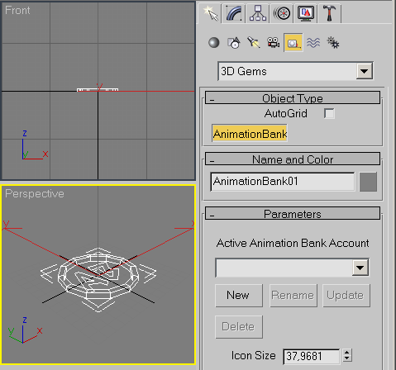
This rollout designed to control the leaves parameters:
- Accounts Combo box – Displays existing accounts and allows you to selected active account.
- New – Allows you to snap current scene animations to new animation account.
- Rename – Allows you to rename selected account.
- Update – Allows you to update selected account by current scene animations.
- Delete - Allows you to delete selected animation account.
- Icon Size – This allows you to change the size of the icon in the viewports.

