**MEMORANDUM**

**TO:** Dr. Bedillion

**FROM:**

**DATE:** April 27, 2018

**RE:** MLC Laboratory

A paragraph or two here should transmit the laboratory report. You should think of this as the report abstract.

This report has been proofread by all members of the group:

____________________________

Print Name Signature and Date

____________________________

Print Name Signature and Date

Introduction

In this lab, we investigated the performance of various controller generation techniques on the Quanser Aero. The Quanser Aero is a DIDO system consisting of two fans mounted perpendicularly on opposing ends of a 2DOF lever arm. The system is able to move about its pitch and yaw axes, with the voltages of the two fans used to control its motion. In this lab we employed loopshaping, H2 synthesis, H∞ synthesis, μ synthesis, and H∞ loop shaping in order to make the system track a desired trajectory.

For all parts of this lab, the desired trajectory consisted of square waves with a pitch angle of π/6 radians and a frequency of .4 rad/s, and a yaw angle of π/4 radians with a frequency of .5 rad/s. The control configuration for the plant is shown below.

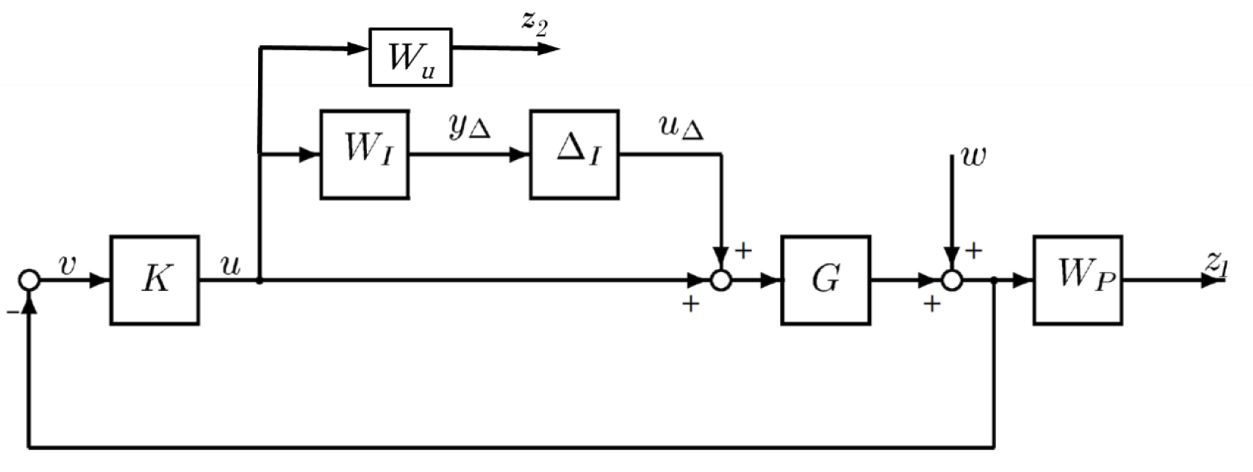

Figure 1. Control configuration for the Quanser Aero

The performance weight was designed to reject DC disturbances by a factor of 100 while keeping sensitivity peaking below 3, and the control weight was set to ensure controller usage did not exceed the maximum system voltage of 25 V.

Preliminaries

1. First, we found the poles and zeros of the nominal plant. We found that there are no zeros, and the poles are all in the closed left half plane. The poles are:
   * -0.1625 + 1.2982i
   * -0.1625 – 1.2982i
   * -1.0004
   * 0

As there are no RHP poles or zeros, we do not have any fundamental control limitations due to waterbed effects.

1. Below is shown the Bode plot for the nominal plant. Note that there is a peak at 1.34 rad/s, due to the complex conjugate pair of poles. Output direction one always has negative gain, so it will have poor tracking at DC.

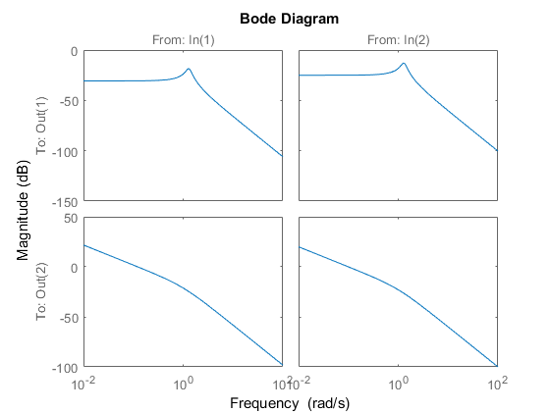

Figure 2. Bode plot of nominal plant

1. We next built a Simulink model based on the nominal plant, including a saturation nonlinearity to limit the voltages to +/- 25V.

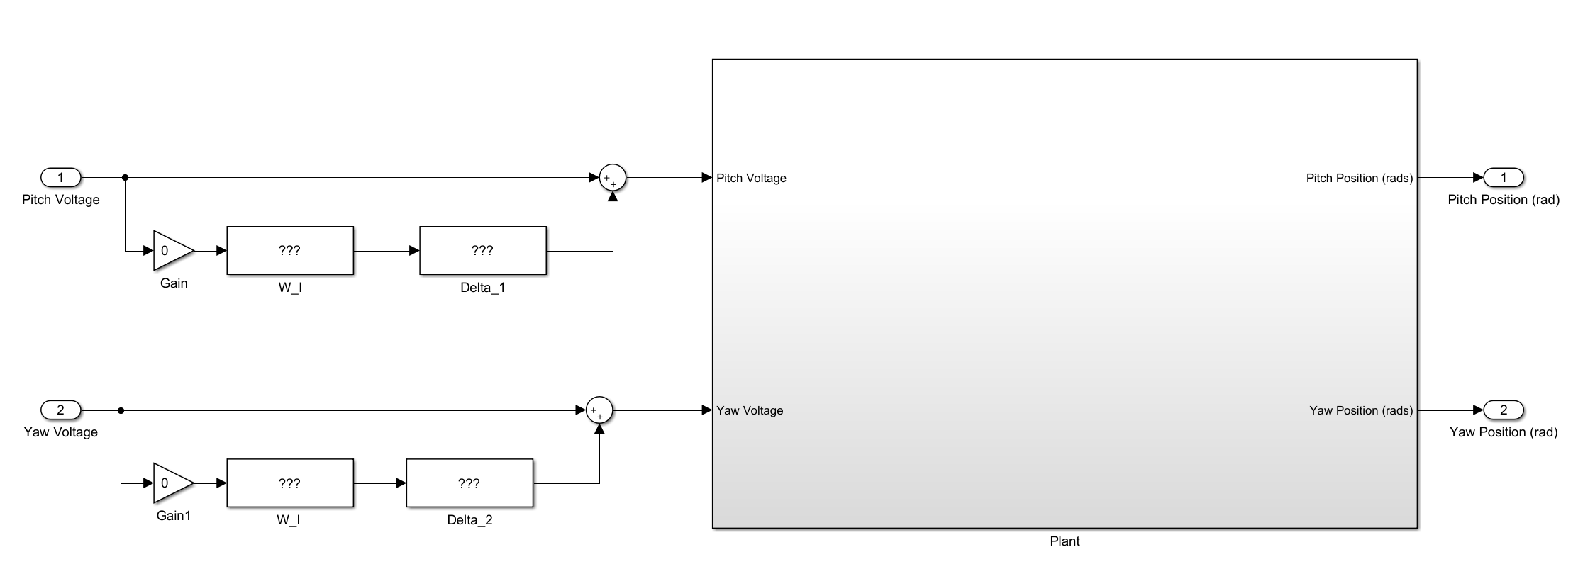

Figure 3. Simulink model of nominal plant.

1. Given 30% uncertainty in Jp and Jy, we built an uncertain model of the plant and fit input multiplicative uncertainty weights using *ucover*. Below, you can see samples from the uncertain plant (blue) plotted with the plant fit with our generated uncertainty weight (red).

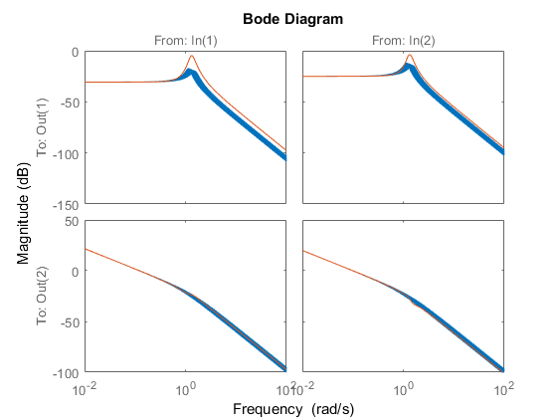

Figure 4. Generated uncertainty weights for the uncertain plant.

Loop Shaping

We first generated an inverse-based controller using classical loopshaping, using a desired loopshape of Ld = wc/s. The crossover frequency was initially set to 5 rad/s. As the generated controller was improper, with a zero excess of 2, we added a repeated high frequency pole at 1000 rad/s to make the controller realizable. Thus our controller is

$$K={G_nom}^{-1}*L_{d}*{(s+1000)}^{-2}$$

1. Below, you can see the output of our simulation with the described controller implemented for no uncertainty. Note that there is a fair deal of overshoot, and that the system angles only vaguely resemble square waves.

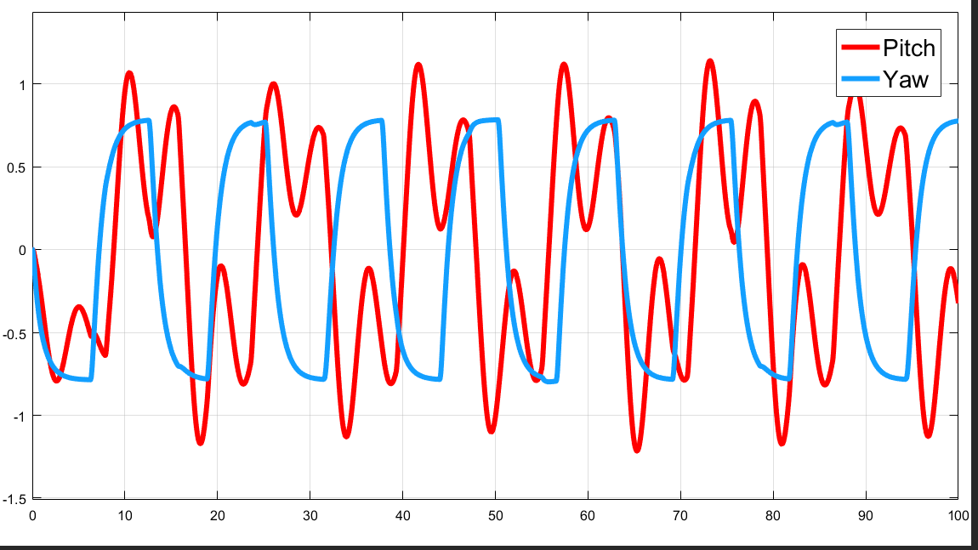

Figure 5. Pitch and yaw angles for loop shaping controller run on the nominal plant

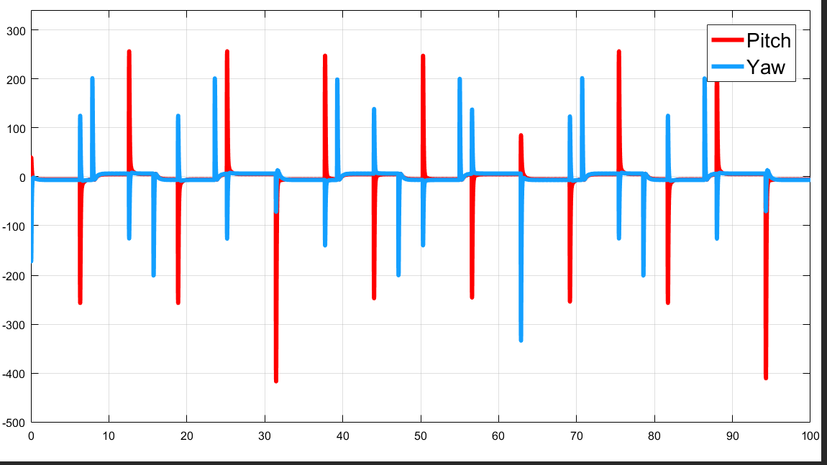

Figure 6. Pitch and yaw voltages for loop shaping controller implemented on the nominal plant

1. Next, we tested the system for robust stability by running it on 10 samples of the uncertain plant.

As you can see, the controller performs very poorly. While you can see the shape of the trajectory followed by the nominal plant, there is very high noise with large amounts of overshoot (enough to easily hit the hard stops). This controller is clearly not robustly stable, and does not have robust performance.

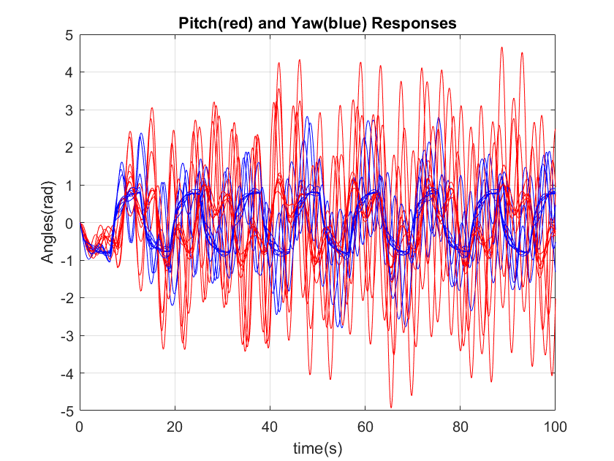

Figure 7. Pitch and yaw angles for loop shaping controller run on 10 samples of the uncertain plant.

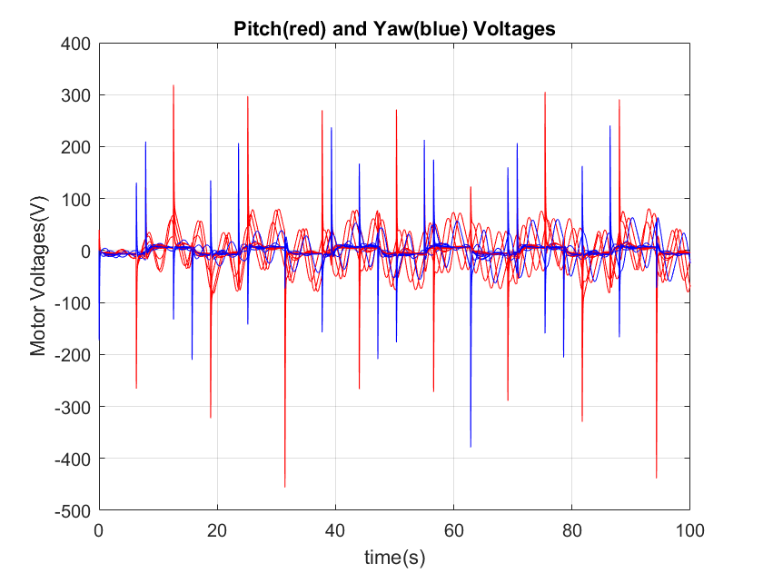

Figure 8. Motor voltages for the pitch and yaw angles for the loop shaping controller run on 10 samples of the uncertain plant.

1. We then implemented the controller on the hardware with no uncertainty. It did not track the desired trajectory very well, often hitting the hard stops of the system. Below are plots of the system angles and voltages.

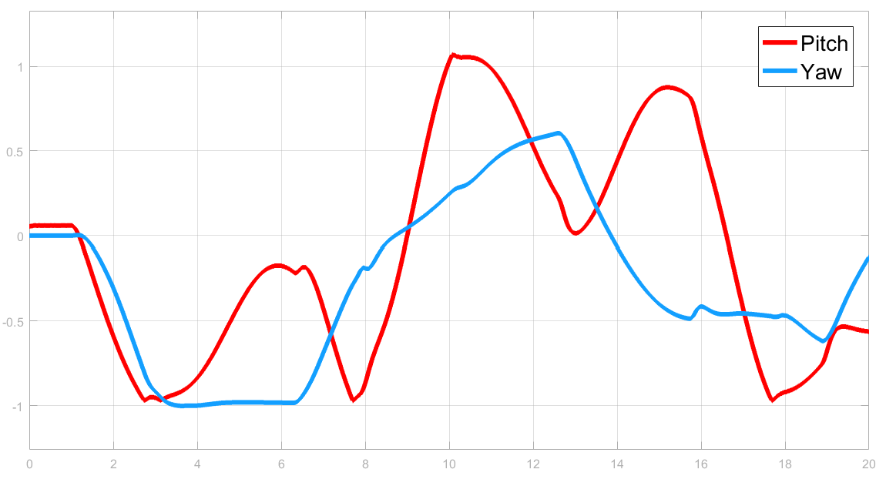

Figure 9. Pitch and yaw angles for the loop shaping controller implemented on the Quanser Aero for the nominal plant.

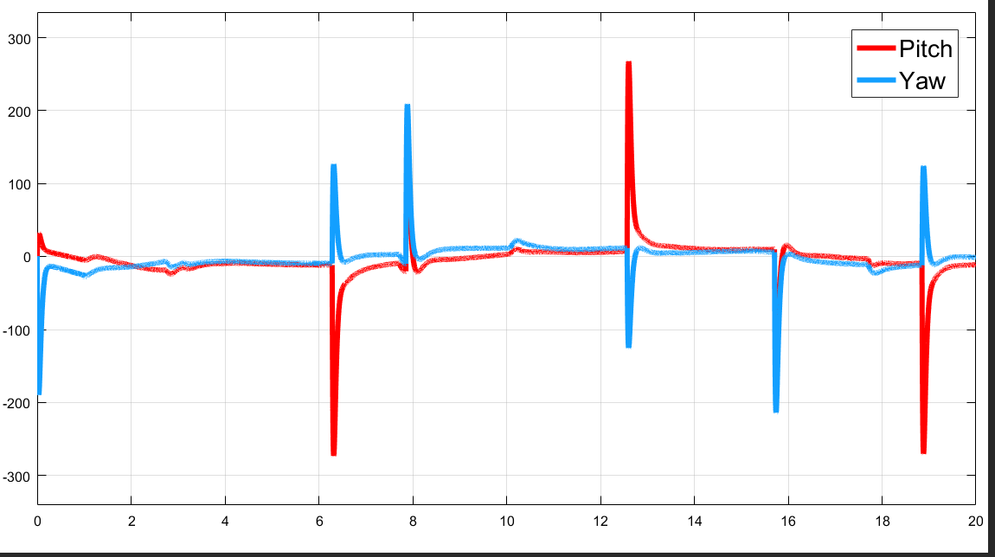

Figure 10. Controller voltages for the loop shaping pitch and yaw implemented on the Quanser Aero for the nominal plant.

1. Finally, we ran the hardware simulation for five samples of the uncertain plant. The system often hit the hard stops, though beyond this overshoot it did reasonably track the trajectory. Below are plots of the pitch and yaw angles and voltages for all five samples.

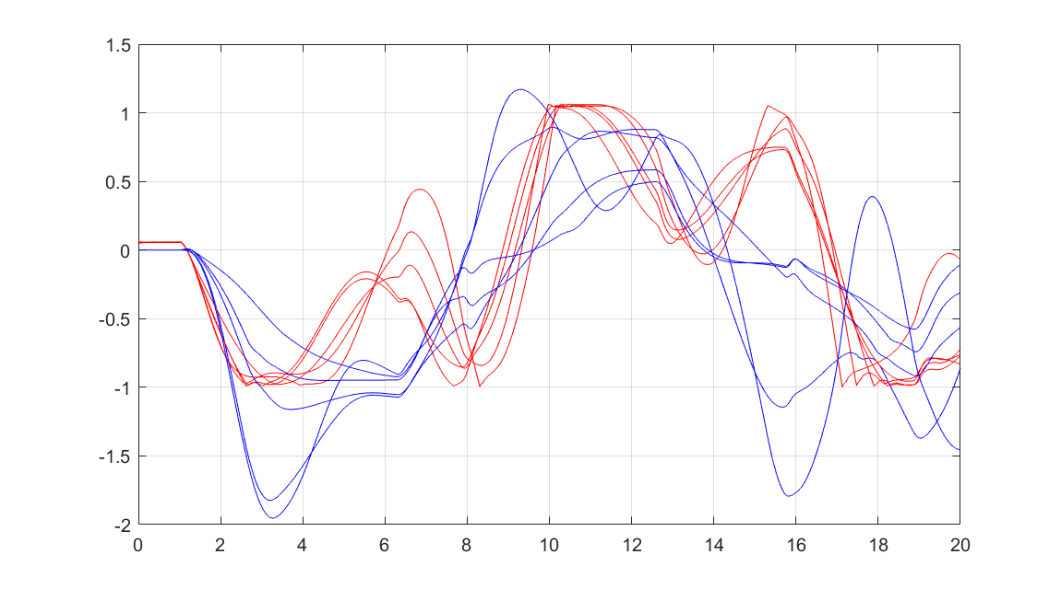

Figure . Pitch (red) and yaw(blue) angles for five trials of the loop shaping controller run on the uncertain plant.

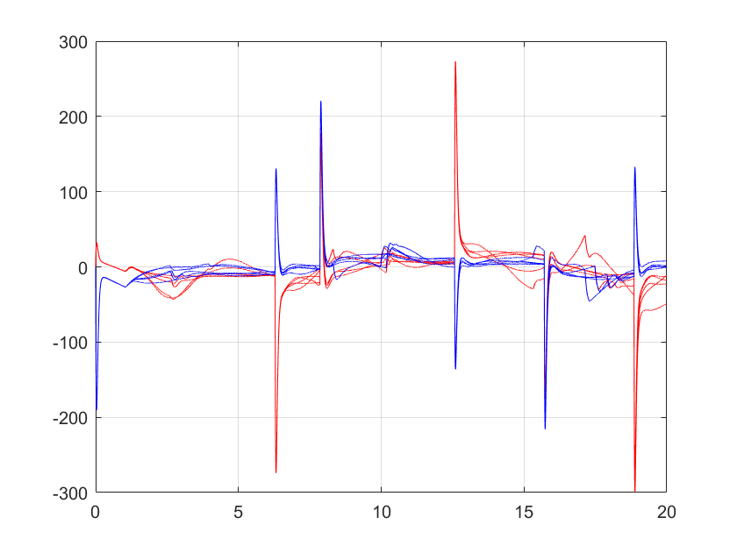

Figure . Pitch (red) and yaw(blue) voltages for five trials of the loop shaping controller run on the uncertain plant.

Video of the controller run on the nominal plant and five samples of the uncertain plant can be viewed here: <https://www.youtube.com/watch?v=RZdholooI4M>

H2 Optimal Synthesis

Next, we synthesized a controller using H2 optimal control, assuming no uncertainty. With tuning, we found a crossover frequency of wc = 10 rad/s to have good performance.

1. Below is the response from the system with no uncertainty, showing system angles and controller usage. Note that the angles have relatively minimal overshoot compared to the loopshaping controller, and overall track the reference much more closely.

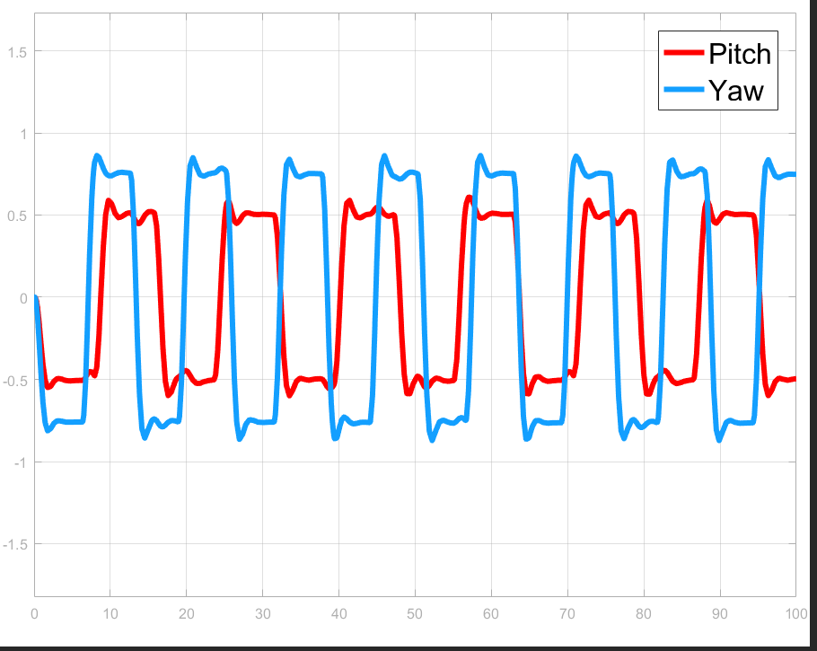

Figure 13. Output of angles from simulation of H2 optimal controller on plant with no uncertainty.

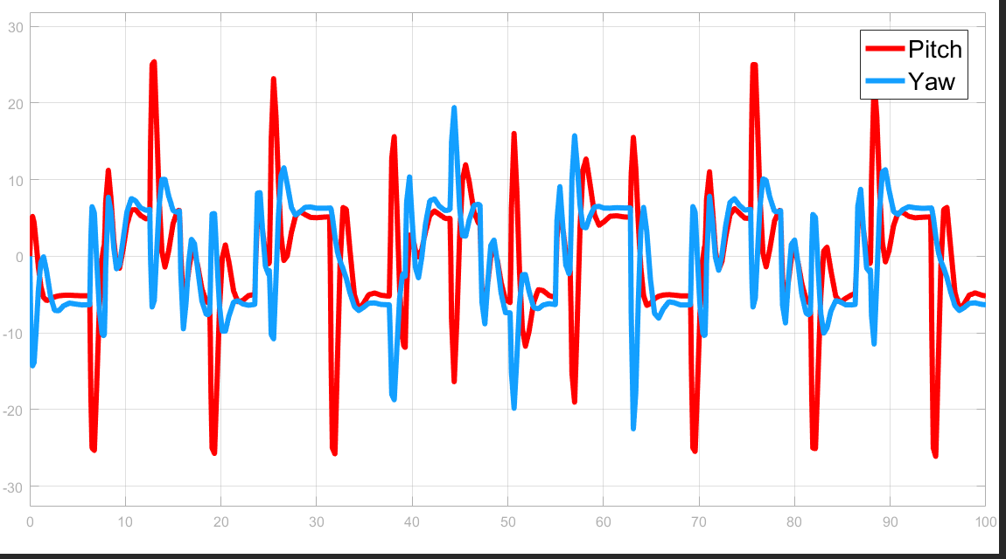

Figure 14. Controller voltages for pitch and yaw motors from simulation of H2 optimal controller on plant with no uncertainty

1. Next, we checked robust stability and robust performance of the system.

[robstab, robperf values here]

1. We then implemented the controller on the hardware. It performed far better than the loop shaped controller, not hitting the hard stops.

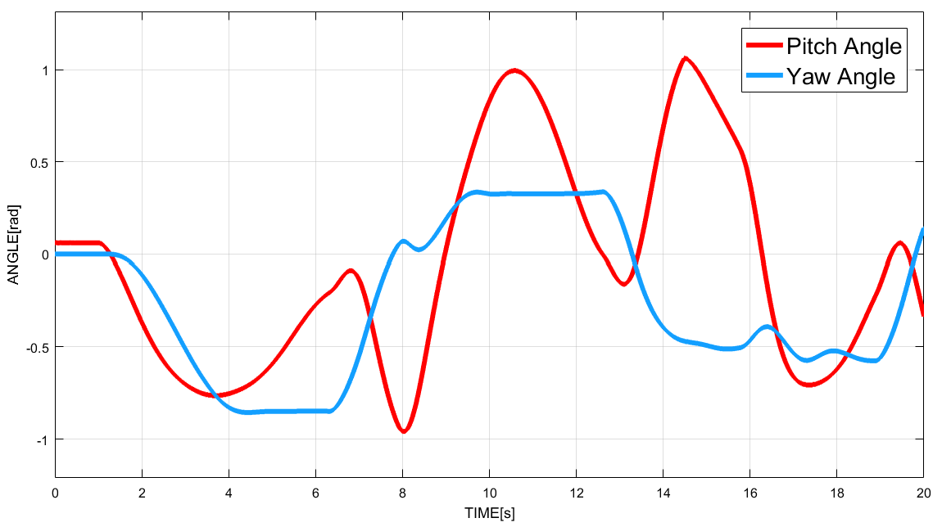

Figure . Pitch and yaw angles for H2 optimal controller implemented on the Quanser Aero for the nominal plant.

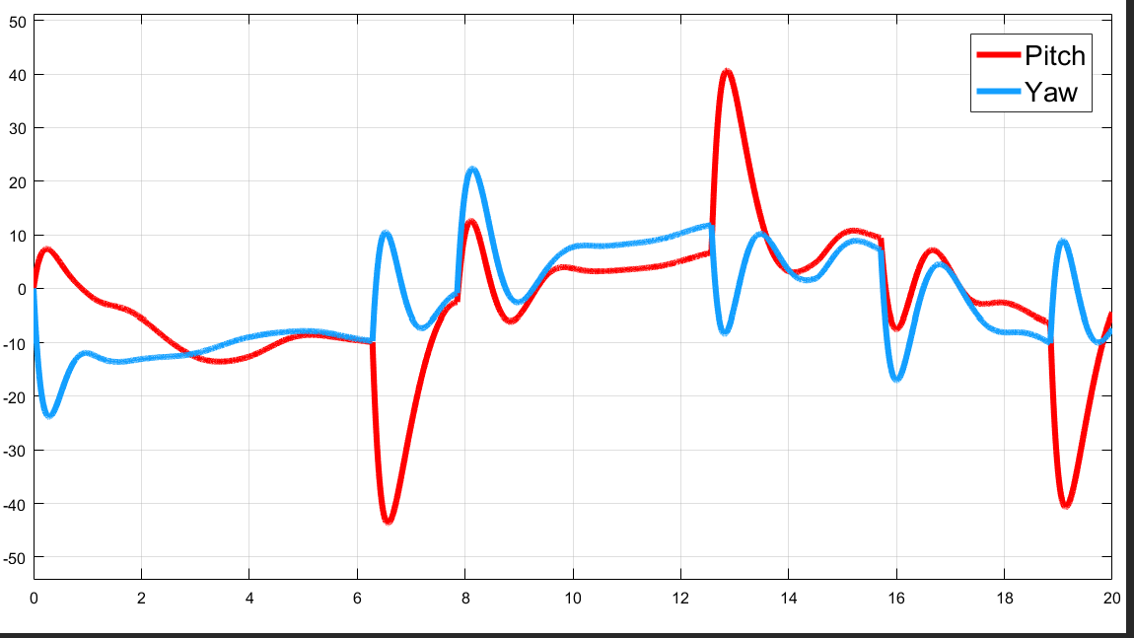

Figure . Pitch and yaw voltages for the H2 optimal controller implemented on the Quanser Aero for the nominal plant.

1. Finally, we ran the simulation for five samples of the uncertain plant. Again, the controller overall performed better than the loop shaped controller. One trial hit the hard stops rather hard, but the others hit only occasionally, following the trajectories relatively well.

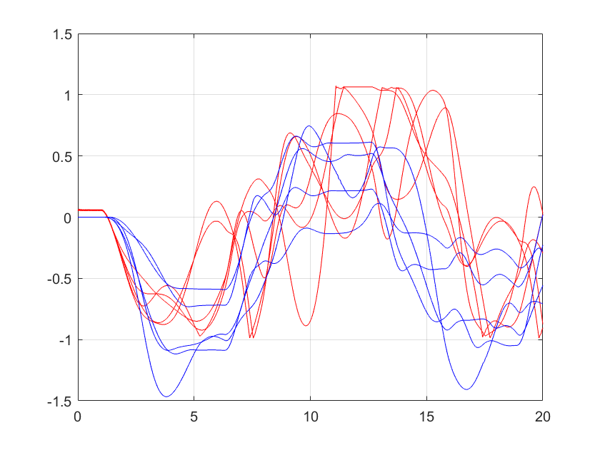

Figure . Pitch (red) and yaw (blue) angles for the H2 optimal controller implemented on the Quanser Aero for five samples of the uncertain plant.

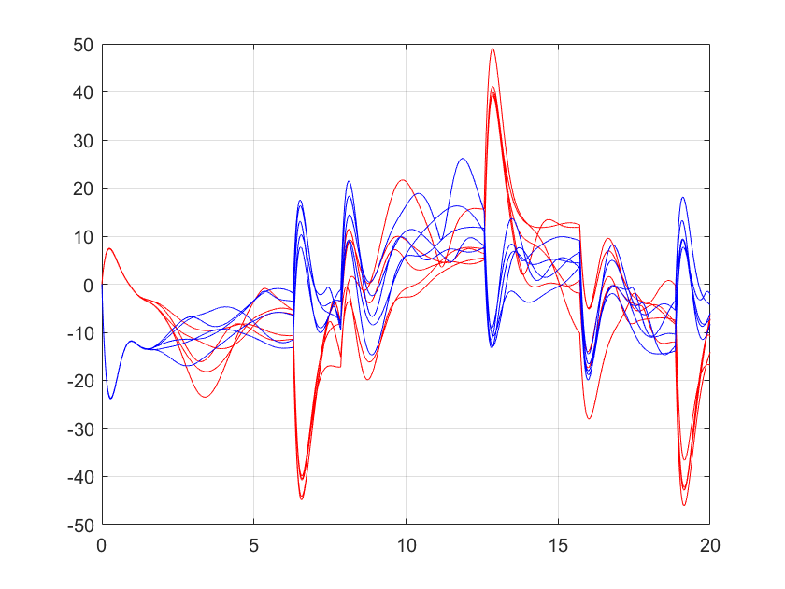

Figure . Pitch (red) and yaw (blue) voltages for the H2 optimal controller implemented on the Quanser Aero for five samples of the uncertain plant.

Video of the controller run on the nominal plant and five samples of the uncertain plant can be viewed here: <https://www.youtube.com/watch?v=qRbQcT-jgC8>

H∞ Optimal Control

We then solved the H∞ optimal control problem, maximizing the crossover frequency while maintaining γ < 1. Our ultimate crossover frequency was 1.07 rad/s, with a corresponding γ = 0.998.

1. Below is the response of our controller when simulated with no uncertainty. There is even less overshoot than observed with the H2 optimal controller.

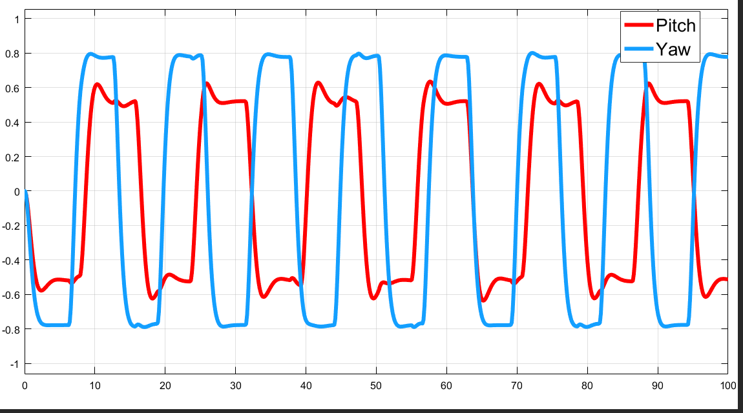

Figure 19. Output of angles from H infinity optimal controller on plant with no uncertainty.

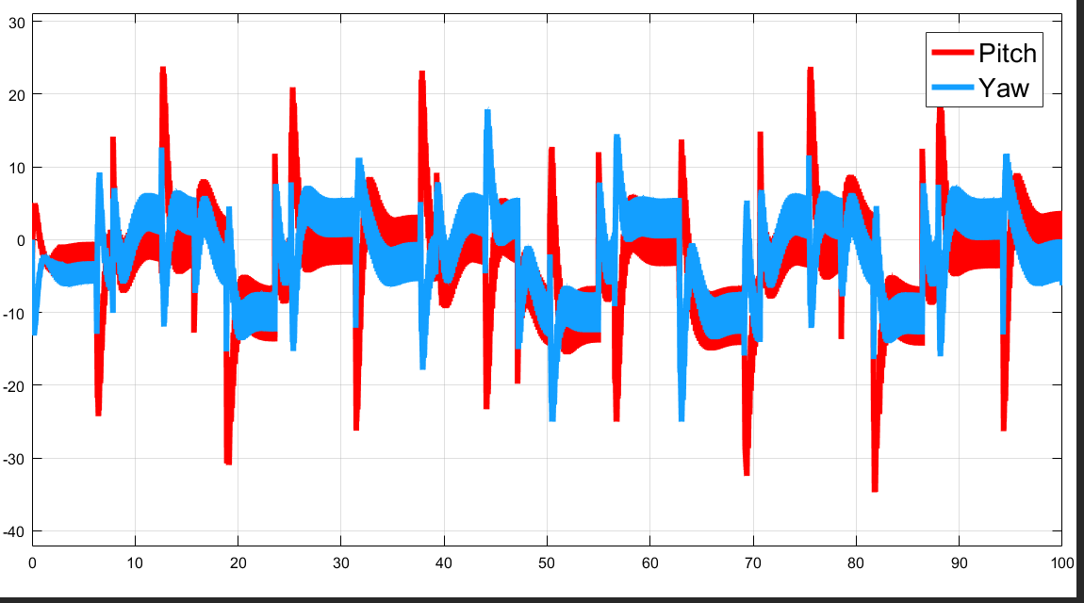

Figure 20. Controller voltages for pitch and yaw motors from simulation of Hinf optimal controller on plant with no uncertainty

The controller usage looks odd in this plot – note that while the lines appear to be thick, this is in fact due to the control usage oscillating at high frequency.

1. Check robust stability
2. We then implemented the controller on the hardware with no uncertainty. Below are plots of the angles and voltages of the Quanser Aero.

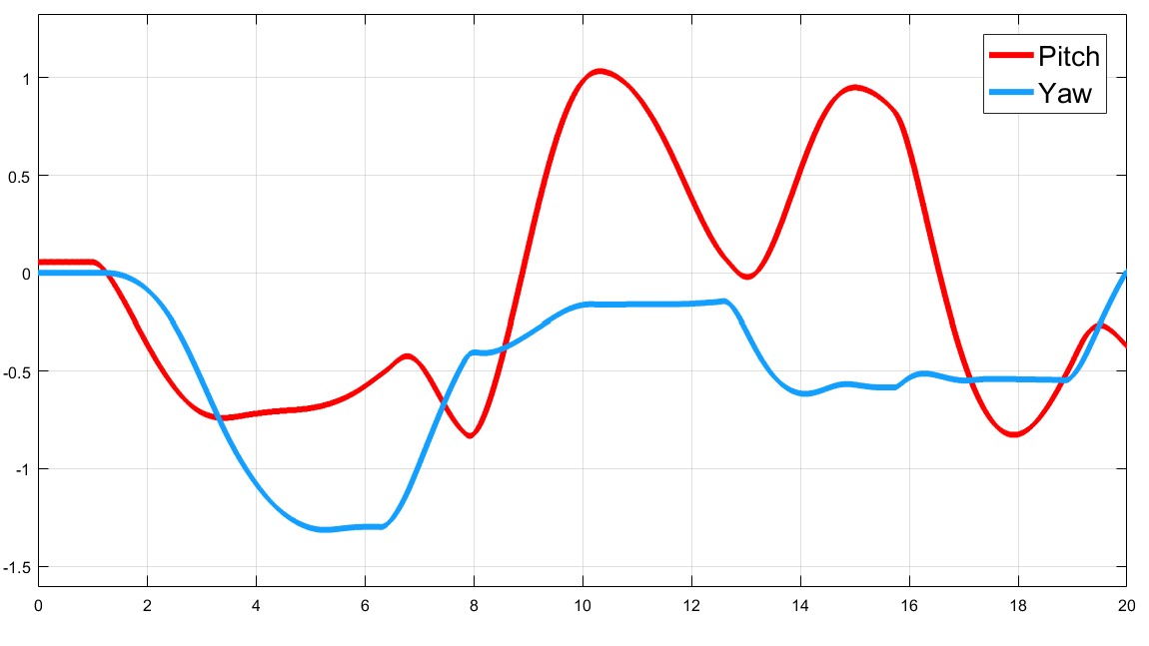

Figure 21. Pitch and yaw angles for the Hinf optimal controller implemented on the Quanser Aero for the nominal plant

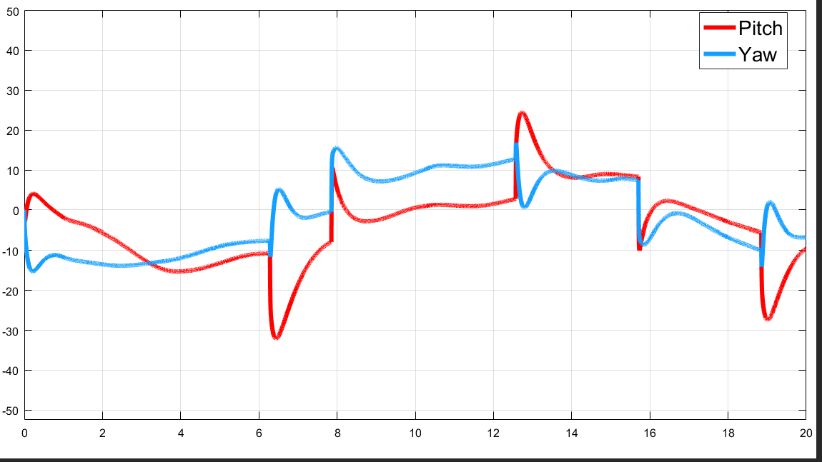

Figure 22. Pitch and yaw voltages for the Hinf optimal controller implemented on the Quanser Aero for the nominal plant.

1. We next ran the controller on the Quanser Aero for five samples of the uncertain plant.

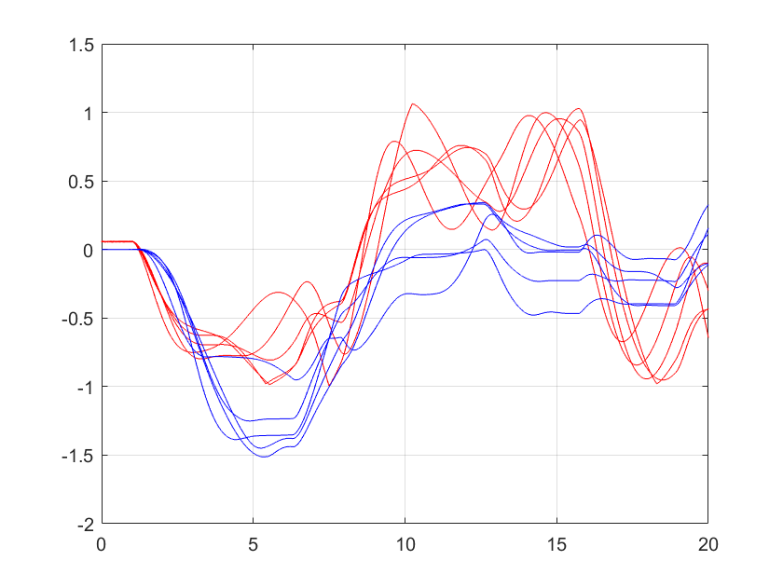

Figure 23. Pitch (red) and yaw (blue) angles for the Hinf optimal controller implemented on the Quanser Aero for five samples of the uncertain plant.

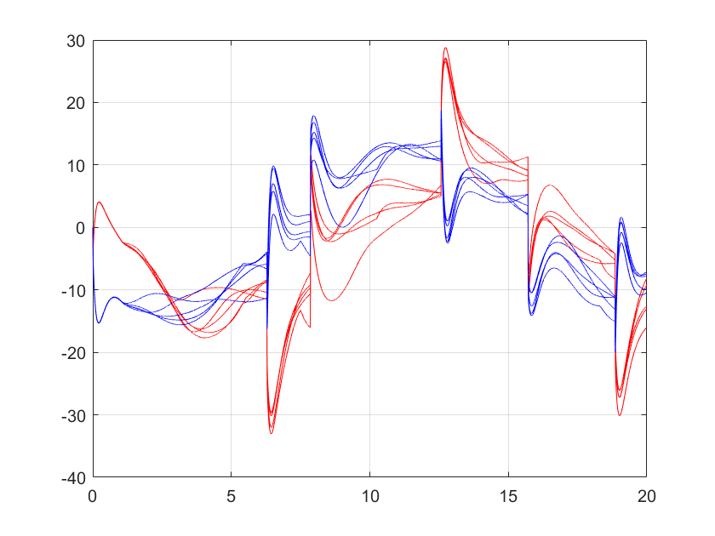

Figure . Pitch (red) and yaw (blue) voltages for the Hinf optimal controller implemented on the Quanser Aero for five samples of the uncertain plant.

Video of the controller run on the nominal plant and five samples of the uncertain plant can be viewed here: <https://www.youtube.com/watch?v=Ai3_BNFdNkM>

μ-Synthesis

Next, we used μ-synthesis to generate a controller, using the same weights as for the H∞ problem. We then reduced the controller order fifth order to match that of the H∞ optimal controller.

1. Sadca
2. Asdas
3. Sfgas
4. Sdfs

Video of the controller run on the nominal plant and five samples of the uncertain plant can be viewed here: <https://youtu.be/1y5eGrjnvVA>

H∞ Loop Shaping

Finally, we used H∞ loop shaping to generate a controller. The desired loopshape was based off of the one found during normal inverse loopshaping synthesis. We synthesized a controller and then reduced it to be fifth order, so that it matched the order of the H∞ optimal controller.

1. Asda
2. Asfas
3. Asfa
4. Asfsd

Video of the controller run on the nominal plant and five samples of the uncertain plant can be viewed here: LINK

Conclusions

Work Distribution

Who did what

Appendix

All Matlab code goes here

Your "Informal Laboratory Report" should start here. It should be organized in terms of numbered items in the lab procedure. For each numbered item in the lab procedure you must address the following items at a minimum:

1.) A brief description of the goals of the lab exercise, and the equipment and procedure used to achieve those goals. The equipment can be specified once per subsection, i.e. describe the pendulum system only once, not *n* times.

2.) The details of all calculations involved in generating your results. Be sure to highlight the main results.

3.) Presentation of your results in the form of plots and tables. This should include all relevant plots and Simulink models. Do not present plots that use the black background that is the Simulink scope default. Place in-line links to your Youtube videos for video results.

4.) General discussion. What sense do you make of the results? What can you conclude?

5.) Answers to all of the discussion questions in the lab procedure.

After completing these tasks for all numbered items in the lab procedure, complete the following sections to finish your report:

• Conclusions: What were the main results? What did you learn (if anything) by completing the lab? What suggestions do you have to make the lab better or more interesting?

• Work Distribution: To what specific tasks did each team member contribute? Address this for both the laboratory exercises and the report writing.

• References: Compile all of your references into a single section at the end of the document. I highly recommend the use of a reference manager, e.g. Bibtex, EndNote, etc.

• Appendix: Attach scans of any hand calculations and copy and paste any Matlab / Arduino code. This is simply for ease of grading; you will also be posting the code files in your .zip file.