INDIVIDUAL ASSIGNMENT

CLASS DIAGRAM:

Signup Sequence diagram

Order sequence diagram:

Sub diagram: product

Reflection:

Why I chose this website?

For the individual assignment of SYD366 I was supposed to choose one website from the given list of websites. Since I am a foodie person, so I often order online food from restaurants. TimHortons.ca was the only option I had from restaurant category, so I chose this. I had an experience of using TimHortons website, so it was easy for me to document both the signup and order process on this website. Since I was familiar with its signup and order process, that is why I chose this website. The first and foremost thing that I liked about this website is that their signup and ordering process is so easy. We don’t need to set any password for creating an account of this website. More than this, it is so easy to order food on this website, the process is simple straight forward. So, it was easy for me to make a sequence diagram of order process of this website.

Documenting the process:

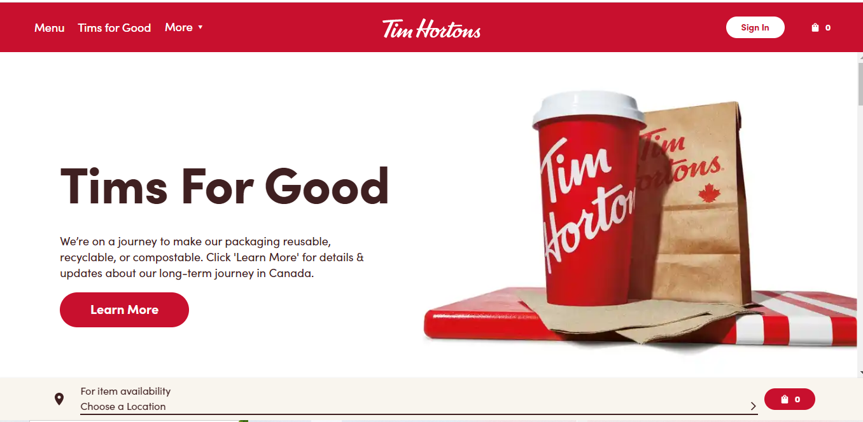

This is the welcome page of this website and is incredibly designed. Signup page can be easily accessed by clicking the signup up button at the top right corner.

This is the signup form for creating an account on this website. It is so easy to create an account on this website, not a lot of information is required for creating an account. Graphical user interface, application

This is the sign in page of this website. If we are creating our account and our email already exists on this website, that is we already have an account on this website, this page will be popped up in front of and after entering our email on this we will have to enter the verification code in the following box:

On the other hand, the ordering process is also so simple for it.

This is the page from where we can start our order. If we want to order pickup order then we don’t have to enter our address, otherwise we have to enter delivery address. So entering delivery address is optional. The next this is which location of the store we want to choose, after choosing the location it will open the list of categories of products available on that store and after clicking on the particular category it opens all the products available under that category.

After choosing a particular product, we have to enter quantity of the product that we want to order, then we have to add it to our shopping cart. This process will be repeated for all the products that we want to choose. After adding all the items to the shopping cart, we can click on the cart and view our total and list of items that we selected, the view of that page is as follows:

After clicking on checkout, it will display us order details, from there we can choose payment option and our order will be placed.