NAME: PAVNI GULYANI
BATCH-16
SAPID- 590033879
EXPERIMENT-4
1. Sequential: Sum, Difference, Product, Quotient, Remainder, Average, Square Of Sum
Flowchart
Start
|
Input a, b
|
sum = a + b
|
diff = a – b
|
prod = a * b
|
quotient = a / b
|
remainder = a % b
|
average = sum / 2
|
square = sum * sum
|
Display all results
|
Stop
Pseudocode
BEGIN
INPUT a, b
sum = a + b
difference = a - b
product = a * b
quotient = a / b
remainder = a % b
average = sum / 2
square = sum * sum
PRINT sum, difference, product, quotient, remainder, average, square
END

C Program
#include <stdio.h>

int main()
{
int a, b;
int sum, difference, product, quotient, remainder;
float average;
int square;
printf("Enter two non-zero positive integers: ");
scanf("%d %d", &a, &b);
sum = a + b;
difference = a - b;
product = a * b;
quotient = a / b;
remainder = a % b;
average = sum / 2.0;
square = sum * sum;
printf("Sum = %d\n", sum);
printf("Difference = %d\n", difference);
printf("Product = %d\n", product);
printf("Quotient = %d\n", quotient);
printf("Remainder = %d\n", remainder);
printf("Average = %.2f\n", average);
printf("Square of Sum = %d\n", square);

return 0;
}
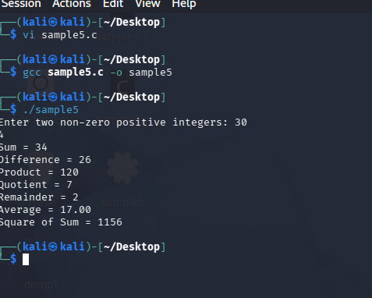
2. Conditional Branching: Temperature Conversion
Flowchart
Start
Input Celsius temperature
Input choice
If choice = 1, Kelvin = C + 273.15
If choice = 2, Fahrenheit = (C * 9/5) + 32
If choice = 3, Reaumur = C * 4/5
If choice = 4, Rankine = (C + 273.15) * 9/5
Display result
Stop

Pseudocode
BEGIN
INPUT celsius
INPUT choice

IF choice = 1 THEN
result = celsius + 273.15
PRINT result in Kelvin
IF choice = 2 THEN
result = (celsius * 9 / 5) + 32
PRINT result in Fahrenheit
IF choice = 3 THEN
result = celsius * 4 / 5
PRINT result in Reaumur
IF choice = 4 THEN
result = (celsius + 273.15) * 9 / 5
PRINT result in Rankine
END

Algorithm
1. Start
2. Read temperature in Celsius
3. Ask the user to choose conversion type
4. If choice is 1, convert Celsius to Kelvin
5. If choice is 2, convert Celsius to Fahrenheit
6. If choice is 3, convert Celsius to Reaumur
7. If choice is 4, convert Celsius to Rankine
8. Display the converted temperature
9. Stop

C Program
#include <stdio.h>

int main()
{
float celsius, result;
int choice;

printf("Enter temperature in Celsius: ");
scanf("%f", &celsius);

printf("Choose conversion:\n");
printf("1. Kelvin\n");
printf("2. Fahrenheit\n");
printf("3. Reaumur\n");
printf("4. Rankine\n");
printf("Enter your choice: ");
scanf("%d", &choice);

if (choice == 1)
{
result = celsius + 273.15;
printf("Temperature in Kelvin = %.2f\n", result);
}

if (choice == 2)
{
result = (celsius * 9 / 5) + 32;
printf("Temperature in Fahrenheit = %.2f\n", result);
}

if (choice == 3)
{
result = celsius * 4 / 5;
printf("Temperature in Reaumur = %.2f\n", result);
}

if (choice == 4)
{
result = (celsius + 273.15) * 9 / 5;
printf("Temperature in Rankine = %.2f\n", result);
}

return 0;
}
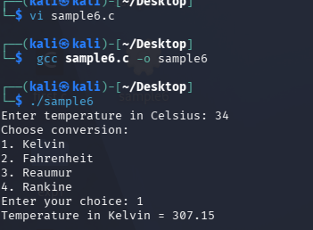
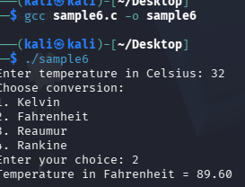
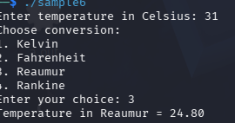
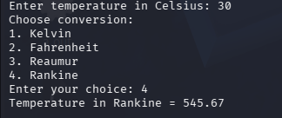
3. Iterative Looping: Number Of Digits, Sum And Product Of Digits

Flowchart
Start
Input num
digits = log10(num) + 1
sum = 0, product = 1
Repeat while num > 0
digit = num % 10
sum = sum + digit
product = product * digit
num = num / 10
Display digits, sum, product
Stop

Pseudocode
BEGIN
INPUT num
digits = log10(num) + 1
sum = 0
product = 1
temp = num

FOR temp > 0
digit = temp % 10
sum = sum + digit
product = product * digit
temp = temp / 10
END FOR

PRINT digits, sum, product
END

Algorithm
1. Start
2. Read a positive integer num
3. Find number of digits using digits = log10(num) + 1
4. Set sum = 0 and product = 1
5. Store num in temp
6. Using a loop, repeat while temp > 0
7. Extract digit using digit = temp % 10
8. Add digit to sum
9. Multiply digit with product
10. Remove last digit using temp = temp / 10
11. Display number of digits, sum of digits, and product of digits
12. Stop

C Program
#include <stdio.h>
#include <math.h>

int main()
{
int num, temp, digit;
int digits, sum = 0, product = 1;

printf("Enter a positive integer: ");
scanf("%d", &num);

digits = log10(num) + 1;
temp = num;

for (; temp > 0; temp = temp / 10)
{
digit = temp % 10;
sum = sum + digit;
product = product * digit;
}

printf("Number of digits = %d\n", digits);
printf("Sum of digits = %d\n", sum);
printf("Product of digits = %d\n", product);

return 0;
}

