HDOC-DAY-28
NAME – PAVNI GULYANI
BATCH -16
SAPID- 590033879
Write a C program to:
- Read the number of rows and columns from the user. Ensure that both values are positive. If not, repeat to get the desired input(s). b) Declare a variable-length 2D integer array using the given dimensions. c) Read the array elements column by column using nested loops, with the outer loop iterating over columns and the inner loop over rows. d) Print the elements in row-major order using a single loop and a linear index.

C PROGRAM
#include <stdio.h>

int main()
{
int rows, cols;

// Read positive rows and columns
do
{
printf("Enter number of rows: ");
scanf("%d", &rows);

printf("Enter number of columns: ");
scanf("%d", &cols);

if (rows <= 0 || cols <= 0)
printf("Rows and columns must be positive.\n");

} while (rows <= 0 || cols <= 0);

// Variable-length 2D array
int a[rows][cols];

// Input column by column
printf("\nEnter array elements column by column:\n");

for (int j = 0; j < cols; j++)
{
for (int i = 0; i < rows; i++)
{
printf("a[%d][%d] = ", i, j);
scanf("%d", &a[i][j]);
}
}

// Print in row-major order using single loop
printf("\nArray in row-major order:\n");

for (int k = 0; k < rows * cols; k++)
{
printf("%d ", a[k / cols][k % cols]);
}

printf("\n");

return 0;
}

Algorithm
- Start.
- Read the number of rows and columns.
- Check that both are positive. If not, repeat the input.
- Declare a VLA a[rows][cols].
- Use nested loops to input elements column by column.
- Use a single loop from 0 to rows × cols - 1.
- Access each element using:
a[k / cols][k % cols]
- Print the elements in row-major order.
- Stop.
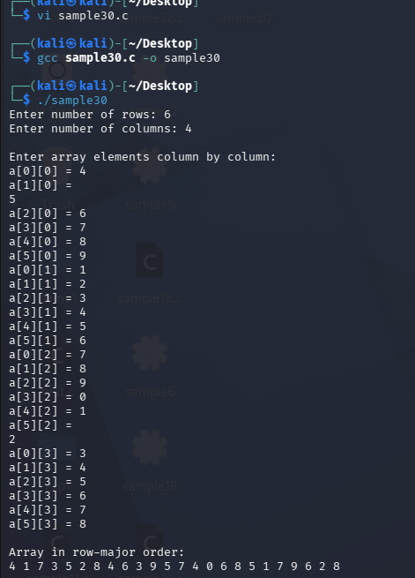

Write a C program that reads elements into a variable-length 2D array, copies them into a 1D array in row-major order, and displays both arrays.

#include <stdio.h>

int main()
{
int rows, cols;

printf("Enter number of rows: ");
scanf("%d", &rows);

printf("Enter number of columns: ");
scanf("%d", &cols);

// Variable-length arrays
int a[rows][cols];
int b[rows * cols];

// Read 2D array
printf("\nEnter elements of 2D array:\n");

for (int i = 0; i < rows; i++)
{
for (int j = 0; j < cols; j++)
{
printf("a[%d][%d] = ", i, j);
scanf("%d", &a[i][j]);
}
}

// Copy 2D array into 1D array in row-major order
int k = 0;

for (int i = 0; i < rows; i++)
{
for (int j = 0; j < cols; j++)
{
b[k] = a[i][j];
k++;
}
}

// Display 2D array
printf("\n2D Array:\n");

for (int i = 0; i < rows; i++)
{
for (int j = 0; j < cols; j++)
{
printf("%d ", a[i][j]);
}
printf("\n");
}

// Display 1D array
printf("\n1D Array in row-major order:\n");

for (int i = 0; i < rows * cols; i++)
{
printf("%d ", b[i]);
}

printf("\n");

return 0;
}
Algorithm
- Start.
- Read rows and columns.
- Declare a VLA a[rows][cols].
- Declare a 1D VLA b[rows × cols].
- Read all elements of the 2D array row by row.
- Traverse the 2D array using nested loops.
- Copy each element into the 1D array using b[k] = a[i][j].
- Increment k after every element.
- Display the 2D array.
- Display the 1D array.
- Stop.
