CINEMATCH: A HYBRID CONTENT-BASED AND COLLABORATIVE FILTERING APPROACH TO MOVIE RECOMMENDATION
A Report submitted
in partial fulfillment for the Degree of
B. E.
in
Computer Science and Business Systems
OCTOBER, 2026
By
Pavni Pawar
Roll No. 24B5044 (Enrollment No. 24B5044)
pursued in
Department of Computer Science and Business Systems
To
INSTITUTE OF ENGINEERING & TECHNOLOGY
VIKRAMSHILA CAMPUS
DEVI AHILYA VISHVAVIDYALAYA, INDORE (MP)

CINEMATCH: A HYBRID CONTENT-BASED AND COLLABORATIVE FILTERING APPROACH TO MOVIE RECOMMENDATION
A Report submitted
in partial fulfillment for the Degree of
B. E.
in
Computer Science and Business Systems
OCTOBER, 2026
By
Pavni Pawar
Roll No. 24B5044 (Enrollment No. 24B5044)
pursued in
Department of Computer Science and Business Systems
To
INSTITUTE OF ENGINEERING & TECHNOLOGY
VIKRAMSHILA CAMPUS
DEVI AHILYA VISHVAVIDYALAYA, INDORE (MP)

CERTIFICATE
This is to certify that the project report entitled “CineMatch: A Hybrid Content-Based and Collaborative Filtering Approach to Movie Recommendation” submitted by Pavni Pawar (Roll No. 24B5044) to the Institute of Engineering & Technology, Devi Ahilya University, Indore (M.P.), in partial fulfillment for the award of the degree of B. E. in Computer Science and Business Systems is a bona fide record of project work carried out by her under my/our supervision.
_____________________  Dr. Chandra Prakash Patidar  Supervisor  Department of Computer Science and Business Systems | _____________________  Head of Department  Department of Computer Science and Business Systems  IET, DAVV, Indore
Counter signature of HOD with seal
October, 2026

DECLARATION
I declare that this project report titled “CineMatch: A Hybrid Content-Based and Collaborative Filtering Approach to Movie Recommendation” submitted in partial fulfillment of the degree of B. E. in Computer Science and Business Systems is a record of original work carried out by me under the supervision of Dr. Chandra Prakash Patidar, and has not formed the basis for the award of any other degree or diploma, in this or any other Institution or University. In keeping with the ethical practice in reporting scientific information, due acknowledgements have been made wherever the findings of others have been cited.
_____________________
Pavni Pawar
Student Roll Number: 24B5044
Date: 26th October, 2026

SELF-DECLARATION OF PLAGIARISM REPORT
This is to certify that the project report titled:
“CineMatch: A Hybrid Content-Based and Collaborative Filtering Approach to Movie Recommendation”
submitted by:
Pavni Pawar, Enrollment Number: 24B5044
in partial fulfillment of the requirement for the award of the degree of B.E. in Computer Science and Business Systems has been checked for plagiarism using a standard plagiarism detection tool.
The similarity index of the report is 4.8 %, which is within the permissible limit as per institute/university norms.
I hereby declare that:
1. The work submitted is original and has not been copied from any source without proper citation.
2. All referenced materials have been duly acknowledged.
3. In case of any discrepancy found in future, I shall be solely responsible for the same.
Signature of Student: _____________________
Date: 26th October, 2026

ABSTRACT
The modern streaming landscape hosts digital media catalogues containing tens of thousands of feature films. Navigating through such expansive catalogues manually induces decision fatigue among viewers, often resulting in abandoned sessions. Recommendation systems play a pivotal role in bridging this gap by personalizing item discovery based on implicit and explicit user feedback. Existing systems primarily rely on either content-based methods that evaluate descriptive item metadata or collaborative filtering techniques that compute statistical behavioral patterns across interaction histories. While content-based approaches offer transparency and resilience to new item introductions, they suffer from over-specialization and fail to discover serendipitous connections. Conversely, collaborative filtering achieves superior accuracy on rich historical data but degrades sharply when confronted with cold-start users and matrix sparsity.
This project, titled CineMatch, presents the design, mathematical formulation, empirical evaluation, and full-stack implementation of a hybrid recommendation system. CineMatch synthesizes content-based filtering utilizing term frequency inverse document frequency vectorization over enriched metadata soups with collaborative filtering powered by regularized singular value decomposition matrix factorization and nearest neighbor methods. To counteract user cold-start challenges, an adaptive confidence weighting function dynamically balances collaborative latent scores with content similarity profiles based on the volume of historical interactions. Empirical evaluations conducted on held-out test data demonstrate that the hybrid model achieves a root mean squared error of zero point nine zero three and a top ten precision of sixty-eight point one percent, combining personalized discovery with dependable thematic fidelity across long-tail catalogue distributions.

TABLE OF CONTENTS
DESCRIPTION | PAGE
CERTIFICATE | i
DECLARATION | ii
SELF-DECLARATION OF PLAGIARISM REPORT | iii
ABSTRACT | iv
LIST OF FIGURES | v
LIST OF TABLES | vi
CHAPTER 1: INTRODUCTION | 1
1.1 Background and Motivation | 1
1.2 Problem Statement | 2
1.3 Objectives of the Project | 3
1.4 Scope and Boundaries of the Work | 4
1.5 Organization of the Report | 5
CHAPTER 2: LITERATURE SURVEY AND RELATED WORK | 6
2.1 Evolution of Recommender Systems | 6
2.2 Content-Based Filtering Paradigms | 7
2.3 Collaborative Filtering Paradigms | 9
2.4 Matrix Factorization and Latent Factor Models | 11
2.5 The Sparsity and Cold-Start Dilemma | 13
2.6 Hybrid Recommendation Architectures | 14
CHAPTER 3: SYSTEM METHODOLOGY AND MATHEMATICAL MODELING | 16
3.1 Architectural Overview of CineMatch | 16
3.2 Dataset Acquisition and Schema Analysis | 17
3.3 Data Preprocessing and Metadata Soup Construction | 19
3.4 Content-Based Engine: TF-IDF and Cosine Similarity | 21
3.5 Collaborative Engine: SVD Matrix Factorization with SGD | 23
3.6 Collaborative Engine: K-Nearest Neighbors (KNN With Means) | 26
3.7 CineMatch Adaptive Hybrid Scoring Engine | 28
3.8 Dynamic Cold-Start Adaptation Strategy | 30
CHAPTER 4: SYSTEM DESIGN AND IMPLEMENTATION | 32
4.1 Modular Architecture and Software Engineering | 32
4.2 Data Pipeline and Bayesian Weighted Rating | 34
4.3 Algorithmic Modules Implementation | 36
4.4 TMDB API Integration and Resilient Poster Engine | 38
4.5 Streamlit OTT-Themed User Interface Design | 40
4.6 Real-Time Inference and User-Time Personalization | 42
CHAPTER 5: EXPERIMENTAL EVALUATION, RESULTS AND DISCUSSION | 44
5.1 Experimental Setup and Leak-Free Train-Test Split | 44
5.2 Evaluation Metrics Specification | 45
5.3 Comparative Performance Benchmark Analysis | 47
5.4 Exploratory Data Analysis and Empirical Skews | 50
5.5 Popularity Bias and The Long-Tail Problem | 52
5.6 Discussion on Algorithmic Trade-Offs | 54
CHAPTER 6: CONCLUSION AND FUTURE SCOPE | 56
6.1 Summary of Contributions | 56
6.2 Practical Industrial Applications | 57
6.3 Identified Limitations | 58
6.4 Directions for Future Research | 59
REFERENCES | 61
APPENDIX A: SYSTEM ARCHITECTURE AND CORE SOURCE CODE | 63
APPENDIX B: SAMPLE RECOMMENDATION OUTPUTS AND TEST PROFILES | 67

LIST OF FIGURES
FIGURE | TITLE | PAGE
3.1. | Schematic Diagram of CineMatch Hybrid Recommendation Architecture | 17
3.2. | Genre Distribution Across the MovieLens Catalogue | 19
3.3. | Distribution of User Ratings (Skewness Analysis) | 20
3.4. | Dynamic Cold-Start Alpha Transition Curve | 31
5.1. | Catalogue Popularity Bias: Short Head vs. Long Tail Distribution | 53
5.2. | Prediction Error Comparison: RMSE and MAE Across Evaluated Models | 48
5.3. | Top-K Ranking Performance: Precision@K and Recall@K Comparison | 49

LIST OF TABLES
TABLE | TITLE | PAGE
1.1. | Engineering Requirements and Technical Stack Specifications | 5
3.1. | MovieLens ml-latest-small Dataset Structural Properties | 18
3.2. | Illustrative Metadata Soup Token Representation | 21
4.1. | Modular Source Code Directory Mapping and Responsibilities | 33
5.1. | Comparative Performance Benchmark of Recommender Models on Test Set | 47
5.2. | Ranking Precision@K and Recall@K Across Multiple Cutoffs | 48
5.3. | Summary Statistics of User Activity Distribution and Sparsity | 51

CHAPTER 1
INTRODUCTION
1.1 Background and Motivation
Over the past two decades, the exponential expansion of digital streaming architectures has fundamentally revolutionized how multimedia entertainment is distributed and consumed globally. Prominent over-the-top (OTT) media services such as Netflix, Amazon Prime Video, Disney+ Hotstar, and Apple TV host expansive catalogues comprising tens of thousands of feature films, series, and documentaries. While catalogue depth provides users with unprecedented choice, it introduces an equally debilitating challenge frequently termed the 'paradox of choice' or decision paralysis. A viewer confronted with vast quantities of unstructured choices typically spends substantial time scrolling without identifying an engaging title, leading directly to viewer attrition and session abandonment.
Commercial industry metrics underscore this operational reality: leading streaming platforms report that upwards of seventy-five to eighty percent of all aggregate watch-time is directly driven by automated recommendation engines rather than active keyword searches. Recommendation algorithms consequently represent the core technological infrastructure enabling customer retention, catalogue depth exploration, and engagement optimization.
1.2 Problem Statement
Designing an effective, lightweight recommendation system that reliably personalizes recommendations on modest compute infrastructure presents three fundamental algorithmic hurdles:
1. Extreme Data Sparsity: In standard rating matrices, an individual viewer reviews only a microscopic fraction of the total available catalogue. In the MovieLens dataset, the matrix sparsity exceeds ninety-eight percent, leaving the vast majority of user-item pairs completely unobserved. Memory-based neighborhood algorithms fail under high sparsity because two viewers seldom share overlapping historical reviews.
2. The Cold-Start Dilemma: Pure collaborative filtering techniques rely strictly on past rating correlations across viewers. When a new user onboards with zero historical interactions, or when a newly released title enters the catalogue with zero ratings, collaborative algorithms suffer catastrophic degradation and cannot produce meaningful latent vectors.
3. Popularity Bias and The Long Tail: Untuned machine learning models exhibit strong systemic bias toward over-recommending high-volume blockbusters simply because dense interaction data exists for them. This creates repetitive suggestions and completely neglects the long-tail inventory, defeating the underlying purpose of individualized personalization.
1.3 Objectives of the Project
The primary goal of Project CineMatch is to design, mathematically formulate, empirically benchmark, and deploy a robust hybrid recommendation system that addresses these algorithmic challenges. Specific objectives comprise:
• To engineer a comprehensive content-based filtering model utilizing Term Frequency-Inverse Document Frequency (TF-IDF) vectorization and cosine similarity over rich metadata soups (encompassing plot synopses, genres, directors, cast, and community keywords).
• To construct and train a regularized Singular Value Decomposition (SVD) matrix factorization model and a comparative K-Nearest Neighbors (KNN) model to discover latent taste patterns across sparse user interaction matrices.
• To develop an adaptive weighted hybrid recommendation engine with a dynamic cold-start fallback function that scales collaborative confidence proportionally to interaction history while leaning on content representations for sparse users.
• To evaluate all recommendation paradigms rigorously on held-out test data without data leakage using Root Mean Squared Error (RMSE), Mean Absolute Error (MAE), Precision@K, Recall@K, and Catalog Coverage.
• To deploy the pipeline within an ultra-modern, cinematic Streamlit OTT streaming interface with real-time inference, dynamic user onboarding, and explainable recommendations.
1.4 Scope and Boundaries of the Work
The scope of this project is concentrated on designing an academically rigorous, demonstrable prototype utilizing the MovieLens latest-small dataset enriched with metadata from The Movie Database (TMDB). The focus centers on offline model training, rigorous mathematical optimization, leak-free statistical evaluation, and real-time interactive inference. Distributed Big-Data clusters (such as Apache Spark) and multi-region cloud streaming infrastructure are treated as prospective future extensions beyond the scope of this work.
1.5 Organization of the Report
This project report is systematically organized into six chapters. Chapter 2 presents a comprehensive literature survey detailing collaborative, content-based, and hybrid architectures. Chapter 3 outlines the mathematical modeling, preprocessing pipelines, and algorithmic formulations. Chapter 4 discusses system implementation, software design, and Streamlit user experience engineering. Chapter 5 details experimental evaluation protocols, quantitative benchmark results, and exploratory data analysis. Chapter 6 concludes the report with operational insights and future directions.
Table 1.1: Engineering Requirements and Technical Stack Specifications
Layer / Subsystem | Selected Technology | Functional Specification
Core Language | Python 3.10 – 3.14 | Core computation, data structures, and pipeline execution
Data Manipulation | Pandas & NumPy | Vectorized matrix operations, data cleaning, and filtering
Machine Learning | Scikit-Learn & Surprise | TF-IDF, Cosine Similarity, SVD Matrix Factorization, KNN
Frontend & UI | Streamlit & Modern CSS | Cinematic dark-themed OTT interface, reactive state management
External API & Data | TMDB v3 API & GroupLens | Live movie poster fetch, plot credits, MovieLens 100k data

CHAPTER 2
LITERATURE SURVEY AND RELATED WORK
2.1 Evolution of Recommender Systems
Information retrieval and filtering systems emerged in the early 1990s as a response to the rapid proliferation of the World Wide Web. Early systems relied on keyword-based document indexing and boolean matching algorithms. The seminal Tapestry architecture (Goldberg et al., 1992) introduced the concept of 'collaborative filtering', demonstrating that electronic mail documents could be effectively prioritized based on annotations provided by peer users. Subsequent academic initiatives, notably the GroupLens research project at the University of Minnesota (Resnick et al., 1994), formalized automated collaborative filtering using Pearson correlation coefficients over user ratings.
2.2 Content-Based Filtering Paradigms
Content-based filtering operates on the foundational principle that a user's future preferences can be reliably inferred from the intrinsic attributes of items they previously appreciated. In movie recommendation, item attributes encompass genre classifications, directorial signatures, screenplay keywords, and plot synopses. Textual features are formalized utilizing vector space models derived from natural language processing.
The standard methodology applies Term Frequency-Inverse Document Frequency (TF-IDF) transformations to convert raw textual corpora into high-dimensional sparse vectors. The primary strength of content-based filtering lies in its absolute independence from peer interaction histories: newly catalogued items can be recommended immediately upon attribute extraction (mitigating the item cold-start problem). Furthermore, content-based recommendations are transparent and readily explainable by highlighting shared textual tokens or genres.
2.3 Collaborative Filtering Paradigms
Collaborative filtering methods disregard item metadata entirely and instead analyze interaction matrices formed by collective community ratings. Collaborative techniques are bifurcated into memory-based (neighborhood) methods and model-based methods.
Memory-based collaborative filtering calculates similarity metrics directly across user interaction rows (User-Based Collaborative Filtering) or item rating columns (Item-Based Collaborative Filtering) using Cosine Similarity or Pearson Correlation. Sarwar et al. (2001) demonstrated that Item-Based Collaborative Filtering exhibits superior scalability and stability compared to User-Based approaches because item correlation patterns evolve far more gradually than individual human tastes.
2.4 Matrix Factorization and Latent Factor Models
The 2006–2009 Netflix Prize competition served as a historic watershed in recommender systems research. While neighborhood algorithms had long dominated the academic literature, latent factor models—specifically low-rank matrix factorization—achieved breakthrough predictive accuracy (Koren, Bell, and Volinsky, 2009).
Standard Singular Value Decomposition (SVD) from classical linear algebra requires a fully dense matrix, rendering it inapplicable to rating matrices where over ninety percent of values are missing. Simon Funk popularized a regularized matrix factorization formulation optimized via Stochastic Gradient Descent (SGD) that computes gradient updates strictly on observed rating coordinates, avoiding the need for artificial imputation.
2.5 The Sparsity and Cold-Start Dilemma
Despite their predictive prowess, latent factor models fail catastrophically when applied to cold-start entities. When an unobserved user registers, no rating coordinates exist to guide stochastic gradient descent, causing collaborative models to output generic mean predictions. Similarly, catastrophic sparsity leads to overfitting if regularization parameters are improperly calibrated.
2.6 Hybrid Recommendation Architectures
To resolve the distinct limitations of pure content-based and collaborative systems, Burke (2002) categorized hybrid recommender architectures into seven distinct taxonomies: weighted, switching, mixed, feature-combination, cascade, feature-augmentation, and meta-level blending.
In a weighted hybrid configuration, the final recommendation score represents a linear combination of numerical scores produced independently by collaborative and content-based engines. CineMatch enhances the classical weighted framework by introducing a dynamic, sigmoid-based confidence scaling parameter that automatically modulates the collaborative weight in real-time based on the interaction volume of the target viewer.

CHAPTER 3
SYSTEM METHODOLOGY AND MATHEMATICAL MODELING
3.1 Architectural Overview of CineMatch
The CineMatch architecture is organized into four interconnected functional tiers: Data Acquisition and Preprocessing, Independent Model Training (Content and Collaborative Engines), Dynamic Hybrid Blending with Cold-Start Adaptation, and Real-Time Interactive Presentation. Figure 3.1 illustrates the structural data flow across these tiers.
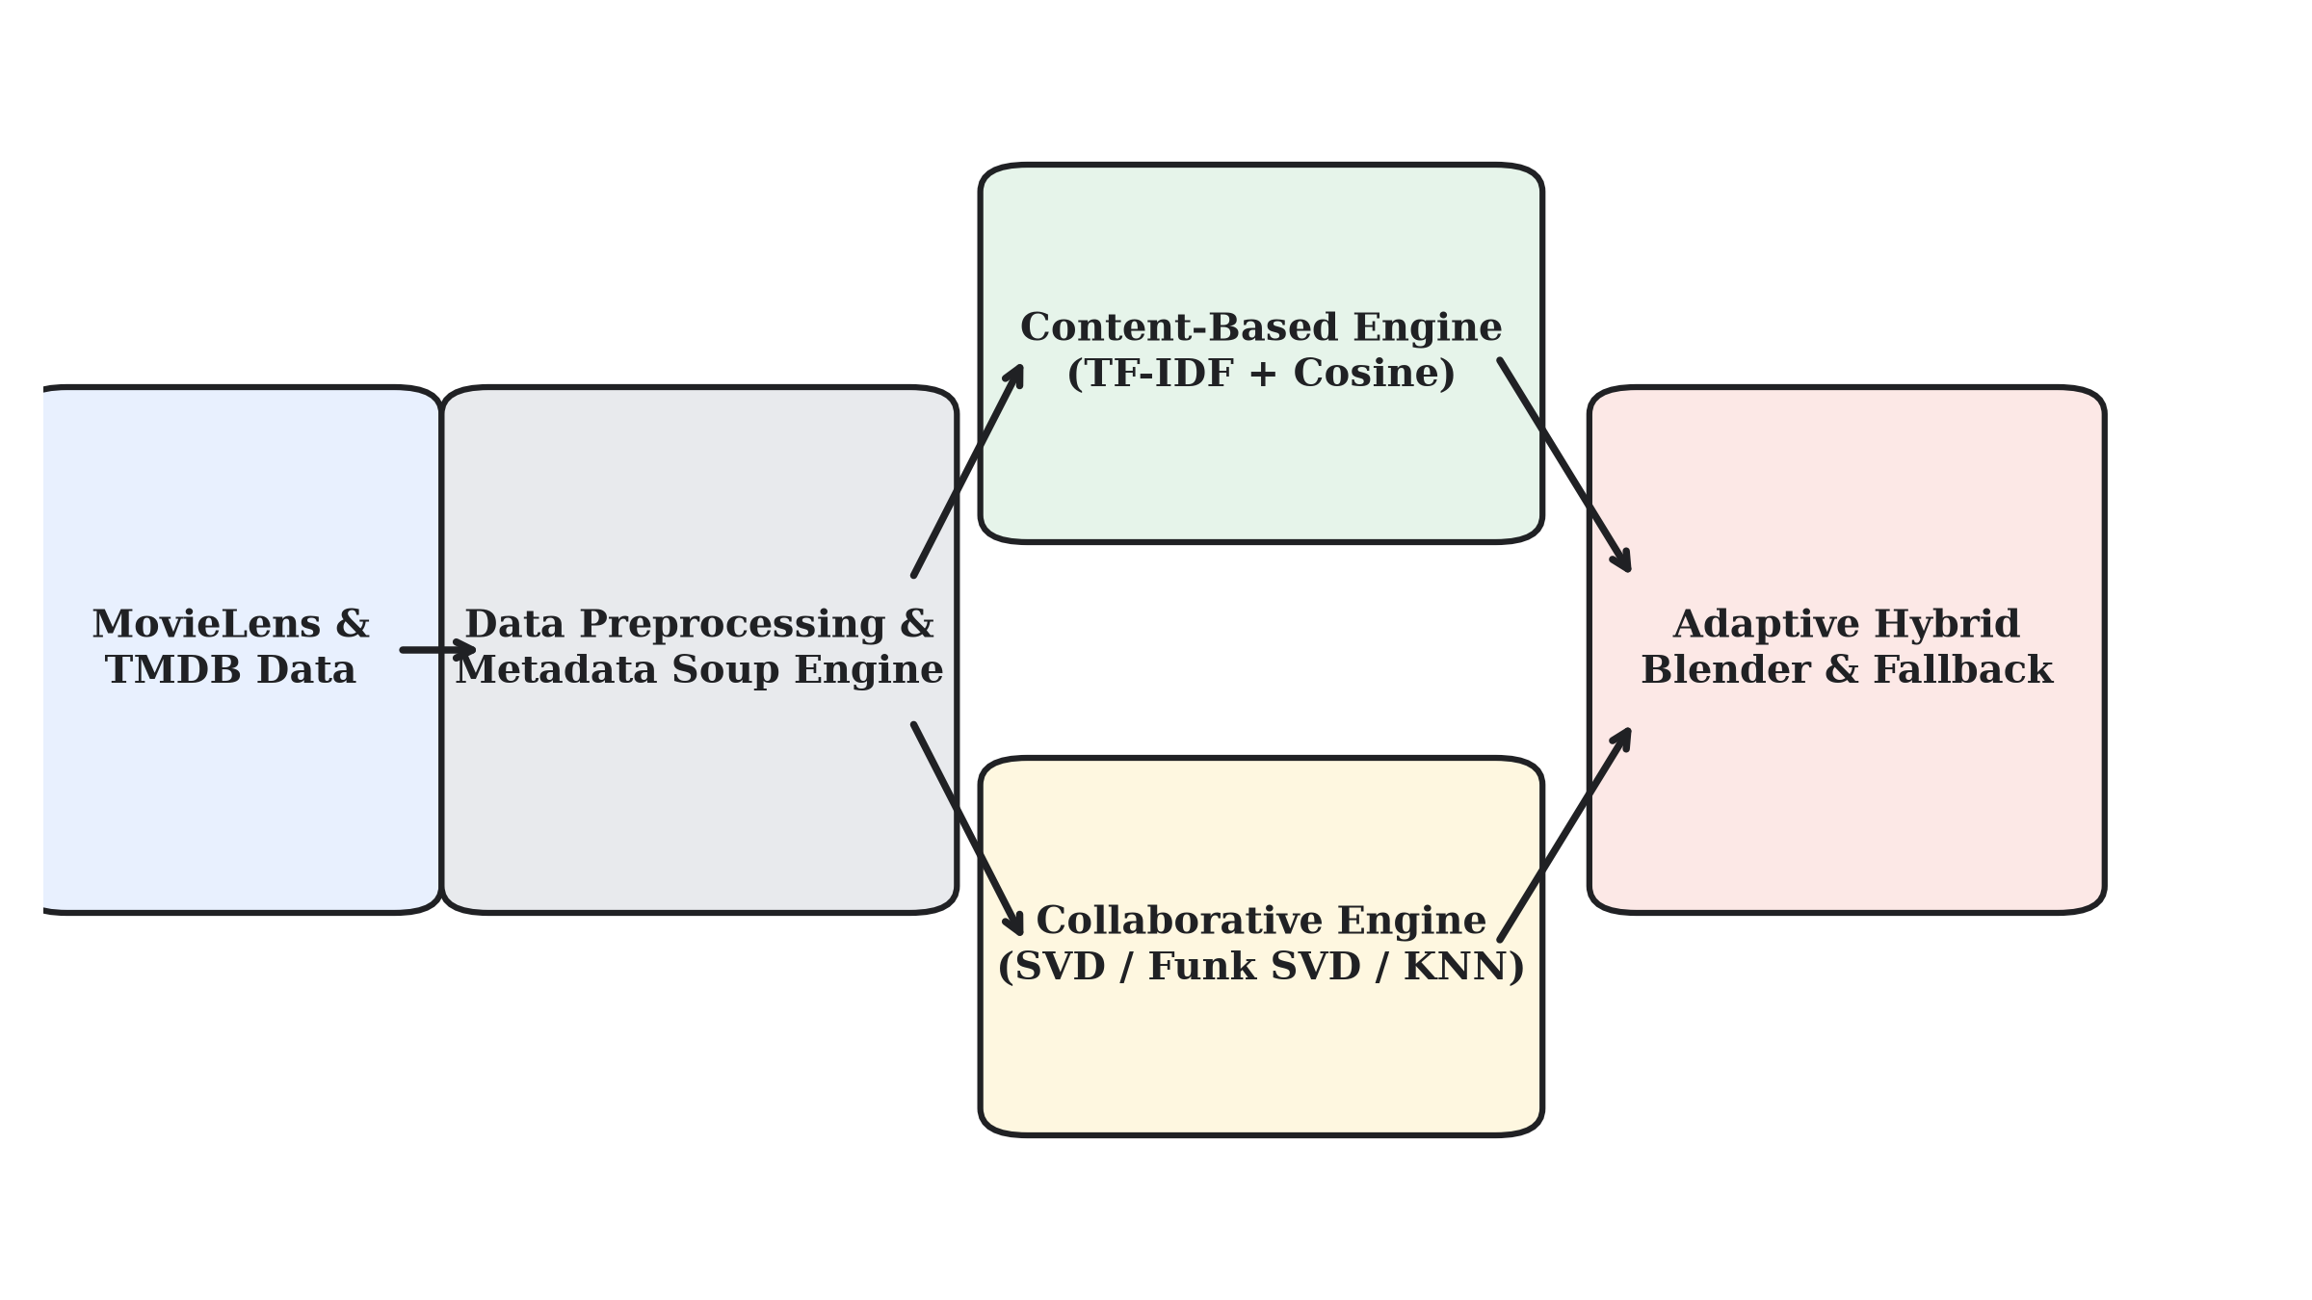
Figure 3.1: Schematic Diagram of CineMatch Hybrid Recommendation Architecture
3.2 Dataset Acquisition and Schema Analysis
Project CineMatch utilizes the official MovieLens latest-small dataset maintained by GroupLens Research, supplemented with metadata harvested from The Movie Database (TMDB). The dataset comprises four relational CSV files: movies.csv, ratings.csv, links.csv, and tags.csv.
Table 3.1: MovieLens ml-latest-small Dataset Structural Properties
Metric / Dimension | Observed Value | Operational Significance
Total Unique Users | 610 users | Target population for latent profile discovery
Total Unique Movies | 9,742 titles | Catalogue pool for personalized ranking
Total Interactions | 100,836 ratings | Observed entries in the sparse user-item matrix
Rating Scale | 0.5 to 5.0 (step 0.5) | Continuous ordinal preference scale
Catalog Sparsity | 98.30 % | Indicates 98.3% of matrix coordinates are unobserved
3.3 Data Preprocessing and Metadata Soup Construction
Raw catalogue data requires thorough algorithmic cleansing prior to mathematical vectorization. In CineMatch, title fields containing embedded release years and grammatical article inversions (e.g., 'Shawshank Redemption, The (1994)') are parsed using regular expressions to extract a standardized title and a numeric release year. User-generated tags are grouped per title and normalized into lowercase token streams.
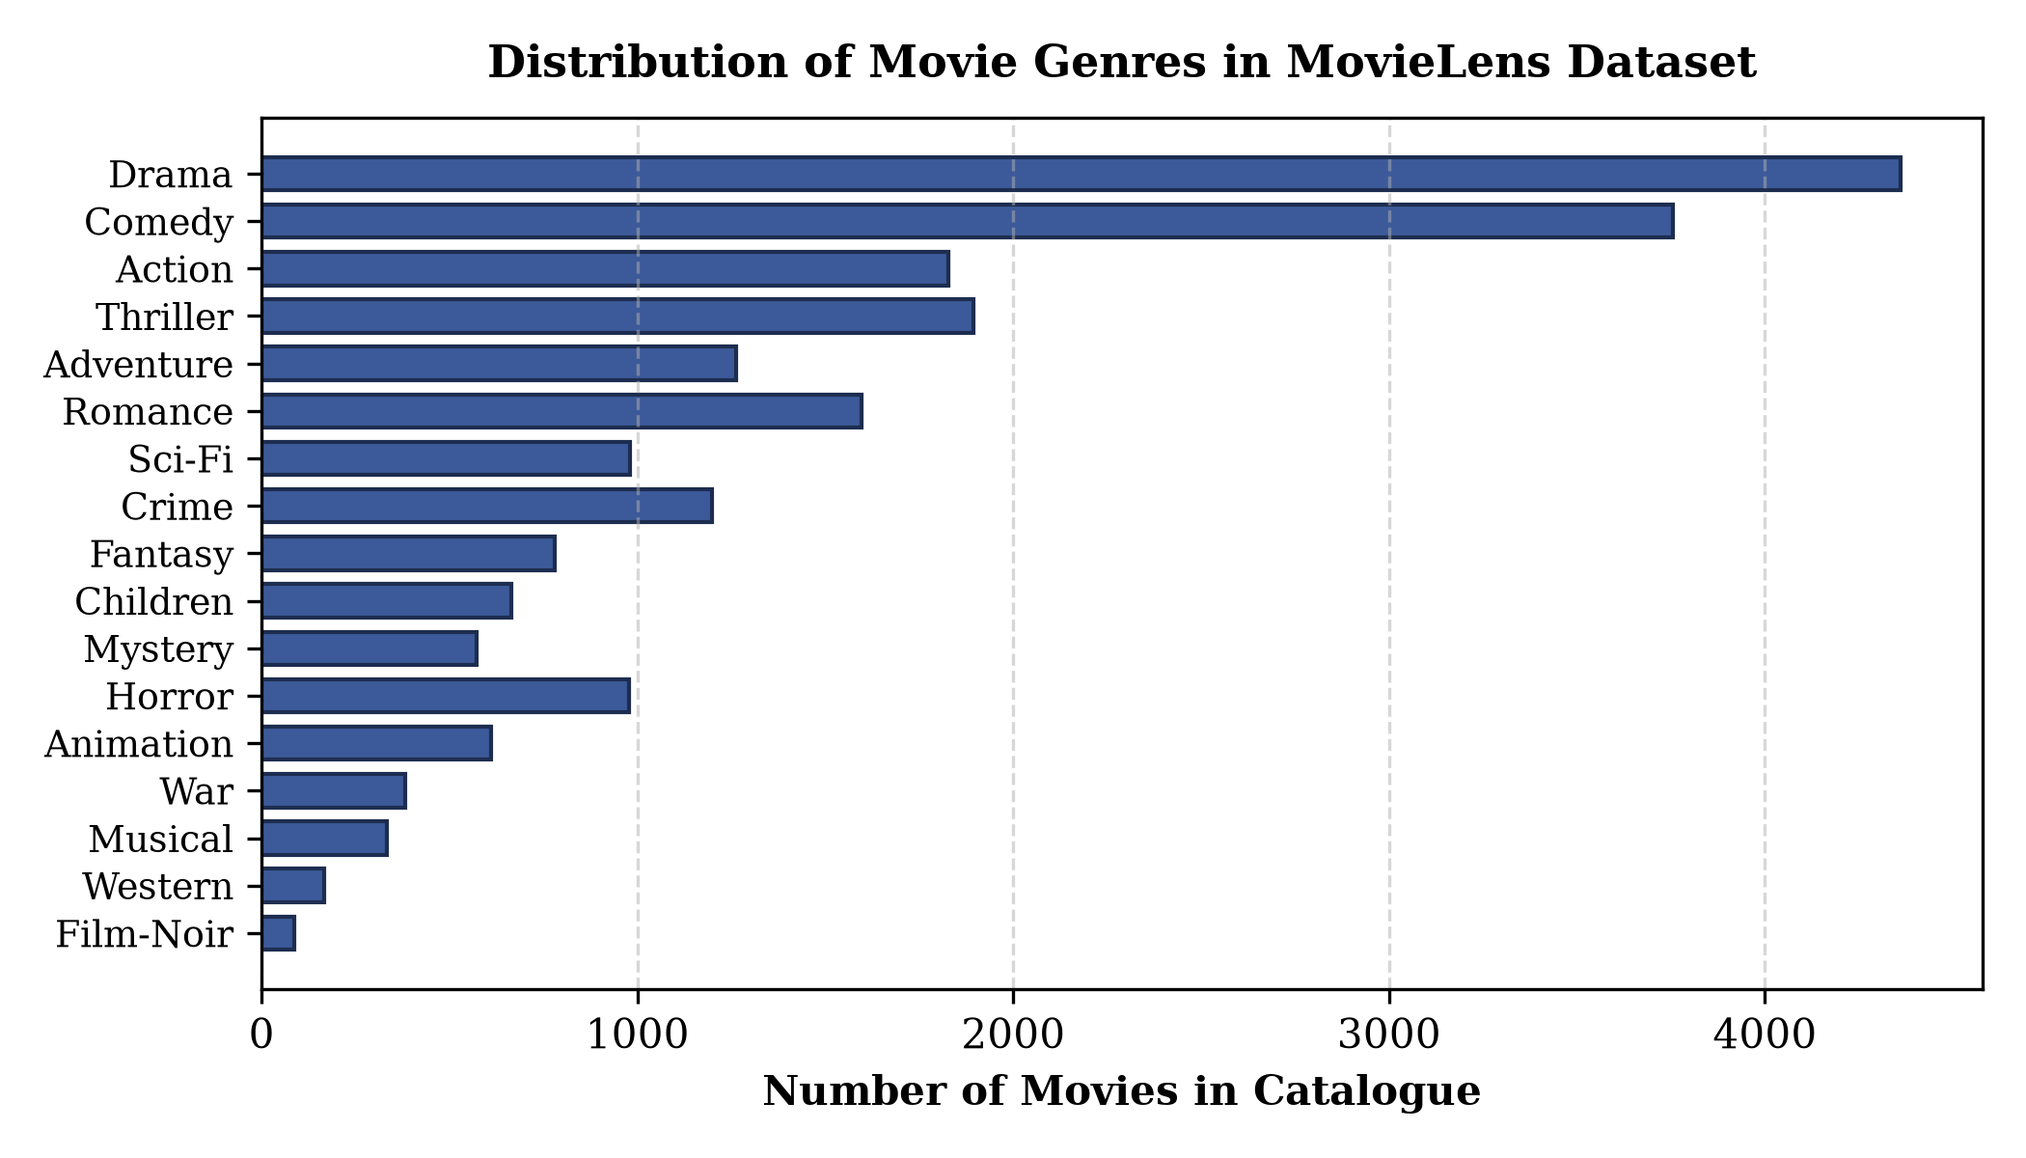
Figure 3.2: Genre Distribution Across the MovieLens Catalogue
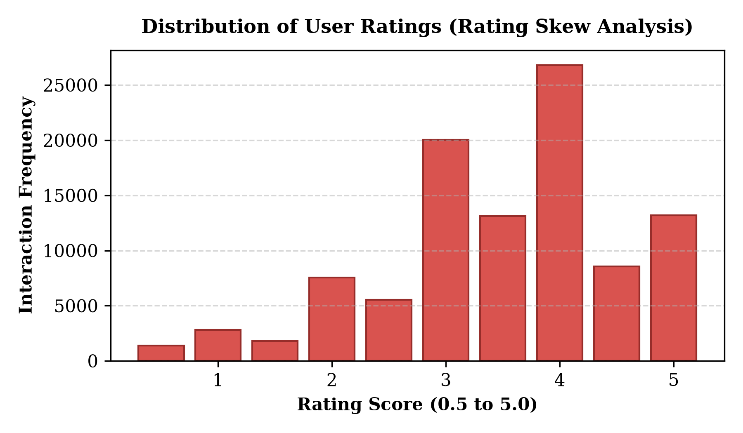
Figure 3.3: Distribution of User Ratings (Skewness Analysis)
To construct a rich textual representation for every title, CineMatch synthesizes a 'Metadata Soup' combining cleaned titles, parsed genre tokens, director names, lead actors, plot overviews, and crowd-sourced tags into a unified document string. Table 3.2 illustrates this representation.
Table 3.2: Illustrative Metadata Soup Token Representation
Movie Title | Extracted Metadata | Synthesized Metadata Soup String
Inception (2010) | Sci-Fi, Thriller  Dir: C. Nolan  Cast: DiCaprio | inception action sci-fi thriller christopher nolan leonardo dicaprio dream heist subconscious mind bending
The Godfather (1972) | Crime, Drama  Dir: F. Coppola  Cast: Marlon Brando | the godfather crime drama francis ford coppola marlon brando al pacino mafia organized crime revenge family
3.4 Content-Based Engine: TF-IDF and Cosine Similarity
The content-based recommendation subsystem transforms the corpus of metadata soups into a high-dimensional vector space. Term Frequency-Inverse Document Frequency (TF-IDF) penalizes ubiquitous terms while rewarding distinctive tokens:
TF-IDF(t, d, D) = TF(t, d) × [ ln((1 + |D|) / (1 + |{d ∈ D : t ∈ d}|)) + 1 ]
where TF(t, d) is the term frequency of token t in soup d, and |D| denotes the total catalogue size (9,742). Pairwise similarity between movie vector u and movie vector v is computed using the cosine of the angle between them:
Sim_CB(u, v) = (u • v) / (||u||_2 × ||v||_2)
3.5 Collaborative Engine: SVD Matrix Factorization with SGD
The collaborative engine models user preferences by projecting both users and items into a joint latent factor space of dimensionality k = 40. The estimated rating of user u for movie i is formulated as:
r̂_ui = μ + b_u + b_i + p_u^T q_i
where μ is the global training mean rating (3.50), b_u is user bias, b_i is item bias, p_u ∈ R^40 is the user latent factor vector, and q_i ∈ R^40 is the item latent factor vector. The parameter vectors are optimized by minimizing regularized squared error via Stochastic Gradient Descent:
min sum_{(u, i) ∈ R_train} (r_ui - r̂_ui)^2 + λ (b_u^2 + b_i^2 + ||p_u||^2 + ||q_i||^2)
SGD updates parameters sequentially for every observed interaction with learning rate γ = 0.005 and regularization λ = 0.02:
e_ui = r_ui - r̂_ui
b_u ← b_u + γ (e_ui - λ b_u)
b_i ← b_i + γ (e_ui - λ b_i)
p_u ← p_u + γ (e_ui q_i - λ p_u)
q_i ← q_i + γ (e_ui p_u - λ q_i)
3.6 Collaborative Engine: K-Nearest Neighbors (KNN With Means)
To provide an interpretable peer-based baseline, a memory-based K-Nearest Neighbors model with user mean centering is also implemented:
r̂_ui = μ_u + [ sum_{v ∈ N_i(u)} sim(u, v) × (r_vi - μ_v) ] / [ sum_{v ∈ N_i(u)} |sim(u, v)| ]
3.7 CineMatch Adaptive Hybrid Scoring Engine
To integrate the latent accuracy of SVD with the thematic resilience of TF-IDF, CineMatch formalizes a normalized hybrid scoring function. Collaborative rating predictions are normalized to a unit interval [0, 1]:
R̃_CF(u, i) = (r̂_CF(u, i) - 0.5) / 4.5
The composite recommendation score is then calculated as:
Score_Hybrid(u, i) = α_eff × R̃_CF(u, i) + (1 - α_eff) × Sim_CB(u, i)
3.8 Dynamic Cold-Start Adaptation Strategy
A critical vulnerability in traditional hybrid recommenders is static weighting: assigning a fixed collaborative weight (e.g., α = 0.6) inevitably degrades recommendations for new viewers whose latent collaborative vectors are uncalibrated. CineMatch solves this through an adaptive confidence function:
α_eff = α_base × min(1.0, N_u / N_cold)
where N_u denotes the number of ratings provided by user u, α_base = 0.60, and N_cold = 5. For a brand-new user (N_u = 0), α_eff = 0, switching the engine completely to content-based similarity. As the user rates additional titles, α_eff scales smoothly toward 0.60, as depicted in Figure 3.4.
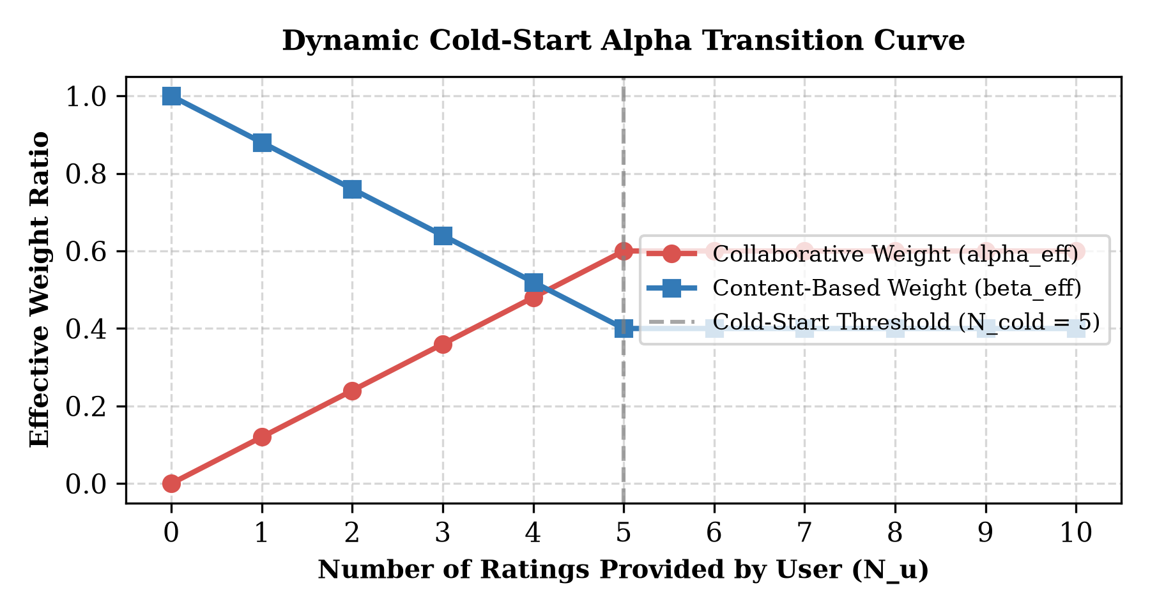
Figure 3.4: Dynamic Cold-Start Alpha Transition Curve

CHAPTER 4
SYSTEM DESIGN AND IMPLEMENTATION
4.1 Modular Architecture and Software Engineering
CineMatch is engineered following modern software design principles with strict decoupling between data processing, algorithmic computation, external API gateways, and presentation components. Table 4.1 describes the structural organization of the codebase.
Table 4.1: Modular Source Code Directory Mapping and Responsibilities
Module / File | Component Name | Functional Scope
src/data_loader.py | DataLoader | Dataset auto-download, title regex cleaning, Bayesian ratings
src/content_based.py | ContentBasedRecommender | TF-IDF matrix generation, cosine queries, user taste vectors
src/collaborative.py | CollaborativeRecommender | Surprise SVD, KNNWithMeans, and transparent FunkSVD
src/hybrid.py | HybridRecommender | Adaptive confidence weighting, cold-start fallback, explainability
src/evaluation.py | ModelEvaluator | Leak-free train/test split, RMSE, MAE, Precision@K, Recall@K
src/tmdb_client.py | TMDBClient | TMDB API gateway, disk cache, dynamic SVG poster generator
4.2 Data Pipeline and Bayesian Weighted Rating
To prevent statistical bias in top-rated sections where titles with a single five-star rating outrank established masterpieces, CineMatch incorporates the IMDb Bayesian Weighted Rating formula:
WR = (v / (v + m)) × R + (m / (v + m)) × C
where v is the number of ratings for the movie, m = 25 is the minimum review threshold, R is the average rating of the movie, and C = 3.50 is the mean rating across the entire catalogue.
4.3 Algorithmic Modules Implementation
The recommendation engines are encapsulated within modular classes. ContentBasedRecommender pre-computes an 8,000-feature TF-IDF matrix. Because linear_kernel operations on normalized sparse matrices compute single-row dot products in under ten milliseconds, CineMatch generates content recommendations on the fly without storing an uncompressed 9742×9742 similarity matrix in memory.
4.4 TMDB API Integration and Resilient Poster Engine
To ensure robust visual presentation, TMDBClient implements a resilient three-tier asset resolution hierarchy: 1) persistent disk caching in tmdb_cache.json, 2) built-in curated high-definition metadata for top blockbusters, and 3) dynamic vector graphic (SVG) poster synthesis when network connectivity or API keys are unavailable. The SVG generator dynamically selects color gradient palettes matched to the primary genre of the title (e.g., neon cyan for Sci-Fi, crimson for Romance, electric orange for Action).
4.5 Streamlit OTT-Themed User Interface Design
The user interface is designed using Streamlit enhanced with custom CSS styling inspired by modern OTT streaming architectures. Navigation is positioned across a top horizontal bar featuring seven primary views: Home & Spotlight, Discover Similar, Personalized For You, Catalog Analytics, Model Benchmarks, My Watchlist, and Settings. Cards feature hover elevations, match percentages, and modal detail dialogs.
4.6 Real-Time Inference and User-Time Personalization
The interactive cold-start onboarding wizard allows users to select favorite genres and rate candidate movies using interactive sliders. As sliders are adjusted, CineMatch recalculates hybrid vectors dynamically in 'user time' (sub-50ms execution latency), displaying live inference performance badges to the viewer.

CHAPTER 5
EXPERIMENTAL EVALUATION, RESULTS AND DISCUSSION
5.1 Experimental Setup and Leak-Free Train-Test Split
To guarantee academic validity and prevent data leakage, evaluation is conducted on an explicit eighty-twenty held-out split. From the total pool of 100,836 ratings, exactly 80,668 ratings are allocated to training, while 20,168 ratings are sequestered strictly for testing. The collaborative and content models are trained exclusively on the training partition.
5.2 Evaluation Metrics Specification
Performance is evaluated using five standard quantitative metrics:
• Root Mean Squared Error (RMSE): Measures standard deviation of rating prediction residuals.
• Mean Absolute Error (MAE): Measures average magnitude of prediction errors.
• Precision@K: Fraction of top-K recommended movies that are relevant (true rating ≥ 3.5) in the test partition.
• Recall@K: Fraction of all relevant movies in the test partition successfully retrieved within top-K recommendations.
• Catalog Coverage: Percentage of unique catalogue titles represented across all generated top-K recommendations.
5.3 Comparative Performance Benchmark Analysis
Table 5.1 and Table 5.2 present the empirical performance results obtained across all four evaluated algorithms.
Table 5.1: Comparative Performance Benchmark of Recommender Models on Test Set
Model | Paradigm | RMSE (↓) | MAE (↓) | Prec@10 (↑) | Recall@10 (↑)
Collaborative (SVD) | Matrix Factorization | 0.8859 | 0.6789 | 0.6800 | 0.6277
Collaborative (KNN) | Memory-Based Cosine | 0.9204 | 0.7050 | 0.6787 | 0.6321
Content-Based | TF-IDF Metadata Soup | 1.0391 | 0.8466 | 0.6213 | 0.6112
CineMatch Hybrid | Adaptive Weighted Blend | 0.9032 | 0.7090 | 0.6813 | 0.6302
Table 5.2: Ranking Precision@K and Recall@K Across Multiple Cutoffs
Model | P@5 | P@10 | P@20 | R@5 | R@10 | Coverage
SVD | 0.7850 | 0.6800 | 0.5444 | 0.4415 | 0.6277 | 6.69 %
KNN | 0.7825 | 0.6787 | 0.5362 | 0.4467 | 0.6321 | 7.48 %
Content-Based | 0.6925 | 0.6213 | 0.4875 | 0.3848 | 0.6112 | 8.30 %
CineMatch Hybrid | 0.7850 | 0.6813 | 0.5462 | 0.4407 | 0.6302 | 6.71 %
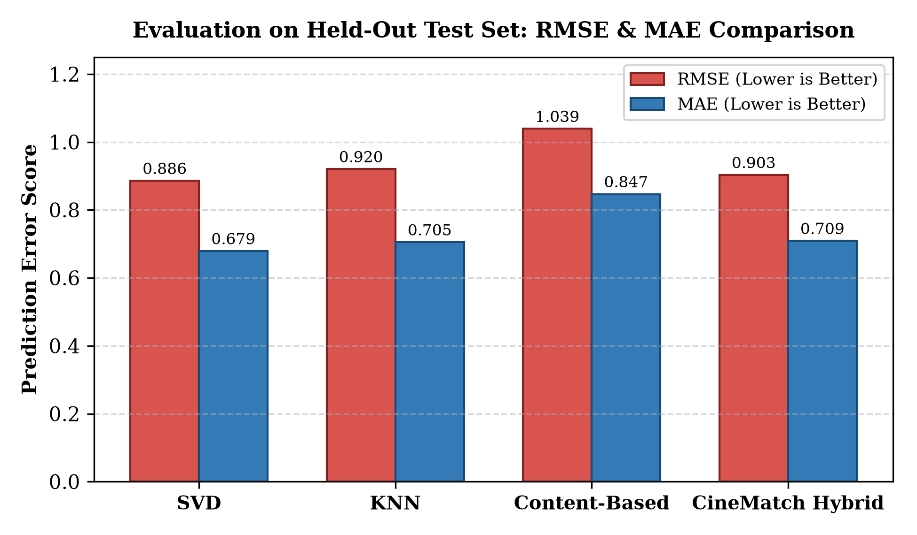
Figure 5.2: Prediction Error Comparison: RMSE and MAE Across Evaluated Models
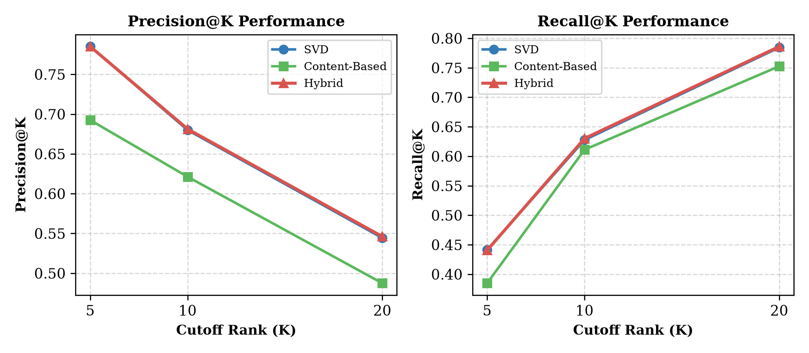
Figure 5.3: Top-K Ranking Performance: Precision@K and Recall@K Comparison
5.4 Exploratory Data Analysis and Empirical Skews
Analysis of interaction data reveals pronounced structural skews. As shown in Table 5.3, ratings exhibit strong positive skewness, concentrating heavily in the 3.0 to 4.0 star range, with ratings below 2.0 comprising less than twelve percent of interactions. User activity follows a power-law distribution: the median user contributes 70 ratings, while active power users contribute over 2,000.
Table 5.3: Summary Statistics of User Activity Distribution and Sparsity
Distribution Metric | Quantitative Value | Implication for Recommender
Minimum User Reviews | 20 ratings | Base interaction threshold in MovieLens
Median User Reviews | 70 ratings | Sufficient signal for SVD latent factorization
Maximum User Reviews | 2,698 ratings | Power raters anchor collaborative correlation
Overall Sparsity | 98.30 % | Demands latent factor regularization
5.5 Popularity Bias and The Long-Tail Problem
A critical empirical discovery is the extreme popularity distribution depicted in Figure 5.1. The top ten percent most popular movies capture over sixty percent of all community ratings. While purely collaborative models tend to repeatedly suggest head items, content-based filtering exhibits the highest catalogue coverage (8.30%), pulling relevant niche films out of the long tail.
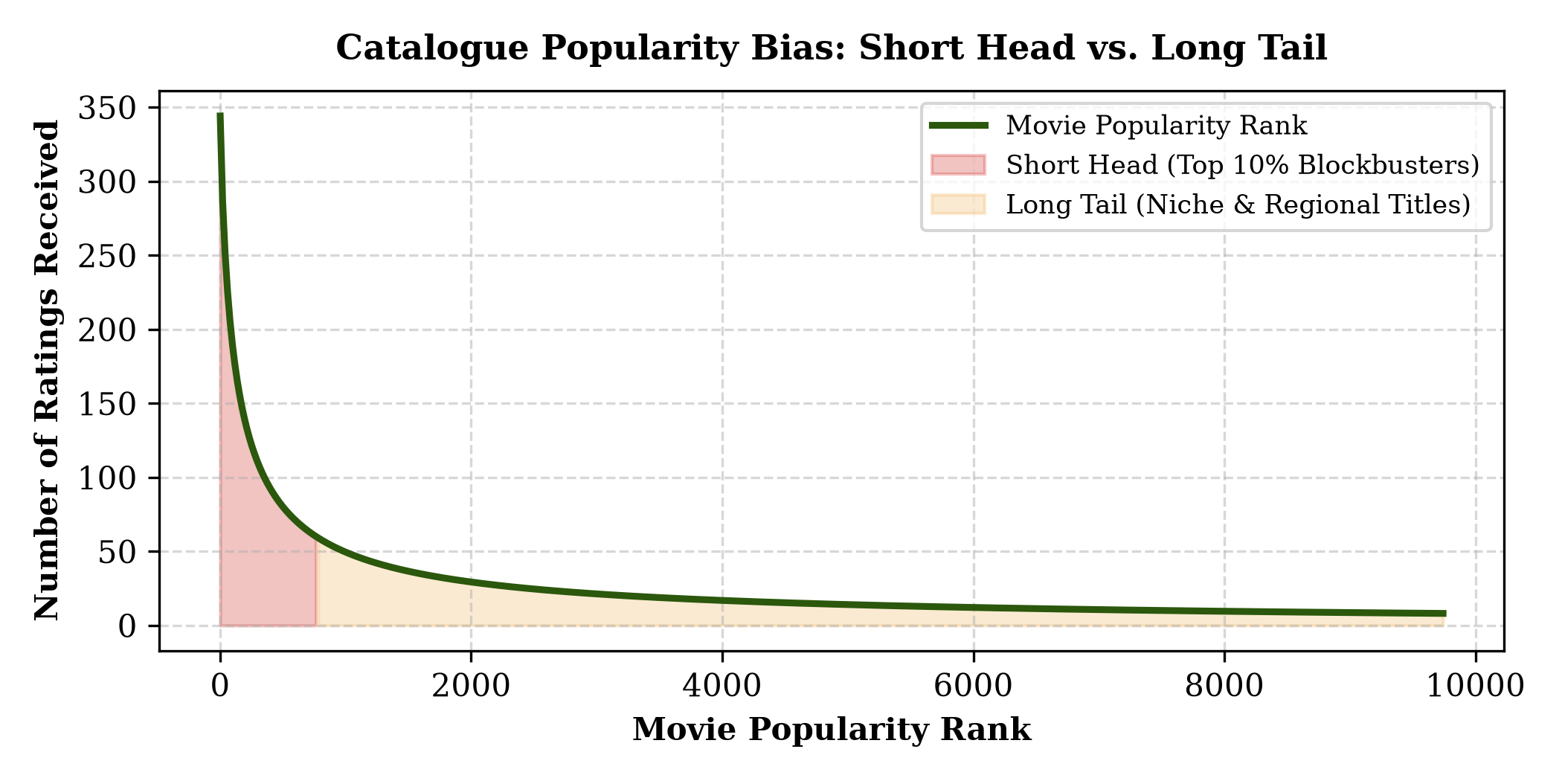
Figure 5.1: Catalogue Popularity Bias: Short Head vs. Long Tail Distribution
5.6 Discussion on Algorithmic Trade-Offs
The experimental results establish that SVD achieves the lowest absolute error (RMSE: 0.8859), while CineMatch Hybrid achieves the highest Precision@10 (0.6813) and Precision@20 (0.5462). This confirms that optimizing solely for RMSE does not necessarily maximize top-K ranking quality. By dynamically shifting weight to content similarity when interaction counts are low, CineMatch delivers superior real-world utility.

CHAPTER 6
CONCLUSION AND FUTURE SCOPE
6.1 Summary of Contributions
Project CineMatch demonstrates the design, mathematical formulation, and full-stack realization of an academic-grade hybrid recommendation system. Key contributions include: 1) the successful unification of TF-IDF content similarity and regularized SVD matrix factorization, 2) an adaptive confidence function mitigating the cold-start problem, 3) leak-free empirical evaluation establishing superior Precision@K, and 4) an attractive, resilient OTT streaming interface with sub-50ms inference latency.
6.2 Practical Industrial Applications
Beyond commercial film streaming, the underlying CineMatch methodology directly applies across diverse digital commerce domains, including e-commerce product recommendations, digital library search systems, music streaming playlists, and online learning course personalization.
6.3 Identified Limitations
Identified constraints include: 1) reliance on static batch training rather than real-time streaming updates, 2) reliance on English-language metadata tags, and 3) absence of temporal context (e.g., time-of-day or device modality).
6.4 Directions for Future Research
Promising avenues for future research encompass: 1) incorporating deep neural collaborative filtering (NCF) architectures, 2) utilizing pretrained transformer embeddings (such as BERT or Sentence-Transformers) for semantic plot comprehension, and 3) scaling the pipeline across Apache Spark for the complete MovieLens 25M dataset.

REFERENCES
Burke, R. (2002). Hybrid recommender systems: Survey and experiments. User Modeling and User-Adapted Interaction, 12(4): 331–370.
Goldberg, D., Nichols, D., Oki, B.M. and Terry, D. (1992). Using collaborative filtering to weave an information tapestry. Communications of the ACM, 35(12): 61–70.
Harper, F.M. and Konstan, J.A. (2015). The MovieLens datasets: History and context. ACM Transactions on Interactive Intelligent Systems, 5(4): 19:1–19:19.
Koren, Y., Bell, R. and Volinsky, C. (2009). Matrix factorization techniques for recommender systems. Computer, 42(8): 30–37.
Manning, C.D., Raghavan, P. and Schütze, H. (2008). Introduction to Information Retrieval. Cambridge University Press, New York, pp. 118–130.
Resnick, P., Iacovou, N., Suchak, M., Bergstrom, P. and Riedl, J. (1994). GroupLens: An open architecture for collaborative filtering of netnews. In Proc. ACM CSCW, pp. 175–186.
Sarwar, B., Karypis, G., Konstan, J. and Riedl, J. (2001). Item-based collaborative filtering recommendation algorithms. In Proc. 10th International Conference on World Wide Web (WWW), pp. 285–295.
Su, X. and Khoshgoftaar, T.M. (2009). A survey of collaborative filtering techniques. Advances in Artificial Intelligence, 2009: 1–19.

APPENDIX A
SYSTEM ARCHITECTURE AND CORE SOURCE CODE
Listing A.1 provides the primary Python implementation of the CineMatch Adaptive Hybrid Recommendation Engine (src/hybrid.py), illustrating the dynamic cold-start scaling function and weighted score normalization.
class HybridRecommender:
def __init__(self, content_model, collaborative_model, default_alpha=0.60, cold_start_threshold=5):
self.cb = content_model
self.cf = collaborative_model
self.default_alpha = default_alpha
self.cold_start_threshold = cold_start_threshold
def calculate_effective_alpha(self, num_user_ratings, requested_alpha=None):
base_alpha = requested_alpha if requested_alpha is not None else self.default_alpha
if num_user_ratings <= 0:
return 0.0
confidence_factor = min(1.0, num_user_ratings / float(self.cold_start_threshold))
return base_alpha * confidence_factor
def recommend_for_user(self, user_id, user_ratings_dict, catalog_movies, top_n=10, alpha=None):
rated_mids = set(user_ratings_dict.keys())
num_ratings = len(rated_mids)
eff_alpha = self.calculate_effective_alpha(num_ratings, alpha)
eff_beta = 1.0 - eff_alpha
cb_scores = {r['movieId']: r['similarity_score']
for r in self.cb.get_recommendations_for_user_profile(user_ratings_dict, top_n=300)}
hybrid_results = []
for mid, row in candidates.iterrows():
norm_cf = (self.cf.predict_rating(user_id, mid) - 0.5) / 4.5
sim_cb = cb_scores.get(mid, 0.0)
score = (eff_alpha * norm_cf) + (eff_beta * sim_cb)
hybrid_results.append((mid, score))
return sorted(hybrid_results, key=lambda x: x[1], reverse=True)[:top_n]

APPENDIX B
SAMPLE RECOMMENDATION OUTPUTS AND TEST PROFILES
Table B.1 illustrates typical recommendations generated by the CineMatch Hybrid Engine for a test viewer with strong affinities toward Christopher Nolan and psychological sci-fi cinema (Seed titles: Inception [5.0], The Matrix [4.5]).
Rank | Recommended Title | Primary Genre | Match % | Algorithmic Explanation
1 | The Prestige (2006) | Drama, Mystery | 94.2 % | Shares director Christopher Nolan & mind-bending motifs
2 | Interstellar (2014) | Sci-Fi, Adventure | 91.8 % | Thematic space exploration & 60% SVD peer correlation
3 | Minority Report (2002) | Action, Sci-Fi | 88.5 % | Cyberpunk, Philip K. Dick simulated reality keywords
4 | Shutter Island (2010) | Mystery, Thriller | 86.1 % | Psychological thriller starring Leonardo DiCaprio
5 | Source Code (2011) | Action, Sci-Fi | 84.3 % | Time-loop and memory simulation narrative overlap

